Spring Oscillation Lab

Goals
To understand and measure the oscillatory behavior of masses hanging from springs.

Equipment
- One half of PASCO Spring Set (3 springs of three different colors)
- Table clamp, metal pole, and arm with three hooks
- Set of masses
- Meterstick
- PASCO Photogate and Smart Timer (with power cord)
- Motion Detector
- Cardstock

Experiments

#1 Measuring the period as a function of mass and spring stiffness

Setup
- Set up the clamp, pole, and arm so that the pole extends downward to the floor and the arm’s hooks are over the floor.
- Open the spring set and examine the springs of different colors. Choose one of the springs for your measurement. Hook the loop of one end on one of the arm hooks.

Measurement
- Carefully hang a mass (choose one) from the bottom of the spring and dampen out any oscillations to see what the equilibrium stretch is. You don’t need to measure the stretch. This is just to help you set up your photogate to get a good measurement of the period.
- Set up the photogate under the mass so that, when you stretch the spring 10 cm or less, the mass will block the photogate. You don’t need to measure the amplitude. We will assume that the amplitude doesn’t affect the period.
- Set the photogate to measure Time in One Gate mode. This will start the time measurement when the photogate is first blocked after having a period of not being blocked, and then the time measurement ends when the photogate becomes blocked again. Think about it: this should measure one period.
- Pull straight down to block the photogate and release. Once it is oscillating nicely up and down, press Start on the smart timer. Record the period measured. Without touching the mass or spring, you may continue to take measurements of the period by pressing start, again and again. Take at least 10 trial measurements of period for that spring and mass combination. This should go quickly. Record all the data into an Excel spreadsheet. Once you inspect for outliers and fix them, average all 10 trial measurements to get an average period for that spring-mass combination.
- Repeat for a total of 5 different masses with the same spring. Then repeat for the two other springs, each with 5 different mass trials. You don’t need to use the same set of 5 masses for all three springs; some may require heavier masses, and some may stretch too much with heavy masses. Also, some of your masses can be a sum of more than one of the masses from your mass set (for example: 50 g + 200 g =250 g). 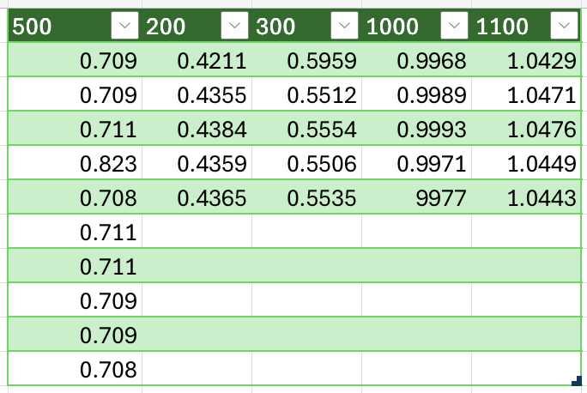
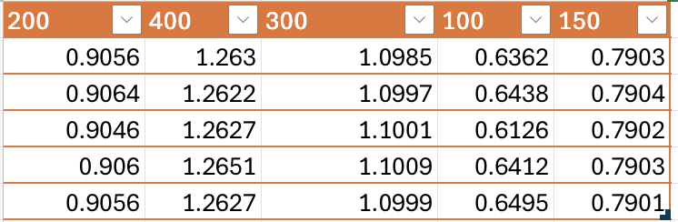
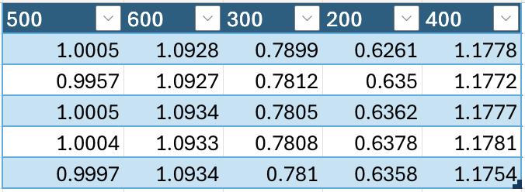

Analysis
- Plot a graph of period-squared vs mass in Excel for the different masses hanging from the same color spring. (Why period-squared? Consider how period and mass are related.)
- Fit this data to a linear trendline and check the box to show the equation on the graph. Interpret the equation to find the spring stiffness.
- Repeat the above (possibly adding data to the same graph) for the other two springs. Post your graph(s) below.
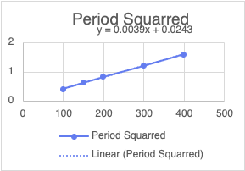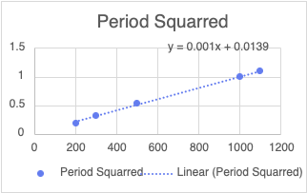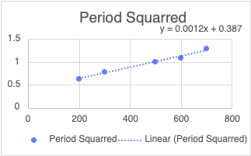

- Discuss how your measured stiffnesses compare to the manufacturer’s stated stiffnesses.
In your conclusion, be sure to discuss your measured spring stiffness and how it compares to the manufacturer’s stated stiffness.

#2 Measuring an unknown mass using a known spring
There is a clamp of unknown mass in the room. How can you use a spring oscillation to determine the mass? Choose one of your springs and use it to measure the mass of the clamp.
Explain below how you chose which spring to use and what you did to determine the unknown mass. How confident are you in your result? I’ll reveal the mass as measured on an electronic balance after all groups have completed this part.

#3 Fitting the position as a function of time
We have discussed how the functional form of the oscillation of a hanging spring mass is that of a sine or cosine. Here, we’ll use a motion detector to directly capture the position as a function of time.
Unfortunately, the motion detector needs a slightly bigger target to track, so we’ll tape a quarter-sheet of cardstock to the bottom of the mass which will be oscillating.

Setup
- Go to this link to access Vernier Graphical Analysis Pro. We will use this to take data from the motion sensor and to analyze it.
- Choose a spring and a mass. Tape the quarter-sheet of cardstock to the bottom of the mass. Hang the mass and spring on a hook.
- Place the motion detector directly under the hanging mass, pointing upward. The mass shouldn’t get too close to the detector, or it may fail to detect it.

First Measurement over 5 seconds
- Pull on the mass and let go to get it into oscillatory motion and then collect data over 5 seconds.
- Fit this curve to a cosine function.
  - Click on this icon in the lower left corner, and then select “Apply Curve Fit” from the menu. Choose “Cosine” from the menu that pops up and click Apply.)
- Interpret the fit data. (Compare the fit equation y=a*cos(bx+c)+d to the cosine equation you know for oscillations, and match up the variables.) What angular frequency does it report? What period does this correspond to? How close is this to your earlier measurement of the period for this particular spring-mass combination? Save the image of the graph with the curve fit and paste it here along with your answer to these questions.

Second Measurement over 60 seconds
- Now set it in motion again, and this time take data over 60 seconds.
- What do you notice about the shape of the curve? Describe it in your lab report. Why does it have this shape?
- Try to fit this to a cosine function. How is this fit? What angular frequency does it report?
- Then try instead to fit it to a Damped Harmonic.
  - You will need to enter in a custom equation. The equation to type is
$$a*exp(-qx)*cos(bx+c)+d$$which corresponds to an exponential decay times a cosine function.
$$y=ae^{-qx}\cos\left(bx+c\right)+d$$
  - How is this better? What angular frequency does this fit report? Save the image of the graph with the curve fit and paste it here along with your answer to these questions.
- Examine the difference between the Damped Harmonic and the Cosine functions? In light of the shape of the curve, how does the Damped Harmonic function make sense? Answer these questions.

Wrap-up
Before you upload your lab report, please ensure that all your lab group members are part of the same group on Canvas. Once you have confirmed this, then upload your lab report.

