Torque Exploration Lab

Introduction
The concept of torque is not merely relevant to car engines. It’s found in many examples of daily life. In this lab, we will do several different activities to explore the concept of torque.
You do not need to do these activities in any particular order. You can proceed as equipment is available. For your lab report, simply have a different section for each activity. Include your data taken or other results and a written conclusion discussing that you learned from that activity.

Activies

Station 1: Balancing Objects

Center of Mass
The center of mass is the average position of all the mass of an object. The force of gravity, acts on all the mass, but for a rigid object, it may be considered to act exactly at the center of mass. Consider how this relates to balance.
If you want to balance an object, say, on the tip of your finger or a small stand, where does the center of mass need to be? Explain using the concept of torque.
The pivot point must be on the tip of your finger. And if its balanced all the values that would lead to rotation will be zero.
Find the center of mass of the meterstick and the broom. For a long object, there is a simple. Rest it across two fingers on opposite hands and slowly bring them together. The center of mass will always remain between your fingers even as you bring them together. Try it! Why does this work?
For the meter stick the center of mass was right in the middle at 50cm. For the broom the center of mass was 85cm from the top of the broom. This works because the friction force will be less on the finger further away from the center of mass. As the fingers get closer the friction force gets closer and closer to the same value, so you narrow down on the center of mass.
I have provided some old cardstock file folders. Cut out an irregular shape and find the center of mass by seeing where it will balance on the tip of a pen or pencil. Take a photo of the shape as it is balancing and include it in your lab report.
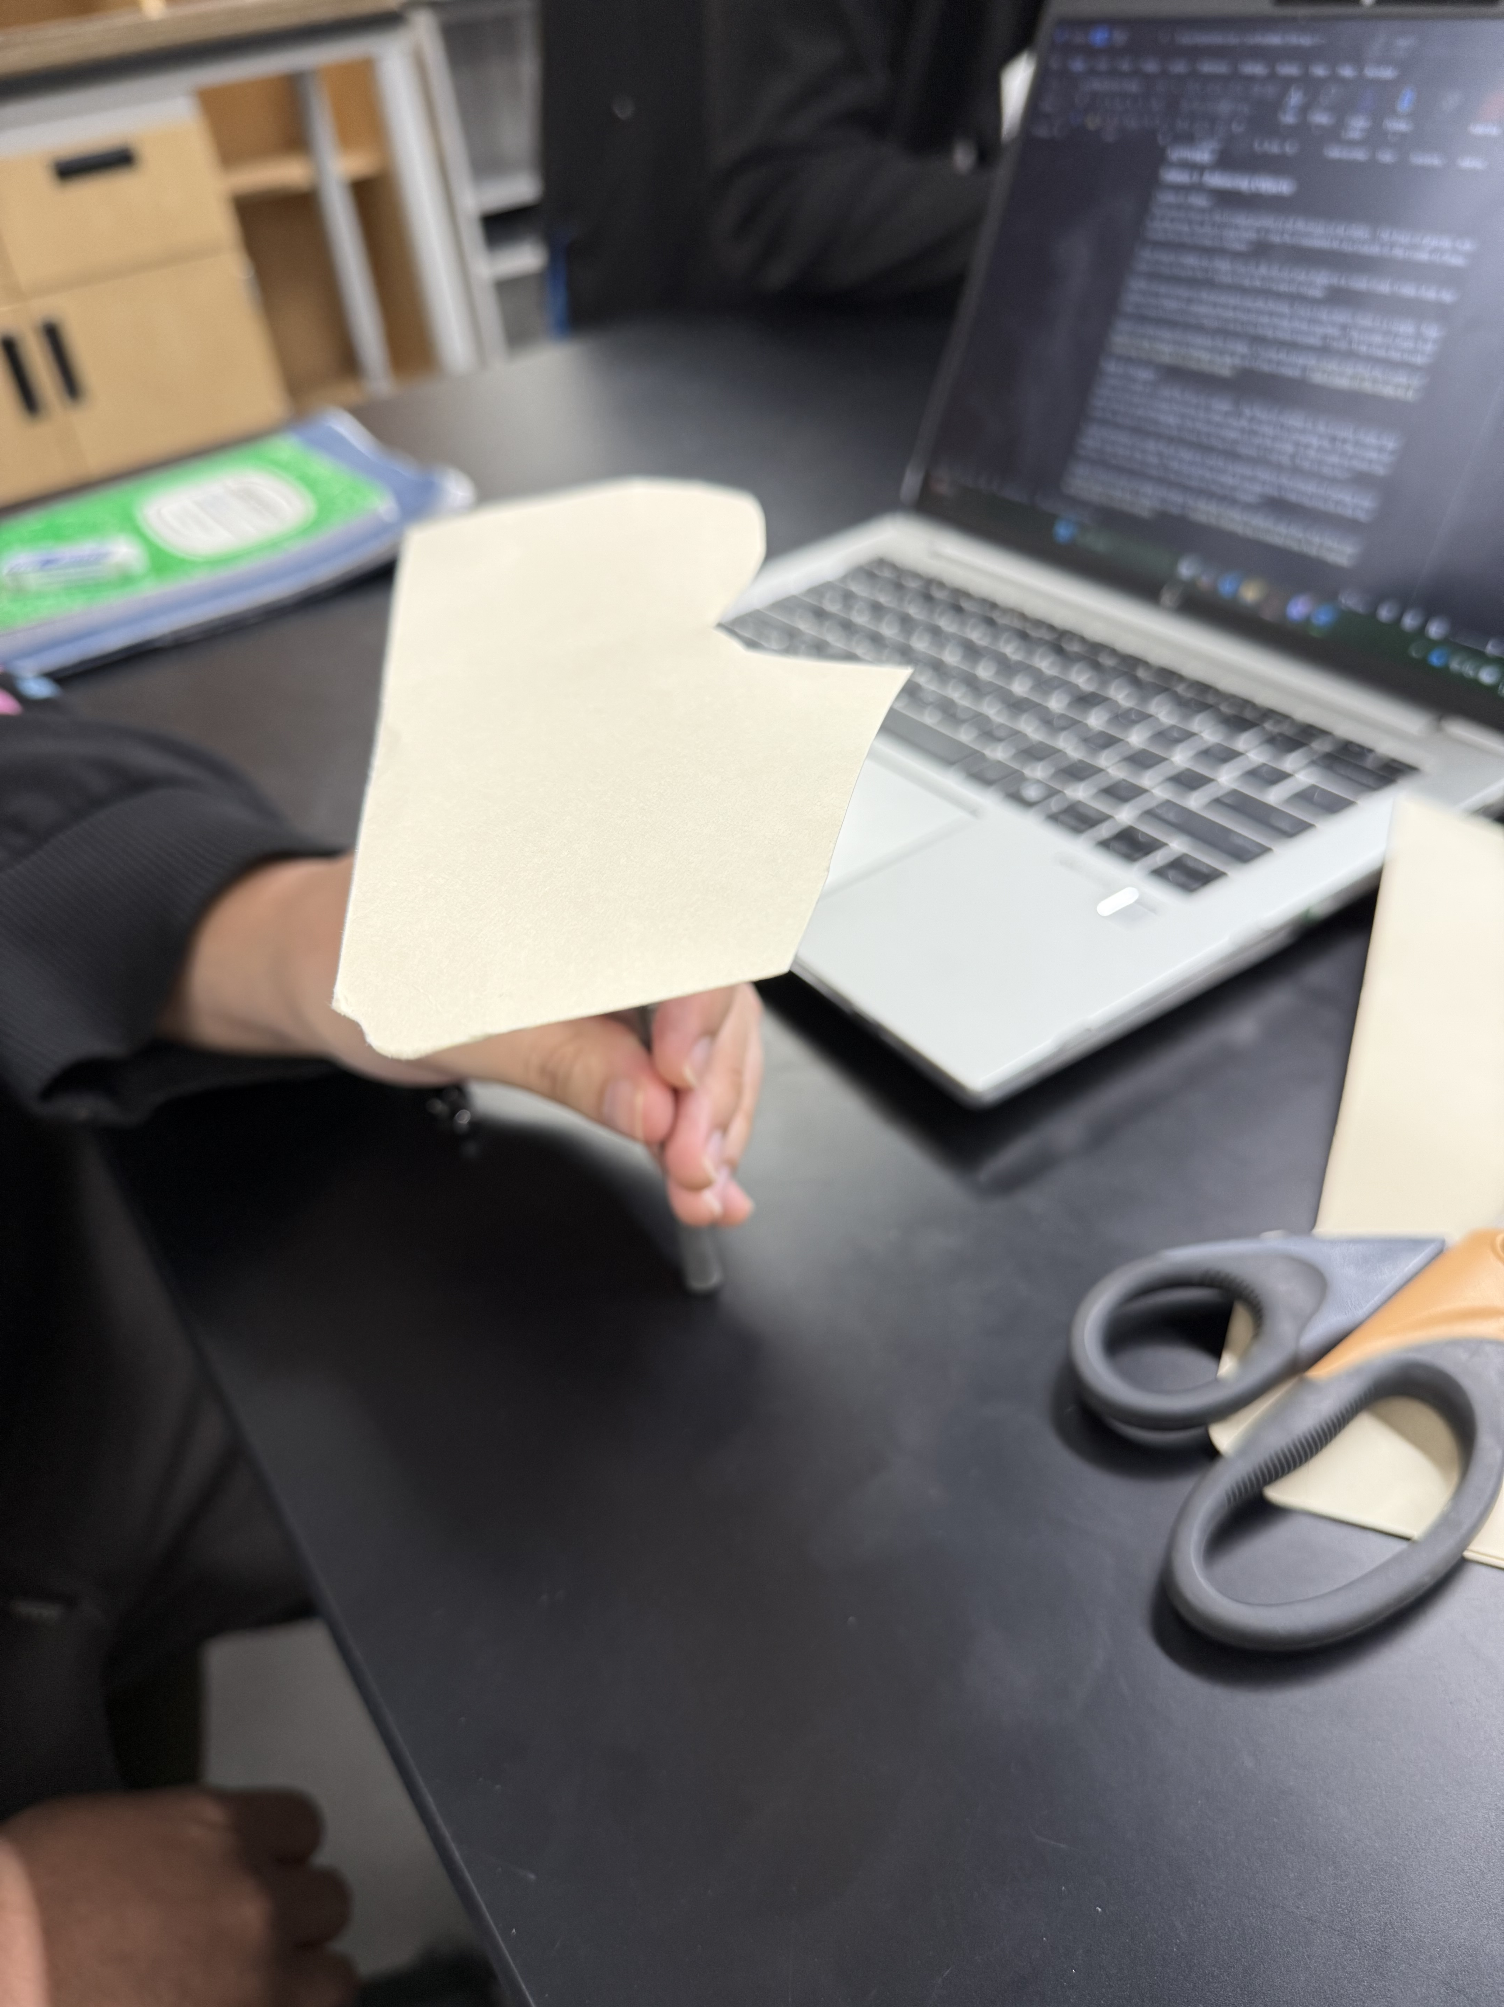

Base of Support
A related concept is called the base of support. The base of support is the convex shape that encloses all points of contact between an object and the surface it is standing on. If the center of mass is above a point belonging to the base of support, it will be stable. If the center of mass lies outside the region of space directly above the base of support, it will tip. Why is this so?
There will be more force outside of the base of support, so the net forces won’t be zero leading to rotation and the object falling.
To help understand, consider that in dance as well as in sports there is the concept of putting your weight on one foot or the other. When all of your weight is on one foot, what can you do with the other foot? How does this relate to the concept of base of support?
When you’re just on one foot you need to use the other to help balance against the rest of your body. If you aren’t stable or don’t have the core strength, your upper body will start leaning outside the base of support, so you need the foot that is off the ground to balance the center of mass.
Similarly, when you are standing with most, but not all, of your weight on one foot, why does one foot have more weight on it than the other? Explain by drawing an extended free body diagram and include this in your lab report. 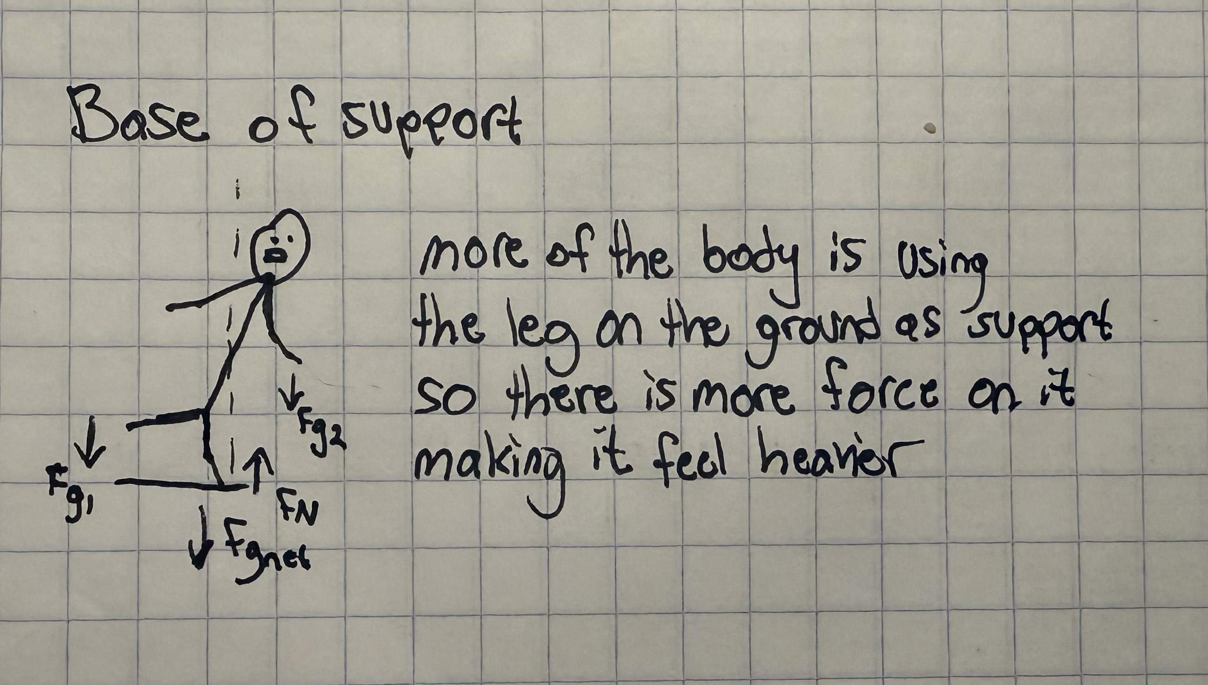

Crazy Stacking
Stack animal blocks or flat blocks to make a tall tower. Instead of neatly lining them up in a stack, try to make it extreme, so that it is close to being unstable. Take a photo and include it in your lab report. Discuss what you had to keep in mind in order to successfully build a tower. Try to use the concepts of center of mass and base of support as relevant to your explanation.
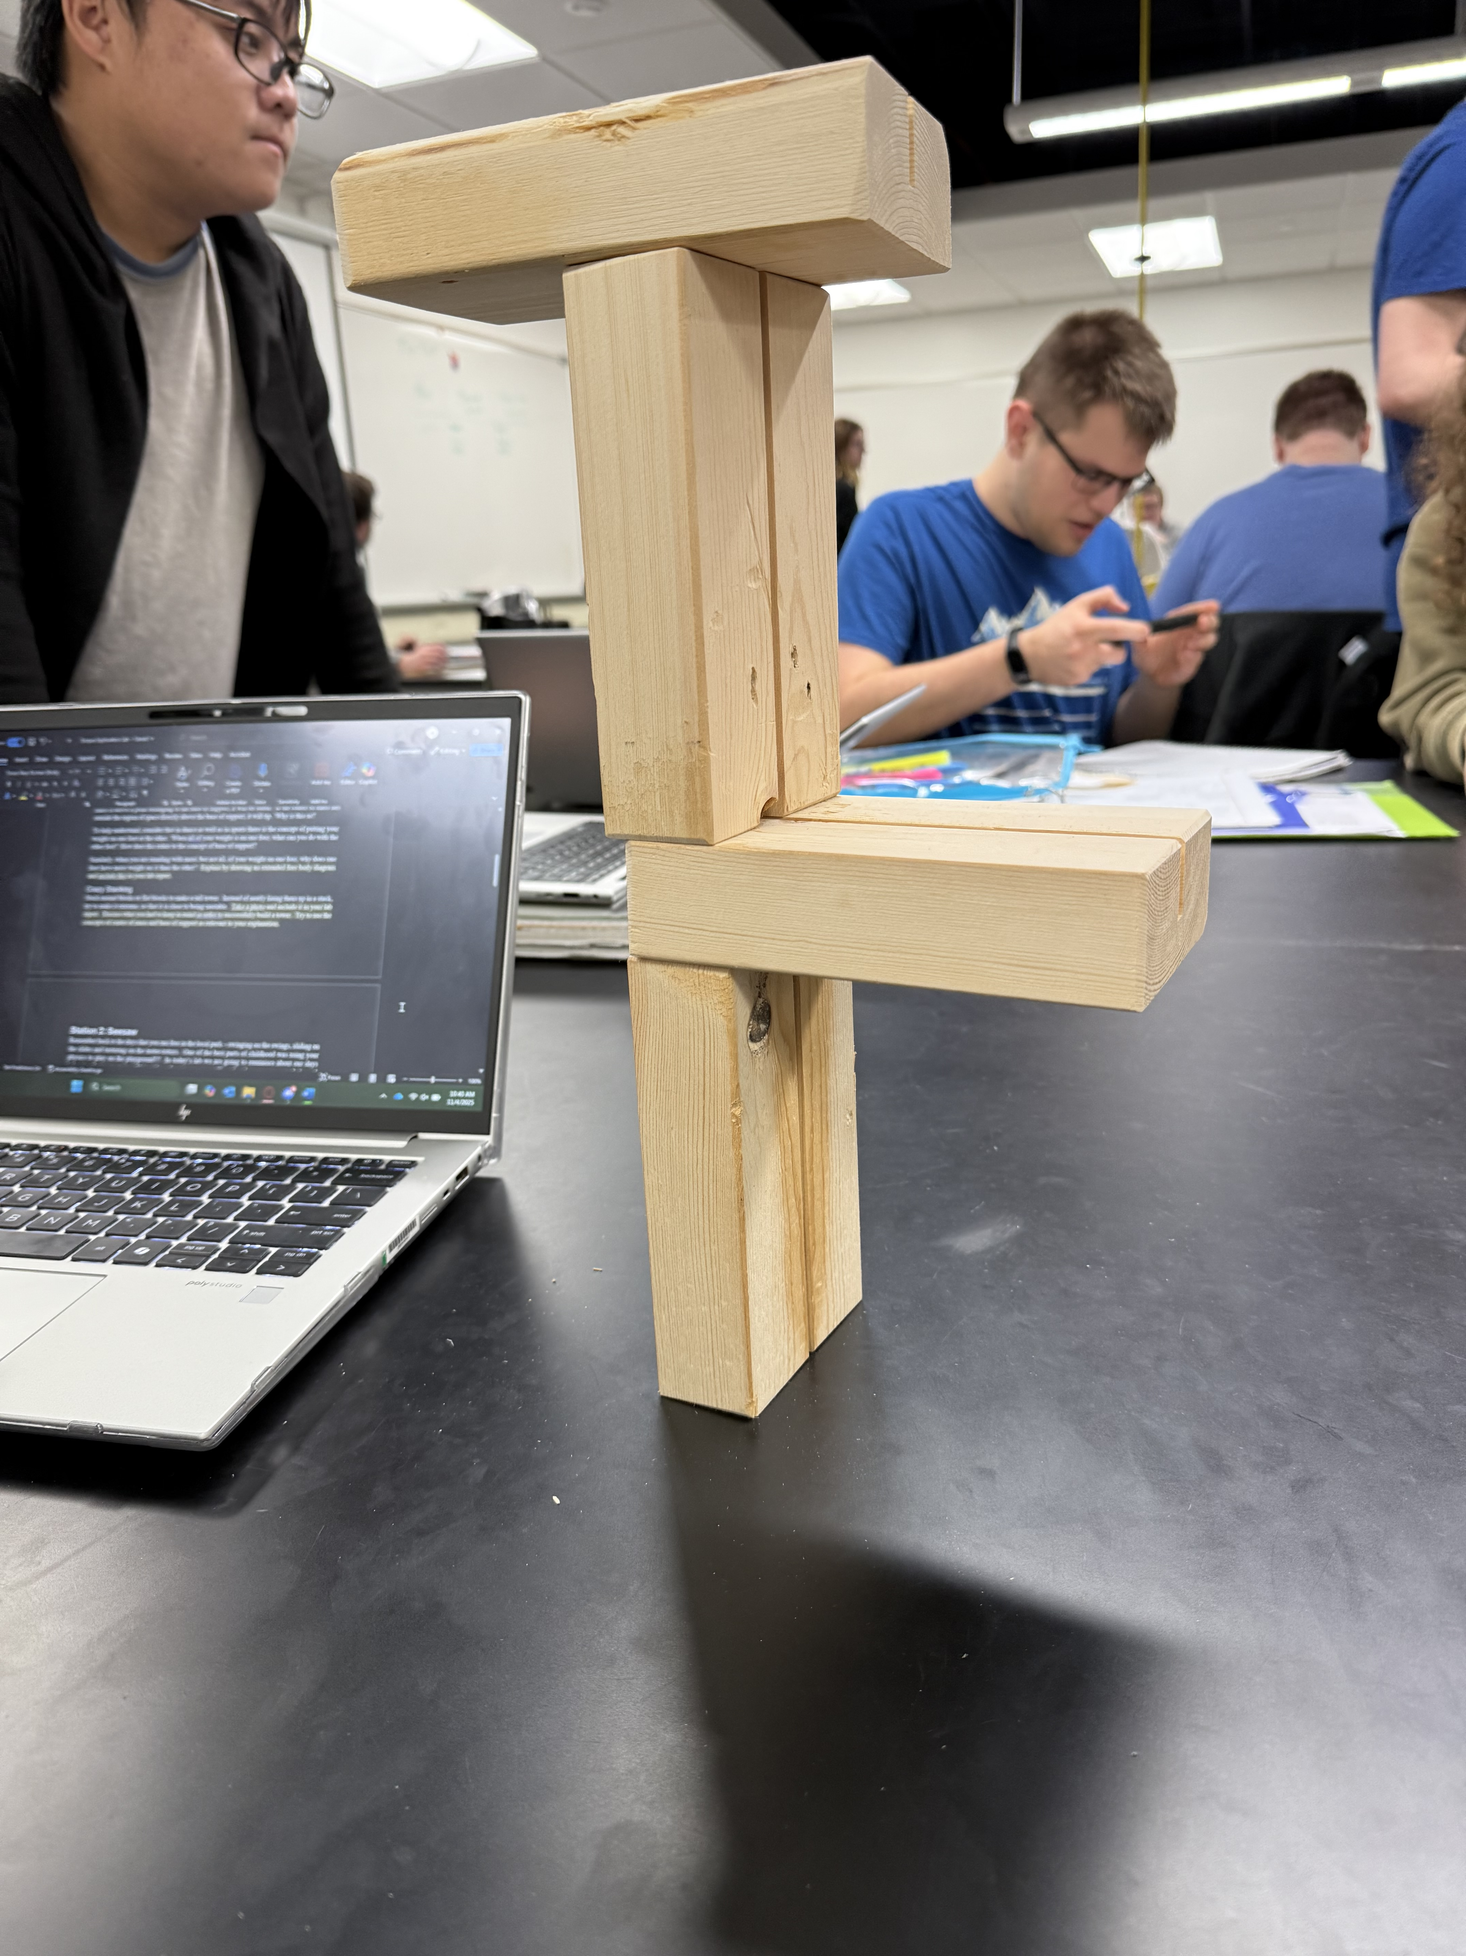
We had 4 blocks so we had to manage how far each block would stick out from the base of support. We found that when one block would stick out in one direction we would need another black in the other direction to balance the center of mass.

Station 2: Seesaw
Remember back to the days that you ran free in the local park – swinging on the swings, sliding on the slides and teetering on the teeter-totters. One of the best parts of childhood was using your physics to play on the playground!!! In today’s lab we are going to reminisce about our days balancing that teeter-totter. Using ideas about torque, we will explore how we can get a balanced teeter-totter.

Setup
Get the following supplies:
- Meterstick
- Metal stand
- Sliding clamps with hangers and one without
- Set of masses
- Electronic balance
Slide the clamp without a hanger onto the meterstick so that it will balance by itself when placed on the stand with the clamp as the pivot point. Important: this clamp should be upside down, so that the center of mass of the system is slightly below the axis of rotation. Consider why this is important. Where was the balance point? Was it exactly where expected?

Predictions and Trials
For each of the following, first work out the answer analytically to make a prediction. Afterward, test your prediction by placing the mass where you predicted it should go, and see if it balances. Then, adjust the location of the mass so that it exactly balances. Note where this was, so that you can compare to your predicted position for the purpose of discussing errors.
- If you place a 100-g mass + clamp at 20 cm from the pivot point, where should you place a 50-g mass + clamp to balance the seesaw?
Prediction: Setting both torques equal and solving for r_2 (the distance for the weight we will add) we got 40cm (from the center)

90.5cm

- If you place a 100-g mass + clamp at 20 cm from the pivot point and a 50-g + clamp at 30 cm from the pivot point on the same side, where should you place a 200-g mass + clamp to balance the seesaw?
Prediction: Using the same process as earlier, we got 17.5cm as our distance. (from the center)
68.5
- Shift the location of the pivot point to be at the 15-cm mark of the meterstick and remove all masses and other clamps. What mass + clamp can you hang, and where do you need to place it, to get the seesaw to balance with an off-center pivot point like this?
Prediction: We think we could hang 300g at 10cm to balance it
At 8cm we hung 500g and it balanced

Station 3: Torque Board
This is very similar to the Force Board that we used a few weeks ago. Use two spring scales to hold up a wooden block from eye hooks that are attached to it and hang a mass from another eye hook. When you are happy with the arrangement, move on to calculations. One trial will be enough for this station.
Using a ruler, a protractor, the spring scale readings, the mass, and data from an electronic balance, compute the net force vector and the net torque in the z direction acting on the block.
Draw a careful extended free body diagram and the newton’s second law equations you can get from it. Include a picture of the EFBD and N2L equations and your calculations in your lab report.
Are your net force vector and net torque what you expect? If the error is unreasonably large, go back and check your calculations. Otherwise, justify why the level of error you see is reasonable from the level of error associated with your measuring devices.

FBD:
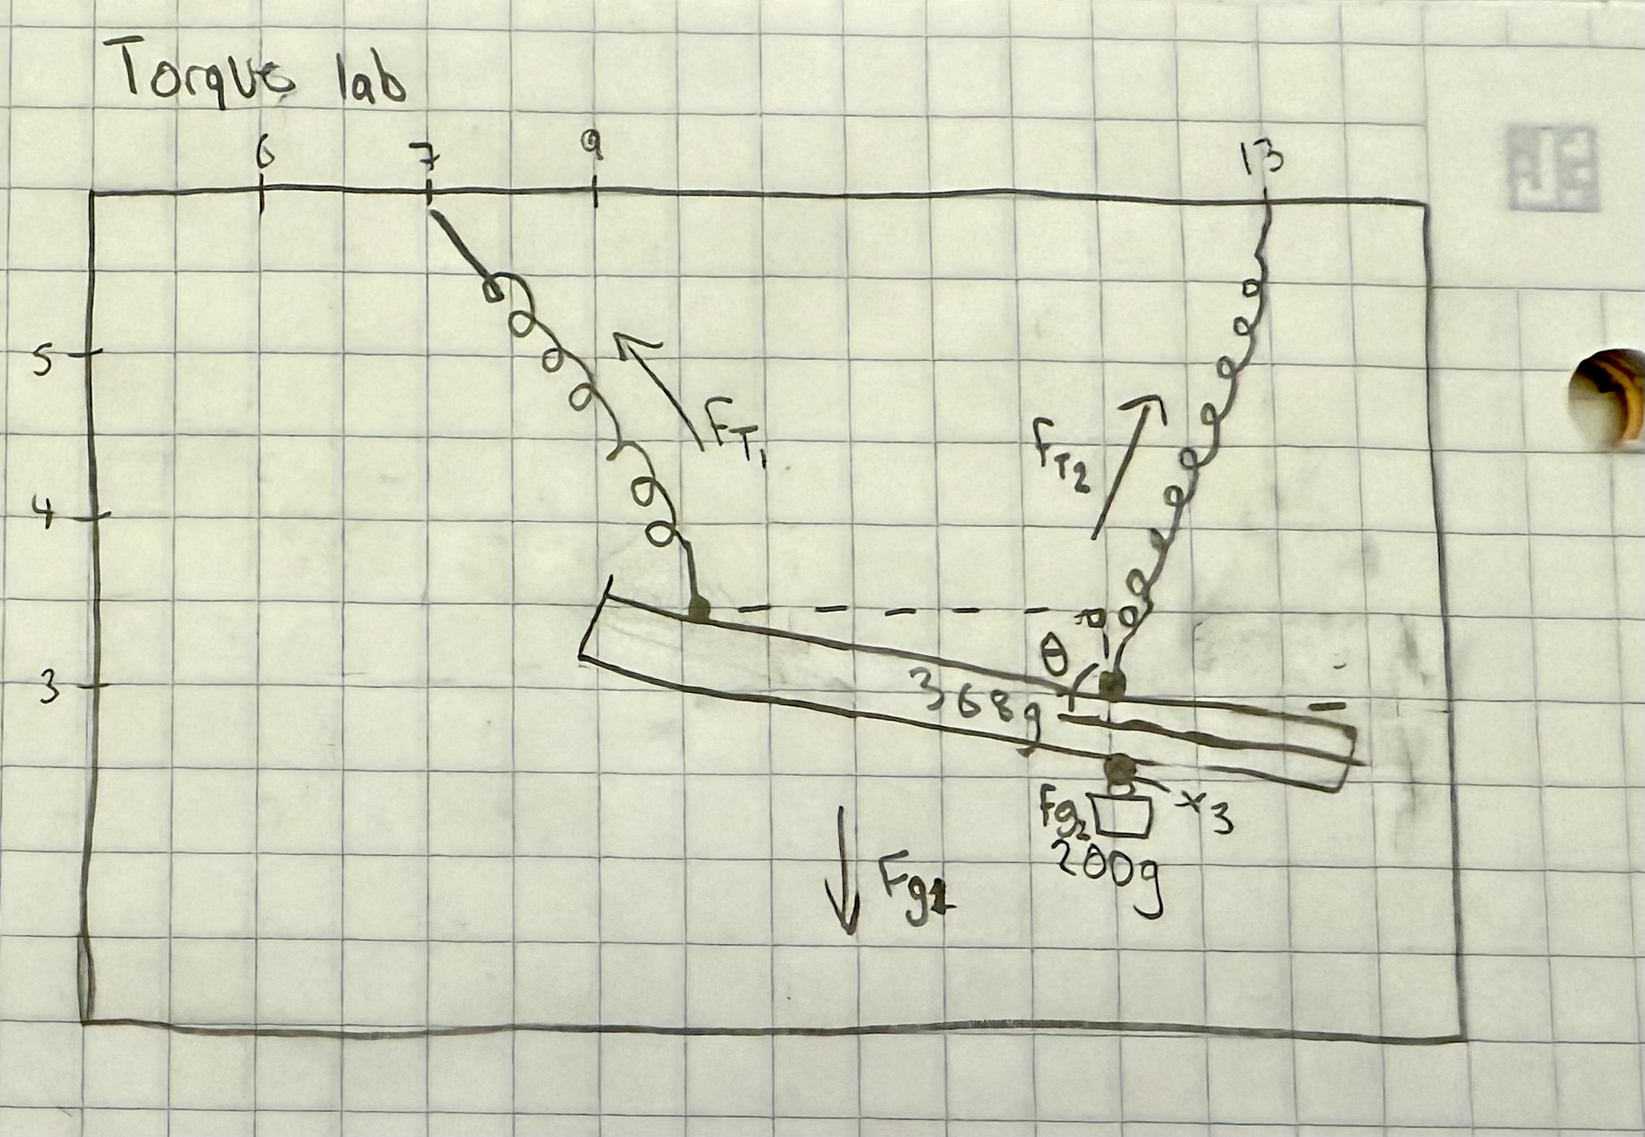

N2L:
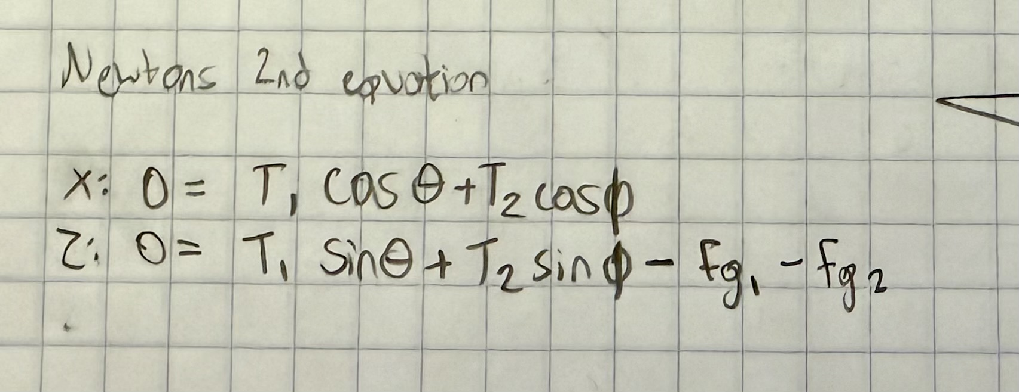

F_netx = 3.714
F_netz = 5.95

Torque_net = 220.08

Station 4: Tricks with Balance
Tipping a cup with your nose
Kneel on the ground. Put your hands together with your fingers sticking out, touch your elbows to your knees and lay your arms flat on the floor with your fingers extended. Have your partner place the cup at the end of your middle fingers.
Now, you’re going to sit up, put your hands behind your back, and lean over and try to tip the cup over with your nose. Don’t do it yet! Make a prediction first.
Prediction: Will you be able to tip over the can without tipping over yourself?
Write on the whiteboard up front if you were able to tip the cup or not.
Observation and Explanation (include in lab report): How did it feel to try to tip the cup? Why do you think you were able or not able to do it? Please consider the concepts of center of mass and base of support. Look over the comments and see who was able to do it and who wasn’t. Can you make any generalizations based on this information? (Generalizations are okay!)
I felt a lot of force on my knees and my feet lifting off the ground. I think if I let my feet get off the ground I would have face planted.
Picking up a ball
Stand with your back and heels touching a wall. Have someone place the ball between your two feet. You will try to pick up the ball without bending your knees. Make a prediction first.
Prediction: Can you pick up the ball?
Observation and Explanation (put in lab report)
Prediction: We think that we won’t be able to pick up the ball
We were not able to pick up the ball. When we backed up against the wall, our center of mass was pretty close to the wall. As we move to bend down and pick up the ball, more of our body would lean over our base of support. Eventually we would just tip over
Water Bottle Stability
Take a look at the three bottles: one empty, one full, and one partway full of water. The most stable will be able to be leaned to the largest angle before falling. Predict how they rank in stability from most to least stable. Explain your prediction.
Prediction: We think the medium one will be the most stable. Because there is space inside the water bottle for the water to change position if necessary.
Set up an experiment where you test your prediction. How did the result compare to your prediction? Can you understand why the bottles behaved the way they did?
We took all 3 bottles and leaned them at an angle. We increased the angle more and more until the first bottle fell. The first bottle to fall was the lightest one. So with the heavy bottle and the medium bottle we kept leaning them at the same angle while still increasing. The medium bottle ended up staying upright while the heavy bottle fell.
Our prediction was correct and our reasoning was correct.
Pop Can Stability
Imagine you are holding a can of ice-cold, refreshing pop, or perhaps sparkling water. (Fill the one in lab with water.) Try to balance it on its bottom edge so it’s tilted by about 45 degrees. Does it balance when full?
Now, slowly “drink” a little bit at a time (pour some into the sink). After each little “drink”, try to balance it again, being careful not to let it tip over and spill.
When you are able to get it to balance, measure how high the liquid was in the can. You can use the cool feeling or the condensation on the outside to do this (it’s a rough measurement).
Keep “drinking” and trying to balance it. Notice if it’s getting easier or harder to balance. Note any significant changes and at what liquid level they occurred.
Observation and Explanation (put in lab report)
The can didn’t balance when it was full. With the first amount we tried after “drinking” some, we were able to balance the can. The height of the liquid was 6cm.

Station 5: Measuring Your Center of Mass

Initial Observations
Go to the setup up front with a board lying across two bathroom scales. First stand at one of the board, and then slowly walk toward the other end. Notice how the weight measurements on the scales change. Describe what you observe.

Measurement
Note the weight measurement on each scale with just the board lying across them. Then, lie down on the board on your back and cross your arms across your chest. Have your partner place tape to mark the location of the bottom of your feet and write down the weight reported on each scale. Use this information to calculate the location of your center of mass. (Assume that the normal force of each scale is acting at the edge of the scale closest to the center of the board.) Use the tape to find the location of your center of mass relative to the bottom of your feet. Finally, have your partner measure your height (feet, inches). Write your height and the height of your center of mass on the whiteboard in front.

Analysis
Once all the data is in the front, make a plot of center of mass height vs height. What trend do you see?

