 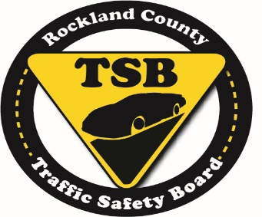

***\*\*Request for Coverage\*\****

**Buckle up, Hang Up and Drive!**

**Rockland County Traffic Safety Board and State Farm Present**

**Distracted Driving and Seat Belt Advocates Jacy Good and Chris Memoli**

**Rockland Community College, Monday, November 2 @ 12 Noon**

The Rockland County Traffic Safety Board and State Farm will host distracted driving and seat belt advocates Jacy Good and Chris Memoli in a powerful afternoon program on Monday, November 2 at 12 Noon at Rockland Community College in Suffern. The program is free and open to the public.

Jacy Good is a nationwide public speaker and advocate for cell-free roads. Since Jacy’s miraculous recovery from a crash caused by a distracted driver that also claimed the lives of both her parents in 2008, she and her husband Steve Johnson, have worked, and will continue to work, tirelessly to educate the country about the dangers of cell phone use behind the wheel, as well as advocate for legislation to help eradicate an epidemic that shatters thousands of American lives every year.

On July 6, 2002, at the age of 17, Chris Memoli was a passenger in a car with a girl he had just met. That ten minute ride changed Chris’ life forever. Chris was a backseat passenger that was not wearing a safety belt. When the vehicle crashed, Chris was thrown around like a beach ball and suffered traumatic brain injuries. Chris has had over two dozen surgeries and had to re-learn just about everything. Though Chris still is unable to speak, he was able to recover enough to go back to school and eventually receive a Masters Degree from Pace University. Over the past decade, Chris has been traveling the metro New York area spreading his message of how he felt invincible like many of the students he speaks to, but there are consequences for not wearing a safety belt.

Learning to drive is an exciting but serious step in life’s journey. Across North America, car crashes remain the No. 1 killer of our teens, and their first year behind the wheel is the most dangerous. Distractions are part of everyday driving, resulting in many of these crashes.

The State Farm Drive 2N2™ movement is designed to improve roadway safety for everyone: 2 eyes on the road and 2 hands on the wheel. Every driver has the power and responsibility to be in control and stay safe behind the wheel or as a passenger.

**WHAT:** **Rockland County Traffic Safety Board and** **State Farm Driver Safety Event**

**WHO: Jacy Good, Chris Memoli, State Farm Agent TBD**

**DATE/TIME: Monday, November 2 @ 12 Noon**

**WHERE: Rockland County Community College, Cultural Arts Theatre, 145 College Road, Suffern, NY**

**COST: Free and Open to the Public**

**Media Contacts:**

Chief William Barbera, Rockland County Traffic Safety Board

[Barbera@RCPIN.net](mailto:Barbera@RCPIN.net) or (845) 638-5438

Rachael Risinger, State Farm

[Rachael.risinger.tqil@statefarm.com](mailto:Rachael.risinger.tqil@statefarm.com) or 516-355-3769

# # #