Information acquisition

Legend:

* **Noun, Object**
* *Predicate*
* Transfered to Excel

# General

* **Computer** *consist of* **hardware components** Image result for haken png
* **Computer** *run* **computer software** Image result for haken png
* **Computer software** may contain **documentation** Image result for haken png
* **Company** *develops* **computer software**  Image result for haken png
* **Companys** *have a* ***name*** Image result for haken png

# Software

* **Computer software** *requires* **hardware components** Image result for haken png
* **Computer software** *requires* other **computer software** Image result for haken png
* **Computer software** *is outdated at* **End-of-Maintanance** date Image result for haken png
* **Computer software** will *be released* *on* **release date** Image result for haken png
* **Computer software** *has a* **price** Image result for haken png
* **Computer software** *has a* **description** Image result for haken png
* **Computer software** *has a* **version number** Image result for haken png
* **Computer software** *is divided* into different **software categories** Image result for haken png
* **Computer software** *has a* **name** Image result for haken png

# Hardware

**Processor** *is a* **hardware component** Image result for haken png

* + **Instruction set** *is a characteristic of* **Processor** Image result for haken png
  + **Clock rate** *is a characteristic of* **Processor** Image result for haken png
  + **Caching size** *is a characteristic of* **Processor** Image result for haken png
  + **Core number** *is a characteristic of* **Processor** Image result for haken png

**RAM** *is a* **hardware component** Image result for haken png

* + **RAM types** *is characteristic of* **RAM** Image result for haken png
  + **RAM size** *is a characteristic of* **RAM** Image result for haken png

**Hard disk** *is a* **hardware component** Image result for haken png

* + **Hard disk capacity** *is characteristic of* *an* **hard disk** Image result for haken png
  + **SSD** *is a* **hard disk type** Image result for haken png
  + **HDD** *is a* **hard disk type** Image result for haken png

**Mainboard** *is a* **hardware component** Image result for haken png

**Graphics card** *is a* **hardware component** Image result for haken png

* + **Graphics card** **memory** *is characteristic of a* **graphics card** Image result for haken png

**Interface** *is an* **hardware component** Image result for haken png

**Peripherals** *are* **hardware components** Image result for haken png

# Proprietary products – properiatry products

* **Proprietary product** *is a* **computer software** Image result for haken png
* **Proprietary product** *have a* **product code** Image result for haken png
* **Proprietary product** *includes* **proprietary product** Image result for haken png

# Software categories

* **Security software** *is a* **software category** Image result for haken png
* **Graphics software** *is a* **software category** Image result for haken png
* **Application software** *is a* **software category** Image result for haken png
* **Standard software** *is a* **software category** Image result for haken png
* **Web browser** *is a* **software category** Image result for haken png
* **Web server** *is a* **software category** Image result for haken png
* **Operating system** *is a* **software category** Image result for haken png
* **Java** *is a* **software category** Image result for haken png
* **DBMS** *is a* **software category** Image result for haken png

# Computer

* **PC** *is a* **computer** Image result for haken png
* **Server** *is a* **computer** Image result for haken png
* **Laptop** *is a* **computer** Image result for haken png
* **Game console** *is a* **computer** Image result for haken png
* **Embedded system** *is a* **computer** Image result for haken png
* **Smartphone** *is a* **computer** Image result for haken png
* **Super computer** *is a* **computer** Image result for haken png
* **Mainframe** *is a* **computer** Image result for haken png

# Current System with ER-Diagram

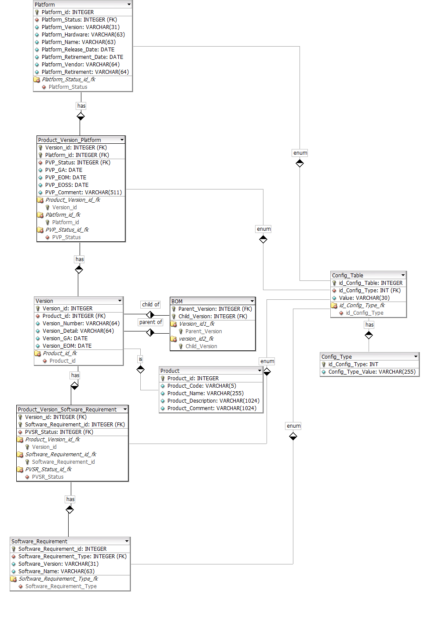

**Not Captured Information from ER-Diagram:**

Operating Systems: **Retirement date, Vendor, Release date**

Properiatry products: **product code**