**Comparative Evaluation of Machine Learning Algorithms for Water Consumption Data Analysis and Forecasting**

Short title: Water Consumption Analysis and Φorecasting

C. Michalopoulos*^, insert names here*, and C. Makropoulos**

* Urban Water Management and Hydroinformatics Group, Department of Water Resources and Environmental Engineering, School of Civil Engineering, National

Technical University of Athens (NTUA), Iroon Politechniou 5, 157 80 Zografou, Athens, Greece

** Bodgett & Billham plc, Hamilton House, Hangover Square, London NC1 4TS, UK (E-mail: [*birdie@walford.cotton.co.uk*](mailto:birdie@walford.cotton.co.uk))

^Corresponding author

[Please note all co-authors email addresses need to be included during the submission process, and you should indicate who the corresponding author is]

# Abstract

[The abstract should be no more than 200 words briefly specifying the aims of the work, the main results obtained, and the conclusions drawn. Citations must not be included in the Abstract.]

In recent years will the effects of global warming there has been a major need for the optimal urban water distribution. With the everyday increasing need for water, forecasting is a major tool that water supply companies must use in order to improve the current infrastructure as well as to plan and manage the natural resources. In this paper several forecasting have been tested from statistical to deterministic ones.

These forecasts can be utilized from the water supply company for the proper billing of the customers to defining and calculating the total amount of water that has been lost during the transportation process. The data that the models have been trained to are real data from over 2 million consumers from the Water and Sewerage Company of Greece (EYDAP). The results of this research highlight the importance of choosing the correct timescale of the data but as well as the difference that different model have in relation to the forecasting needs.

# Keywords

[Please include six keywords in alphabetical order. These should indicate the main subject matter of your paper.]

Timeseries forecasting, Machine Learning, Long-Short-Term Memory, collaborate filtering, Timeseries data preprocessing, Water consumption

**Main text:** [for clarity this should be subdivided into:]

**Introduction:** describing the background of the work and its aims.

Trying to understand and predict the water demand in the consumer level has been an active research topic since 1960(Reference). Nowadays, with the introduction new electronic water meters, which can monitor the consumption within very small time intervals (give examples of such meters), many researchers have developed numerous models and methods for consumption forecasting(Rahim et al., 2020). The majority of the installed meters are still the typical mechanic ones (i.e., single-jet, multi-jet, volumetric)(American Water Works, 1962). Replacing all the mechanic meters with electronic/smart ones is not only financially but also technically unobtainable, since the current infrastructure in most cities (especially historic ones) cannot support the installation of these meters as in order to be able to electronically measure the drawn volume because, special probes are needed with a dedicated power supply(Hauber-Davidson and Idris, 2006).

The major drawback of the typical water meters is that they have to be physically read, a process that is time and labor consuming(Randall and Koech, 2019). Hence, the majority of water companies struggle and sometimes do not have adequate resources to actually read every single meter in a timely manner and under a feasible schedule.

Recently, a multitude of approaches in water demand forecasting have been proposed. The methods are varying depending on numerous factors such as the type quality (systematic data frame)(Mamo et al., 2013) of data available, as well as the time scale of the forecast(Kofinas et al., 2014). In terms of urban demand water forecasting the majority of research articles are focused more on short-term time frame (hourly and daily) but in our case the timeframe of research is mid-term(quarter-year). In order to overcame this problem studies from other fields were examined that behaved similarly in term with the seasonality of the timeseries, such as residential natural gas consumption(Liu and Lin, 1991).

The models are addressed into two categories stochastic and deterministic. Deterministic models take into consideration all the factors that inference the result and are built finding the patterns between those factors. On the other hand, the majority of stochastic models are generated with the help of statistical models that are adapted on the previous data in the time-series(Box et al., 2015).

The most common stochastic models are: the autoregressive (AR), the moving average (MA), the combination of those two with an integration step autoregressive integrated moving average (ARIMA) and the seasonal autoregressive integrated moving average (SARIMA)(Box et al., 2015; Hyndman and Athanasopoulos, 2018). The forecasting of those models is derived from a linear function of the previous observations. In order to overcome this problem and to be able to describe more complex behaviors long short-term memory neural networks (LSTM) have been proposed(Lim and Zohren, 2021). The introduction of nonlinear activation functions in the neural network architecture will overcome the problem that regular stochastic models have. Another deterministic method that is used is collaborative filtering. Collaborative filtering is primarily used in recommendation systems and matrix completion(Schafer et al., 2007), the structure of the forecast and the data available (measured and unmeasured customers) is similar to a matrix completion problem. The clustering model that is tested are k-nearest neighbors (k-NN) with the variation of adding a similarity coefficient as described in (Cui, 2017)

Generally, in water demand forecasting it is observed that neural network models and more specific LSTM had the best forecasting performance with statistical models (SARIMA) not failing a lot behind.(Kontopoulos et al., 2023). Also, another method that is proposed in the literature is forecasting with clustered customers which only one model is trained for a group of customers. In this paper such models were not examined because of its high complexity but also, it is showed that they perform worse than regular models for the same format of timeseries data(Kontopoulos et al., 2023).

Because of the inconsistency of the data, it is common in other research to just discard the timeseries that have missing values or having values at different times. In order to overcome this problem some techniques have been proposed one simple way is with interpolation and more complex such as kernel-based models (Rehfeld et al., 2011), for this research the data were corrected with the total amount of water that was exported from the water treatment facility.(“Θα μπει κι άλλο για το data preprocessing”)

The goal of this paper is to compare numerous Statistical and Machine Learning models in terms of their accuracy and computational efficiency in predicting water consumption. The predictions are utilized by the water company to bill the customers accurately but could also be used to reduce the number of visits that are needed by the water metering crew. Also, the predictions will be compared with the most widespread method that the majority of distribution companies (water, electricity and gas) use the Naïve approach. Finally the models will be tested for their performance as a total, this will give an insight if these models can provide reliable data in order for the water distribution companies to calculate the total water losses during the phase of distribution(Mutikanga et al., 2013). The results will also be compared computationally, that mean that the time that is needed in order to run will be considered.

**Methods**: [a brief description of the methods/techniques used (the principles of these methods should not be described if readers can be directed to easily accessible references or standard texts).]

1. Seasonal Naïve Approach

With this method each forecast is set to be equal to the last value from the same season. For example, the prediction for this winter quarter-year will be equal to the previous value of last year’s winter quarter-year.

|  |  |  |
| --- | --- | --- |
|  |  | (1) |

where m = the seasonal period, and k = , and denotes the integer part of u. (Hyndman and Athanasopoulos, 2018). This approach is used for reference because of its simplicity and its speed.

Β. ARIMA-SARIMA

ARIMA(p,d,q) is the combination of AR,I and MA models. AR(p) is Autoregressive, p is the number of regression terms, ΜΑ is the moving average, q is the number of moving average terms, and d is the difference time to make the data stationary series. Firstly, a stable timeseries is developed by differencing by d the original non-stationary historical data. Then the ARMA(p,q) model is fitted to predict the consumption. The ARMA(p,q) model is expressed as follows:

|  |  |  |
| --- | --- | --- |
|  |  | (2) |

where and are constant, is the white noise sequence. The regression, moving average coefficient and the white noise variance of the ARIMA(p,d,q) are estimated by least square method and moment estimate method. In order to express more seasonal phenomena, the SARIMA model have been developed which takes into consideration the seasonality of the problem. The additional parameters of the SARIMA model are (P,D,Q),m in which are the seasonal order terms while m is the seasonality. The models is expressed as SARIMA(p,d,q)(P,D,Q)m. For this research the seasonal order was m=4 for quarter year analysis while when studying for monthly analysis it is chosen m=12 in order to follow the seasonality of a year.

C. Long Short Term Memory (LSTM)

Long Short Term Memory Neural Networks (LSTM) is a special kind of Recurrent Neural Networks which are designed to eliminate the standard problems RNN suffer(Hochreiter and Schmidhuber, 1997) . Each individual LSTM cell contains three different gates: input gate, forget gate and output gate. With this architecture we can increase the length of sequence without worrying about gradient vanishing or exploding problem. The internal architecture of a typical LSTM cell is shown below:

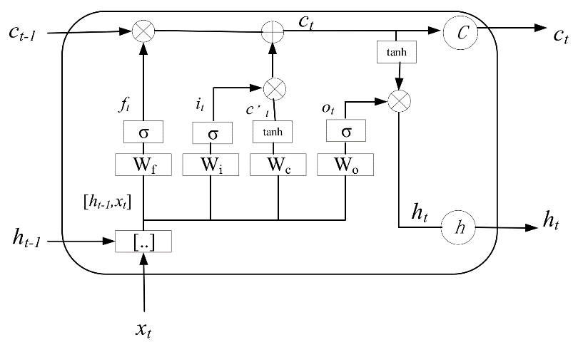

Figure 1: Architecture of a single LSTM block

|  |  |  |
| --- | --- | --- |
|  |  | (3) |
|  |  | (4) |
|  |  | (5) |
|  |  | (6) |
|  |  | (7) |
|  |  | (8) |

where and the weight matrices for the inputs of the network, , are the bias factors, is the input vector and the hidden state which is also the output of the cell. The calculation process is illustrated in Figure 1. Throw out the training process the weighted matrices are modified accordingly in order to decode the important information from the previous values of the timeseries. Tuning LSTM models is not that easy, there are a lot of hyperparameters that must be tuned in order to achieve the optimal performance (Abbasimehr et al., 2020). For this study the only parameters that were tuned by trial and error was the lag (the number of previous data that it was feed to the LSTM, the number of units in the hidden layer and the number of epochs).

D. k-Nearest Neighbors

Many researchers are using collaborate filtering methods in order to complete missing data in various formats from matrix completions to recommending systems and timeseries missing data correction. Because of the nature of the data that we have available (measured and unmeasured customers), the unmeasured customers could be forecasting through matrix completion algorithms as it is proposed in (Ma et al., 2019). There are a lot of matrix completion algorithms available but in this research is tested only the simpler and most common k-Nearest neighbors (k-NN). For this algorithm the forecasting is calculated as:

|  |  |  |
| --- | --- | --- |
|  |  | (9) |

where is the value of the i nearest neighbor from the known customers and k being the number of nearest neighbors. The only hyperparameter of the model is the number k which is chosen through trial and error. A flowchart of this process is described in figure 2. The only problem with this model it’s that it does account every neighbor the same despite how close or other similarities. For that reason, it is wise to introduce some type of similarity coefficient in the equation. One popular example that it is used in recommendation systems is thru Pearson correlation (Schafer et al., 2007). In this research cosine similarity (Cui, 2017) is used and it expressed as:

|  |  |  |
| --- | --- | --- |
|  |  | (10) |
|  |  | (11) |

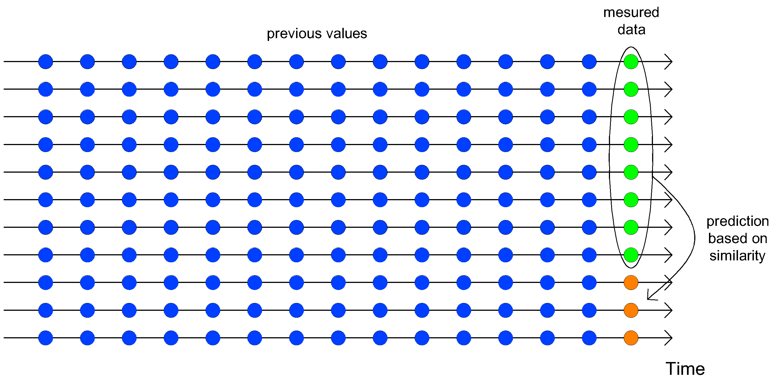

Figure 2: Flow diagram of collaborative filtering approach

Dataset # TODO

The figure 2 illustrates the procedure of calculations for quarter and monthly time scale analysis. Because the billing of each customer is published per quarter year the monthly analysis must make three consecutive guesses. That means for the monthly timestep the models will have to take as inputs previous forecasted values and the errors will be calculated for the sum of those three values. Those two approaches are tested in order to see if the bigger training set can overcome the instability of using previous forecasts as inputs.

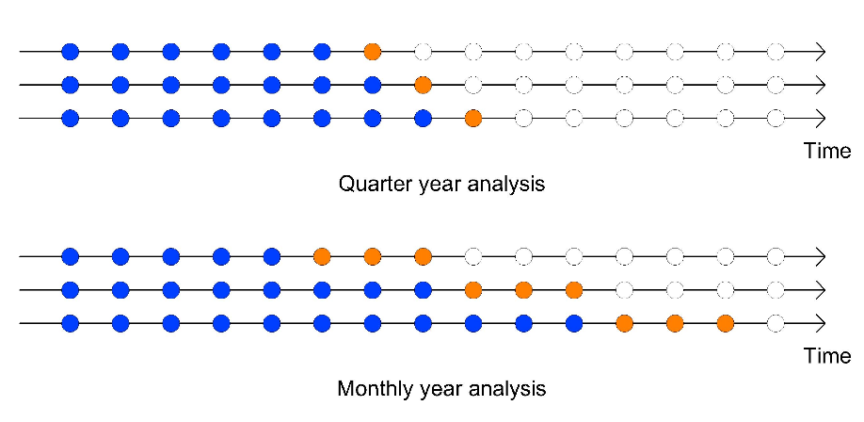

Figure 3:Train and Test data in a timeseries

In order to be able to evaluate the performance of each model and also to simulate the measured and unmeasured behavior of the dataset, the timeseries are split in two subsets, the measured who’s the working crew has managed to record the consumption and into unmeasured were the crew did not record the usage. In reality the actual measured to unmeasured ration for the given case study is approximately 90-10 but in order to simulate more uncertain cases the chosen ration was picked to be at 80-20, to be more specific the measured was at 80% of the total timeseries while the rest 20% was the unmeasured. Furthermore, the unmeasured timeseries are broken down to train set and test set for measuring the performance for each model. The metrics that are used to evaluate the performance are:

1. Mean Absolute Percentage Error (MAPE) this metric was chosen instead of Mean Absolute Error (MAE) because of the ability to be a scale independent, MAPE is expressed as: , where is the actual value and is the forecasted value.
2. Total Balance is the metric that evaluates the tendency of the model to over or underestimate the forecasting and it is expressed as: . The closer to zero this metric is the more accurate this model is to predict for the total sum of the consumers.

**Results and Discussion**: a clear presentation of experimental results obtained, highlighting any trends or points of interest.

In order to visualize better the distribution of the results of each model we used boxplots (box-and-whisker) diagrams for MAPE for quarter and monthly year bases. As for the total water balance a bar plot is used to represent the results.

Figure 4: Performance of each model

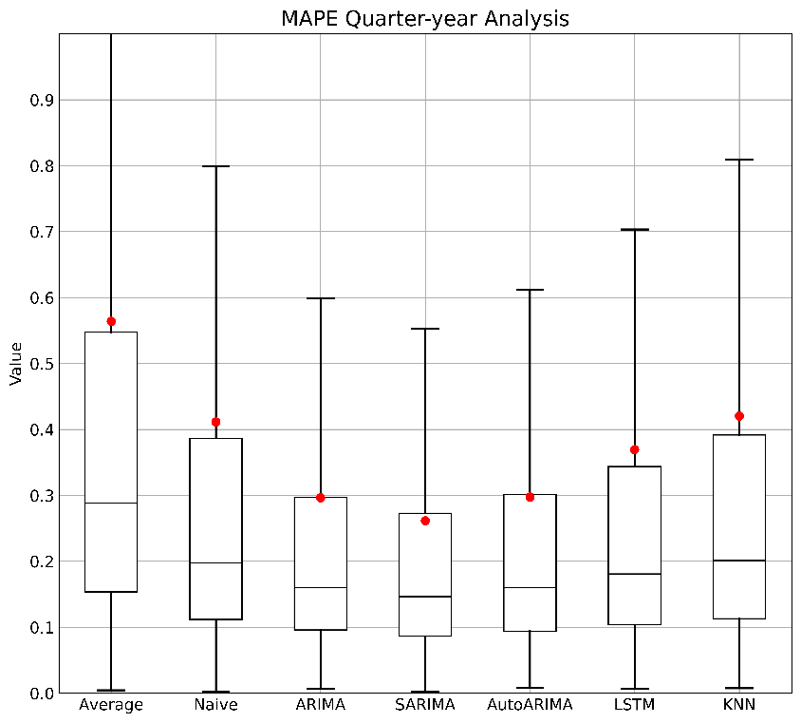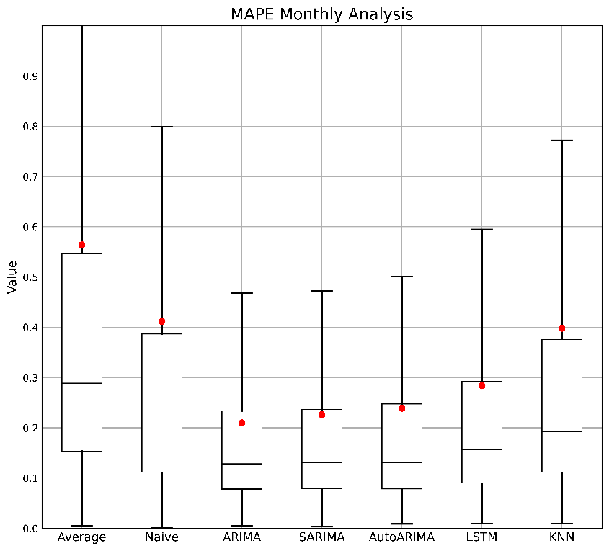

As we can observe in figure 3 models performed better for a monthly time scale despite that they generate two values that are coming from predictions which is not the case for (Kofinas et al., 2014) while (Liu and Lin, 1991) suggest that monthly timeframe results to better forecasts. The reason behind this behavior must be the existence of more data to train the models, because of the finer timescale there are more data for a given time. Obviously, the error of the naïve model remains the same because it is not influenced by the time step. The model with the best overall performance is ARIMA(1,1,0) with a mean error close to 20% . The SARIMA(0,1,0) (1,0,1),12 did not fell too much behind having the same error distribution as the ARIMA. The reason ARIMA and SARIMA achieve lower percentage error is that the parameters are chosen to reduce the MAPE while AutoARIMA focuses to lower the Bayesian and Akaike information criterion. The exact average performance of each model can be shown in Table 1-2 below.

Table 1: Average MAPE performance for Monthly and Quarter year analysis

|  |  |  |  |  |  |  |  |
| --- | --- | --- | --- | --- | --- | --- | --- |
| Models | | Naïve | ARIMA | SARIMA | AutoARIMA | LSTM | k-NN |
| MAPE | Quarter | 0.411 | 0.296 | 0.261 | 0.297 | 0.369 | 0.420 |
| Monthly | 0.411 | 0.209 | 0.226 | 0.239 | 0.283 | 0.398 |

Table : Median MAPE performance for Monthly and Quarter year analysis

Figure 5: Total Balance performance

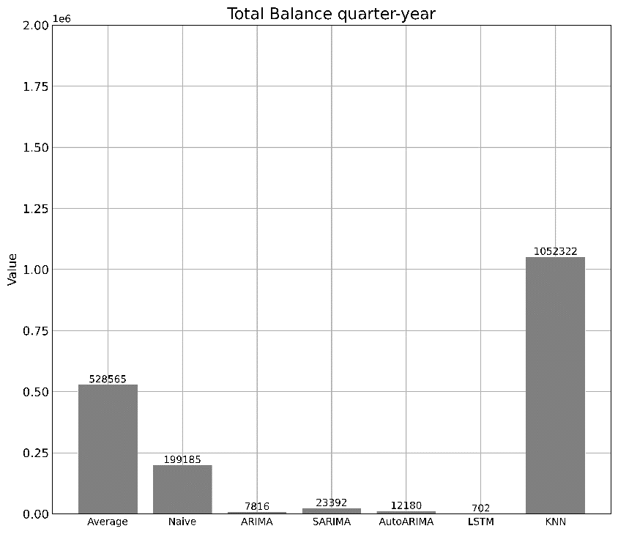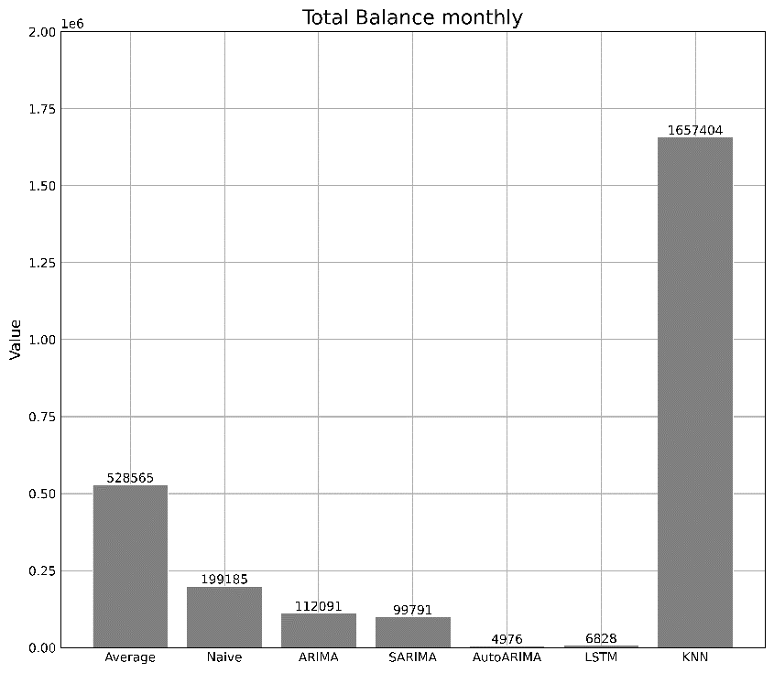

|  |  |  |  |  |  |  |  |
| --- | --- | --- | --- | --- | --- | --- | --- |
| Models | | Naïve | ARIMA | SARIMA | AutoARIMA | LSTM | k-NN |
| MAPE | Quarter | 0.197 | 0.160 | 0.146 | 0.160 | 0.180 | 0.201 |
| Monthly | 0.197 | 0.128 | 0.131 | 0.130 | 0.157 | 0.192 |

Despite the greater performance for monthly timestep in the MAPE metric, the Total Balance metrics seems to favor quarter year scale as all the models manage to reach values closer to zero. All models are underestimate the consumption with the best of one being LSTM as we can see in Figure 3. The collaborate filtering method achieved the worst performance by far for the two cases. Finally for the monthly scale we measure the performance of each model by quarter year in order to see if the models have any time preference. The results that are shown in figure 4 confirm the results of figure 2 and it illustrate the best model of every season being the ARIMA. All the models behaved with the same pattern so it can be said that the models can be fitted more easily with data from the 2nd quarter. One possible explanation about the poor performance for the collaborative filtering method is the mass amount of measured data so the model suffers from overfitting. (Maybe needs some cite)

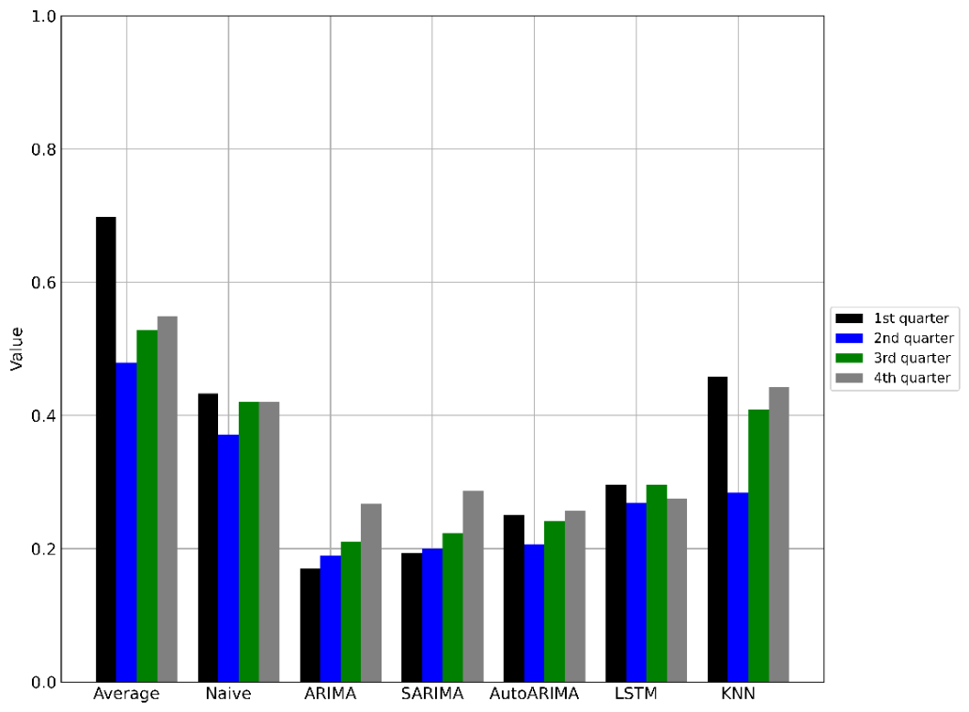

Figure 6: Model performance per season

**Conclusions**: a brief explanation of the significance and implications of the work reported.

In this paper, we compare the effectiveness of the models in forecasting the water consumption of the customers based on the data provided by the Water Supply and Sewerage Company of Greece (EYDAP). Because of the inconsistent data the timeseries were filled with data from the main refineries making a consistent monthly scale timeserie for each costumer. These timeseries were feed into the models also, the same models were tested with a quarter-year scale. The results indicated that all models are achieving less average error for monthly time scale timeseries with the best model being ARIMA(1,1,0). The other statistical models did not fall further behind. The LSTM model might not be the most accurate model for forecasting the individual consumption but performed great in the total Balance metrics making it the best model for predicting the water usage as a total. Furthermore, the model that did not show any preference in which quarter the data was from was LSTM while the statistical models showed the same pattern. The aim of this study was to measure the performance of some timeseries forecasting algorithms for some basic but very important processes for the water utility companies such as, billing the customers or to be able to calculate the water leaks in the distribution system.

**References**: these should be to accessible sources. Please ensure that all work cited in the text is included in the reference list, and that the dates and authors given in the text match those in the reference list. References must always be given in sufficient detail for the reader to locate the work cited (see below for formats). Note that your paper is at risk of **rejection if there are too few (<10) or too many (>25) references,** or if a disproportionate share of the references cited are your own.

Please make sure to cite all references in the paper

**Supplementary Material**: Appendices and other Supplementary Material are permitted, and if the paper is accepted they will be published online only. A link to the supplementary material will be provided in the print version.

**Figures** should be embedded in the paper, as well as being supplied as a gif, jpeg, tie file at the end of the paper. They should be a minimum of 300dpi for readability.

**Tables** should be included in an editable format and not as images. Number tables consecutively in accordance with their appearance in the text and place any table notes below the table body. Be sparing in the use of tables and ensure that the data presented in them do not duplicate results described elsewhere in the article. Please avoid using vertical rules.

# REFERENCES

The reference should be arranged according to the alphabetical order by the lead author’s last name. Please make sure to include all authors of references.

# Examples of Journal References

Andrews, J.F. 1993 Modeling and simulation of wastewater treatment processes. *Wat. Sci. Tech.* **28** (11/12), 141–150.

Casey, T.G., Ekama, G.A., Wentzel, M.C. and Marais, G.v.R. 1993 An hypothesis for the causes and control of low F/M filamentous organism bulking in nitrogen (N) and nutrient (N & P) removal activated sludge systems. In *Proc. of the IAWQ First Int. Conf. on Microorganisms in Activated Sludge and Biofilm Processes*, Paris, 27–28 September.

Dold, P.L., Ekama, G.A. and Marais, G.v.R. (1980) A general model for the activated sludge process. *Prog. Wat. Tech.* **12**, 47–77.

# Examples of Book References

Bell J. 2002 *Treatment of Dye Wastewaters in the Anaerobic Baffled Reactor and Characterisation of the Associated Microbial Populations*. PhD thesis, Pollution Research Group, University of Natal, Durban, South Africa.

Henze M., Harremoës P., LaCour Jansen J. & Arvin E. 1995 *Wastewater Treatment: Biological and Chemical Processes*. Springer, Heidelberg.

McInerney M. J. 1999 Anaerobic metabolism and its regulation. In: *Biotechnology*, J. Winter (ed.), 2nd edn, Wiley-VCH Verlag, Weinheim, Germany, pp. 455-478.

Sobsey M. D. & Pfaender F. K. 2002 *Evaluation of the H2S method for Detection of Fecal Contamination of Drinking Water*, Report WHO/SDE/WSH/02.08, Water Sanitation and Health Programme, WHO, Geneva, Switzerland.

*Standard Methods for the Examination of Water and Wastewater* 1998 20th edn, American Public Health Association/American Water Works Association/Water Environment Federation, Washington DC, USA.

# Example of an Online Reference

Alcock S. J. & Branston L. 2000 SENSPOL: Sensors for Monitoring Water Pollution from Contaminated Land, Landfills and Sediment. <http://www.cranfield.ac.uk/biotech/senspol/> (accessed 22 July 2005)

A more detailed description can be found on each journal’s online Instructions to Authors page: <https://iwaponline.com/pages/Instructions_for_authors>

Abbasimehr, H., Shabani, M., Yousefi, M., 2020. An optimized model using LSTM network for demand forecasting. Comput. Ind. Eng. 143, 106435. https://doi.org/10.1016/j.cie.2020.106435

American Water Works, 1962. Water Meters: Selection, Installation, Testing, and Maintenance. American Water Works Association.

Box, G.E.P., Jenkins, G.M., Reinsel, G.C., Ljung, G.M., 2015. Time Series Analysis: Forecasting and Control. John Wiley & Sons.

Cui, B.-B., 2017. Design and Implementation of Movie Recommendation System Based on Knn Collaborative Filtering Algorithm. ITM Web Conf. 12, 04008. https://doi.org/10.1051/itmconf/20171204008

Hauber-Davidson, G., Idris, E., 2006. SMART WATER METERING.

Hochreiter, S., Schmidhuber, J., 1997. Long Short-Term Memory. Neural Comput. 9, 1735–1780. https://doi.org/10.1162/neco.1997.9.8.1735

Hyndman, R.J., Athanasopoulos, G., 2018. Forecasting: principles and practice. OTexts.

Kofinas, D., Mellios, N., Papageorgiou, E., Laspidou, C., 2014. Urban Water Demand Forecasting for the Island of Skiathos. Procedia Eng., 16th Water Distribution System Analysis Conference, WDSA2014 89, 1023–1030. https://doi.org/10.1016/j.proeng.2014.11.220

Kontopoulos, I., Makris, A., Tserpes, K., Varvarigou, T., 2023. An evaluation of time series forecasting models on water consumption data: A case study of Greece.

Lim, B., Zohren, S., 2021. Time-series forecasting with deep learning: a survey. Philos. Trans. R. Soc. Math. Phys. Eng. Sci. 379, 20200209. https://doi.org/10.1098/rsta.2020.0209

Liu, L.-M., Lin, M.-W., 1991. Forecasting residential consumption of natural gas using monthly and quarterly time series. Int. J. Forecast. 7, 3–16. https://doi.org/10.1016/0169-2070(91)90028-T

Ma, W., Nowocin, K., Marathe, N., Chen, G.H., 2019. An interpretable produce price forecasting system for small and marginal farmers in India using collaborative filtering and adaptive nearest neighbors, in: Proceedings of the Tenth International Conference on Information and Communication Technologies and Development, ICTD ’19. Association for Computing Machinery, New York, NY, USA, pp. 1–11. https://doi.org/10.1145/3287098.3287100

Mamo, T.G., Juran, I., Shahrour, I., 2013. Urban Water Demand Forecasting Using the Stochastic Nature of Short Term Historical Water Demand and supply Pattern. J. Water Resour. Hydraul. Eng. 2.

Mutikanga, H.E., Sharma, S.K., Vairavamoorthy, K., 2013. Methods and Tools for Managing Losses in Water Distribution Systems. J. Water Resour. Plan. Manag. 139, 166–174. https://doi.org/10.1061/(ASCE)WR.1943-5452.0000245

Rahim, M.S., Nguyen, K.A., Stewart, R.A., Giurco, D., Blumenstein, M., 2020. Machine Learning and Data Analytic Techniques in Digital Water Metering: A Review. Water 12, 294. https://doi.org/10.3390/w12010294

Randall, T., Koech, R., 2019. SMART WATER METERING TECHNOLOGY FOR WATER MANAGEMENT IN URBAN AREAS. Water E-J. 4, 1–14. https://doi.org/10.21139/wej.2019.001

Rehfeld, K., Marwan, N., Heitzig, J., Kurths, J., 2011. Comparison of correlation analysis techniques for irregularly sampled time series. Nonlinear Process. Geophys. 18, 389–404. https://doi.org/10.5194/npg-18-389-2011

Schafer, J.B., Frankowski, D., Herlocker, J., Sen, S., 2007. Collaborative Filtering Recommender Systems, in: Brusilovsky, P., Kobsa, A., Nejdl, W. (Eds.), The Adaptive Web: Methods and Strategies of Web Personalization, Lecture Notes in Computer Science. Springer, Berlin, Heidelberg, pp. 291–324. https://doi.org/10.1007/978-3-540-72079-9_9