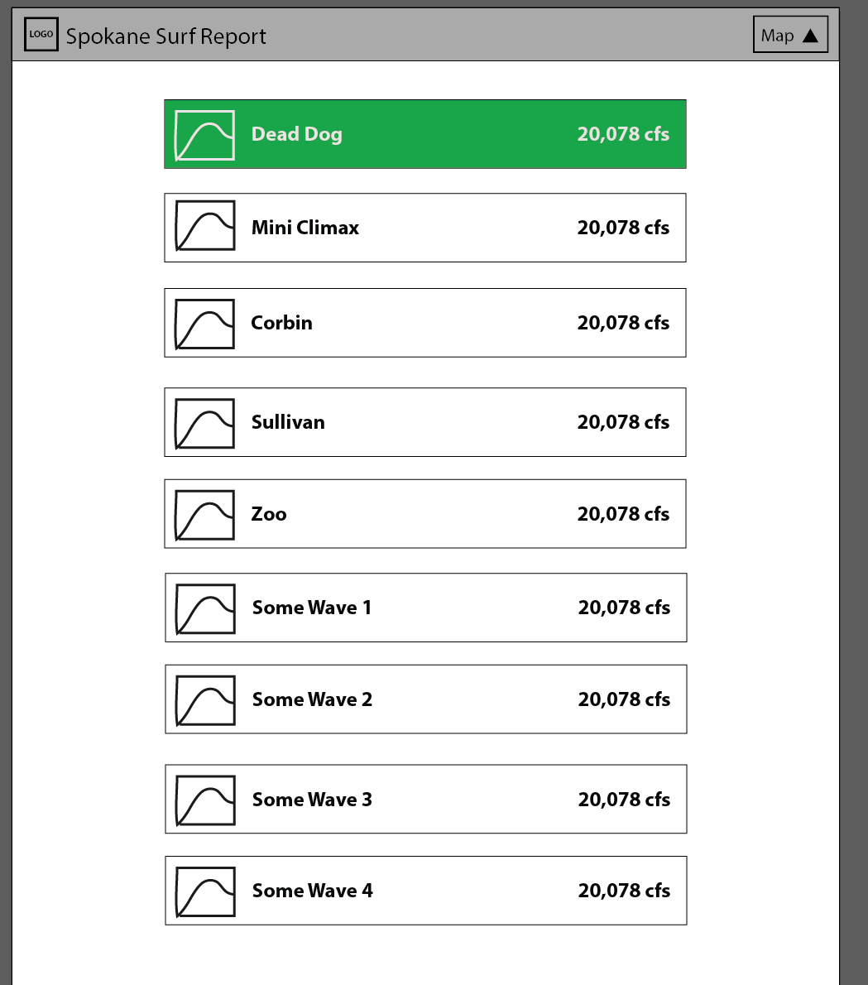

Expands on click,

Green if in otherwise clear

Level Reading

Graph of flow

Toggles Map Panel Visibility