1. Line 29 starts the derived class from the base class. Inherited publically, it allows access to the base class public functions and data members. Line 37 proves this. Further derived class is created on line 44 and we can still access the functions and data members from the base class in there as indicated by line 52.
2. Line 29 is the derived class from the base class. Publically inherited, we can see on line 38 that the base class protected data members can be accessed, as we can also access any protected functions too. Line 44 is our further derived public class. Can still access the protected functions and data members from the base class as indicated by line 53.
3. Line 39 and Line 54 don’t compile because we cannot access the base class data functions and members. Here is the error code: 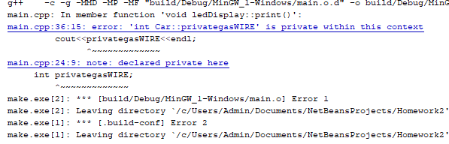 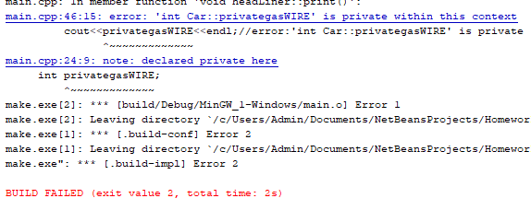
4. In line 58, we have our protected inheritance of car class, our base class. This can access our public and protected variables and functions from the base class as proven on line 66 and 67. They are derived as protected and can further be derived from other protected inheritance classes like the one on line 73. As shown, we can still access the public and protected data members.
5. For our two protected inheritance classes that I created, both would throw errors if I wanted to access the base class private data member. Cannot do this and the error message is shown below from lines 68 and 83: 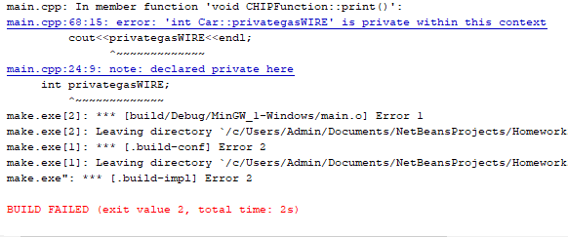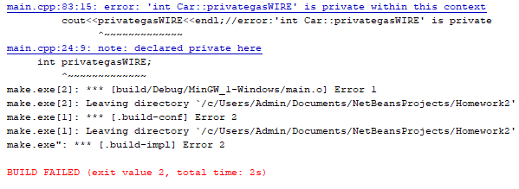
6. For this one, our private derived class is created on line 88 and the client of that on line 103. The public and protected data members worked for the first derived class, but the client and further derived classes thrown me an error. Errors happened on line 111 and 112: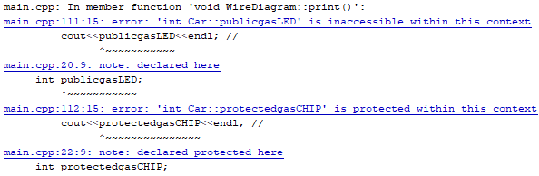
7. Cannot access private data and functions from base class in the derived class as shown on lines 98 and 114, where I received error codes.