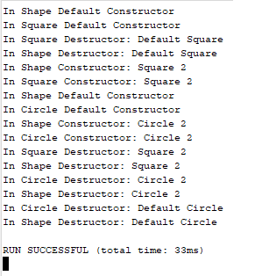CSE 335 – Chris Nosowsky Homework 5 Explaination

Lines 1-4: For the first four lines the constructor and destructor for the Shape and Square classes are called. The destructors are called on line 3 and 4 instead of the end due to the object being inside a block. The object was only a variable, so the default constructor was called. The shape was called first due to constructors being in a stack and being called inside to outside; inside being the parent and outside being the child. Destructors are the other way around, outside to inside as shown because the Square destructor got called before the Shape destructor.

Lines 5-6: Another square object created, this time using new so memory was allocated. A constructor goes inside to outside so the Shape constructor was called first, then Square.

Line 7-8: This is a circle object variable created. Default constructor for Shape first then Circle created due to constructor calling going from inside to outside.

Line 9-10: This is the second circle object, this one being created with new. Shape constructor then Circle constructor called

Line 11-end: Since we go out of main function, we go out of scope and the destructors are finally called for the objects that were not inside a block. Destructors are called from the outside to inside and it is a stack style creation or “first in, first out”. I have “delete sq2” first, so it’s first to have the destructor called. Next, I had “delete circ2” so that’s the next destructor called. I never ended up deleting the default constructor circle, so it calls the default destructor for me and that goes last.