**Documentation -> SVN To Git**

This is documentation of how I converted from the testsvn2git SVN repo to the GitTest Repo on Azure Devops.

**Steps:**

1. Need to open up Git-Batch or some command prompt. Make sure Git + Subversion are both installed. Go to the SVN repo directory(folder just above branch/tags/trunk).

cd C://Development/SVN/testsvn2git/TestProject

2. Need to extract SVN Authors on the repo. Use this command:

svn log -q | awk -F '|' '/^r/ {sub("^ ", "", $2); sub(" $", "", $2); print $2" = "$2" <"$2">"}' | sort -u > users.txt

3. SVN users.txt file now appears in the TestProject/ folder. Open it up, put each user on each line and need to change the formatting.

**SVN Format:**

AMERISURE\P01004lr = AMERISURE\P01004lr <AMERISURE\P01004lr>

**Git Format:**

P01004LR = Christopher Nosowsky <[cnosowsky@amerisure.com](mailto:cnosowsky@amerisure.com)>

4. Once author file configured, now we can clone the repo. Use this command.

git svn clone https://fhsbvnin01.amerisure.int/svn/testsvn2git/TestProject --authors-file "users.txt" --trunk=trunk --branches=branches/11.0 --tags=tags/1.0 --tags=tags/2.0 --no-minimize-url ~/TEMPDIR

TEMPDIR can be any name, you’ll be able to remove it later. It is used as a temporary directory for copying the svn files. If the repo uses a standard layout, please get rid of the red and replace it with –stdlayout

5. Once the clone finishes, do this:

cd ~/TEMPDIR

5. Now we can push it to our remote which happens to be Azure DevOps. Your specific remote can be found here:

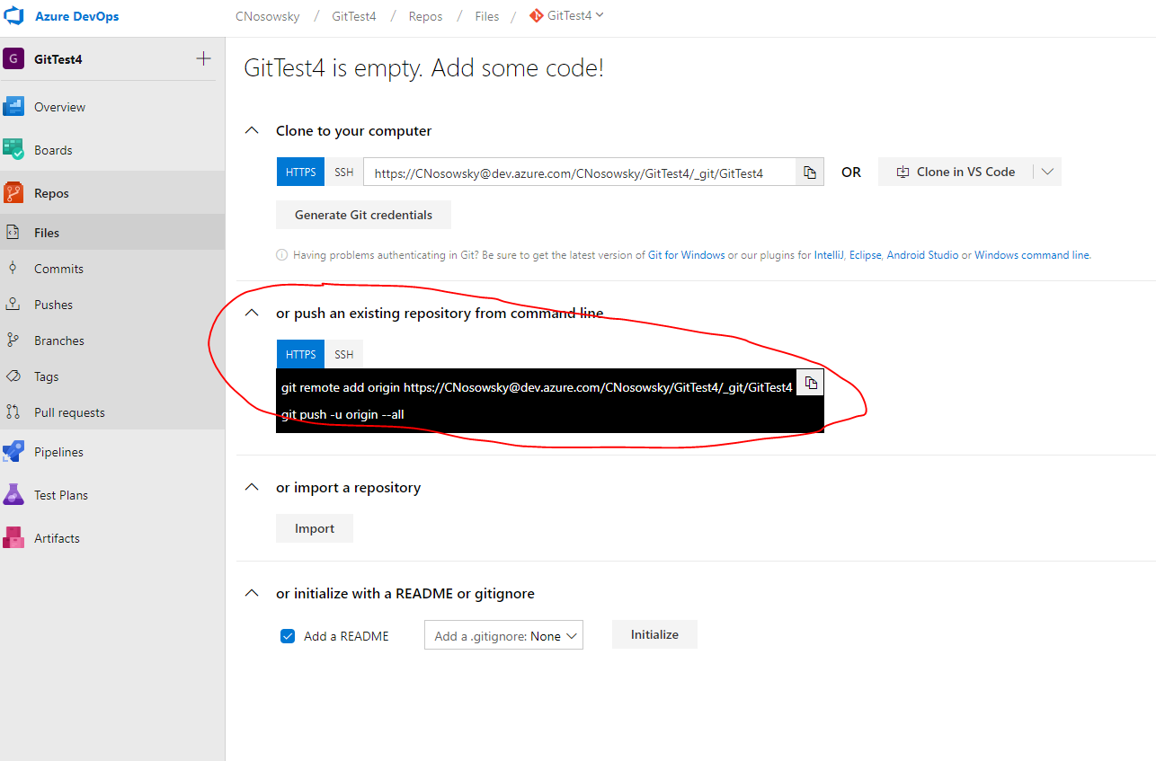

Copy that and paste it.

6. If you want to add tags, run this command after the above step finishes being pushed to Azure:

git for-each-ref --format='%(refname)' refs/remotes/origin/tags | cut -d/ -f5 | while read ref; do

git tag -a "$ref" -m "$(git log --pretty=oneline refs/remotes/origin/tags/$ref | head -n1 | cut -d' ' -f2-)" "refs/remotes/origin/tags/$ref"

git update-ref -d "refs/remotes/origin/tags/$ref"

done

git push origin 'refs/remotes/origin/*:refs/heads/*'

git push origin --tags

You should see this:

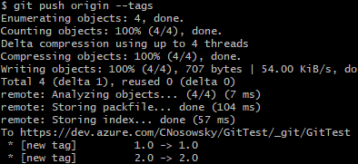

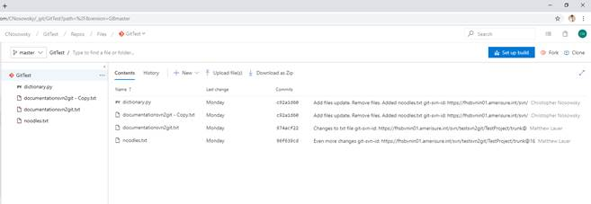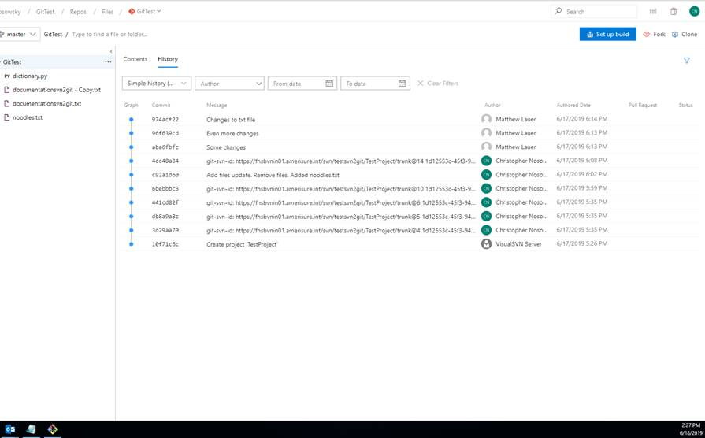7. Refresh Azure DevOps Repo page and you should see the files that include history.

**Making A Change + Pushing it back up to Azure:**

1. Clone the repo to your local machine. To do this, click the “Clone” button on the upper right of DevOps and copy the HTTPS
2. Go into your command/git batch prompt and run:

git clone PASTE_URL_HERE

1. You now have the local git repository on your machine. Make changes to any file as you need.
2. Once you want to commit these changes, go back to batch file and type:

cd YOUR_DIRECTORY_NAME

git commit -a -m “MESSAGE_OF_COMMIT_OPTIONAL”

git push

1. Go back to Azure DevOps, refresh page and view the committed results.

Resources:

<https://john.albin.net/git/convert-subversion-to-git>

<https://docs.microsoft.com/en-us/azure/devops/repos/git/perform-migration-from-svn-to-git?view=azure-devops>

<https://azure.microsoft.com/en-us/resources/videos/connect-2017-moving-from-subversion-to-git/>

Learn to clone your Azure Repo to local machine and make changes then commit and push them back up to Azure:

<https://docs.microsoft.com/en-us/azure/devops/user-guide/code-with-git?view=azure-devops>