|  |  |
| --- | --- |
| Team Name | E.g. Team-K8S |
| Team Contributors (People that contributed during group discussion(s) or whatsapp meetings | 1. Omeh, Chukwuemeka |
| Team Rep (Name) | E.g. David |
| Team Assignment | Networking Fundamentals Assignment |

**SOLUTION TO NETWORKING FUNDAMENTALS ASSIGNMENT**

**Question One**

**1.0 Address Class Identification**

|  |  |
| --- | --- |
| **Address** | **Class** |
| 10.250.1.1 | A |
| 150.10.15.0 | B |
| 192.14.2.0 | C |
| 148.17.9.1 | B |
| 193.42.1.1 | C |
| 126.8.156.0 | A |
| 220.200.23.1 | C |
| 230.230.45.58 | C |
| 177.100.18.4 | B |
| 119.18.45.0 _ | B |
| 249.240.80.78 | E |
| 199.155.77.56 | B |
| 117.89.56.45 | A |
| 215.45.45.0 | C |
| 199.200.15.0 | C |
| 95.0.21.90 | A |
| 33.0.0.0 | A |
| 158.98.80.0 | B |
| 219.21.56.0 | C |

**Question Two**

2.0 Using the IP address and subnet mask shown write out the network address:

188.10.18.2 _____________________________188.10.0.0

255.255.0.0

10.10.48.80 _____________________________10.10.48.0

255.255.255.0

192.149.24.191 ___________________________ 192.149.24.0

255.255.255.0

150.203.23.19 ____________________________150.203.0.0

255.255.0.0

10.10.10.10 ______________________________ 10.0.0.0

255.0.0.0

186.13.23.110 _____________________________186.13.23.0

255.255.255.0

223.69.230.250 _____________________________223.69.0.0

255.255.0.0

200.120.135.15 _____________________________200.120.135.0

255.255.255.0

27.125.200.151 ____________________________ 27.0.0.0

255.0.0.0

199.20.150.35 _____________________________ 199.20.150.0

255.255.255.0

191.55.165.135 _____________________________191.55.165.0

255.255.255.0

28.212.250.254 _____________________________ 28.212.0.0

255.255.0.0

**Question Three**

3.0 Subnetting

1. Number of needed usable hosts 14 ===

Network Address 192.168.50.0

Solution:

*Comment: Since the question is in regards to usable host, we use the principle of power of two minus two.*

* 2n – 2, here n = number of zeros since we are interested in usable host
* IP Class = C
* Default Subnet Mask = 255.255.255.0
* n = 4 which will be 16 – 2 which will accommodate 14 usable hosts.
* Incremental Value = 16 which lowest bit after 4bit given to host on octet 4(32 bit block).
* Legend: Green color of usable host represents the answer.

|  |  |  |  |  |
| --- | --- | --- | --- | --- |
| **Subnets** | **Network Address** | **Subnet Mask** | **Usable host (14)** | **Broadcast Address** |
| 1 | 192.168.50.0 | 255.255.255.240 | 192.168.50.1 – 192.168.50.14 | 192.168.50.15 |
| 2 | 192.168.50.16 | 255.255.255.240 | 192.168.50.17 – 192.168.50.30 | 192.168.50.31 |
| 3 | 192.168.50.32 | 255.255.255.240 | 192.168.50.33 – 192.168.50.46 | 192.168.50.47 |
| 4 | 192.168.50.48 | 255.255.255.240 | 192.168.50.49 – 192.168.50.62 | 192.168.50.63 |
| 5 | 192.168.50.64 | 255.255.255.240. | 192.168.50.65 – 192.168.50.78 | 192.168.50.79 |

1. Number of needed usable hosts 60

Network Address 165.100.0.0

* 2n – 2, here n = number of zeros since we are interested in usable host
* IP Class = B
* Default Subnet Mask = 255.255.0.0
* n = 6 which will be 64 – 2 which will accommodate 60 usable hosts.
* Incremental Value = 64 which lowest bit after 6bit given to host on octet 3(24 bit block).
* Legend: Green color of usable host represents the answer.

|  |  |  |  |  |
| --- | --- | --- | --- | --- |
| **Subnets** | **Network Address** | **Subnet Mask** | **Usable host** | **Broadcast Address** |
| 1 | 165.100.0.0 | 255.255.0.192 | 165.100.0.1 – 165.100.0.62 | 165.100.0.63 |
| 2 | 165.100.0.64 | 255.255.0.192 | 165.100.0.65 – 165.100.0.126 | 165.100.0.127 |
| 3 | 165.100.0.128 | 255.255.0.192 | 165.100.0.129 – 165.100.0.190 | 165.100.0.191 |

1. Number of needed subnets 6

Network Address 210.100.56.0

* 2n , here n = number of ones since we are interested in subnets
* IP Class = C
* Default Subnet Mask = 255.255.255.0
* Subnet mask = 255.255.255.224
* n = 3 which will be 8 which will accommodate 6 subnets.
* Incremental Value = 32 which lowest bit after 3bit given to host on octet 4(32 bit block).
* Legend: Green color represents the subnets.

|  |  |  |  |  |
| --- | --- | --- | --- | --- |
| **Subnets** | **Network Address** | **Subnet Mask** | **Usable host** | **Broadcast Address** |
| 1 | 210.100.56.0 | 255.255.255.224 | 210.100.56.1 – 210.100.56.30 | 210.100.56.31 |
| 2 | 210.100.56.32 | 255.255.255.224 | 210.100.56.33 – 210.100.56.62 | 210.100.56.63 |
| 3 | 210.100.56.64 | 255.255.255.224 | 210.100.56.65 – 210.100.56.94 | 210.100.56.95 |
| 4 | 210.100.56.96 | 255.255.255.224 | 210.100.56.97 – 210.100.56.126 | 210.100.56. 127 |
| 5 | 210.100.56.128 | 255.255.255.224 | 210.100.56.129 – 210.100.56.158 | 210.100.56. 157 |
| 6 | 210.100.56.160 | 255.255.255.224 | 210.100.56.161 – 210.100.56.190 | 210.100.56.191 |
| 7 | 210.100.56. 192 |  |  |  |
| 8 | 210.100.56. 224 |  |  |  |

1. Number of needed usable hosts 30

Network Address 195.85.8.0

* 2n – 2, here n = number of zeros since we are interested in usable host
* IP Class = C
* Default Subnet Mask = 255.255.255.0
* Subnet mask = 255.255.255.224
* n = 5 which will be 32 – 2 = 30, which will accommodate 30 usable hosts.
* Incremental Value = 32 which lowest bit after 5bit given to host on octet 4(32 bit block).
* Legend: Green color of usable host represents the answer.

|  |  |  |  |  |
| --- | --- | --- | --- | --- |
| **Subnets** | **Network Address** | **Subnet Mask** | **Usable host** | **Broadcast Address** |
| 1 | 195.85.8.0 | 255.255.255.224 | 195.85.8.1 - 195.85.8.30 | 195.85.8.31 |
| 2 | 195.85.8.32 | 255.255.255.224 | 195.85.8.33 - 195.85.8.62 | 195.85.8.63 |
| 3 | 195.85.8.64 | 255.255.255.224 | 195.85.8.65 - 195.85.8.94 | 195.85.8.95 |
| 4 | 195.85.8.96 | 255.255.255.224 | 195.85.8.97 – 195.85.8.126 | 195.85.8.127 |

1. Number of needed usable hosts 15

Network Address 178.100.0.0

* 2n – 2, here n = number of zeros since we are interested in usable host
* IP Class = B
* Default Subnet Mask = 255.255.0.0
* Subnet mask = 255.255.255.224
* n = 5 which will be 32 – 2 = 30, which will accommodate 15 usable hosts.
* Incremental Value = 32 which lowest bit after 5bit given to host on octet 4(32 bit block).
* Legend: Green color of usable host represents the answer.

|  |  |  |  |  |
| --- | --- | --- | --- | --- |
| **Subnets** | **Network Address** | **Subnet Mask** | **Usable host** | **Broadcast Address** |
| 1 | 178.100.0.0 | 255.255.255.224 | 178.100.0.1 - 178.100.0.30 | 178.100.0.31 |
| 2 | 178.100.0.32 | 255.255.255.224 | 178.100.0.33 - 178.100.0.62 | 178.100.0.63 |
| 3 | 178.100.0.64 | 255.255.255.224 | 178.100.0.65 - 178.100.0.94 | 178.100.0.95 |
| 4 | 178.100.0.96 | 255.255.255.224 | 178.100.0.97 – 178.100.0.126 | 178.100.0.127 |

1. Number of needed usable hosts 45

Network Address 200.175.14.0

* 2n – 2, here n = number of zeros since we are interested in usable host
* IP Class = C
* Default Subnet Mask = 255.255.255.0
* Subnet mask = 255.255.255.192
* n = 6 which will be 64 – 2 = 62, which will accommodate 45 usable hosts.
* Incremental Value = 64 which lowest bit after 6bit given to host on octet 4(32 bit block).
* Legend: Green color of usable host represents the answer.

|  |  |  |  |  |
| --- | --- | --- | --- | --- |
| **Subnets** | **Network Address** | **Subnet Mask** | **Usable host** | **Broadcast Address** |
| 1 | 200.175.14.0 | 255.255.255.192 | 200.175.14.1 - 200.175.14.62 | 200.175.14.63 |
| 2 | 200.175.14.64 | 255.255.255.192 | 200.175.14.65 - 200.175.14.126 | 200.175.14.127 |
| 3 | 200.175.14.128 | 255.255.255.192 | 200.175.14.129 - 200.175.14.190 | 200.175.14.191 |

4.0 **Practical Subnetting**

i) Based on the information in the graphic shown, design a network addressing scheme that will supply the **minimum number of hosts per subne**t, and allow enough extra subnets and hosts for 30% growth in all areas. Circle each subnet on the graphic and answer the questions below.

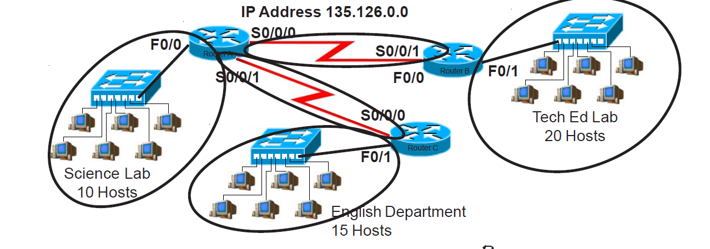

**Solution:**

The IP address:135.126.0.0

Class = B

Subnet Mask: 255.255.0.0, have 216  = 655,536 i.e. over 65,000 hosts.

To create extra subnet and that allow for at least 30% growth; this means that for any unit(lab or department) in the school, the subnet should be able to take minimum of 10 and 30% increase will be accommodated. This means:

* For Science Lab with 10 hosts, 1.3 * 10 = 13, 1.3*13 = 16.9 approx. 17
* For English Department with 15 hosts, 1.3 * 15 = 19.5, 1.3 * 19.5 = 25.35
* For Tech Ed Lab with 20 hosts, 1.3 * 20 = 26

From above, at 30% growth rate, the max host to achieve is 26. This implies

25 – 2 = 30. So, n = 5 will give a host that will allow 30% which is octet 3 with 24 bits and above. 32 bit of whole octets – 5bit for 30% growth rate host = 27bits. Therefore, we would subnet the IP block to **/27** which is a block size of 32 bits.

* 2n – 2, here n = number of zeros since we are interested in usable host
* IP Class = B
* Default Subnet Mask = 255.255.0.0
* Subnet mask = 255.255.255.224
* n = 5 which will be 32 – 2 = 30, which will accommodate 45 max usable hosts.
* Incremental Value = 32 which lowest bit after 5bit given to host on octet 4(32 bit block).
* Legend: Green color of usable host represents the answer.

|  |  |  |  |  |
| --- | --- | --- | --- | --- |
| **Subnets** | **Network Address** | **Subnet Mask** | **Usable host (32)** | **Broadcast Address** |
| 0 | 135.126.0.0 | 255.255.255.224 | **135.126.0.1 - 135.126.0.30** | 135.126.0.31 |
| 1 | 135.126.0.32 | 255.255.255.224 | **135.126.0.33 - 135.126.0.62** | 135.126.0.63 |
| 2 | 135.126.0.64 | 255.255.255.224 | **135.126.0.65 - 135.126.0.94** | 135.126.0.95 |
| 3 | 135.126.0.96 | 255.255.255.224 | **135.126.0.97 - 135.126.0.126** | 135.126.0.127 |

Based on the above table, we choose to do the following assignment,

* **Tech Ed Lab** = subnet 1 === 30 hosts. (Allows for about 30% growth from 20 hosts)

|  |  |  |  |  |
| --- | --- | --- | --- | --- |
| **Subnets** | **Network Address** | **Subnet Mask** | **Usable host** | **Broadcast Address** |
| 1 | 135.126.0.32 | 255.255.255.224 | **135.126.0.1 - 135.126.0.30** | 135.126.0.63 |

* **English Department:** = subnet 2 == 30 hosts (which allows for 30% growth)

|  |  |  |  |  |
| --- | --- | --- | --- | --- |
| **Subnets** | **Network Address** | **Subnet Mask** | **Usable host (14)** | **Broadcast Address** |
| 2 | 135.126.0.64 | 255.255.255.224 | **135.126.0.65 - 135.126.0.94** | 135.126.0.95 |

Now we will take the subnet 135.126.0.96 255.255.255.224. and break it down further to get a block of 16 hosts for science lab. We use 16bit increment which is lowest bit after taking n = 4 to get 30% growth rate from 15 host.

|  |  |  |  |  |
| --- | --- | --- | --- | --- |
| **Subnets** | **Network Address** | **Subnet Mask** | **Usable host** | **Broadcast Address** |
| 0 | 135.126.0.96 | 255.255.255.240 | **135.126.0.97 - 135.126.0.110** | 135.126.0.111 |
| 1 | 135.126.0.112 | 255.255.255.240 | **135.126.0.113 - 135.126.0.126** | 135.126.0.127 |

* **Science Lab** = 135.126.0.96 255.255.255.224 (/28) at 4bits increment since we gave 6 zeros to get 10 hosts with 30% growth rate.

Finally, subnet; 135.126.0.112 255.255.255.240 and break it down further to get a block size of 4bit (2 usable hosts).

**255.255.255.252** which is **135.126.0.252** is the last subnet we can get from 135.126.0.0 that will give 30% growth across various school units.

(/30) networks

|  |  |  |  |  |
| --- | --- | --- | --- | --- |
| **Subnets** | **Network Address** | **Subnet Mask** | **Usable host** | **Broadcast Address** |
| 0 | 135.126.0.112 | 255.255.255.252 | **135.126.0.113 - 135.126.0.114** | 135.126.0.115 |
| 1 | 135.126.0.116 | 255.255.255.252 | **135.126.0.113 - 135.126.0.114** | 135.126.0.119 |
| 2 | 135.126.0.120 | 255.255.255.252 | **135.126.0.113 - 135.126.0.114** | 135.126.0.123 |
| 3 | 135.126.0.124 | 255.255.255.252 | **135.126.0.113 - 135.126.0.114** | 135.126.0.127 |

ii) Based on the information in the graphic shown, design a classfull network addressing scheme that will supply the **minimum number of hosts per subne**t, and allow enough extra subnets and hosts for 25% growth in all areas. Circle each subnet on the graphic and answer the

Questions below:

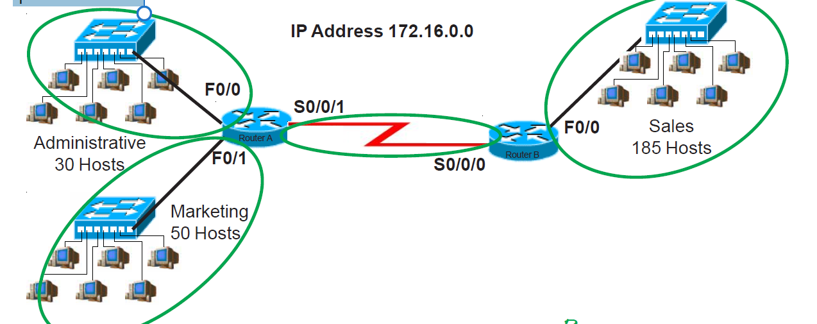

**Solution:**

The IP address:172.16.0.0

Class = B

Subnet Mask: 255.255.0.0, have 216  = 655,536 i.e. over 65,000 hosts.

To create extra subnet and that allow for at least 30% growth; this means that for any unit (administrative, Sales or marketing), the subnet should be able to take minimum of 30 and 30% increase will be accommodated. This means:

* For Administrative with 30 hosts, 1.3 * 30 = 39, 1.3*39 = 50.7 approx. 51
* For Marketing with 50 hosts, 1.3 * 15 = 65, 1.3 * 65 = 84.5
* For Sales with 185 hosts, 1.3 * 185 = 240.5

From above, at 30% growth rate, the max host to achieve is 240. This implies

28 – 2 = 254. So, n = 8 will give a host that will allow 30% which is octet 3 with 24 bits and above. 32 bit of whole octets – 8bit for 30% growth rate host = 24bits. Therefore, we would subnet the IP block to **/24** which is a block size of 24bits.

* 2n – 2, here n = number of zeros since we are interested in usable host
* IP Class = B
* Default Subnet Mask = 255.255.0.0
* Subnet mask = 255.255.255.224
* n = 5 which will be 32 – 2 = 30, which will accommodate 45 max usable hosts.
* Incremental Value = 32 which lowest bit after 5bit given to host on octet 4(32 bit block).
* Legend: Green color of usable host represents the answer.

Available IP Block = 172.16 .0.0 255.255.0.0

Sales department will require a minimum block size of 256

New subnets 🡺 255.255.254.0 (/23)

|  |  |  |  |  |
| --- | --- | --- | --- | --- |
| **Subnets** | **Network Address** | **Subnet Mask** | **Usable host** | **Broadcast Address** |
| 0 | 172.16 .0.0 | 255.255.254.0 | **172.16 .0.1 - 197.16 .1.254** | 172.16 .1.255 |
| 1 | 172.16 .2.0 | 255.255.254.0 | **172.16 .2.1 - 197.16 .3.254** | 172.16 .3.255 |
| 2 | 172.16 .4.0 | 255.255.254.0 | **172.16 .4.1 - 197.16 .5.254** | 172.16 .5.255 |
| 3 | 172.16 .6.0 | 255.255.254.0 | **172.16 .6.1 - 197.16 .7.254** | 172.16 .7.255 |

* So**, Sales =172.16 .0.0 255.255.254.0 (/23)**

Provides 254 usable host addresses. Gives room for about 37% growth.

Subnet1; **172.16 .2.0 255.255.254.0** broken down further to smaller subnet to provide block size of 64 which serves for Administrative and Marketing department

New Subnets, 255.255.255.192 (/26)

|  |  |  |  |  |
| --- | --- | --- | --- | --- |
| **Subnets** | **Network Address** | **Subnet Mask** | **Usable host** | **Broadcast Address** |
| 0 | 172.16 .2.0 | 255.255.255.192 | **172.16 .2.1 - 197.16 .2.62** | 172.16 .2.63 |
| 1 | 172.16 .2.64 | 255.255.255.192 | **172.16 .2.65 - 197.16 .2.126** | 172.16 .2.127 |
| 2 | 172.16 .2.128 | 255.255.255.192 | **172.16 .2.129 - 197.16 .2.254** | 172.16 .2.255 |
| 3 | 172.16 .3.0 | 255.255.255.192 | **172.16 .3.1 - 197.16 .3.63** | 172.16 .3.64 |

So, **Marketing Dept. = 172.16 .2.0 255.255.255.192** (/26) = 62 usable host addresses

**Sales Department = 172.16** .2.64 **255.255.255.192** (/26) = 62 usable host addresses

Finally, we take subnet 172.16 .2.128 255.255.255.192; break it further into block size of 4 (/30) to serve for P2P connection

New Subnets: 16 subnets of (/30) are created from this

|  |  |  |  |  |
| --- | --- | --- | --- | --- |
| **Subnets** | **Network Address** | **Subnet Mask** | **Usable host (2)** | **Broadcast Address** |
| 0 | 172.16 .2.128 | 255.255.255.252 | **172.16 .2.129 - 172.16 .2.130** | 172.16 .2.131 |
| 1 | 172.16 .2.132 | 255.255.255.252 |  | 172.16 .2.135 |
| 2 | 172.16 .2.136 | 255.255.255.252 |  | 172.16 .2.139 |
| 3 | 172.16 .2.140 | 255.255.255.252 |  | 172.16 .2.143 |
| 4 | 172.16 .2.144 | 255.255.255.252 |  | 172.16 .2.147 |