|  |  |
| --- | --- |
| User Manual | |
|  |  |
| Med-XMay 2024Team 1B |  |

**Table of Contents**

Introduction ............................................................................ 4

Getting Started ......................................................................... 5

I. Logging into your Account ........................................ 5

Patient ....................................................................... 5

Doctor ....................................................................... 7

II. Creating an Account .................................................. 8

Patient ....................................................................... 8

Doctor ..................................................................... 10

Navigation .............................................................................. 13

I. Dashboard ................................................................... 13

II. Search Bar .................................................................. 15

III. Report Notifications ............................................... 16

Profile ...................................................................................... 17

I. View Profile ................................................................ 17

II. Update Profile Information ..................................... 18

III. Logout of Account .................................................. 20

X-Ray Detection ..................................................................... 21

I. Upload Chest X-Ray .................................................. 21

II. View Historical Reports .......................................... 24

III. Print or Download Report ..................................... 25

IV. Review and Update Report ................................... 27

Doctor ..................................................................... 27

Contact Information ............................................................. 29

**Introduction**

Welcome to the user manual for the Med-X AI application. This document is designed to provide a complete step-by-step guide for using our web app. It is meant for use by radiologists, doctors, and patients who upload x-ray chest images. Med-X AI uses a deep-neural network model that detects known chest conditions. By providing a preliminary diagnosis, our web app connects radiologists, physicians, and patients in one application, thus reducing the time it takes for patients to receive their diagnosis and improve physician workflow.

|  |  |
| --- | --- |
| Getting Started Before using Med-X AI to detect a preliminary chest diagnosis and connecting patients with medical physicians, private and secure accounts must be created. Having a personal account will ensure access to your own x-ray reports and private contact between patients and doctors. The following steps will guide you on how to start a session when you first arrive at our web app.  **I. Logging into your Account** Patient A screenshot of a computer  Description automatically generated   1. Select the “Patient” text or the image above “Patient”. A “Login As Patient” screen should then display as shown below.   A person in a wheelchair  Description automatically generated   1. Select the “Enter an email account” field. 2. Enter a valid email address for your account. 3. Select the “Enter a password” field. 4. Enter the password registered to your account. 5. To view the password you entered, you can click the eye icon on the right of the field. Select the icon again to mask your password. 6. Select the “Login” button below the entered fields.   By following these steps, you will be brought to your account’s Dashboard page. Doctor A screenshot of a computer  Description automatically generated   1. Select the “Doctor” text or the image above “Doctor”. A “Login As Doctor” screen should then display as shown below.   A person walking with a guitar case  Description automatically generated   1. Select the “Enter an email account” field. 2. Enter a valid email address for your account. 3. Select the “Enter a password” field. 4. Enter the password registered to your account. 5. To view the password you entered, you can click the eye icon on the right of the field. Select the icon again to mask your password. 6. Select the “Login” button below the entered fields.   By following these steps, you will be brought to your account’s Dashboard page.  **II. Creating an Account**  If you have not registered an account on Med-X AI already, the following steps guide you on creating one. Patient A screenshot of a computer  Description automatically generated   1. Select the “Patient” text or the image above “Patient”. A “Login As Patient” screen should then display as shown below.   A person in a wheelchair  Description automatically generated   1. Select the “SIGN UP” link below “Need an Account?”.   A screenshot of a cartoon of a person in a wheelchair  Description automatically generated   1. Select the “Enter your Full Name” field. 2. Enter your full name that will be associated with your account. 3. Select the “Enter an email” field. 4. Enter a valid email address for your account. 5. Select the “Confirm email” field. 6. Enter the same email address from the previous field (step 6) again to confirm. 7. Select the “Enter a password” field. 8. Enter a unique password that will be registered to your account. 9. To view the password you entered, you can click the eye icon on the right of the field. Select the icon again to mask your password. 10. Select the “Sign Up” button below the entered fields.   By following these steps, you will have created your Med-X AI account. Doctor A screenshot of a computer  Description automatically generated   1. Select the “Doctor” text or the image above “Doctor”. A “Login As Doctor” screen should then display as shown below.   A person walking with a guitar case  Description automatically generated   1. Select the “SIGN UP” link below “Need an Account?”.   A screenshot of a cartoon of a person walking  Description automatically generated   1. Select the “Enter your Full Name” field. 2. Enter your full name that will be associated with your account. 3. Select the “Enter an email” field. 4. Enter a valid email address for your account. 5. Select the “Confirm email” field. 6. Enter the same email address from the previous field (step 6) again to confirm. 7. Select the “Enter a password” field. 8. Enter a unique password that will be registered to your account. 9. To view the password you entered, you can click the eye icon on the right of the field. Select the icon again to mask your password. 10. Select the “Sign Up” button below the entered fields.   By following these steps, you will have created your Med-X AI account. |  |

**Navigation**

Once you have logged into your personal account, you are brought to your account’s Dashboard page. The following steps explain what is displayed on the dashboard and guide you on navigating the different components of your portal.

**I. Dashboard**

This screen displays the Dashboard page, the main page reached when a patient or doctor signs in. Below is the same Dashboard page with numbers indicating different sections that are explained in the following list with their associated number.

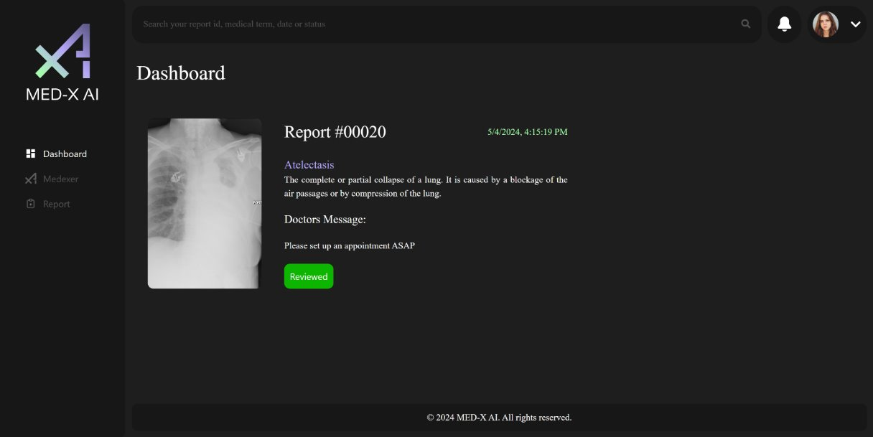

1. **Most recent report**: The Dashboard displays the report of the most recent x-ray image uploaded. Information of the report is presented, such as the report ID number, date of image submission, preliminary result detected, and a friendly definition of the result.
2. **Doctor’s message**: Below the latest report is a message section where a medical professional may provide and update a note to the patient about the report.
3. **Status bar**: Indicates if a doctor has reviewed an uploaded x-ray image report. Once an x-ray image is uploaded, it is in the “Reviewing” status, specifying that a doctor has yet to verify the report. After a doctor reviews the report (steps to do so are listed under Review Report), the status changes to “Reviewed”.
4. **Search bar**: Entering a report ID, medical term, date, or status into the search bar will filter and display the related reports associated with your account.
5. **Notification bell**: This icon notifies that a comment and/or the status of a report has been changed or if a new report is submitted by displaying a dot alongside it. By clicking on the notification bell, a dropdown will be shown with the associated report ID(s) and information about the update(s).
6. **Profile**: Your profile image is displayed at the top right. When clicking on the down-facing arrow, profile details, update option, and logout button display.
7. **Navigation menu**: Links to Med-X AI pages are listed. “Medexer” leads to the x-ray upload and AI detection and “Report” to a historical gallery of all reports.

**II. Search Bar**

1. To filter and display specific reports associated with your account, select the search bar at the top of the page.
2. Enter a report ID, medical term, date, or status into the search bar to filter your reports for a specific attribute.
3. A list of reports related to the data entered in the search field will be displayed below the search bar as shown in the image above.
4. Any of the reports listed can be selected to display its report page and view more details and options for that report as shown in the image below.

By following these steps, you will have viewed a report through utilizing the search bar.

**III. Report Notifications**

1. When a comment and/or the status of a report has been changed or if a new report is submitted, a dot is displayed beside the notification bell icon by the top right of the page.
2. To view more details about the changes made to the reports, select the notification bell.
3. Once selected, a dropdown will be shown with the associated report ID(s) and information about the update(s) as shown in the image above.

By following these steps, you will have viewed any changes to your reports.

# Profile

**I. View Profile**

1. Select the profile icon located at the top right of the page.
2. Once selected, a dropdown is displayed with your name, contact number, a "Logout” button, and a “Profile” button as shown in the image above.
3. To view more information in your profile, select the “Profile” button.
4. Once selected, your profile page will be displayed as shown in the image below. The page contains information such as your full name, email address, date of birth, sex, and contact number.

**II. Update Profile Information**

1. Select the profile icon located at the top right of the page.
2. Once selected, a dropdown is displayed with your name, contact number, a "Logout” button, and a “Profile” button as shown in the image above.
3. To update your profile information, select the “Profile” button.
4. Once selected, your profile page will be displayed as shown in the image below. The page contains information such as your full name, email address, date of birth, sex, and contact number.

1. To change your name, select the field below “Full Name” and enter your updated name.
2. To change your date of birth, select the field below “Date of Birth” and enter your updated date.
3. To change your sex, select the field below “Sex” and select one of the options from the dropdown.
4. To change your contact number, select the field below “Contact Number” and enter your updated telephone number.
5. Once all desired changes are made, select the “Submit” button below all the fields to save the changes.
6. Once submitted, a popup is displayed to confirm that the profile information has been updated.
7. Select “OK” to close the pop-up message.

By following these steps, you will have updated your profile information.

**III. Logout of Account**

1. Select the profile icon located at the top right of the page.
2. Once selected, a dropdown is displayed with your name, contact number, a "Logout” button, and a “Profile” button as shown in the image above.
3. To logout of your account and end the current session, select the “Logout” button.
4. Once selected, you will return the Med-X AI login screen.

By following these steps, you will have successfully logged out of your account.

# X-Ray Detection

**I. Upload Chest X-Ray**

1. Click on the “Medexer” option on the right navigation menu to display the page as shown in the image above.
2. To select a chest x-ray image file, do either of the following:
   1. Select the “Browse” button located in the middle of the page.
   2. From your device’s file explorer, drag and drop the desired image file.

Note: With either method of file selection, only .png and .jpeg file formats are supported by the Medexer.

1. After having selected the desired chest x-ray image file, the page as shown in the image above will be displayed.
2. If the image selected is not the one you want to submit, click the “Re-upload” button and repeat steps 1 - 3 with the preferred image file.
3. If the x-ray image and file name displayed is the image you want to submit, click the “Submit” button and wait for the report result to load.

1. Once Medexer finishes processing your image submission, a report of the chest x-ray result is displayed as shown in the image above. The report contains the x-ray image, date and time of submission, detected result, and a friendly definition of the medical term.
2. To save the report into your account, select the “Submit Report” button.

1. A pop-up confirming the report submission with a report identification number will be displayed as shown in the image above.
2. Click the “OK” button to close the pop-up.

1. After closing the report submission confirmation pop-up, you will be brought to the Dashboard with the newly submitted report being displayed.

By following these steps, you will have uploaded a chest x-ray image and received a report with a preliminary diagnosis to your Med-X AI account.

**II. View Historical Reports**

1. Click on the “Report” option on the right navigation menu to display the page as shown in the image above.
2. A gallary of all historical reports associated with your personal account will be displayed. Each report listed shows its chest x-ray image, review status, report identification number, and result. Reports are listed in numerical order from least to greatest based on report ID.
3. The numbers below the listed reports represent the current and total number of pages for the report gallery.
   1. To view more reports that are not shown on the first gallery page, select “Next” up to the maximum page number.
   2. To view previous pages on the report gallery, select “Previous” down to “1”
4. To view more details about a report, select any of the reports displayed in the gallery list.

1. Once selected, a detailed report page like the image above will be displayed.

By following these steps, you will have navigated through your historical reports.

**III. Print or Download Report**

1. To print or download a report, first reach a detailed result page like the image above by selecting a report.
2. Click the “Print Report” button located by the bottom right of the page.
3. A print pop-up window would then be displayed by your device. The preview should look similar to the PDF report image below.

1. To print, make sure the destination is set to your printer and select a print button. Your printer should then produce a physical copy of the report.
2. To download, make sure the destination is set to “Save as PDF” and select a save button. You will also be asked to choose a location in your device to save the PDF report file.

By following these steps, you will have printed or downloaded one of your chest x-ray reports.

**IV. Review and Update Report**

In order to verify reports, a doctor must view the report and may leave a comment for the patient. The following steps guide a medical professional on how to review reports, which allows for quick and easy connection with their patients.

##### Doctor

1. To review or update a report, first reach a detailed result page like the image above by selecting a report in the Report gallery or from the search bar.
2. To leave a note for the patient, select the text box below “Medical Practitioner’s Comment” and enter a message.
3. To update the report and notify the patient that the report has been reviewed, select the “Update Report” button located by the bottom right of the page.
4. Once selected, a pop-up message is displayed to confirm that the report has been updated as shown in the image below.
5. Click “OK” to close the pop-up message.

By following these steps, you will have reviewed and commented on one of your patient’s chest x-ray reports.

# Contact information

Date: May 8, 2024

**Feedback and Updates**

We value your feedback and are committed to continuously improving user experience and the software itself. Your input is invaluable to us, and we encourage you to share your thoughts, suggestions, or report any issues you encounter during your experience.

Email: **medxteam2024@gmail.com**