Robotics Final Report

Christopher Porteous - 11971429

MANIPULATE THE WORLD

Task 1 asks to show calculations to determine the tool offset as a homogeneous transform matrix to attach the blasting nozzle to the robot.

%% Tool Transform
toolTransform = transl(0, 0, 0.2) * troty(pi/4);
disp('Tool Transform');
p560.tool = toolTransform

Place the robot base according to your student number. Choose a location for the drum based upon your personalised robot base transform, the drum transform, and the transfrom between the robot base and the drum.

Using my student number (11971429), the robot base comes to:

% Student number: 1197 1429
studentID = [1197 1429];
robotBase = [(studentID(1))/1000 (studentID(2))/1000 1];

%% Show the robot base transform
disp('Robot base transform');
baseTransform = transl(robotBase(1), robotBase(2),1)

The drum transform was ‘random’ in a way that I personally didn’t want to deal with decimal places, so the transform is as follows;

%% Setup Objects
drumCoord = [1, 0, 0];

disp('Drum Transform');
drumTransform = transl(drumCoord(1), drumCoord(2), drumCoord(3))

The transform between the robot base and the drum is calculated:

%% Show the transform between the robot base and the drum
disp('Transform from base to drum');
b2deltaTransform = inv(baseTransform) * drumTransform

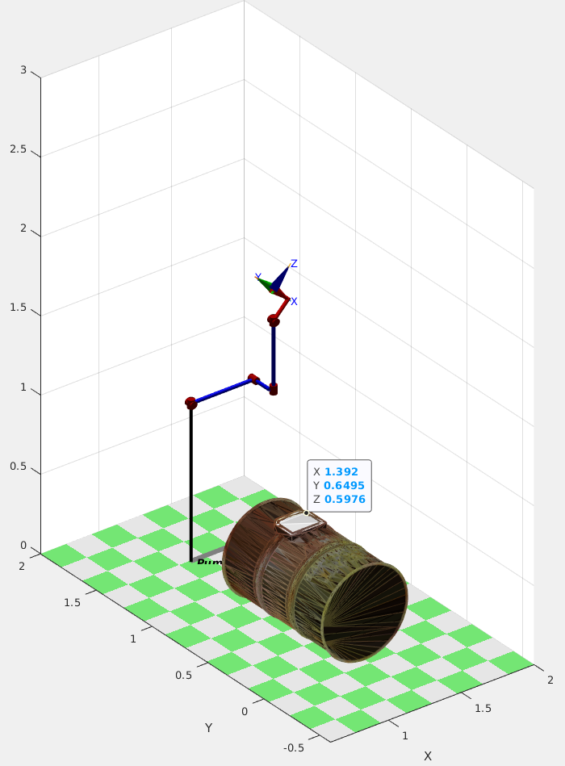
Show how you used an inverse kinematic solver to find a starting pose that points the nozzle at one corner of the white window on the drum.

Taking the advice from the Assignemnt sheet, I used Data Tips to pinpoint a starting and ending location for the window corners:

NOTE: These screenshots are rough xyz coordinates, not the ones used in the code. It should behave the same way if they are changed to the values in the screenshots.

After getting these coordinates, these points were converted to homogenous matrices:

% Move to first corner position
firstWindowPos = [1.392 0.6495 0.5976];
firstWindowTrans = transl(firstWindowPos) * troty(-pi/2) * trotz(pi/4) * trotx(-pi/8);
disp('Moving to first corner');
q1 = p560.ikcon(firstWindowTrans);
qMatrix = jtraj(q0, q1, steps);
p560.plot(qMatrix);

% Move to second corner position
secondWindowPos = [1.228 0.6746 0.5976];
secondWindowTrans = transl(secondWindowPos) * troty(-pi/2) * trotz(pi/4) * trotx(-pi/8);
disp('Moving to second corner');
q2 = p560.ikcon(secondWindowTrans);

Feedback includes graphs for respective joint angles, velocities, and acceleration.

Joint Angles:

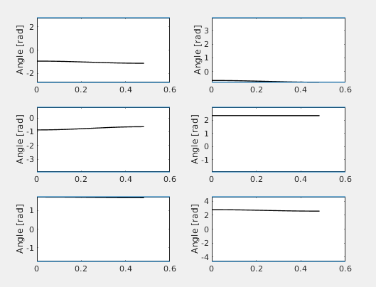

Joint Velocities:

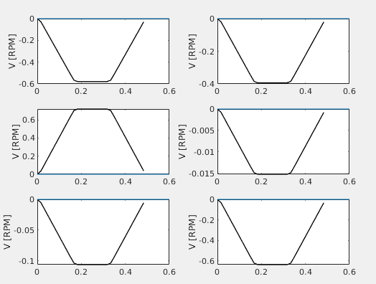

Joint Acceleration:

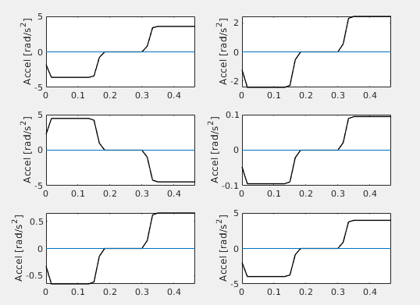

ROBOTS AFFECTING OUR WORLD

In what ways do you imagine that robots be more integrated in your life in within the next 5 years in a post COVID-19 world?

Personally, the rate at which robotics are progressing, the chances that my current occupation will be replaced by autonomous machines is highly unlikely. The opportunity to work with robotics within my occupation increases as Australia strives towards industry 4.0 where my occupation will be aiming to blend the lines between Industry 3.0 and 4.0. The application of the robotics in these instances will be mainly for highly repetitive actions – these will enable the company to digitally transform their workspace into a flexible, fast, and cost-efficient environment.

Similar to the application in Assignment 2, I believe that there will be an increase in robotics usage for shelving in supermarkets and/or retails stores. These robots could also relay information back to the main control system detailing the quantity of items that were sold of that type and other information that may be relevant to that business. The use of object recognition, trajectory and path planning, and collision avoidance would be successful in navigating congested curves and any obstacles that may appear in the robots path.

The further research into self-driving automobiles has become quite popular. This is clearly seen in car companies, most notably Tesla, where there is progression to try and push these vehicles to the commercial market. At the moment, the ‘self-drving’ capability of most vehicles is staying within lines on a highway where there is minimal objects to be processed by the onboard vision system. The application of combining event data and deep learning were shown to perform well on applications in the field of motion estimation. The introduction of these vehicles to everyday life would greatly reduce traffic jams, inefficient fuel consumption, and increase safety for any other vehicles nearby as well.

Another application of robotics in my family’s life would be for backyard gardening. A commercially available system that can be bought and utilised is the FarmBot. This is a system that uses a top down robot in an X Y Z cartesian configuration which uses various sensors and is capable of watering and caring for plants. As mentioned before, it is commercially available and easy to set up. Due to the measurements taken based on soil moisture sensors, this device can save up to 47% of water when compared on traditional farming methods. From using a machine such as the FarmBot (including some modifications), the user would be able to jog the axis and visually inspect individual sections of the plantation. This implementation would restrict the amount of time that the user is outside and exposed to the environment. Furthermore, it reduces the amount of time the end user would spend bending over to manually inspect crops which then reduces physical strain.

ROBOT AND FRANK

Frank interacts with a robot 10 seconds into the clip asking where the librarian is. This is possible with today’s technology of speech recognition. However, most speech recognition systems tend to suffer from high amounts of environmental noise – this case is slightly more realistic as the robot and user are situated in a library, which shouldn’t be a noisy environment in the first place. The ability to track the librarians movements within the library is also possible. If the environment is mapped within the robot’s controller, and a way to track the librarian was implemented, a pendent through the use of a keycard, her position could be accurately tracked within the bounds of the 3D mapped environment. The robot would then be able to give the answer that Frank is asking. It cuts to her being present at the desk, so whether there was a simple signal sent to her remotely or not remains to be seen.

The robot that Hunter brings to Frank is a stout humanoid robot which seemingly recognises Frank as soon as it is set down. This is a use of facial recognition. The part which is seemingly vague is that the robot required no prior data before meeting with Frank. Today’s object and facial recognition require a database to reliably identify objects and people. There is ongoing research using GoogleNET and NVIDIA Deep Learning where the overall accuracy is 91.43%. In the short clip, there is no evidence of any data processed by the robot prior to being introduced to our main character. In a world where data is freely available, including images of everyone held in a univerally available database, this type of recognition is possible as that data could be easily accessed once the robot is powered up. The chances of having this much information available regarding one person is inconcievable in today’s society is slim.

The robot’s ability to create and care for gardens is possible for robots that have that fixed task to perform. Having an all-in-one robot is difficult to achieve especially considering that the more robust and adaptable a robot is, the more balance control it will require. The ability to determine where the garden be optimally plated to ensure growth can be determined using soil samples in the robots feet. The analysis of these samples will assist the robot in determining the prime location for the bed. The robot’s capability of analysing this data is difficult in its compact frame as it would have to be in the centre of the robot to ensure it has a controllable centre of mass (in the lower torso) to mimic the human body.

The power supply used for the robot is not specified, and there is no indication of it throughout the trailer. It is possible that there is a charging dock elsewhere located within the house, however, as mentioned before, it was not made present. A comparison that can be used is Boston Dynamic’s Atlas Robot. The robot uses a 3.7kW-hour lithium-ion battery pack which enables it to undertake up to one hour of ‘mixed missions’. With respect to the Robot & Frank trailer, there is no indication that this robot requires charging or has any issues with power consumption. Everyday implementation would suggest that it charges either at night or throughout the day using inbuilt solar panels.

The robot displays an artifical intelligence where it can learn from experiences and environmental factors. This is present in the scene where it is being taught how to pick a lock. This can be taught in robots today through the use of Evolutionary Artifical Neural Networks and search procedures such as Genetic Algorithms. This method is a slow, repetitive process that will eventually teach a system this skill. The processing power required to teach a robot this at the same time as processing all other incoming data may prove too much information for the Central Porcessing Unit of the robot. Further development in processing power is required before this can be fully implemented.

References

Robots affecting our world

Paolanti, M., Romeo, L., Martini, M., Mancini, A., Frontoni, E. and Zingaretti, P., 2019. Robotic retail surveying by deep learning visual and textual data. Robotics and Autonomous Systems, 118, pp.179-188.

Gallagher, S., 2017. Industry 4.0 Testlabs in Australia-Preparing for the Future.

Almasri, M.M., Alajlan, A.M. and Elleithy, K.M., 2016. Trajectory planning and collision avoidance algorithm for mobile robotics system. IEEE Sensors journal, 16(12), pp.5021-5028.

Blahunka, Z. and Szabó, Z.B.I., AUTOMATION AND ROBOTICS IN THE PRECISION FARMING. In 3rd International Conference on Water Sciences (p. 30).

Brown, J., Colombo, K., Salem, L., Jeng, N., Stothers, R. and Lees, S., 2017. Polar coordinate Farm Bot final project report.

Robot and Frank (2012)
Doostdar, M., Schiffer, S. and Lakemeyer, G., 2008, July. A robust speech recognition system for service-robotics applications. In Robot Soccer World Cup (pp. 1-12). Springer, Berlin, Heidelberg.
Anand, R., Shanthi, T., Nithish, M.S. and Lakshman, S., 2020. Face recognition and classification using GoogleNET architecture. In Soft Computing for Problem Solving (pp. 261-269). Springer, Singapore.
Reher, J.P., Hereid, A., Kolathaya, S., Hubicki, C.M. and Ames, A.D., 2020. Algorithmic foundations of realizing multi-contact locomotion on the humanoid robot DURUS. In Algorithmic Foundations of Robotics XII (pp. 400-415). Springer, Cham.
McCarty, G.W. and Reeves, J.B., 2006. Comparison of near infrared and mid infrared diffuse reflectance spectroscopy for field-scale measurement of soil fertility parameters. Soil Science. 171(2), pp.94-102.
Yao, X., 1993. Evolutionary artificial neural networks. International journal of neural systems, 4(03), pp.203-222.

