AUC baseline is minority/total = 0.1659

Baseline – no over/undersampling and no weights (have datasize issue though…)

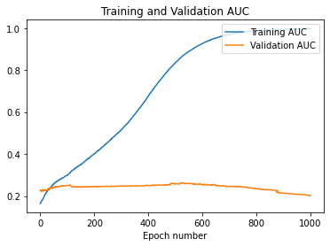

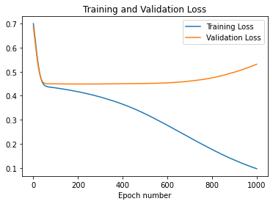

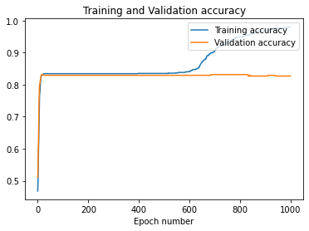

40/40 [==============================] - 0s 745us/step - loss: 0.0961 - accuracy: 0.9805 - auc: 0.9976

14/14 [==============================] - 0s 846us/step - loss: 0.5310 - accuracy: 0.8267 - auc: 0.2023

14/14 [==============================] - 0s 804us/step - loss: 0.4736 - accuracy: 0.8384 - auc: 0.2513

[0.83403657 0.16596343]

Using weights

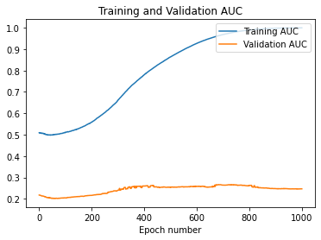

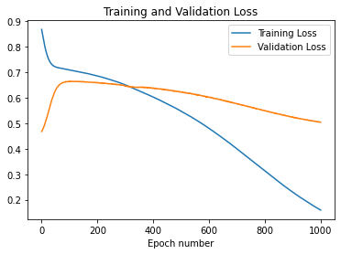

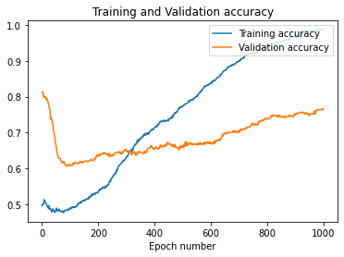

40/40 [==============================] - 0s 412us/step - loss: 0.1592 - accuracy: 0.9898 - auc: 0.9974

14/14 [==============================] - 0s 1ms/step - loss: 0.5041 - accuracy: 0.7658 - auc: 0.2468

14/14 [==============================] - 0s 1ms/step - loss: 0.5094 - accuracy: 0.7635 - auc: 0.2229

[0.83403657 0.16596343]

Training with oversampling (minority doubled) and undersampling (ratio of new minority to majority = 1:2 – 738 total samples. Batch_size= 4 so quite small..

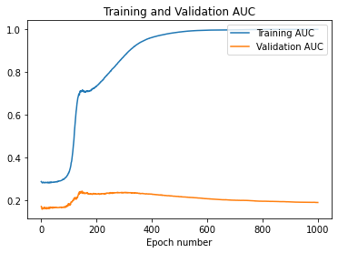

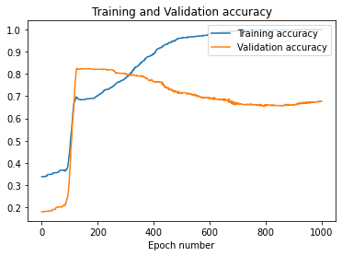

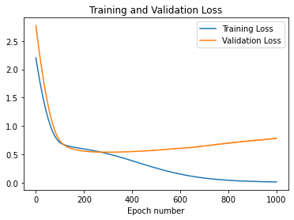

Same as above but batch_size=18. Notice these is an issue where the oversampled data is being included in validation and test samples which is incorrect. Need to resolve and retrain.

