**Software Project Management Plan “Healthy Competition”**

Project Name: Healthy Competition

Version Release Responsible Party Major Changes Date

0.1 Initial Document Release for Comment

# **Table of Contents**

Build the table of contents here. Insert it when you finish your document.

1. Introduction

1.1 Project Overview

Website allows users to create a single account or add users to join the healthy challenge with them as a team. The healthy challenge site will allow users to track progress during the course of their journey of making healthy choices and lifestyle changes. Players will also receive notifications via email about goals reached and encouraging messages as they get closer to their milestones for added support. The intent of this game is to help family members or co-workers who could benefit from a competitive playing environment towards a healthy goal. The website fosters a sense of community and support by allowing players to share progress among each other and remain focused on their goal towards a healthier lifestyle.

Major work activities:

Major milestones include:

* Hosting interviews with clients to receive their input and personal goals to incorporate those desired characteristics into our product
* React comparability with API
* Project adaptability to conform to new challenges desired from users

1.2 Project Deliverables (all items to be delivered, including delivery dates and location)

* Hosted prototype site that includes account creation and management, donating and at least one of the game modes outlined in the use cases.

1.3 Evolution of the SPMP

Per our use cases we have set, we anticipate adding both team multiplayer and solo play features to the project. Any unscheduled updates will be addressed and communicated to the group during weekly meetings. Change control will be managed through realistic expectations and communicating with our client.

1.4 Reference Materials

* Repository: GitHub link: <https://github.com/ChrisPastor/healthy-competition-website>
* Web framework: MERN stack
* <https://cs.uwaterloo.ca/~apidduck/se362/Assignments/A2/spmp> - SPMP Doc Template
* <https://trello.com/>
* <https://www.aaf.org/_pdf/aaf%20website%20content/513_ethics/iae_principles_practices.pdf> - Institute of Advertising Ethics Principles and Practices
* Team Gantt chart software

<https://prod.teamgantt.com/gantt/schedule/?ids=2339380#ids=2339380&user=&custom=&company=&hide_completed=false&date_filter=&color_filter=>

Provide a complete list of all documents and other sources of information referenced in the plan. Include for each the title, report number, date, author, and publishing organization.

1.5 Definitions and Acronyms

* MERN = MongoDB, Express.js, React, Node.js
* HL - Healthy Lifestyles committee (client name)
* Solo Play - Single player mode where it is solely based on personal performance and progress
* Solo Multiplayer - This mode is where solo players compete against each other in the group
* Team Multiplayer - This mode is similar to Solo Multiplayer, but instead of scoring individually, the entire team’s progress is scored and competing against another team’s progress

# **2.** **Project Organization (Elizabeth Miller)**

This section specifies the process model for the project and its organizational structure.

2.1 Process Model

Specify the life cycle model to be used for this project or refer to an organizational standard model that will be followed. The process model must include roles, activities, entry criteria and exit criteria for project initiation, product development, product release, and project termination.

In this project we will utilize a spiral process model. The spiral model will help us to break down our project into separate phases, in which we will be able to continuously reassess risks, requirements and our plan.

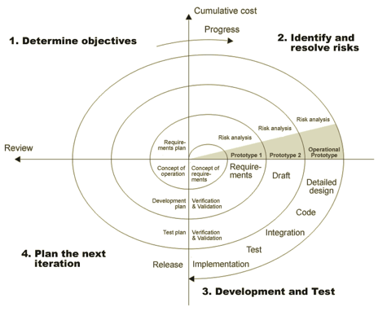

2.2 Organizational Structure

Describe the internal management structure of the project, as well as how the project relates to the rest of the organization. It is recommended that charts be used to show the lines of authority.

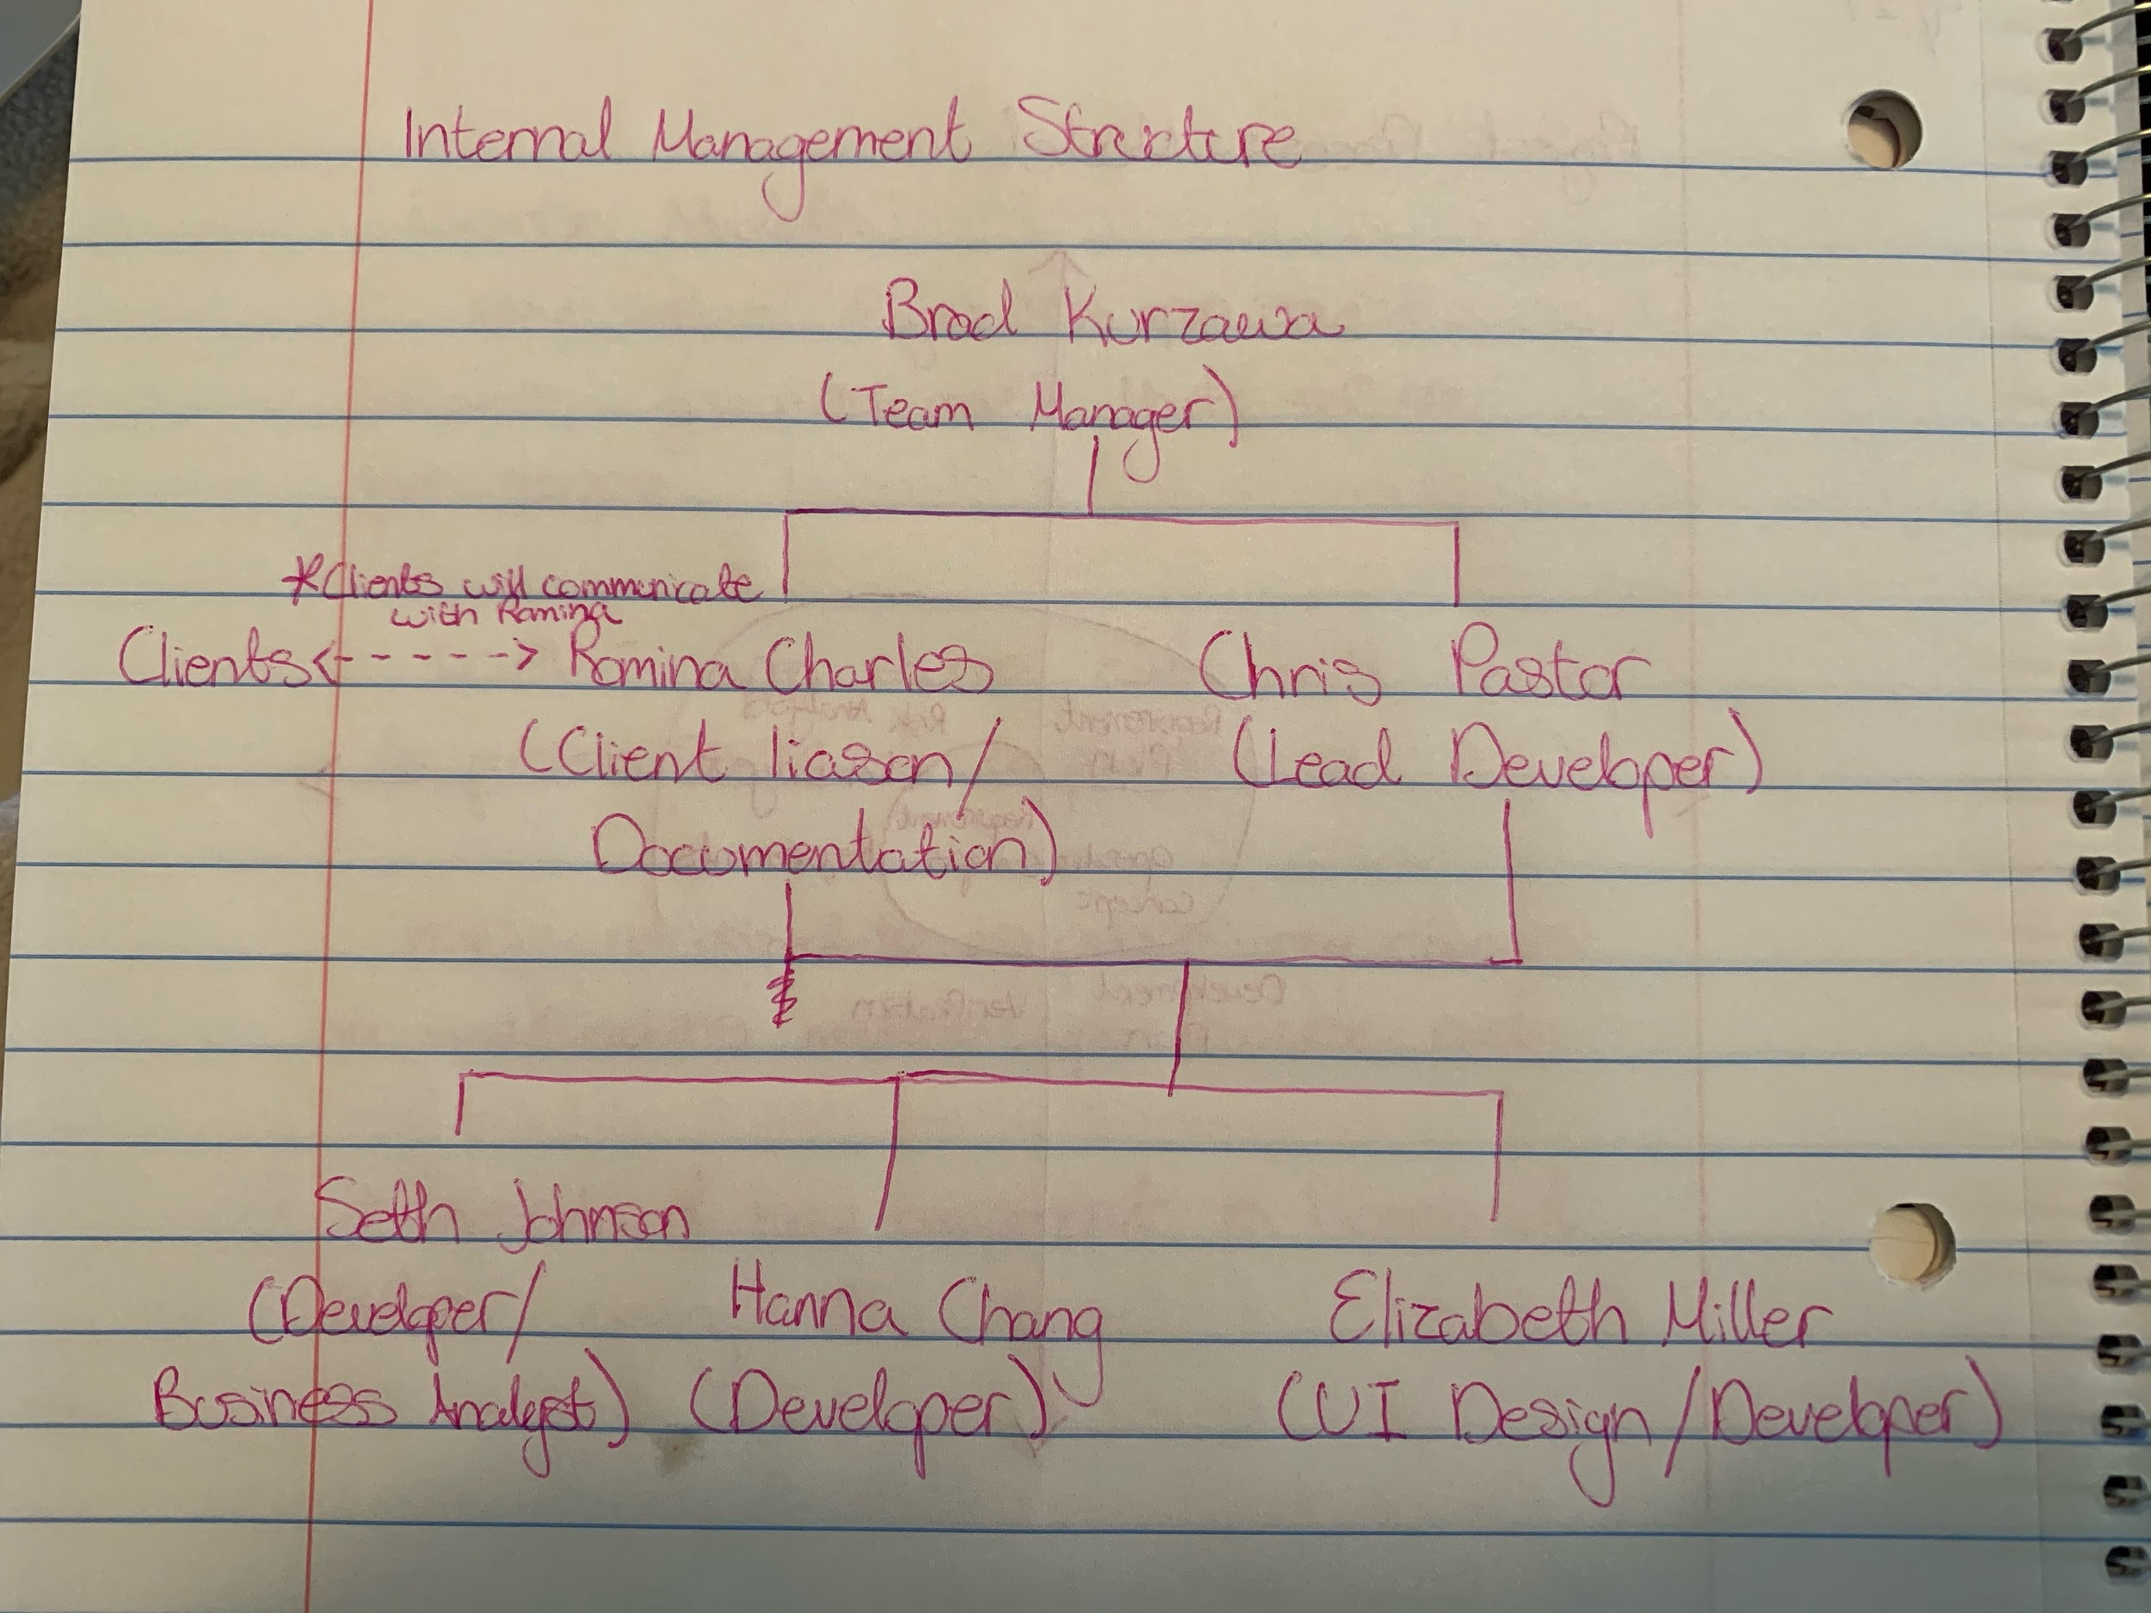

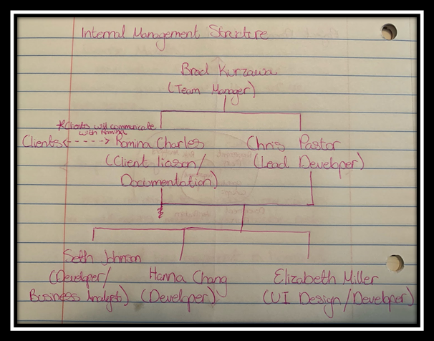

Figure F-2: Organization Chart

2.3 Organizational Interfaces

Describe the administrative and managerial interfaces between the project and the primary entities with which it interacts. A table may be a useful way to represent this information.

Parent/Customer Organization: Towson University

Table F-1. Project Interfaces

|  |  |  |  |  |  |  |
| --- | --- | --- | --- | --- | --- | --- |
| Name | Romina Charles | Chris Pastor | Brad Kurzawa | Hanna Chang | Seth Johnson | Elizabeth Miller |
| Structural Work |  |  |  |  |  | UI designer |
| Operational Work | Developer, testing and documentation. | Lead developer and tester. He will direct the development process given Romina’s requirements and deliverables, as well as Seth’s cost projections. | Developer and team manager. He will ensure all phases are completed in a timely manner and the team is cohesive. | Developer/Tester | Developer/Tester | Developer/Tester |
| Conceptual Work | Interacts with clients to determine the project requirements and deliverables. |  |  |  | Business analysts will help determine the cost and feasibility of all aspects of the project. |  |

2.4 Project Responsibilities

|  |  |  |  |  |  |  |
| --- | --- | --- | --- | --- | --- | --- |
| Name: | Romina Charles | Chris Pastor | Brad  Kurzawa | Hanna Chang | Seth Johnson | Elizabeth Miller |
| Role: | Client Liaison/ Documentation/Developer | Lead Developer/ DevOps | Developer/ Team Manager | Developer/ | Developer/Documentation  (Business Analyst) | UI Design/ Developer |
| Contact Information: | rcharl6@students.towson.edu | cpasto1@students.towson.edu | bkurza1@students.towson.edu | hchang8@students.towson.edu | sjohns98@students.towson.edu | emille51@students.towson.edu |
|  |  |  |  |  |  |  |

Documentation Leads: Romina

Developers: Basically everybody

Testers: Everybody will be testing as well

# **3.** **Managerial Process**

3.1 Management Objectives and Priorities

* Creating and updating project documentation.
* Facilitate consistent communication among team members to ensure deadlines are met.
* Ensuring developed software meets HL mandates.
* Organizing regular client meetings to provide updates and garner feedback.
* Keeping track of major development changes and monitoring proper use of the GitHub repository.

|  |  |  |  |
| --- | --- | --- | --- |
| Project Dimension | Fixed | Constrained | Flexible |
| Cost |  | X |  |
| Schedule | X |  |  |
| Scope (functionality) |  |  | X |

3.2 Assumptions, Dependencies, and Constraints

Constraint: The project must have a working prototype by early December that showcases basic functionality.

Contingency: Organize consistent development meetings and regularly update task scheduling. This will help ensure deadlines are met.

Constraint: HL states the general purpose of the project is to be fun and interactive.

Contingency: Research on industry trends to better understand users’ expectations and desires. Ensuring there are a plethora of opportunities for users to interact with the site will be essential.

Constraint: There is no budget or expectation of funding.

Contingency: All development will require using open-source software for implementation.

Constraint: The site must facilitate advertising.

Contingency: With the site being contracted by a government agency, all potential advertisers will have to adhere to a strict code of conduct. Our team will use the Institute’s of Advertising Ethics’ Principles and Practices guidelines to audit potential advertisers.

3.3 Risk Management

Risk: The COVID-19 pandemic has pushed all development remote, meaning in-person

meetings are not possible for the duration of this project.

Risk: The lack of funding will prove detrimental to product testing. All testing will be done by the in-house development team.

3.4 Monitoring and Controlling Mechanisms

Scheduling of important milestones will be monitored through Trello, an online scheduler. A list of project needs and tasks, as well as the development Gantt chart, will be viewable there. The team will meet Mondays during our scheduled class time, Wednesdays from 6-8 p.m. every week to monitor progress. Monday’s meetings will be used to set weekly deliverables and to check in on each team members’ progress. Wednesday meetings serve as workshop meetings and will provide a time for the entire development team to work in unison. Additional workshop meeting times will be scheduled as needed. Individual team members are expected to adhere to these deadlines and will be responsible for informing the client liaison of their completion.

Team documentation is being done in a collaborative method. Once members complete their individual portions, the lead developer and client liaison will ensure that work meets demands and is adhering to the expectations set in the SPMP.

3.5 Project Log

The team will collect certain management documents in a project log that will serve as a paper trail for the activities of the team over the life of the project. The project log is meant to aid the team in evaluating their progress, tracking key decisions, and meeting scheduled deadlines.

The Project Log will include the following eight categories:

1 Team Meeting Agendas and Minutes

2 Faculty Advisor Meeting Agendas and Minutes

3 Project Baseline Schedules

4 Technical Review Reports

5 Change Requests

# **4.** **Technical Process**

This section specifies the technical methods, tools, and techniques to be used on the project. It also includes identification of the work products and reviews to be held and the plans for the support group activities in user documentation, training, software quality assurance, and configuration management.

4.1 Methods, Tools, and Techniques

The Application will be developed as a web application, so should run on all common browsers (chrome, firefox?, edge, safari?).

Code will be written in Javascript using Node.js and UI framework written in React.

Backend server written in Node.js using express.

Database will be MongoDB.

Login and user authentication done with Auth0.

Unit Testing framework will be done with Jest.

Hosting on heroku and build and deploy through travis.

Identify the computing system(s), development method(s), standards, policies, procedures, team structure(s), programming language(s), and other notations, tools, techniques, and methods to be used to specify, design, build, test, integrate, document, deliver, modify or maintain the project deliverables

4.2 Software Documentation

Specify the work products to be built for this project and the types of peer reviews to be held for those products. It may be useful to include a table that is adapted from the organization's standard collection of work products and reviews. Identify any relevant style guide, naming conventions and documentation formats. In either this documentation plan or the project schedule provide a summary of the schedule and resource requirements for the documentation effort.

4.2.1 Software Requirements Specification (SRS)

The SRS clearly and precisely describes each of the essential requirements (functions, performances, design constraints, and attributes) of the software and the external interfaces. Each requirement is defined such that its achievement is capable of being objectively verified and validated by a prescribed method, for example, inspection, analysis, demonstration, or test.

4.2.2 Software Design Description (SDD)

The SDD describes the major components of the software design including databases and internal interfaces.

4.2.3 Software Test Plan

Template: <https://xbosoft.com/website-testing/web-application-testing-services/?gclid=EAIaIQobChMItO7t-6-K7AIViYzICh1ARgzOEAAYASACEgIyh_D_BwE>

# **5.** **Work Packages, Schedule, and Budget (Romina )**

**5.1 Work Packages**

The work packages needed to implement the Healthy Competition website and app are as follows:

In order to develop a website certain information was researched to ensure tools used are efficient, compatible, and cost effective. During the planning process of the website a system of steps were created to guide the team members towards this goal. Tasks were subdivided into smaller subcategories to allow team members to see how tasks relate to each other, observe dependencies among these tasks to understand which section should be completed first. Below Trello software image is displayed to show how each category is divided.

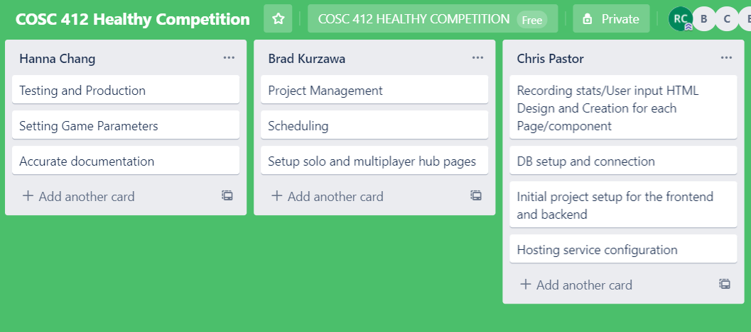

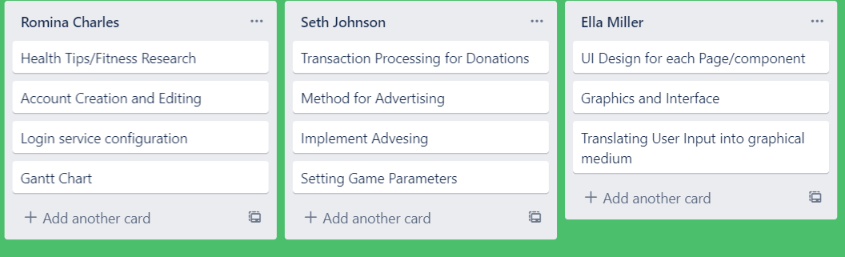

The Lead Developer and DevOps will handle the Initial application setup,HTML Design and Creation, and initial setup for frontend and backend. During this stage the framework for how the website will be laid out is determined. Furthermore, set up for different components needed to implement each section of logging interface, account creating and editing will be taken into consideration during this stage. The parameters that the website will be taking and how donations are received will be established at this stage.

The graphics and interface stage is concerned with user interaction with the website and how the player views information as they navigate through game selection, settings, and other options. The main goal during the graphics and interface section is to ensure players and website visitors enjoy a user friendly layout and accessibility as well as an appealing visual design.

**5.2 Resource Requirements**

The resources required for the completion of the website will be existing computers each team team member owns. Software needs to organize team members' progress and the overall completion of the project is all open source and free Github extension using student ID to eliminate all start up cost and maintenance of product. All meetings and work will be entirely online and therefore no cost is added towards gas expense or salaries since staff working on coding will be done as a volunteer work.

**Personnel and work assignation:**

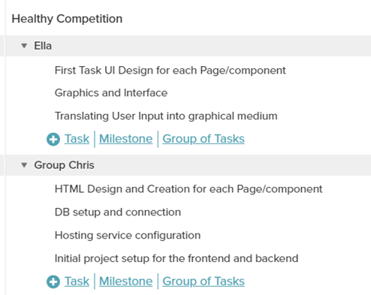

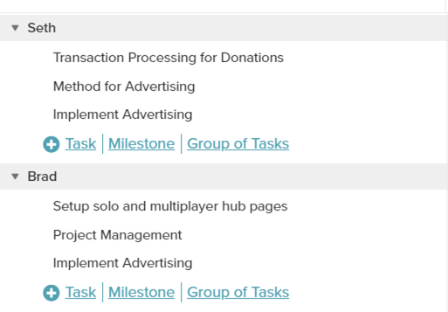

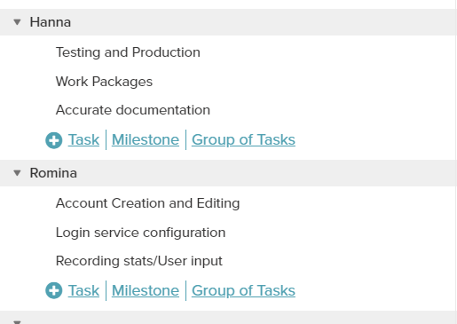

Scheduling:

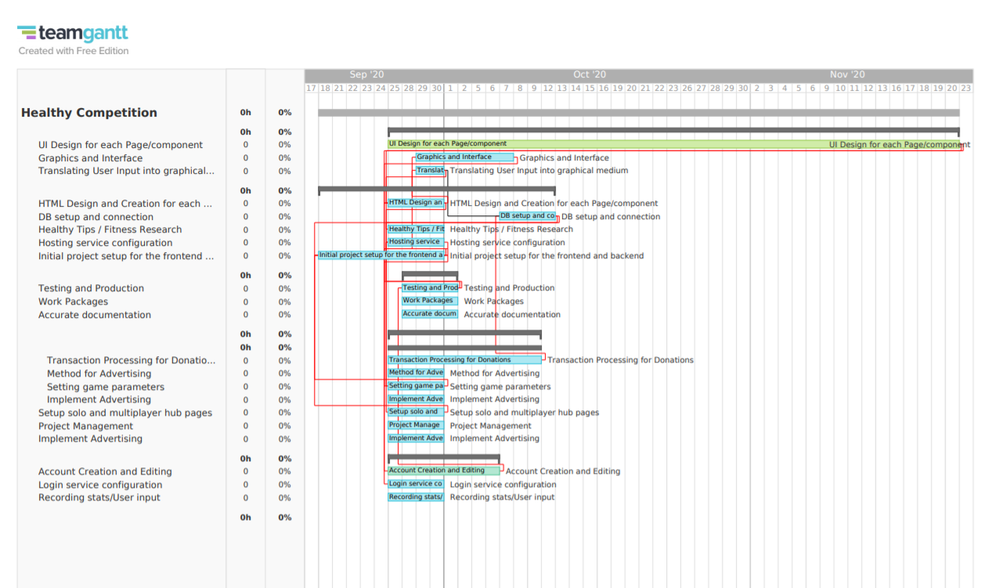

# **6.** **Additional Components**

Certain additional components may be required and may be appended as additional sections or subsections to the SPMP. Additional items of importance on any particular project may include subcontractor management plans, security plans, independent verification and validation plans, training plans, hardware procurement plans, facilities plans, installation plans, data conversion plans, system transition plans, or the product maintenance plan.

6.1 Index.

An index to the key terms and acronyms used throughout the SPMP is optional, but recommended to improve usability of the SPMP.

6.2 Appendices

Appendices may be included, either directly or by reference, to provide supporting details that could detract from the SPMP if included in the body of the SPMP. Suggested appendices include:

<https://docs.google.com/document/d/1MVmaLZTv0mU7Q9QnR7tU7DbdaKaOaqaZQqA0wUt0MYI/edit>

<https://docs.google.com/document/d/1ou10-SgOmfzDGG8BZAjNawguzBBBqUMvZh2wbJTrm4s/edit>