

**Development of a Secure Raspberry Pi Based Home Surveillance System**

A dissertation submitted in partial fulfilment of the requirements of Glasgow Caledonian University for the degree of Master of Science in Big Data Technologies

Christopher Dillon

S1514278

**“Except where explicitly stated, all work in this report, including the appendices, is my own original work and has not been submitted elsewhere in fulfilment of the requirement of this or any other award”**

**Signed: _____________________ Date: ________**

# Abstract

TODO

# Acknowledgments

TO DO

Table of Contents

1.0 Introduction 6

1.1 Background 6

1.2 Problem Description 7

1.3 Project objectives 7

2.0 Literature Review 9

2.1 Internet of Things Architecture 9

2.1.1 Perception Layer 9

2.1.2 Network Layer 9

2.1.3 Application Layer 9

2.2 Network Communication Protocols 10

2.2.1 Bluetooth 10

2.2.2 Wi-Fi 11

2.2.3 ZigBee 11

2.3 Application Communication Protocols 12

2.3.1 Message Queue Telemetry Transport 12

2.3.2 Advanced Message Queueing Protocol 13

2.3.3 Constrained Application Protocol 14

2.3.4 Redis (google) 15

2.4 Data Exchange Formats 16

2.4.1 XML 16

2.4.2 JSON 16

2.4.3 Protocol Buffers 17

2.5 Security Protocols 18

2.5.1 SSH Protocol 18

2.5.2 WPA2 Protocol 18

2.6 Security Threats 19

2.6.1 DOS Attack 19

2.6.2 Man in The Middle Attack 19

2.6.3 Malicious Code Attack 19

2.6.4 Physical Tampering 19

2.7 Cryptography Options 19

2.7.1 RSA Algorithm 19

2.7.2 AES Algorithm 19

2.8 Password Handling Best Practices 20

3.0 Technology Review 21

3.1 Face Recognition Technology 21

3.2 Application Development 21

3.3 Remote Access Security 21

3.3.1 Fail2Ban 21

3.4 MQTT Broker 21

3.3 Simulating Cyber Attacks 21

5.0 References 23

# Table of Tables

Table 1: Comparison table of common IoT Network Communication Protocols 12

Table 2: Table highlighting features of most common IoT Application Communication Protocols 16

Table 3: Serialized size in bytes (Sumaray and Makki, 2012) 18

Table 4: Average serialization time in ms (Sumaray and Makki, 2012) 18

Table 5: Average deserialization time in ms (Sumaray and Makki, 2012) 18

# Table of Figures

Figure 1: Smart Home - revenue forecast for the segment Security worldwide* from 2017 to 2023 (in million U.S. dollars) (source: www.statista.com) 8

Figure 2: IoT 3 layered architecture in relation to a home surveillance system 11

Figure 3: MQTT Architecture using a Raspberry Pi as both a Publisher and Broker 13

Figure 4: Block diagram showing basic AMQP protocol process 14

Figure 5: Block diagram showing a basic GET/Response between a CoAP Client & Server 15

Figure 6: Code Snippet showing basic XML Schema 17

Figure 7: Code snippet showing basic JSON Schema 17

Figure 8: Diagram detailing the SSH Protocol for Machine-To-Machine Communication (ssh.com, 2019) 19

# 1.0 Introduction

## 1.1 Background

Smart security is growing at an exponential rate with an expected revenue forecast of 28 million by the end of 2023 as shown in Figure 1. Although such technology poses many advantages over traditional non-internet based security, cybersecurity has been a rising concern with small IoT based devices. A recent report by HP highlighted that out of the ten home security systems analysed, 100% of them had security vulnerabilities such as not requiring strong passwords and only one offered two-factor authentication (HP, 2015).

This is concerning enough that the UK Government poses to introduce new legislation based on Internet of Things (IoT) security, requiring products to pass security requirements before being sold and introducing mandatory labelling schemes for each product, showing how secure they are (Ashford, 2019). This is further highlighted with recent media scares such as baby monitors being hacked with the hacker being able to speak through the baby monitor and threatening the parents (Wang, 2018).

With mainstream IoT devices being consistently hosted on the cloud, this offers individuals with malicious intent another method in taking down or accessing IoT devices. Recently, Google Cloud, one of the cloud vendor giants was taken down in a possible cyber-attack (Merriman, 2019), highlighting the potentially unreliability of Cloud hosted services. Organisations that depended on Googles Cloud, including security company Nest had their services taken down for over 4 hours. This is problematic in an area such as face-recognition based CCTV, meaning if data cannot be accessed from the Cloud, the whole system could break.

To limit the scope of potential security vulnerabilities, a locally stored Raspberry Pi based security system has been proposed. Presently, there are many people opting for Raspberry Pi smart systems at home due to the flexibility and cost of the Raspberry Pi. This, as with all Internet of Things devices, has many security flaws which are easily exploitable by those with malicious intent. Offering set guidelines and covering every layer of IoT architecture can present a model to base future systems on and prevent these cyber-attacks.

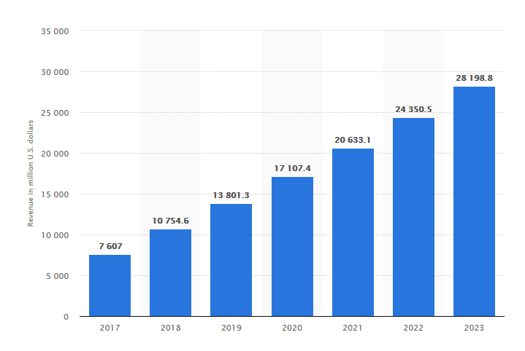

Figure : Smart Home - revenue forecast for the segment Security worldwide* from 2017 to 2023 (in million U.S. dollars) (source: [www.statista.com](http://www.statista.com)) //Diagram needs recreated

## 1.2 Problem Description

Modern IoT-based security systems pose various security risks to the individual. With the majority of these services using cloud technology, there is a larger scope of security concerns covering the full system stack. The development of a home security system using a Raspberry Pi model is proposed to create a system with a smaller scope of security vulnerabilities using local data storage to reduce information exposure over the system. The Raspberry Pi will interact with a smart phone app, with each family member having access to the application. This means security can be focused down to the perception, network and application layers of the IoT architecture.

This project aims to tackle the following areas of security:

* Authorised access to the Raspberry Pi (authentication)
* Integrated authentication for the smart phone app and IoT platform
* Explore security through restricting port access
* Storage security through encryption and reducing exposure of data to the network

These will be created in accordance with the best practices outlined by the IoT security foundation (IoT Security Compliance Framework, 2018). If time permits, a separate machine can be set up with the Kali Linux operating system, an operating system used in cyber security and digital forensics. The machine can perform various cyber-attacks (sniffing, MITM, DoS) and evaluate how the system performs against them. A recent paper demonstrates various types of DoS attacks were carried out in a test bed environment against an IoT device, resulting in a success attack against the network it was hosted on (Liang et al., 2016).

## 1.3 Project objectives

//Needs Revised

This project aims to achieve the following objectives:

* Identify, from the literature available, state of the art guidelines for Internet of Things based device security. It is important to understand commonly used attacks or threats to these devices to prevent attacks against them. Furthermore, identifying common security weaknesses in IoT can help develop an understanding on why these attacks occur in the first place.
* There are multiple security flaws inherent with IoT devices present at multiple layers of the basic IoT architecture, giving individuals with malicious intent different angles of attack at the perception, network and application layers. Developing best practices to ensure security at all levels can bring forth a model to base similar IoT Projects on.
* Establish best practices for handling a user’s data. In the case of an unlikely breach, the data held on an individual must be non-intrusive. This is to minimize the damage caused by security attacks and ensure the safety of the individuals. Best data handling practices must be established and carried out throughout the project.

# 2.0 Literature Review

This section covers the overall Internet of Things architecture and the current security issues present in each layer. State of the art network and communication protocols are reviewed as well as security protocols to determine the most suitable protocols for the proposed system. Various security threats are reviewed as well as forms of cryptography to determine best practices for the proposed system.

## 2.1 Internet of Things Architecture

IoT security faces three levels of architecture that can be attacked with malicious intent. As detailed in a recent 2018 paper, the most basic agreed upon architecture consists of three layers: Perception Layer, Network Layer and Application Layer (Burhan et al., 2018). For cloud based systems, an additional Processing layer is also considered (Aziz and Haq, 2018).

### 2.1.1 Perception Layer

This layer consists of the physical sensors which collect information and identify objects. Commonly used sensors include RFID, barcode & cameras. In this experiment the security camera is the main focus of this layer and can pose multiple potential security issues. As highlighted in the article mentioned previously, eavesdropping is definitely the most concerning security issue in this layer. Having unauthorised access to video footage is a serious breach of privacy. This is accomplished by taking advantage of insecure modes of transmission, granting access to a third party without authorisation.

### 2.1.2 Network Layer

The network layer is responsible for the transmission of data, acting as a sort of bridge between the perception and application layer. This involves carrying and transmitting information using through a wireless network which poses a set of security challenges. The layer acts as a sort of Central Nervous System for the whole network. In this scenario, the network layer consists of a standard wireless home network.

### 2.1.3 Application Layer

This layer is used to define all applications that use IoT technology. Common examples of this layer include smart homes, smart cities, smart health etc. This layer utilises the data gained from the previous layers and allows the user to use the application and enjoy its benefits. In this experiment the application layer would consist of the smart phone app used to operate the door and receive images/information from the security camera.

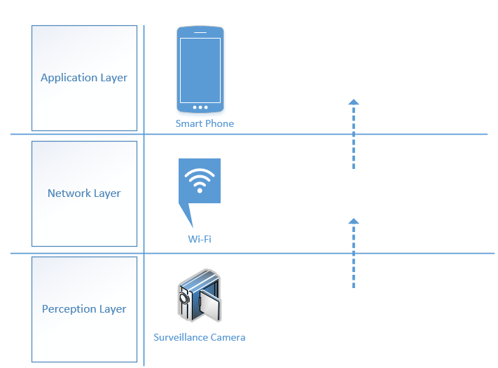

Figure : IoT 3 layered architecture in relation to a home surveillance system

## 2.2 Network Communication Protocols

Internet of Things devices differ to traditional computing devices in terms of network communication, utilising additional communication technologies such as ZigBee and Bluetooth, compared to traditional computers solely relying on Wi-Fi based communication.

The network communication protocol to be used will have the following attributes:

* An adequate range to reach the Raspberry Pi carrying out the surveillance
* Commonplace in home, to increase scalability
* High levels of security capability (encryption & authentication)
* Capable of fast data transmission (50mb/s+)

### 2.2.1 Bluetooth

Bluetooth is used to communicate between two devices within a short distance. It provides a layer of encryption by converting a message or data into cipher text before sending it to the receiver device. This message, cannot be understood by other devices except those which have the rights to see the message. The sender must always get permission rights from the receiving device before the message can be sent. This is done through the sender device requesting permission to send data to the received device, once agreed to, the devices can then communicate within the short distance. Bluetooth has a max signal rate of 1mb/s and an average range of 10 meters (Lee, Su and Shen, 2007).

### 2.2.2 Wi-Fi

Wi-Fi is a wireless communication network that transmits communication in the form of radio signalling. This is the most common type of communication used in modern homes which is problematic as it provides multiple security vulnerabilities. The main issue being, by default, there is no encryption mechanism. This leaves the network prone to MITM attacks, sniffing etc. It is well documented that Wi-Fi is one of the most commonly used network protocols in smart homes (Alam, Reaz and Ali, 2012). Wi-Fi has the added benefit of being the fastest of all common communication technologies with a recent report showing the average speed being 16.51Mbps (Cable, 2019). The average range of a Wi-Fi connection is around 100 meters (Lee, Su and Shen, 2007).

### 2.2.3 ZigBee

ZigBee is a communication protocol, which utilises small, low-power and cost radios. It is frequently utilised in the smart homes in conjunction with hubs such as the Amazon Echo (ZigBee Alliance, 2019). The technology is very limited in terms of signal rate with a rate of 250Kb/s (Lee, Su and Shen, 2007), making it unsuitable for video transmission. The transmission range is rated between 10 and 100 meters. In the paper (Romashchenko, Brutscheck and Chmielewski, 2018), a secure surveillance system was created based on ZigBee and AES encryption, showing success against brute force attacks.

### 2.2.4 HART

Highway Addressable Remote Transducer or Hart for short is a communication protocol used primarily in an industrial setting due to its ability to accurately encode and decode communication signals in settings with noisy or harsh environments (Treacy, 2019).

|  |  |  |  |  |
| --- | --- | --- | --- | --- |
| Requirement | Bluetooth | Wi-Fi | ZigBee | Hart |
| High range |  |  |  |  |
| Commonplace in home |  |  |  |  |
| Security |  |  |  |  |
| Fast Data Transmission |  |  |  |  |

Table : Comparison table of common IoT Network Communication Protocols

## 2.3 Application Communication Protocols

### 2.3.1 Message Queue Telemetry Transport

MQTT is the most commonly used application layer protocol, being light weight and using a publish-subscribe model. The protocol is mainly used where a small code footprint is required i.e. sensor data and where bandwidth is limited. With the maximum amount of data being transferred 256MB (Rastovich, 2015); speed is the priority with this protocol. It is based on the client/server architecture, the server being responsible for handling the clients request of receiving or sending data between each other. This means when a device sends data to the broker (client) it is ‘publishing’ data for any ‘subscribers’ listening to that particular topic.

It supports three levels of Quality of Service (QoS), with each having different volumes of packets exchanged. QoS Level 0 sends a message once and does not check if the message arrived to its given destination. Level 1 improves upon this by sending the message at least once and checks the delivery status using PUBACK, a status check message. If the PUBACK is lost, this can result in the same message being sent twice, due to no confirmation of the original message. Finally, Level 2 sends the message exactly once by utilising a 4-way handshake between the client and broker. This has the benefit of there being no possibility of the message being lost, but can cause additional delays. In a correlation analysis measuring lost and delay of MQTT QoS levels, it was found that for Levels 0 and 1, the average packet loss was around 0.90% to 1.40% whereas packet loss only occurred at maximum, 0.18% with QoS level 2 (Lee et al., 2013). Although QoS level 2 did have the highest end-to-end delay, this was at maximum one second, suggesting QoS Level 2 would be most suitable for the proposed system. Sharing the same attributes as MQTT, SMQTT introduces an encryption/decryption protocol to enhance security (Singh et al., 2015).

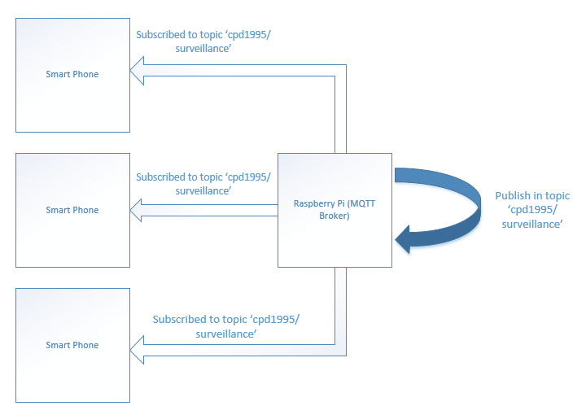

Figure : MQTT Architecture using a Raspberry Pi as both a Publisher and Broker

### 2.3.2 Advanced Message Queueing Protocol

AMQP is an open standard application layer protocol for middleware messaging. It has additional features such as message orientation, switching, reliability and queueing. Both request/response and publisher subscriber models are available with this protocol. Communication via this protocol is done through either the publisher or consumer creating an “exchange” with a given name, that name can then be broadcasted for both publishers and consumers to discover each other. Along with this exchange, the consumer creates a “queue”, attaching it to the exchange. Messages that are received by the exchange are matched to the queue via a binding process. AMQP offers the most flexibility when it comes to message exchange, offering multiple methods such as message by topic (similar to MQTT), directly, based on headers or in a fan-out form. In terms of Quality of Service, AMQP offers two types of delivery of messages: Unsettle Format and Settle Format, being similar to MQTT’s Level 0 and 1.

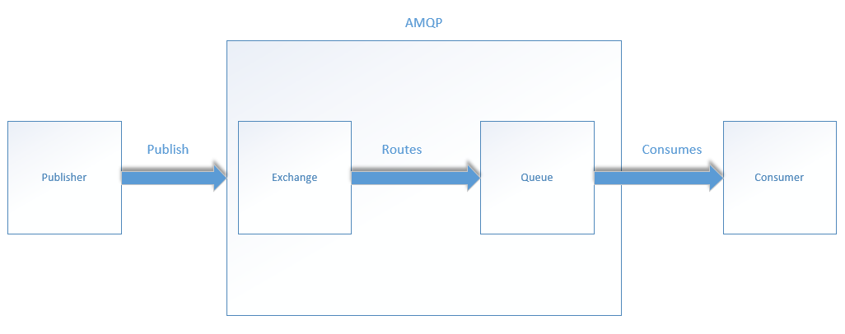

Figure : Block diagram showing basic AMQP protocol process

### 2.3.3 Constrained Application Protocol

CoAP is a stateless client/server application protocol based on the REST framework. This is based on a request/response model using the request types ‘GET’, ‘POST’, ‘PUT’ and ‘DELETE’, being similar to the standard HTTP protocol. CoAP uses Universal Resource Identifier (URI) instead of topics seen in protocols such as MQTT. This works using a similar publish/subscribe method. The publisher sends new data to the URI, and all the subscribers are notified about the new value indicated by the URI, similar to MQTT. CoAP utilises UDP as a transport protocol and DTLS for security (Ludovici, Moreno and Calveras, 2013). Using UDP instead of TCP does create less reliability as there is no guaranteed delivery of a packet. To combat this; there is the option of “confirmable” and “non-confirmable” messages to provide a Quality of Service architecture. Confirmable messages work by being acknowledged by the receiver via an ACK packet. Non-confirmable messages have no such system in place.

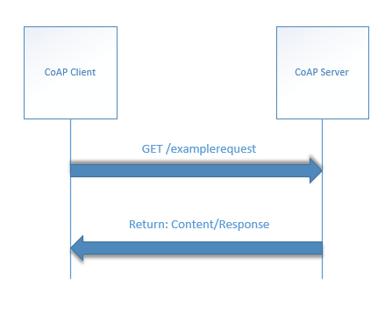

Figure : Block diagram showing a basic GET/Response between a CoAP Client & Server

### 2.3.4 Redis (google)

TODO

|  |  |  |  |  |
| --- | --- | --- | --- | --- |
| Feature | MQTT | CoAP | AMQP | Redis |
| Header Size | 2 Byte | 4 Byte | 8 Byte |  |
| Architecture | Client/Broker | Client/Server or Client/Broker | Client/Server or Client/Broker |  |
| Abstraction | Publish/Subscribe | Request/Response or Publish/Subscribe | Request/Response or Publish/Subscribe |  |
| Message Size | 256mb Max | Small & Undefined | Negotiable & Undefined |  |
| QoS / Reliability | QoS 0 – At most once  QoS 1 – At least once,  QoS 2 – Exactly once | Confirmable or Non-Confirmable Message | Settle Format or Unsettle Format |  |
| Transport Protocol | TCP | UDP | TCP, SCTP |  |
| Default Port | 1883/8883 (TSL/SSL) | 5683 (UDP) | 5671/5672 (TLS/SSL) |  |

Table : Table highlighting features of most common IoT Application Communication Protocols

As shown in table 2, MQTT seems to offer the most in terms of reliability of message delivery. Utilising QoS Level 2 has the guarantee the message is not lost, whereas the other protocols offer no such service, with CoAP and AMQP only offering the equivalent to a Level 1 QoS service. Transport protocol is also a consideration when selecting a communication protocol, as TCP is much more reliable than its UDP counterpart. It was also shown when it comes to sending small bytes of data similar to the payloads of most IoT devices, MQTT appears to perform better with overall less latency compared to its AMQP counterpart (Sreeraj and Kumar, 2018). In contrast, a recent comparison study found that out of all the common IoT communication protocols, MQTT was scored on the lowest in terms of security (Naik, 2017). This suggests that that SMQTT is the preferred choice for a home security system, as this protocol would meet all the given requirements.

## 2.4 Data Exchange Formats

Due to the Internet of Things still being in its infancy, there is little standardisation in most of its areas. This holds true for data exchange (Al-Fuqaha et al., 2015), with there being multiple data formats currently being used. This section aims to review the current data exchange formats and suggest the most suitable format for the proposed system.

Data serialization is the process of writing he state of an object to a stream and rebuilding this object when received on the other end. This is a way of sending and receiving data over a network.

When choosing an appropriate data exchange format, the following must be considered:

* Message Size
* Serialization Time
* Deserialization Time

### 2.4.1 XML

XML, published in 1996, is one of the oldest data exchange formats created by W3C. It was designed to be used over the internet and human legible. It is text based, which can be problematic in terms of speed, as it will also need to be parsed character by character.

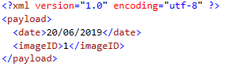

Figure : Code Snippet showing basic XML Schema

### 2.4.2 JSON

JSON or JavaScript Object Notation, is a message format that arose as a subset of the JavaScript programming language. It holds a similar structure to XML, being human readable with a similar schema, but with less overhead (as shown in Figure 7). In AJAX applications, JSON and XML were compared, with JSON outperforming XML in terms of data size occupancy and transmission speed (Lin et al., 2012).

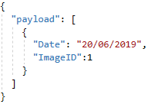

Figure : Code snippet showing basic JSON Schema

### 2.4.3 Protocol Buffers

ProtoBuf is a form of protocol buffer developed by Google which utilises binary instead of text to perform fast serialization and deserialization. When compared to JSON, Protobuf outperformed JSON in both message size and speed in both Java to Java communication and Java to JavaScript, showing promising results (Krebs, 2017). The author claims Protobuf can perform up to six times faster than JSON. It should be noted that this test only tested these environments and should not be used as a whole representative for the two data exchange formats.

In a comparison study, the serialization size, average serialization time and average deserialization time were compared between XML, JSON and ProtoBuf (Sumaray and Makki, 2012). The protocol buffer outperformed both JSON and XML with XML performing the worse in every scenario (shown in Tables 3, 4 & 5). This held true regardless of the size of the object (large or small) and highlights the efficiency of the protocol buffer. Although this study was carried out on a mobile platform, it gives a clear perspective on the performance of each of the data exchange formats available for IoT communication. It can be concluded that the main advantage of using JSON is its human readable interface, which is not necessary for IoT based systems. Therefore, ProtoBuf is the most suitable due to its performance in the aforementioned qualities.

|  |  |  |  |
| --- | --- | --- | --- |
|  | XML | JSON | ProtoBuf |
| Book | 873 | 781 | 687 |
| Video | 231 | 139 | 59 |

Table : Serialized size in bytes (Sumaray and Makki, 2012)

|  |  |  |  |
| --- | --- | --- | --- |
|  | XML | JSON | ProtoBuf |
| Book | 22.284 | 4.177 | 2.339 |
| Video | 17.884 | 4.097 | 1.800 |

Table : Average serialization time in ms (Sumaray and Makki, 2012)

|  |  |  |  |
| --- | --- | --- | --- |
|  | XML | JSON | ProtoBuf |
| Book | 7.908 | 1.199 | 0.298 |
| Video | 6.742 | 0.755 | 0.197 |

Table : Average deserialization time in ms (Sumaray and Makki, 2012)

## 2.5 Security Guidelines for Internet of Things

In accordance with the best practices outlined by the IoT security foundation (IoT Security Compliance Framework, 2018), the following security measures have been highlighted relating to the project:

|  |  |  |  |
| --- | --- | --- | --- |
| *Req. No* | *Requirement* | *Section* | *Solution* |
| 2.4.5.1 | Device has measures to prevent unauthenticated software and files being loaded onto it. | Software |  |
| 2.4.5.2 | Regarding remote software updates, software images are digitally signed and approved by the appropriate signing authority. | Software |  |
| 2.4.5.5 | Device disables any virtual ports not required for normal operation, the ports are disabled or only allowed to communicate with authenticated devices | Software |  |
| 2.4.5.6 | Watchdog timer is present and cannot be disabled to prevent stalling or disruption of operations | Software |  |
| 2.4.5.8 | Devices protects against unauthorised reversion of software to earlier & potentially insecure version | Software |  |
| 2.4.5.21 | Devices communicates over TCP, device software uses cryptography to protect data | Software | Device will utilise MQTT for communication & use cryptography outlined in 2.5.3.1 |
| 2.4.6.1 | OS is implemented with relevant security updates prior to release | Process |  |
| 2.4.6.3 | All unnecessary logins or accounts are disabled at end of software development lifecycle | Software |  |
| 2.4.6.4 | Minimum access privileges required to function are assigned to relevant files, directories and data | Software |  |
| 2.4.6.5 | If passwords are stored on device, password files are only accessible by most privileged accounts | Software |  |
| 2.4.6.6 | All non-essential services have been removed from devices software | Software |  |
| 2.4.6.7 | All OS command line access to most privileged accounts have been removed from OS | Software |  |
| 2.4.6.8 | Devices OS Kernel cannot be called by external product level interfaces or unauthorised products | Software |  |
| 2.4.6.9 | Applications are operated at lowest privilege level and only have access to necessary resources | Software |  |
| 2.4.6.10 | All supported security features available on OS are enabled | Software |  |
| 2.4.6.11 | OS is separate from application & is only accessible via defined secure interfaces | Software |  |
| 2.4.7.1 | Devices prevents unauthorised connections to it, i.e. firewall enabled & internet layer protocol | Software |  |
| 2.4.7.4 | Device only supports versions of application layer protocols with no known vulnerabilities | Process |  |
| 2.4.7.5 | If unauthorised change is detected, device should alert admin | Software |  |
| 2.4.7.6 | All unused ports are closed & only required ports are active | Process |  |
| 2.4.7.10 | For any Wi-Fi connection using WPA2, secure encryption is used and WPA is disabled | Software |  |
| 2.4.7.13 | When a TCP protocol such as MQTT is used, it is protected by a TLS connection | Software |  |
| 2.4.7.18 | Device only enables network, application protocols and network services appropriate for device | Policy |  |
|  |  |  |  |
| 2.4.8.4 | Device does not accept null or blank passwords | Software | Ref. to 2.5.4 |
| 2.4.8.5 | Device does not allow new passwords containing the users username | Software | Ref. to 2.5.4 |
| 2.4.8.6 | Passwords entry follows industry standard | Software | Ref. to 2.5.4 |
| 2.4.8.7 | Device has defence against brute force attacks | Software | Ref. to 3.3.1 |
| 2.4.8.8 | Device securely stores passwords using industry standard cryptography | Software | Ref. to 2.5.3 |
| 2.4.8.11 | Product only allows controlled user account access, no guest user accounts are supported | Software | No guest user accounts will be created |
| 2.4.8.12 |  |  |  |

### 2.5.1 SSH Protocol

Secure Shell protocol or SSH as its commonly referred to is a method to remotely access one computing from another securely (Ylonen, 1996). Based on client-server model, a connection is established by the SSH client by connecting to the SSH server. The client then uses public key cryptography to verify the identity of the SSH server. For data exchange, the protocol uses symmetric encryption and hashing algorithms, ensuring the privacy and integrity of the data sent between the two devices.

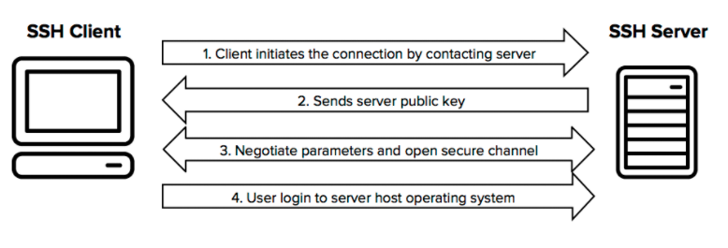

Figure : Diagram detailing the SSH Protocol for Machine-To-Machine Communication (ssh.com, 2019)

### 2.5.2 WPA2 Protocol

WPA2 is the most widely spread security protocol for Wi-Fi based communication. WPA2 accomplishes Authentication and Key Agreement via two different modes. For most personal networks, this involves using a Pre-Shared Key (PSK). AES is typically used for encryption, which is a symmetric-key algorithm that uses the one key both encryption and decryption. The initial cryptographic keys for both authentication and data encryption is initiated by both the client and access point knowing the shared passphrase, allowing access to the network. This is then used with additional variables such as Service Set Identifier (SSID) and SSID length to produce a Pairwise Master Key (PMK). A recent paper included that this protocol is especially vulnerable to dictionary based attacks and key reinstallation attacks (Abo-Soliman and Azer, 2017).

### 2.5.3 Cryptography Options

### 2.5.3.1 RSA Algorithm

RSA works on a public-private key basis which is a form of asymmetric encryption. The public key is available to everyone, i.e. placed on the server (Raspberry Pi) whereas the private key is used to ‘unlock’ that specific public key. This gives an added layer of security as the data can only be decrypted using the individuals private key. The private key is usually stored on a client device e.g. computer or mobile phone (Goshwe, 2013). This form of encryption was used successfully in the creation of a payment terminal using a Raspberry Pi, TSL and AES based encryption, highlighting its efficiency (Kakar, 2016).

### 2.5.3.2 AES Algorithm

Advance Encryption Standard is symmetric form of encryption, supporting key lengths of 127, 192 and 256 bits. In a comparison study against 4 different algorithms, it was shown that AES has the highest avalanche effect, which is recorded as how much change there is in an output based on the change of an input. Scoring high in the avalanche effect reflects a high level of cryptographic strength. This suggests when confidentially and integrity are the highest priority, AES should be used (Patil et al., 2016).

### 2.5.4 Password Handling Best Practices

With there being various different methods of retrieving an individual’s password such as keylogging, insecure password storage and brute-force attacks, this section aims to establish the correct methodology in dealing with those threats. The UK government has provided a manual for password handling to establish best practices (ukgov, 2015):

1. Change all default passwords. When it comes to small devices like the Raspberry Pi the default username is always ‘pi’ with the password being ‘raspberry’. These should both be changed, as an unauthorised user using a remote connection such as SSH will have to guess the username as well.
2. Prioritise administrator and remote user accounts. Good practices involve not using administrator accounts for day-to-day activities with a separate account being established for this purpose. If remote access to the Raspberry Pi were granted, limits should be set on the account along with two-factor authentication to verify who is accessing the device remotely.
3. Implement a form of account lockout. As mentioned previously, brute force attacks are a large security threat to IoT devices. The UK government recommends a maximum of 10 login attempts before locking out the account.
4. Do not store passwords as plan text. If a password was stored within a database in plain text, that database being compromised leaves the users vulnerable to their details being stolen. It is recommended that passwords be stored in a form of hashing and salt combination.

## 2.6 Security Threats

This section highlights potential security threats relating to IoT devices. The aim of this section is to uncover the most frequent security vulnerabilities present within the IoT architecture.

### 2.6.1 DOS Attack

Denial of Service attacks are used to prevent access to devices or network resources, essentially taking the network offline. It is accomplished by flooding a network with packets and redundant requests to the point of the network being unable to be accessed by authentic users (Prabhakar, 2017).

### 2.6.2 Man in The Middle Attack

The man-in-the-middle has the ability to capture all messages between a server and IoT device via network spoofing. Using this spoofing strategy, it can assume identification of both the IoT device and server and trick both devices into believing they are still communicating with each other (Conti, Dragoni and Lesyk, 2016).

### 2.6.3 Malicious Code Attack

This is code in any part of the software intended to cause undesirable effects and potentially causing the system to malfunction. This cannot be detected by security tools such as anti-viruses as it not detected as a virus or malware.

### 2.6.4 Physical Tampering

Physical manipulation of a device could occur. This is when the device is modified to act in unexpected ways by someone with malicious intent. It is safe to assume that if this happens the intruder is already in the individual’s home and there is not much that can be done. A way to protect the user’s data if this occurred would be full encryption of the storage and 2-factor authentication to prevent users from accessing the micro SD that is present in the device.

### 2.6.5 Botnet

A botnet is a collection of computers performing repetitive tasks to keep websites going (Uk.norton.com, n.d.). The problem arises when this architecture is used for malicious intent, harvesting a machines power to be used in assisting in DDoS attacks. Although traditionally used against computers, IoT devices are starting to be the main target, due to their lack of security. In 2017, it was that the ‘Rakos’ botnet consisted of nearly half its entire collection being Raspberry Pi models. In 2017, it was discovered that there were various botnets designed specifically to infect IoT devices (Krebs, 2017), namely ‘Mirai’, ‘Reaper’ and ‘IoTroop’, further adding to the problem.

https://ieeexplore.ieee.org/stamp/stamp.jsp?tp=&arnumber=8567540

## 2.7 Face Recognition

### 2.7.1 Haar Cascade

The Haar Cascade method is a form of deep learning classified as a machine learning object detection algorithm. The purpose of the algorithm is to identify objects within a video or image based on feature selection. The algorithm is trained via positive and negative images and once trained, is then used to detect objects in other images. Each image is broken up into ‘Haar-Features’ which can be used to detect specific features of an image, the most common being edge, line and four rectangle features, the latter being used to detect slanted lines (as seen in Figure 9). Each calculated feature results in a single value by summing both rectangles and subtracting the sum of the white rectangle from the sum of the black rectangle. Although possible to calculate every single feature, there is very computationally expensive (Docs.opencv.org, n.d.).

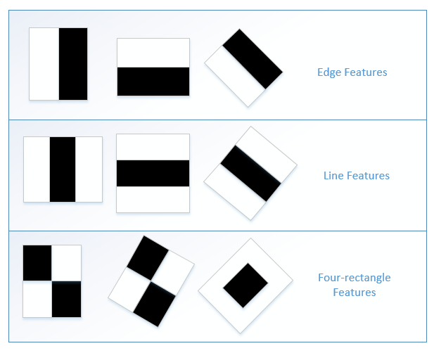

Figure 9: Diagram showing the most commonly detect features in the Haar Cascade algorithm

To remedy this, Adaboost is normally implemented. When it comes to training, every feature is applied on every training image. Adaboost then finds the best threshold for each feature, determining which features contain the minimum error rate. This is done through classification and is continually readjusted until the desired error rate is achieved. The resulting final classifier is a weighted sum of these weak classifiers. The term ‘weak’ is used because these features detected cannot classify an image, but when the selected features are used together, it gives strong classification results.

# 3.0 Technology Review

## 3.1 Hardware Selection

To create a home surveillance system, a hardware device must be proposed which has the following capabilities:

1. Wi-Fi capability.
2. Low cost. The idea of this system is for it to be scalable to the general population
3. Camera/Video support capabilities
4. Operating system flexibility. The device can support a wide variety of operating systems

### 3.1.1 Raspberry Pi

The proposed hardware for this system would be a Raspberry Pi 3 and one or multiple cameras placed near the vicinity of the home entrance. Although simplistic, a similar system was used for border surveillance and shown successful (Abdalla and Veeramanikandasamy, 2017).

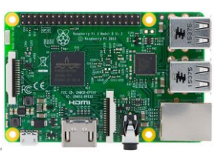

Figure : Raspberry Pi Model 3b

## 3.2 Operating System

### 3.2.1 Raspbian

Raspbian is an operating system based on the Linux distribution Debian. The OS was designed to be specifically optimised for the Raspberry Pi board (Raspbian.org, n.d.)

## 3.2 Software Review

### 3.2.1 Fail2Ban

Fail2Ban is a Python based open source software that interacts with the Raspberry Pi’s operating system’s firewall (Fail2ban.org, n.d.). Its main purpose is to ban IPs that show malicious intent. This includes too many password attempts, seeking for exploits, etc. It is recommended by the Raspberry Pi Foundation, giving it additional credibility (Raspberrypi.org, n.d.). The software is also claimed to help protect again DDoS attacks (George, 2019).

## 3.3 Programming Language Selection

## 3.4 Library Selection

### 3.4.1 OpenCV

OpenCV is an open source library that offers a range of feature detecting and feature matching algorithms. It is shown that the majority of the algorithms used, detect thousands of features with seconds (Noble, 2016), making it suitable for a face detection system. To highlight the accuracy of this technology, a recent paper showed success in detecting eye fatigue in drivers using OpenCV (Manoharan and Chandrakala, 2015).

### 3.4.2 Dlib

Dlib is an open source library containing support for deep learning and machine learning respectively. It has excellent image processing support, with support for SURF, HOG and FHOG algorithms and additional tools for frontal face detection (Dlib.net, n.d.).

## 3.4 Application Development

Due to time constraints on this project, hybrid app development is proposed.

To allow a family member receive an image and notification of who is at the door, a smart phone application is proposed. A recent 2018 paper showed a similar system using image notifications from a Raspberry Pi Camera sent via email when a potential intruder was located at their door (Pawar and Umale, 2018).

## 3.5 Simulating Cyber Attacks

Currently, the standard operating system used in cyber security and digital forensics is Kali Linux, derived from the Linux distribution Debian (ref). The operating system contains over 300 programs and tools used in ethnical hacking, making it the gold standard for carrying out simulated attacks. In the 2016 paper (Liang et al., 2016), three different types of DoS attacks were carried out, resulting in all three being successful against a small IoT device.

# Methodology

## Raspberry Pi Specific Security

This section details security measures specific to the Raspberry Pi 3b board along with its predominately used operating system, Raspbian. According to the Raspberry Pi official documentation, the following are considered best practices (Raspberrypi.org, n.d.) for securing the device:

1. Change both the default username and password. Protocols such as SSH require both a username and password to access a remote device. The default username and password for the Raspberry Pi is ‘pi’ and ‘raspberry’ for all devices. By changing these we add another layer of security by limiting the amount of information an individual with malicious intent has.
2. Sudo command should require a password. Sudo in Linux operating systems allows commands to be run with admin privileges. By doing this a user must know the password required in order to execute commands at a higher level.
3. Ensure latest security fixes. This means having the most recent up-to-date version of the operating system and ensuring SSH is up to date.
4. Use key-based authentication. As discussed in the Cryptography section there are various ways of encrypting a service. By forcing an encryption based authentication, an additional layer of security is added as now there are two factors required to login.
5. Firewall installation. By default, the firewall available on the Raspbian operating system is not configured and must be setup by the user.

# 5.0 System Design

The main functionality of the system is based on two common scenarios, one being an identified (family or friend) enters the premises and no alert is send to the family members. Another is if the person is unidentified, then an image is captured and sent via MQTT to each the users containing the application (See Figure $).

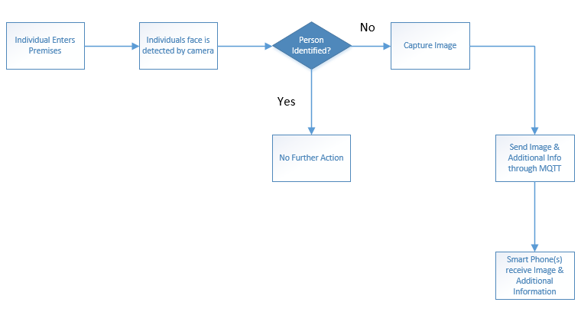

Figure : Diagram showing the main flow of the system

<https://ieeexplore.ieee.org/stamp/stamp.jsp?tp=&arnumber=8589403>

<https://ieeexplore.ieee.org/stamp/stamp.jsp?tp=&arnumber=7354752> smart home security guidelines

<https://ieeexplore.ieee.org/stamp/stamp.jsp?arnumber=7902207>

<https://blog.ipswitch.com/internet-of-things-101-iot-device-authentication-explained>

<https://www.sbprojects.net/projects/raspberrypi/ga.php> - 2 factor auth

<https://opensource.com/article/17/3/iot-security-raspberry-pi>

<https://www.raspberrypi.org/forums/viewtopic.php?t=196010>

<https://www.zymbit.com/securing-raspberry-pi/> - data and file encryption

<https://www.raspberrypi.org/forums/viewtopic.php?t=196010> app dev

<https://mntolia.com/mqtt-python-with-paho-mqtt-client/#0_Installing_Paho-MQTT> – mqtt tut

<https://www.pyimagesearch.com/2018/06/25/raspberry-pi-face-recognition/>

https://developer.ibm.com/recipes/tutorials/sending-and-receiving-pictures-from-a-raspberry-pi-via-mqtt/

# 6.0 References

1. Merriman, C. (2019). *Google Cloud burst downs G Suite, Nest and Snapchat during 4-hour outage | TheINQUIRER*. [online] http://www.theinquirer.net. Available at: https://www.theinquirer.net/inquirer/news/3076657/google-cloud-outage [Accessed 7 Jun. 2019].
2. Wang, A. (2018). ‘I’m in your baby’s room’: A hacker took over a baby monitor and broadcast threats, parents say. [online] Washington Post. Available at: https://www.washingtonpost.com/technology/2018/12/20/nest-cam-baby-monitor-hacked-kidnap-threat-came-device-parents-say/?noredirect=on&utm_term=.04321c476652 [Accessed 7 Jun. 2019].
3. Ashford, W. (2019). *UK gears up for new laws on IoT security*. [online] ComputerWeekly.com. Available at: https://www.computerweekly.com/news/252462505/UK-gears-up-for-new-laws-on-IoT-security [Accessed 7 Jun. 2019].
4. Aziz, T. and Haq, E. (2018). Security Challenges Facing IoT Layers and its Protective Measures. *International Journal of Computer Applications*, [online] 179(27), pp.31-35. Available at: https://www.researchgate.net/publication/323892938_Security_Challenges_Facing_IoT_Layers_and_its_Protective_Measures [Accessed 9 Jun. 2019].
5. Prabhakar, S. (2017). NETWORK SECURITY IN DIGITALIZATION: ATTACKS AND DEFENCE. *INTERNATIONAL JOURNAL OF RESEARCH IN COMPUTER APPLICATIONS AND ROBOTICS*, [online] Vol. 5 Issue 5(ISSN 2320-7345). Available at: https://www.ijrcar.com/Volume_5_Issue_5/v5i512.pdf [Accessed 9 Jun. 2019].
6. Conti, M., Dragoni, N. and Lesyk, V. (2016). A Survey of Man In The Middle Attacks. *IEEE Communications Surveys & Tutorials*, [online] 18(3), pp.2027-2051. Available at: https://ieeexplore.ieee.org/document/7442758 [Accessed 9 Jun. 2019].
7. Burhan, M., Rehman, R., Khan, B. and Kim, B. (2018). IoT Elements, Layered Architectures and Security Issues: A Comprehensive Survey. *Sensors*, [online] 18(9), p.2796. Available at: https://www.researchgate.net/publication/327272757_IoT_Elements_Layered_Architectures_and_Security_Issues_A_Comprehensive_Survey [Accessed 9 Jun. 2019].
8. Noble, F. (2016). Comparison of OpenCV's feature detectors and feature matchers. *2016 23rd International Conference on Mechatronics and Machine Vision in Practice (M2VIP)*. [online] Available at: https://ieeexplore.ieee.org/document/7827292 [Accessed 26 May 2019].
9. Diachok, R., Dunets, R. and Klym, H. (2018). System of detection and scanning bar codes from Raspberry Pi web camera. *2018 IEEE 9th International Conference on Dependable Systems, Services and Technologies (DESSERT)*. [online] Available at: https://ieeexplore.ieee.org/document/8409124 [Accessed 26 May 2019].
10. Abdalla, G. and Veeramanikandasamy, T. (2017). Implementation of spy robot for a surveillance system using Internet protocol of Raspberry Pi. *2017 2nd IEEE International Conference on Recent Trends in Electronics, Information & Communication Technology (RTEICT)*. [online] Available at: https://ieeexplore.ieee.org/document/8256563 [Accessed 26 May 2019].
11. Alam, M., Reaz, M. and Ali, M. (2012). A Review of Smart Homes—Past, Present, and Future. *IEEE Transactions on Systems, Man, and Cybernetics, Part C (Applications and Reviews)*, [online] 42(6), pp.1190-1203. Available at: https://ieeexplore.ieee.org/document/6177682 [Accessed 9 Jun. 2019].
12. Pawar, A. and Umale, V. (2018). Internet of Things Based Home Security Using Raspberry Pi. *2018 Fourth International Conference on Computing Communication Control and Automation (ICCUBEA)*. [online] Available at: https://ieeexplore.ieee.org/document/8697345 [Accessed 9 Jun. 2019].
13. Manoharan, R. and Chandrakala, S. (2015). Android OpenCV based effective driver fatigue and distraction monitoring system. *2015 International Conference on Computing and Communications Technologies (ICCCT)*. [online] Available at: https://ieeexplore.ieee.org/document/7292757 [Accessed 10 Jun. 2019].
14. Rastovich, R. (2015). *Why the MQTT Protocol is Ideal for the Internet of Things – ThingLogix, Inc*. [online] Thinglogix.com. Available at: https://www.thinglogix.com/why-the-mqtt-protocol-is-ideal/ [Accessed 10 Jun. 2019].
15. Liang, L., Zheng, K., Sheng, Q. and Huang, X. (2016). A Denial of Service Attack Method for an IoT System. *2016 8th International Conference on Information Technology in Medicine and Education (ITME)*. [online] Available at: https://ieeexplore.ieee.org/document/7976501 [Accessed 12 Jun. 2019].
16. Ssh.com. (2019). *SSH Protocol – Secure Remote Login and File Transfer | SSH.COM*. [online] Available at: https://www.ssh.com/ssh/protocol/#sec-How-to-Cite-SSH [Accessed 13 Jun. 2019].
17. Ylonen, T. (1996). SSH - Secure Login Connections over the Internet. *Proceedings of the 6th USENIX Security Symposium*, pp.37-42.
18. Abo-Soliman, M. and Azer, M. (2017). A study in WPA2 enterprise recent attacks. *2017 13th International Computer Engineering Conference (ICENCO)*. [online] Available at: https://ieeexplore.ieee.org/document/8289808 [Accessed 13 Jun. 2019].
19. Sreeraj, S. and Kumar, G. (2018). Performance of IoT protocols under constrained network, a Use Case based approach. *2018 International Conference on Communication, Computing and Internet of Things (IC3IoT)*. [online] Available at: https://ieeexplore.ieee.org/document/8668105 [Accessed 13 Jun. 2019].
20. Singh, M., Rajan, M., Shivraj, V. and Balamuralidhar, P. (2015). Secure MQTT for Internet of Things (IoT). *2015 Fifth International Conference on Communication Systems and Network Technologies*. [online] Available at: https://ieeexplore.ieee.org/abstract/document/7280018 [Accessed 13 Jun. 2019].
21. How safe are home security systems?. (2015). [ebook] HP. Available at: http://go.saas.hpe.com/l/28912/2015-07-21/32bhy5/28912/69170/IoT_Home_Security_Systems.pdf [Accessed 13 Jun. 2019].
22. Goshwe, N. (2013). Data Encryption and Decryption Using RSA Algorithmin a Network Environment. *IJCSNS International Journal of Computer Science and Network Security*, [online] VOL. 13(No. 7). Available at: http://paper.ijcsns.org/07_book/201307/20130702.pdf [Accessed 16 Jun. 2019].
23. Kakar, V. (2016). Secure communication and authentication using Raspberry Pi. *2016 5th International Conference on Reliability, Infocom Technologies and Optimization (Trends and Future Directions) (ICRITO)*. [online] Available at: https://ieeexplore.ieee.org/document/7785011 [Accessed 16 Jun. 2019].
24. Patil, P., Narayankar, P., Narayan D.G. and Meena S.M. (2016). A Comprehensive Evaluation of Cryptographic Algorithms: DES, 3DES, AES, RSA and Blowfish. *Procedia Computer Science*, [online] 78, pp.617-624. Available at: https://www.sciencedirect.com/science/article/pii/S1877050916001101?via%3Dihub [Accessed 16 Jun. 2019].
25. Lee, S., Kim, H., Hong, D. and Ju, H. (2013). Correlation analysis of MQTT loss and delay according to QoS level. *The International Conference on Information Networking 2013 (ICOIN)*. [online] Available at: https://ieeexplore.ieee.org/stamp/stamp.jsp?tp=&arnumber=7428475 [Accessed 17 Jun. 2019].
26. Ludovici, A., Moreno, P. and Calveras, A. (2013). TinyCoAP: A Novel Constrained Application Protocol (CoAP) Implementation for Embedding RESTful Web Services in Wireless Sensor Networks Based on TinyOS. *Journal of Sensor and Actuator Networks*, [online] 2(2), pp.288-315. Available at: https://www.researchgate.net/publication/276039057_TinyCoAP_A_Novel_Constrained_Application_Protocol_CoAP_Implementation_for_Embedding_RESTful_Web_Services_in_Wireless_Sensor_Networks_Based_on_TinyOS [Accessed 17 Jun. 2019].
27. Naik, N. (2017). Choice of effective messaging protocols for IoT systems: MQTT, CoAP, AMQP and HTTP. *2017 IEEE International Systems Engineering Symposium (ISSE)*. [online] Available at: https://ieeexplore.ieee.org/document/8088251 [Accessed 17 Jun. 2019].
28. UK Government advice on Password Guidance, Simplifying your approach. (2015). [ebook] CESG and CPNI. Available at: https://assets.publishing.service.gov.uk/government/uploads/system/uploads/attachment_data/file/458857/Password_guidance_-_simplifying_your_approach.pdf [Accessed 18 Jun. 2019].
29. Fail2ban.org. (n.d.). *Fail2ban*. [online] Available at: https://www.fail2ban.org/wiki/index.php/Main_Page [Accessed 18 Jun. 2019].
30. Cable. (2019). *Worldwide Broadband Speed League 2018 | Cable.co.uk*. [online] Available at: https://www.cable.co.uk/broadband/speed/worldwide-speed-league/ [Accessed 20 Jun. 2019].
31. Al-Fuqaha, A., Guizani, M., Mohammadi, M., Aledhari, M. and Ayyash, M. (2015). Internet of Things: A Survey on Enabling Technologies, Protocols, and Applications. *IEEE Communications Surveys & Tutorials*, [online] 17(4), pp.2347-2376. Available at: https://ieeexplore.ieee.org/document/7123563 [Accessed 20 Jun. 2019].
32. Krebs, B. (2017). *Beating JSON performance with Protobuf*. [online] Auth0 - Blog. Available at: https://auth0.com/blog/beating-json-performance-with-protobuf/ [Accessed 20 Jun. 2019].
33. Lin, B., Chen, Y., Chen, X. and Yu, Y. (2012). Comparison between JSON and XML in Applications Based on AJAX. *2012 International Conference on Computer Science and Service System*. [online] Available at: https://ieeexplore.ieee.org/document/6394535 [Accessed 20 Jun. 2019].
34. Sumaray, A. and Makki, S. (2012). A comparison of data serialization formats for optimal efficiency on a mobile platform. *Proceedings of the 6th International Conference on Ubiquitous Information Management and Communication - ICUIMC '12*. [online] Available at: https://dl.acm.org/citation.cfm?id=2184810 [Accessed 20 Jun. 2019].
35. IoT Security Compliance Framework. (2018). [ebook] Available at: https://www.iotsecurityfoundation.org/wp-content/uploads/2018/12/IoTSF-IoT-Security-Compliance-Framework-Release-2.0-December-2018.pdf [Accessed 17 Jun. 2019].
36. Raspbian.org. (n.d.). *FrontPage - Raspbian*. [online] Available at: https://www.raspbian.org/ [Accessed 21 Jun. 2019].
37. Raspberrypi.org. (n.d.). *Securing your Raspberry Pi - Raspberry Pi Documentation*. [online] Available at: https://www.raspberrypi.org/documentation/configuration/security.md [Accessed 21 Jun. 2019].
38. George, G. (2019). *How to secure your Raspberry Pi board [Tutorial] | Packt Hub*. [online] Packt Hub. Available at: https://hub.packtpub.com/how-to-secure-your-raspberry-pi-board-tutorial/ [Accessed 21 Jun. 2019].
39. Uk.norton.com. (n.d.). *What Is A Botnet?*. [online] Available at: https://uk.norton.com/internetsecurity-malware-what-is-a-botnet.html [Accessed 21 Jun. 2019].
40. Krebs, B. (2017). *Reaper: Calm Before the IoT Security Storm? — Krebs on Security*. [online] Krebsonsecurity.com. Available at: https://krebsonsecurity.com/2017/10/reaper-calm-before-the-iot-security-storm/ [Accessed 21 Jun. 2019].
41. Dlib.net. (n.d.). *dlib C++ Library*. [online] Available at: http://dlib.net/ [Accessed 24 Jun. 2019].
42. Docs.opencv.org. (n.d.). *OpenCV: Face Detection using Haar Cascades*. [online] Available at: https://docs.opencv.org/3.4.1/d7/d8b/tutorial_py_face_detection.html [Accessed 24 Jun. 2019].
43. Treacy, F. (2019). *HART Communication Made Easy*. [ebook] Available at: https://www.analog.com/media/en/technical-documentation/technical-articles/HART_Communication_Made_Easy.pdf [Accessed 24 Jun. 2019].