**TrionicCANFlasher**

**Users Manual**



Table of Contents

PURPOSE AND SCOPE 2

REFERENCES 2

Step1 - Installing and Setting Up – TrionicCANFlasher 3

TrionicCanFlasher Screen 3

Setting Up TrionicCanFlasher 3

Selection of ECU Type 4

The Flag options 4

Only P-Bus connection 4

Selecting and Adapter from the Menu 5

Step 2 – Installing your hardware 6

Installation of Drivers for currently supported interface/cables: 6

Selection of COM port 6

Selection of COM Speed / Settings 6

Step 3 – Getting to know the functions of TrionicCANFlasher 8

Description of the Buttons on the TrionicCanFlasher Screen. 8

Set E85 percent 8

Read ECU DTC 8

Read ECU 8

Set ECU VIN 8

Get ECU info 9

Read SRAM 9

Set Speed Limiter 9

Recover ECU 9

Exit 9

Step 4 - Using the software – The fun begins 9

Read ECU data 9

Read ECU 9

FLASH ECU 10

RECOVER ECU 10

READ SRAM 11

Set E85 Percent 11

Set ECU VIN 11

Set Speed Limiter 12

# PURPOSE AND SCOPE

The purpose of this document is to provide the users with all the knowledge available in the TrionicTuning.com community to allow a faster learning in the use of the tool and to ensure the correct use of the functionality of the software. The information from this document should be followed as stated and compared with expected output from the software. Shall you find any points where instructions are not easy to follow or vary to the actual performance of the software please send a note to the developers at TrionicTuning.com.

# REFERENCES

This section references, by identity and title, documents that facts in this document depend upon. Those documents are not necessarily the latest version.

TrionicCANFlasher Developers:

Dilemma

Mattias Claesson

User manual author:

WildBoar – Carlos Irving

# Step1 - Installing and Setting Up – TrionicCANFlasher

Thank you for downloading and installing TrionicCANFlasher.

Make sure that you have the latest available version of the suite at:

<http://develop.trionictuning.com/TrionicCANFlasher/>

In this manual you will find an overview of the most commonly used functions. After starting TrionicCANFlasher a splash screen will be displayed and after all components are loaded and the application is initialized the main screen will be displayed.

# TrionicCanFlasher Screen

The following picture shows a screenshot of the TrionicCanFlasher dashboard and a detailed description of each of the buttons and configuration menus.

## Setting Up TrionicCanFlasher

Before starting any procedure with your car it is highly recommended to perform the following actions to ensure that your session is successful:

* The car must be cleared from all DTC codes especially those related to the ECU.
* Car battery must be fully charged.
* Turn off any other accessories that are not necessary for the purpose of ECU programming, i.e. Radio, Lights, AC, etc.
* Attach a battery charger to the battery if it is not fully charged or if battery is OLD and is not retaining charge properly.
* On Trionic7 remove the fuse to the engine fan and put the headlight switch to off.

## Selection of ECU Type

Select Trionic 7 or Trionic 8 depending on your vehicle ECU Type.

## The Flag options

All flags should be enabled by default.

**Enable Logging** - allows the software to record LOGs of your sessions and be able to check activity-events in case required. 

Log files descriptions:

* **canLog.txt** - is the raw CAN message log.
* **deviceLog.txt** - Low level details on the device communication.
* **flasherLog.txt** - Show information about the flasher.
* **kwpLog.txt** - This is a Trionic7 specific log with KWP messaging.
* **uiLog.txt** - Saves the output that is shown in the user interface.

Default all log files are rolled each day and the historic log file name will be appended with date pattern "yyyy-MM-dd".  
The flasher use log4net as logging framework, for the advanced user logging are fully configurable in log4net.xml.  
**Please upload all logs to- trionictuning.com - if a error has been encountered.**

Only P-Bus connection – tells the software to connect only to P-Bus. If unchecked it will try to connect first to I-Bus and then P-Bus.  
Disable Connection Check – used to force the connection to open even if the CAN Bus is inactive.

## Selecting and Adapter from the Menu

The current options available for interfaces supported by TrionicCanFlasher - Select the one that matches your interface cable.

|  |  |
| --- | --- |
| * Lawicel CAUSB   http://elmicro.com/site/assets/files/1606/canusb.jpg | * Combiadapter – Developed by JohnC   http://i631.photobucket.com/albums/uu32/SaabNoob/Saab%20Stuff/IMAG0228.jpg |
| * ELM327 v 1.3 or higher – (select this option for OBDLinkSX) elm327 cableOBDLink SX - FREE 2-DAY PRIORITY SHIPPING - USB OBD2 ii module,  ScanTool 425801 | * Just4Trionic developed by Sophie Dexter   http://mbed.org/media/uploads/Just4pLeisure/just4trionic_bdm.jpg |

# Step 2 – Installing your hardware

## Installation of Drivers for currently supported interface/cables:

It is very important to make sure that your device is installed properly BEFORE attempting any work on your ECU. Make sure you have the latest drivers and that COM Port selection and Speed are set of properly as well as latency parameters. Following are some tips to get you started:

* **Lawicel CAUSB** – follow instructions on Lawicel’s web site and download the correct drivers for your device:

<http://www.can232.com/>

* **Combiadapter**  -- [viewtopic.php?f=46&t=191#p1269](http://www.trionictuning.com/forum/viewtopic.php?f=46&t=191#p1269)
* **ELM327 v 1.3 or higher** – (select this option for OBDLinkSX) – make sure to get the latest FTDI drivers for your device and set up COM port and correct speed to allow your device to work properly. You can check latest drivers for ELM327 and OBDLinkSX at:

<http://www.ftdichip.com/Support/Documents/InstallGuides.htm>

* **Just4Trionic** - [http://mbed.org/users/Just4pLeisure/not ... t4trionic/](http://mbed.org/users/Just4pLeisure/notebook/just4trionic/)

## Selection of COM port

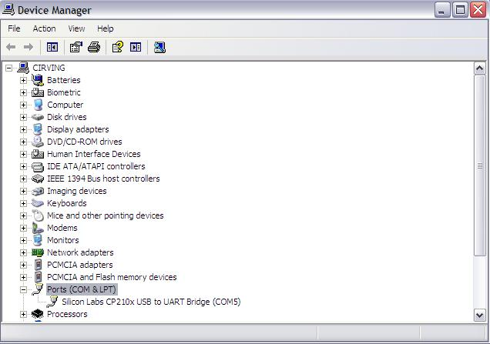Select the port in which you installed your interface hardware – for reference check – Control Panel 🡪 System 🡪 hardware 🡪Device Manager 🡪 Network Adapters 🡪 Ports (COM&LPT).

**In this example** - the device is installed in COM5. The option to select COM5 should appear in TrionicCanFlasher – if for some reason it is not listed, close the application and start again, it must appear after refreshing.

Selection of COM Speed / Settings  
Latency settings is very important for FTDI based ELM devices, it should be set to 2ms latency in the com port advanced settings.   
<I have recently added a warning to be displayed when a FTDI based ELM device have the wrong setting>

This is a very important step - select the highest speed in which your interface works stable:

Usually the top speeds for each interface are:

* Lawicel CAUSB – 250 Kbps up to 1Mbps
* Combiadapter - 2Mbps
* ELM327 – 230.4 Kbps
* OBDLinkSX – 1 Mbps
* Just4Trionic - ??? Mbps

You will be able to identify the limits of your cable when you select a higher speed, the CAN session will not be established, selecting the correct speed is crucial for successful – Reading, Flashing and Recovery of your ECU.

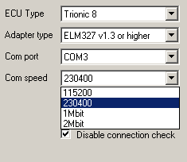

# Step 3 – Getting to know the functions of TrionicCANFlasher

## Description of the Buttons on the TrionicCanFlasher Screen.

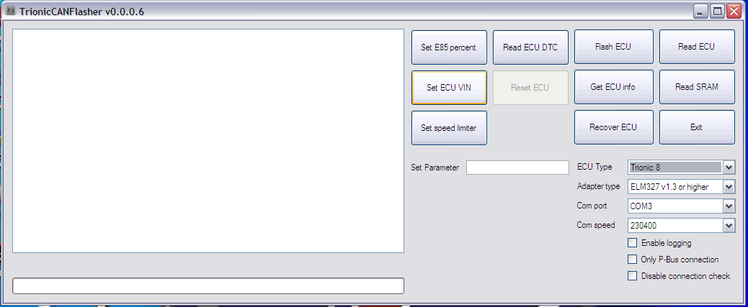

Set E85 percent - use this mode when your vehicle runs with E85 fuel.

Read ECU DTC – this function allows you to read DTC directly from the ECU. Very useful when you buy used ECUs – just plug on-desk and read if ECU is good!

**Flash ECU** – this button allows you to FLASH your ECU with either original or modified BIN files.

* Trionic 7 needs to be rebooted after a successful flash. Remove the ECU fuse or negative battery terminal for the duration of 10 seconds.
* Trionic 8 – After successful flashing – Remove Key from Ignition.

Read ECU – this button allows you to read your current BIN file stored in the flash memory of the ECU.

Set ECU VIN **-** This option allows you to change VIN code for the ECU. Do this if you need to marry a used ECU to a new Car. The new VIN is entered first in the Set parameter field – BEFORE activating the button.

For this function to work, the used/new ECU must not be married to another car.

* A used ECU can be divorced from a car using Tech2. This procedure requires the use of SPS function in TECH2 and TIS2WEB/TIS2000.

Get ECU info **-** This option shows you a list of all the important data recorded in the ECU.

Read SRAM – reads the SRAM contents from the device.

Set Speed Limiter – is used to set a different speed limiter to the engine ECU– higher or lower depending on your needs. The target speed limit is entered first in the Set parameter field – BEFORE activating the button.

Recover ECU– allows you to do a recovery of your ECU in case of failed read or write.

Exit – closes the application.

# Step 4 - Using the software – The fun begins

## Read ECU data

1. Hook up your cables to laptop and car – connect laptop to AC outlet and disable Energy Saving options from the Power Manager in the computer. This is very important to avoid interrupted CAN sessions that are potentially damaging to the ECU.
2. Turn ignition ON-OFF two times to wake up ECU and put it in learn mode.
3. Leave ignition in OFF position.
4. Press button Read ECU data
5. The screen will list ECU data recorded in the BIN file.
6. When the ECU has been erased NO data will be listed in the fields.

## Read ECU

1. Follow Steps 1-4 described in Read ECU data
2. Press button 🡪Read ECU data – to make sure you have communication with ECU.
3. The screen will list ECU data recorded in the BIN file. If data is listed and you are able to see your VIN number and other data you are ready to READ ECU.
4. Press button 🡪Read ECU
5. A dialog box will appear asking you - where do you want to store the file and to name the file to allow easy identification of your BIN. This is especially important when reading ORIGINAL ECU BIN files – this file is recommended to be stored in a safe location and use only copies of it when making a modified BIN.
6. The READ process starts and you will see progress on your screen.
7. When the READ ECU process is completed 🡪 Remove the ignition KEY and disconnect your interface.

## FLASH ECU

1. Follow Steps 1-4 described in Read ECU data
2. Press button 🡪Read ECU data – to make sure you have communication with ECU.
3. The screen will list ECU data recorded in the BIN file. If data is listed and you are able to see your VIN number and other data you are ready to READ ECU.
4. Press button 🡪 FLASH ECU
5. A dialog box will appear asking you for the BIN file that you want to Flash to the ECU.
6. The FLASH ECU process starts and you will see progress on your screen.
7. When FLASH ECU is completed 🡪 press READ ECU data to check if ECU is good and communicating after flashing is completed. If all is OK go to next step, if your ECU shows NO data on the screen – go to RECOVER ECU.
8. Remove the ignition KEY and disconnect your interface.
9. Flashing times vary depending on the interface.

## RECOVER ECU

1. Follow Steps 1-4 described in Read ECU data
2. Press button 🡪Read ECUdata – to make sure you have communication with ECU.
3. The screen will list ECU data recorded in the BIN file. If data is listed and you are able to see your VIN number and other data you are ready to READ ECU.
4. Press button 🡪 RECOVER ECU
5. A dialog box will appear asking you for the BIN file that you want to use for Recovery of the ECU, usually the original BIN file from the car is better to ensure the recovery process get your car back to life as usual!
6. The RECOVER ECU process starts and you will see progress on your screen.
7. When RECOVER ECU is completed 🡪 press READ ECU data to check if ECU is good and communicating after Programming Flash is completed. If all is OK go to next step, if your ECU shows NO data on the screen – run RECOVER ECU again.
8. Remove the ignition KEY and disconnect your interface.
9. Flashing times vary depending on the interface.

## READ SRAM

1. Turn ignition ON-OFF two times to wake up ECU and put it in learn mode.
2. Leave ignition in OFF position.
3. Press button 🡪Read ECU data – to make sure you have communication with ECU.
4. The screen will list ECU data recorded in the BIN file. If data is listed and you are able to see your VIN number and other data you are ready to READ ECU.
5. Press button 🡪Read SRAM - A dialog box will appear asking you - where do you want to store the file and to name the file to allow easy identification of your BIN.
6. After Read SRAM is completed remove KEY from Ignition.

## Set E85 Percent

1. Follow Steps 1-4 described in Read ECU data
2. Press button 🡪 Set E85 Percent
3. Your car is set now to run Bio-fuel E85

## Set ECU VIN

1. Follow Steps 1-4 described in Read ECU data
2. Enter VIN in the blank field marked 🡪 Set Parameter
3. Press button 🡪 Set ECU VIN
4. Run🡪 Read ECU data to make sure new VIN code was recorded in ECU.
5. If you do not enter any data in the -Set Parameter field- and run this button, the ECU may not be able to run properly and you may need to do a recovery to be able to use it again. **Do not activate this button if you do not need to use it.**

## Set Speed Limiter

1. Follow Steps 1-4 described in Read ECU data
2. Enter desired speed limit in the blank field marked 🡪 Set Parameter
3. Press button 🡪 Set Speed Limiter
4. Run🡪 Read ECU data to make sure new Speed Limiter shows in the listed data.
5. **Your car will be ready to run to higher speeds! Better check your brakes my friend!!**