**Montgomery College**

**CMSC 203**

**Assignment 3 Design**

Class: CMSC203 CRN 34165

 Program: Assignment 3 Design

Instructor: Dr. Grinberg

 Summary of Description: program can encrypt and decrypt ceasar ciphers and bellaso ciphers

 Due Date: 3/07/2022

 Integrity Pledge: I pledge that I have completed the programming assignment independently.

 I have not copied the code from a student or any source.

Student: Christopher Perez Lebron

**Part 1: Pseudo Code:**

Turn in pseudo-code for each of the methods specified in CryptoManager.java.   Refer to the **Pseudocode Guideline**on how to write Pseudocode.

As always pasting from google docs doesn’t end well so heres a link:

https://docs.google.com/document/d/1GqCWejNNrruncL9jNhUMB4kz2gx2vG7T-ZD84pKMmJI/edit?usp=sharing

and below are screenshots

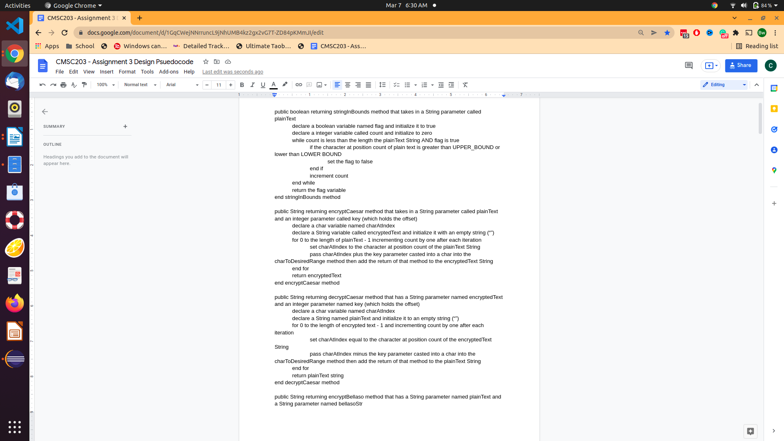

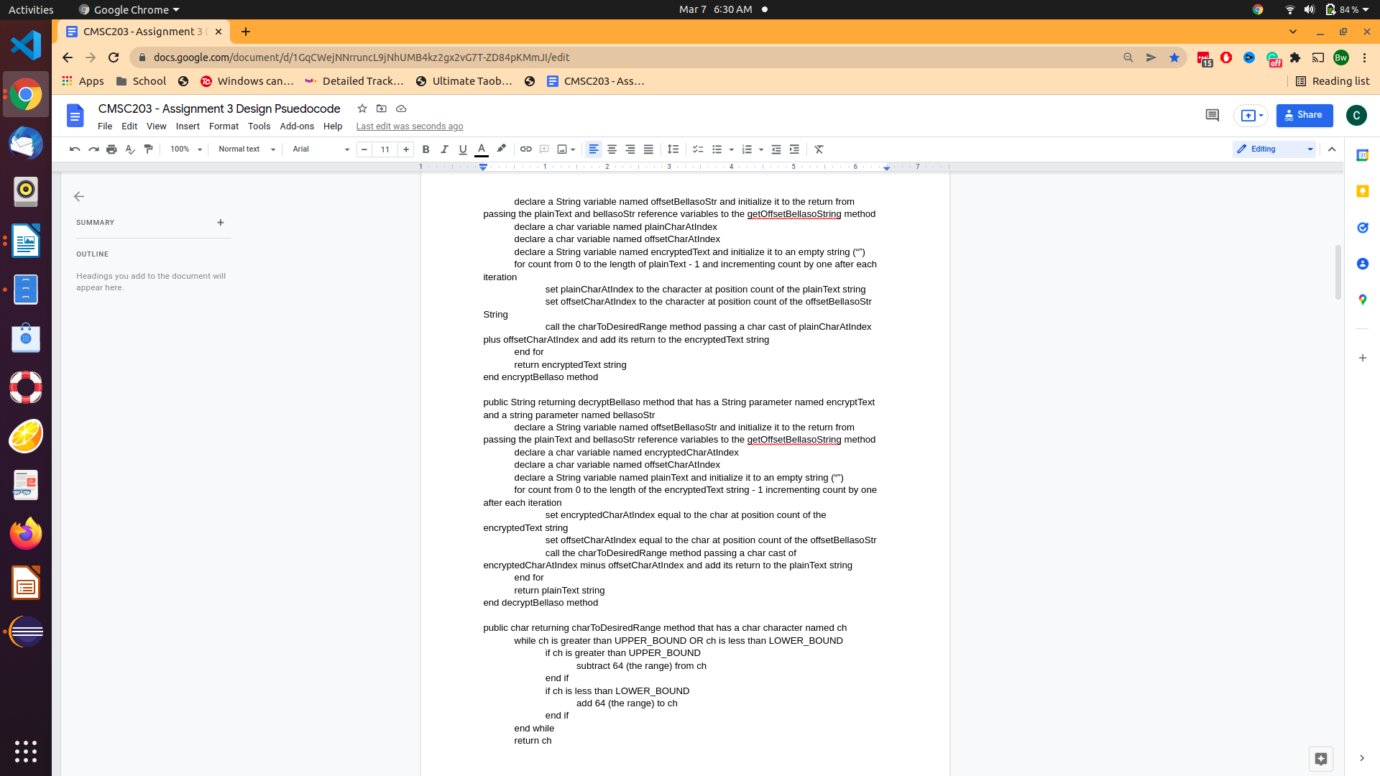

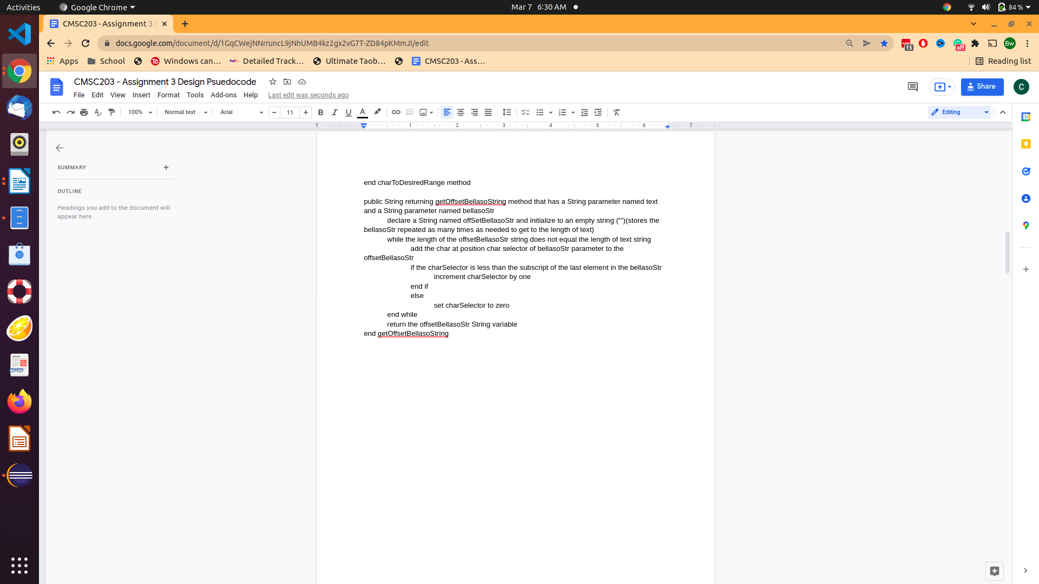

**Part 2: Comprehensive Test Plan**

Turn in a Test Plan table. Test Plan should include:

* at least two tests for the Caesar Cipher
* at least two for the Bellaso Cipher.
* at least one string that will fail because it has characters outside the acceptable ones.

|  |  |  |  |  |  |
| --- | --- | --- | --- | --- | --- |
| Input text | Input Key | Encrypted (method1)  Caesar | Encrypted (method2)  Bellaso | Decrypt (method1)  Caesar | Decrypt (method2)  Bellaso |
| HELLO WORLD  (case 1) | 15  CMSC203 | WT[[^/&^![S | KR_OAPJR__G | HELLO WORLD | HELLO WORLD |
| JIMMY  (case 2) | 5  THIS | ONRR^ | ^QV - | JIMMY | JIMMY |
| CHRIS  (case 3) | 13  ABC | PU_V | DJUJU | CHRIS | CHRIS |
| \t_{17239JDSK{lowercase:)  (case 4) | N/A | N/A  I would test validity of the string before passing it to any of the encrypt or decry pt methods |  |  |  |

**Make sure your tests cover all the possible scenarios.**

**Part3: Screenshots related to the Test Plan:**

**NOTE:**

I asked if screenshots should be taken from GUI or console and you stated from eclipse. Both GUI and console based output are from eclipse so that response did not provide any certainty in what was desired. Hence, I am providing both to be safe.

Also, you stated that I could add input validation to the encryption and decryption methods if “[I] want to” so I will assume this is optional and will not be adding it. As a result of this, the GUI will still accept invalid strings as input and encrypt or decrypt them resulting in invalid output. Thus, when I test the validity of input I will only provide output from the console because the GUI does not implement the input validation method and your statement meant it was optional to address it.

**Case 1**

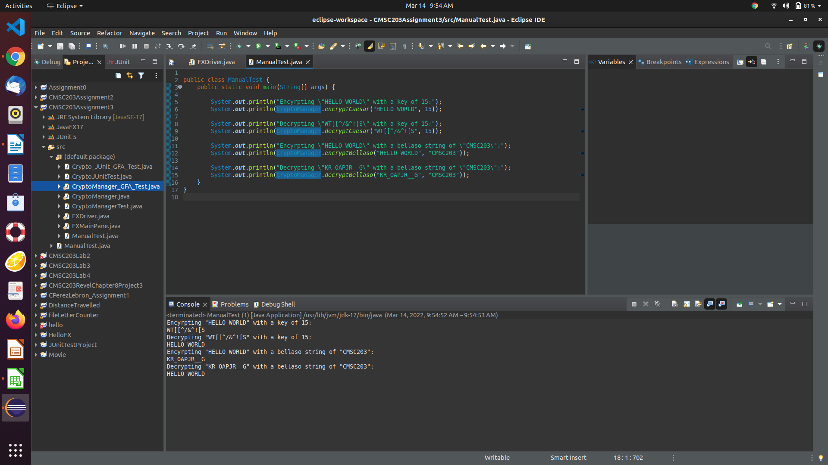**^^^^case one from console ^^^^**

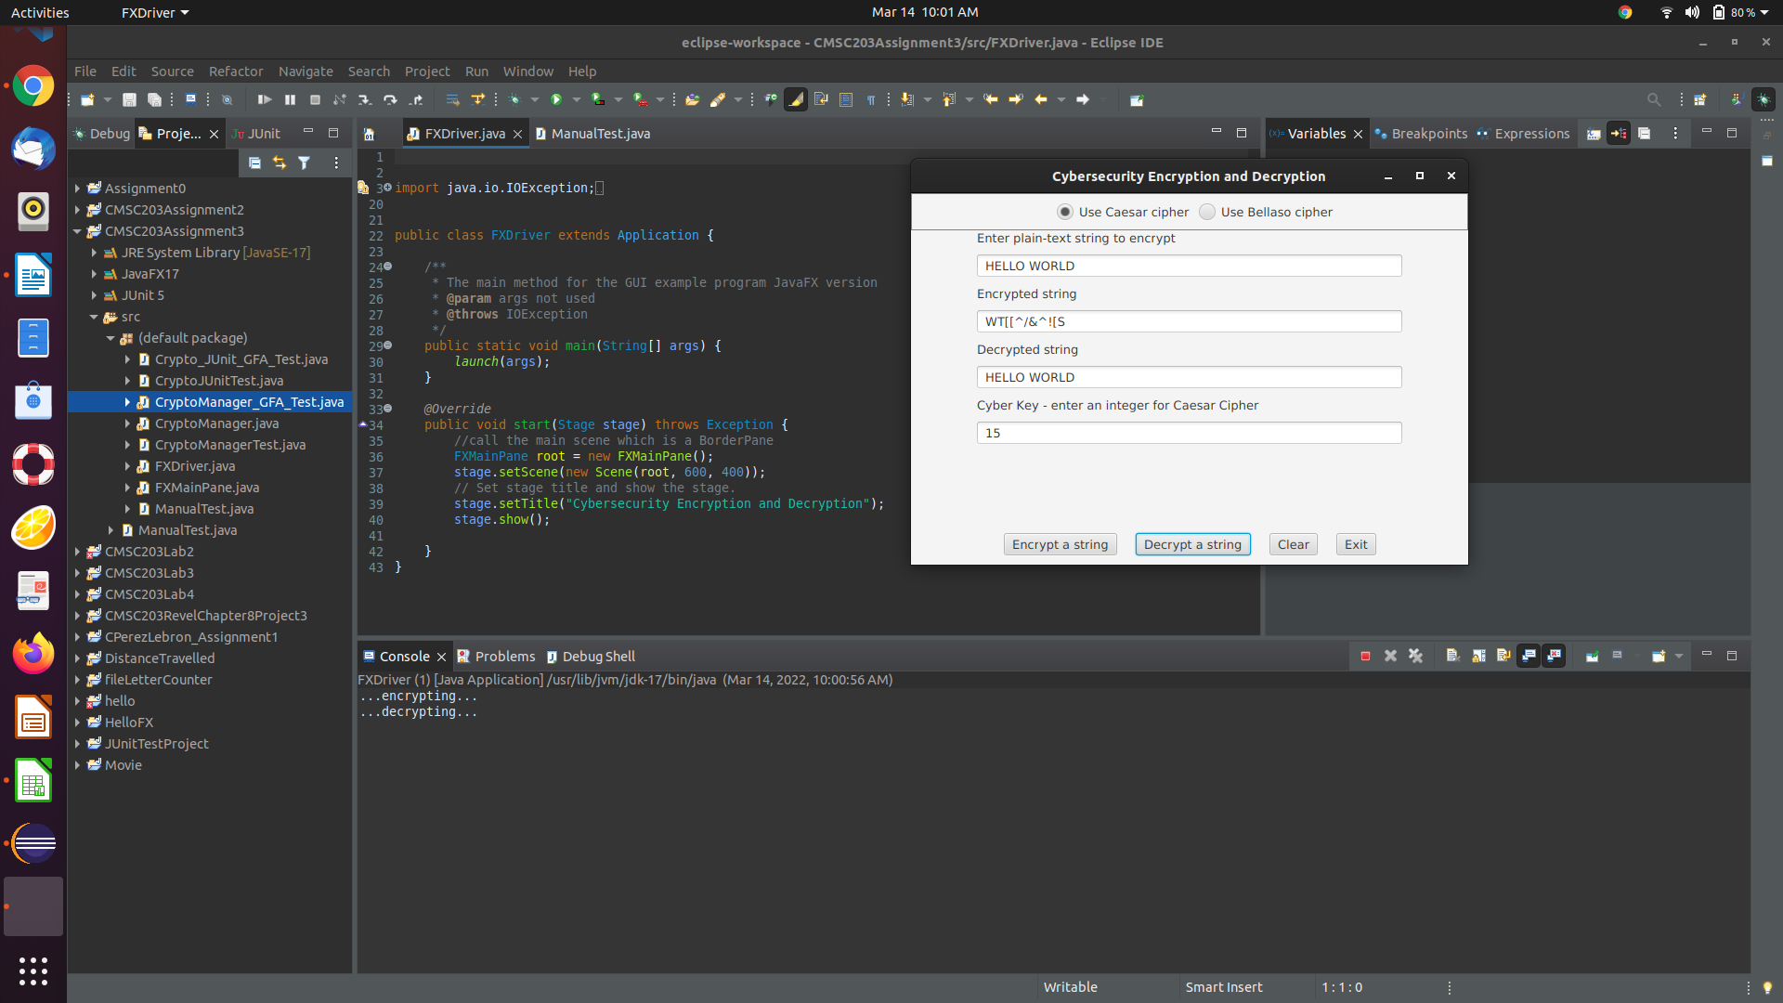**^^^^case one GUI caesar ^^^^**

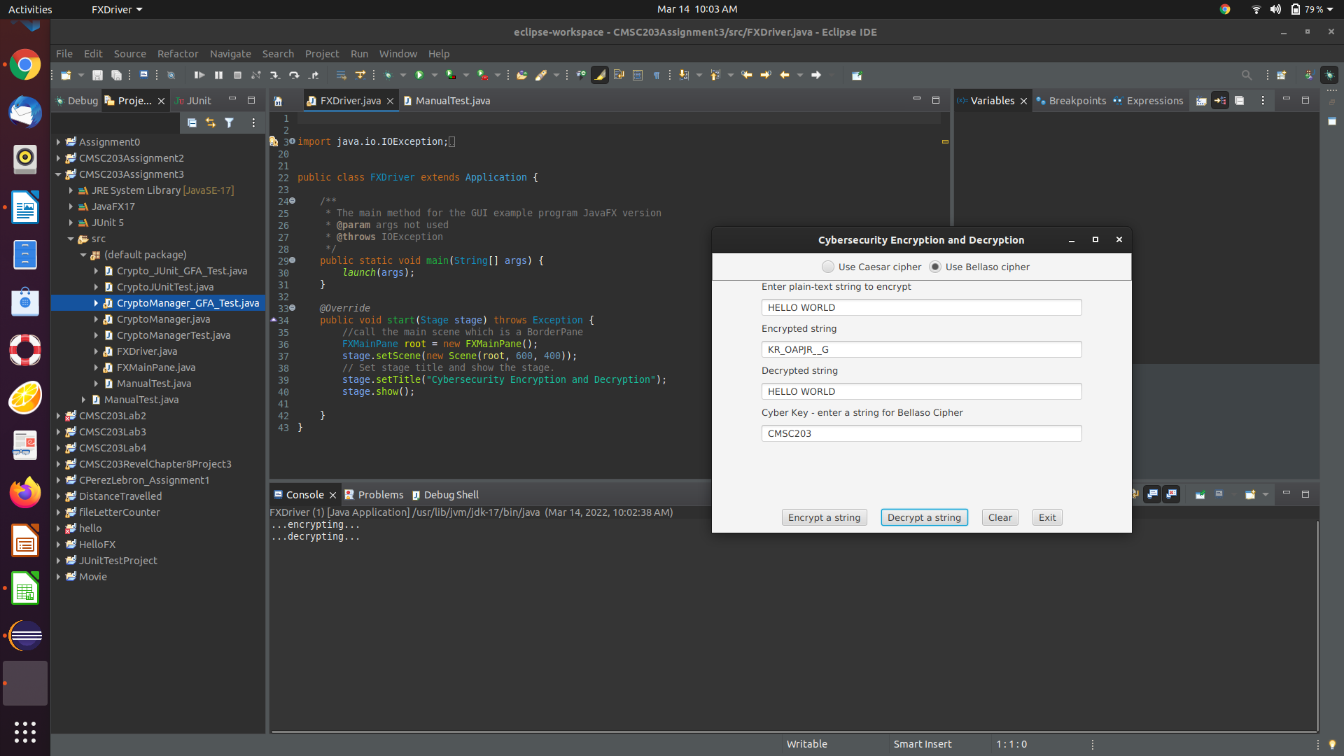**^^^^ Case one GUI bellaso ^^^^**

**Case 2**

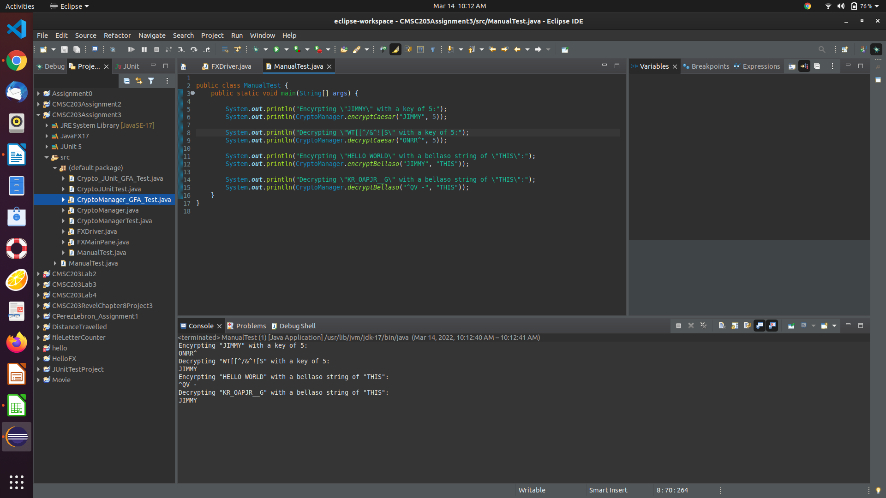**^^^^ Case two console ^^^^**

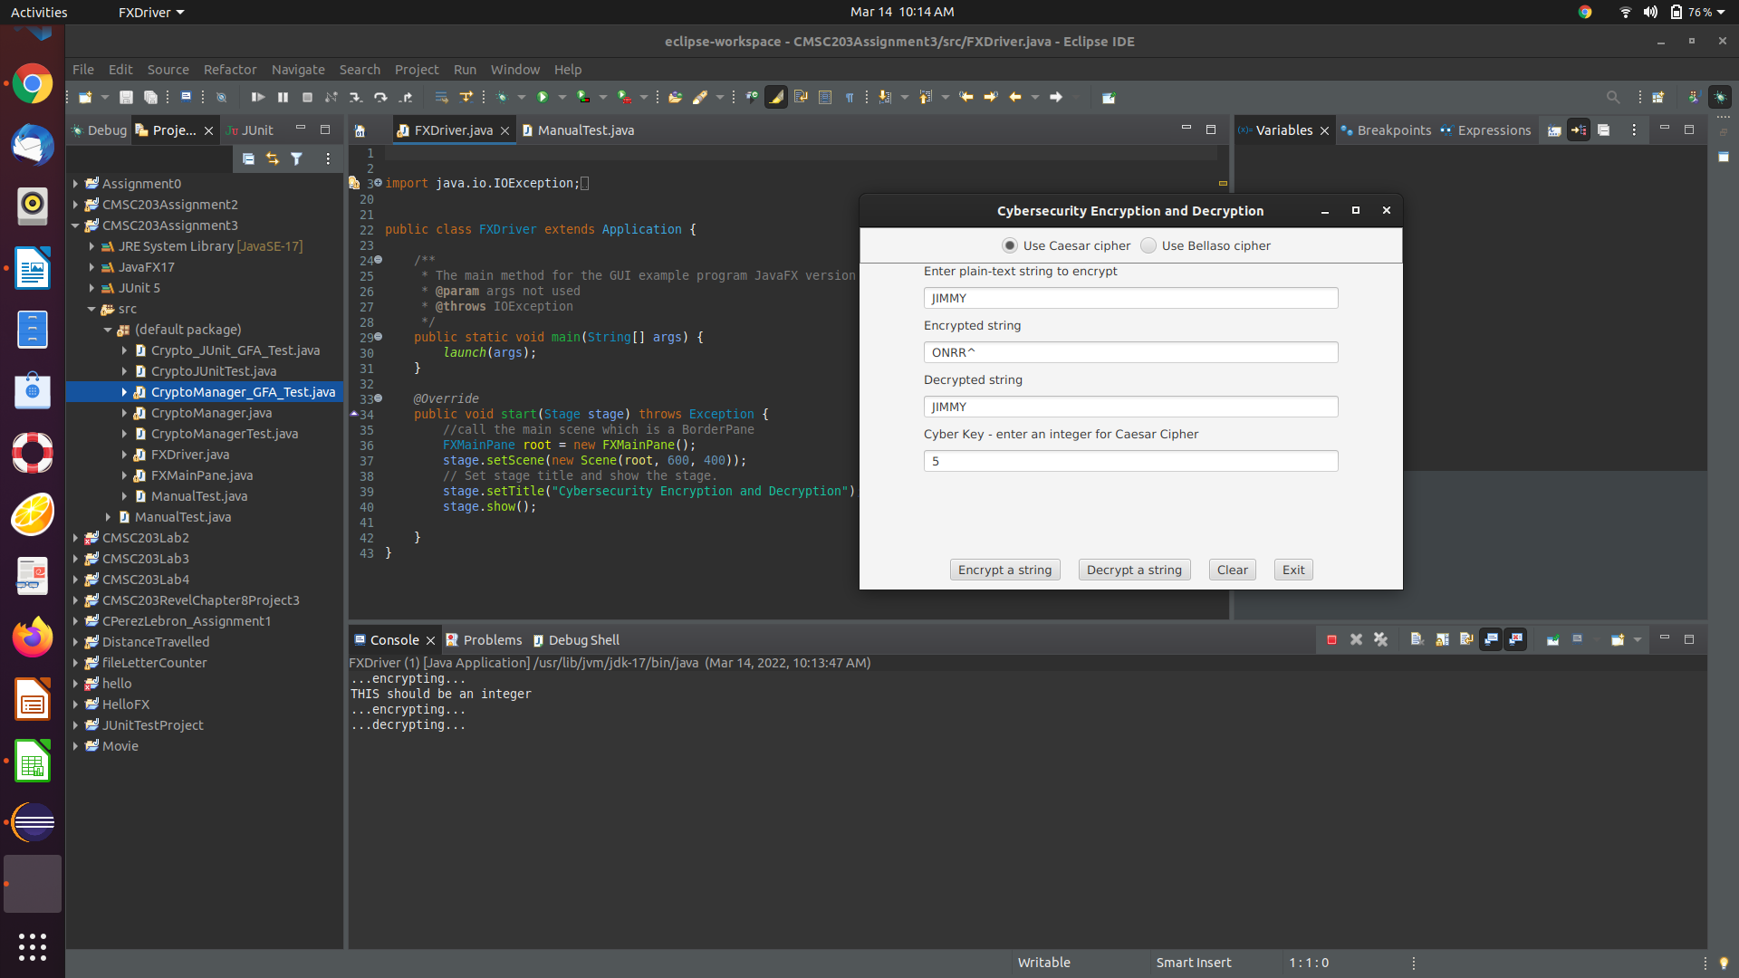**^^^^ Case two GUI Caesar ^^^^**

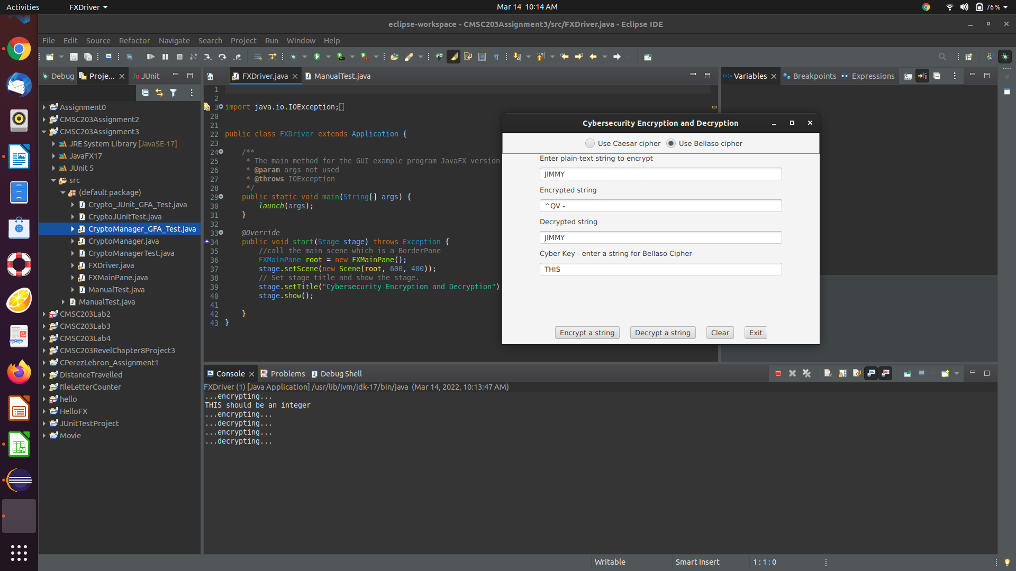**^^^^ Case two GUI Bellaso ^^^^**

**Case 3**

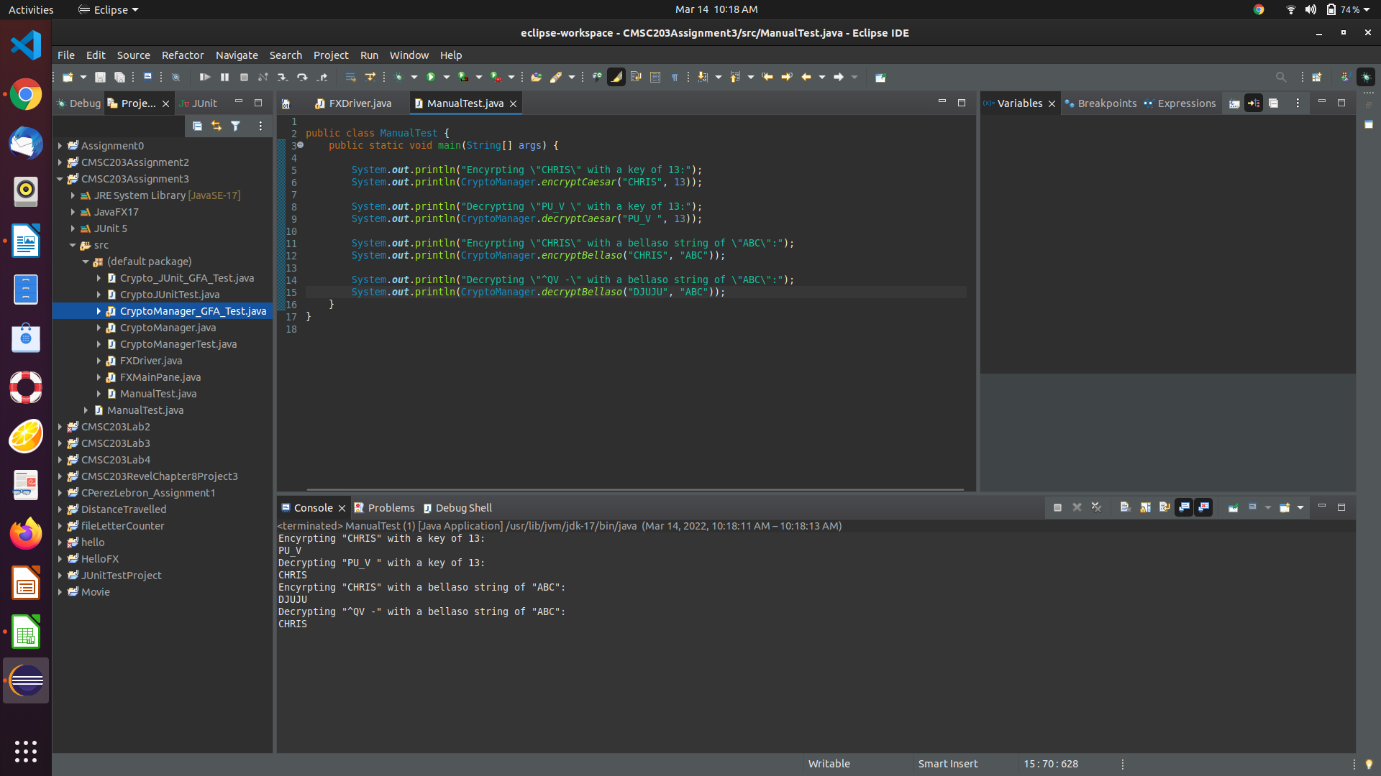**^^^^ Case three console ^^^^**

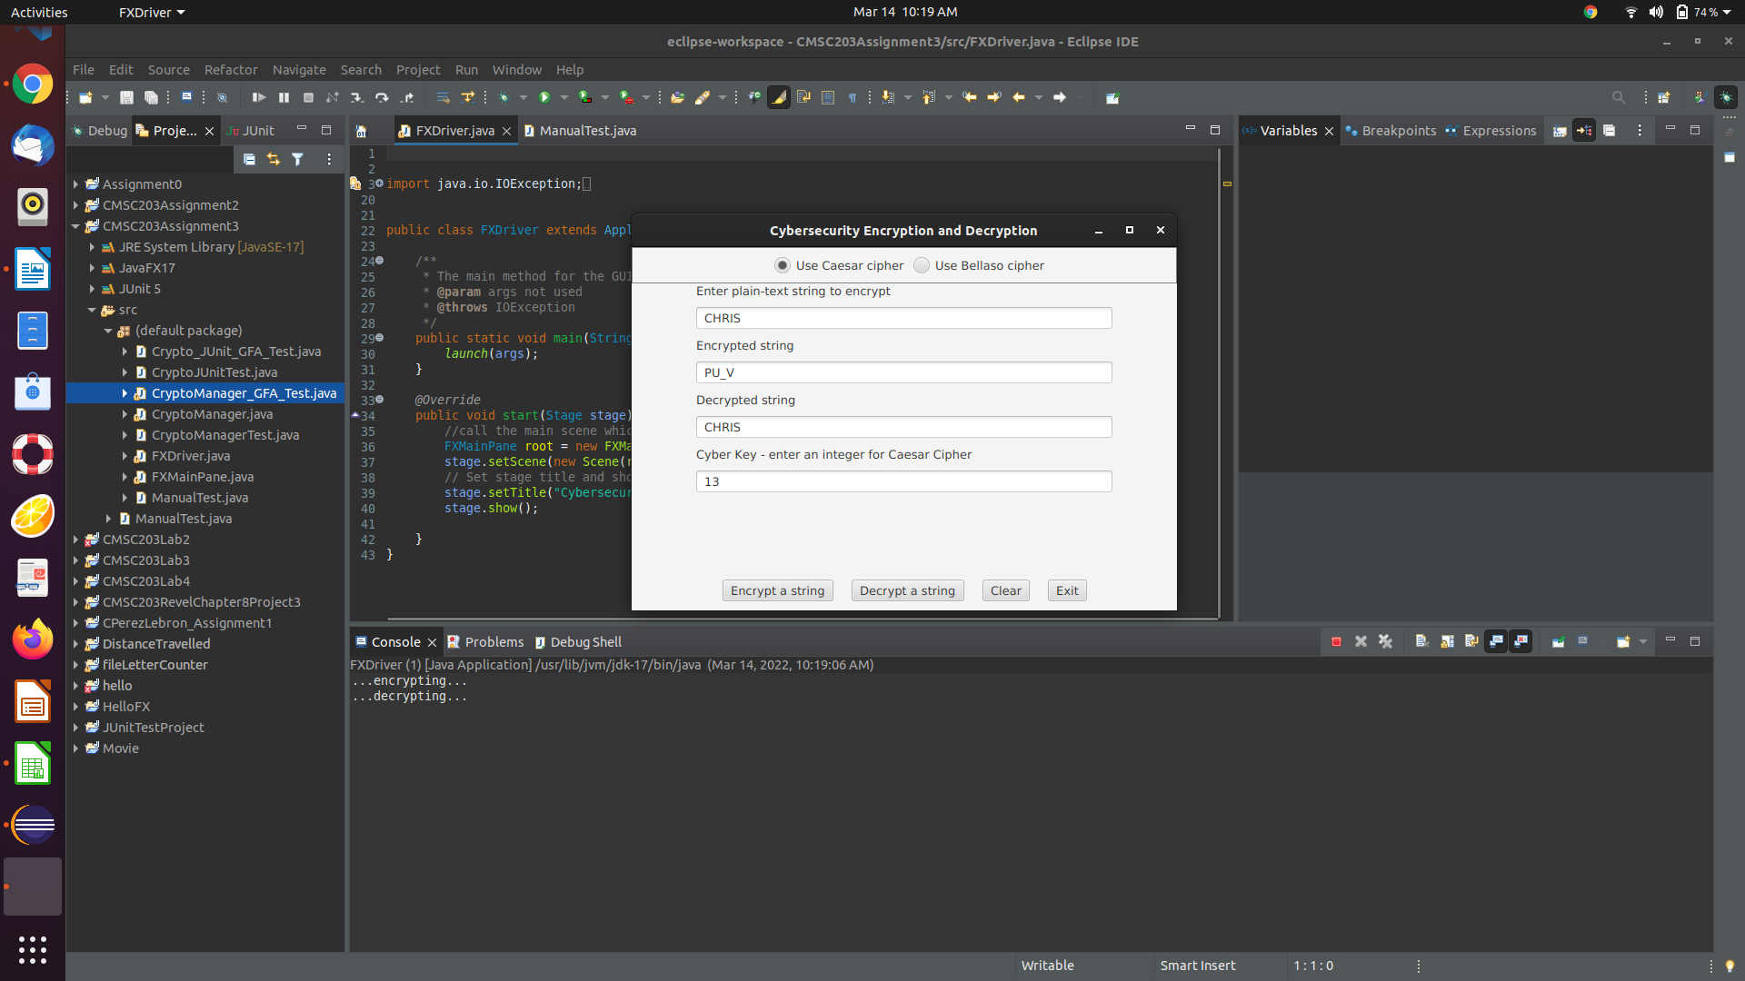**^^^^ Case three GUI Caesar ^^^^**

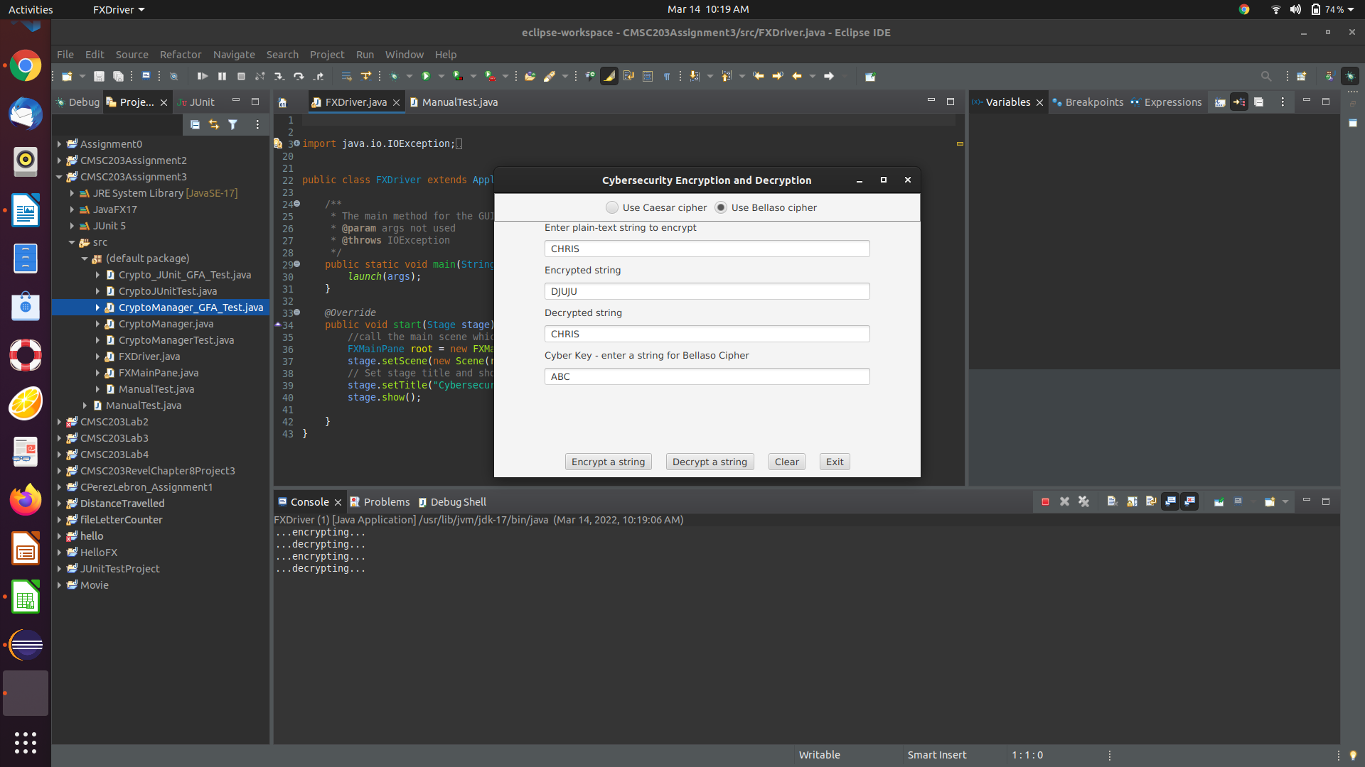**^^^^ Case three GUI Bellaso ^^^^**

**Case 4**

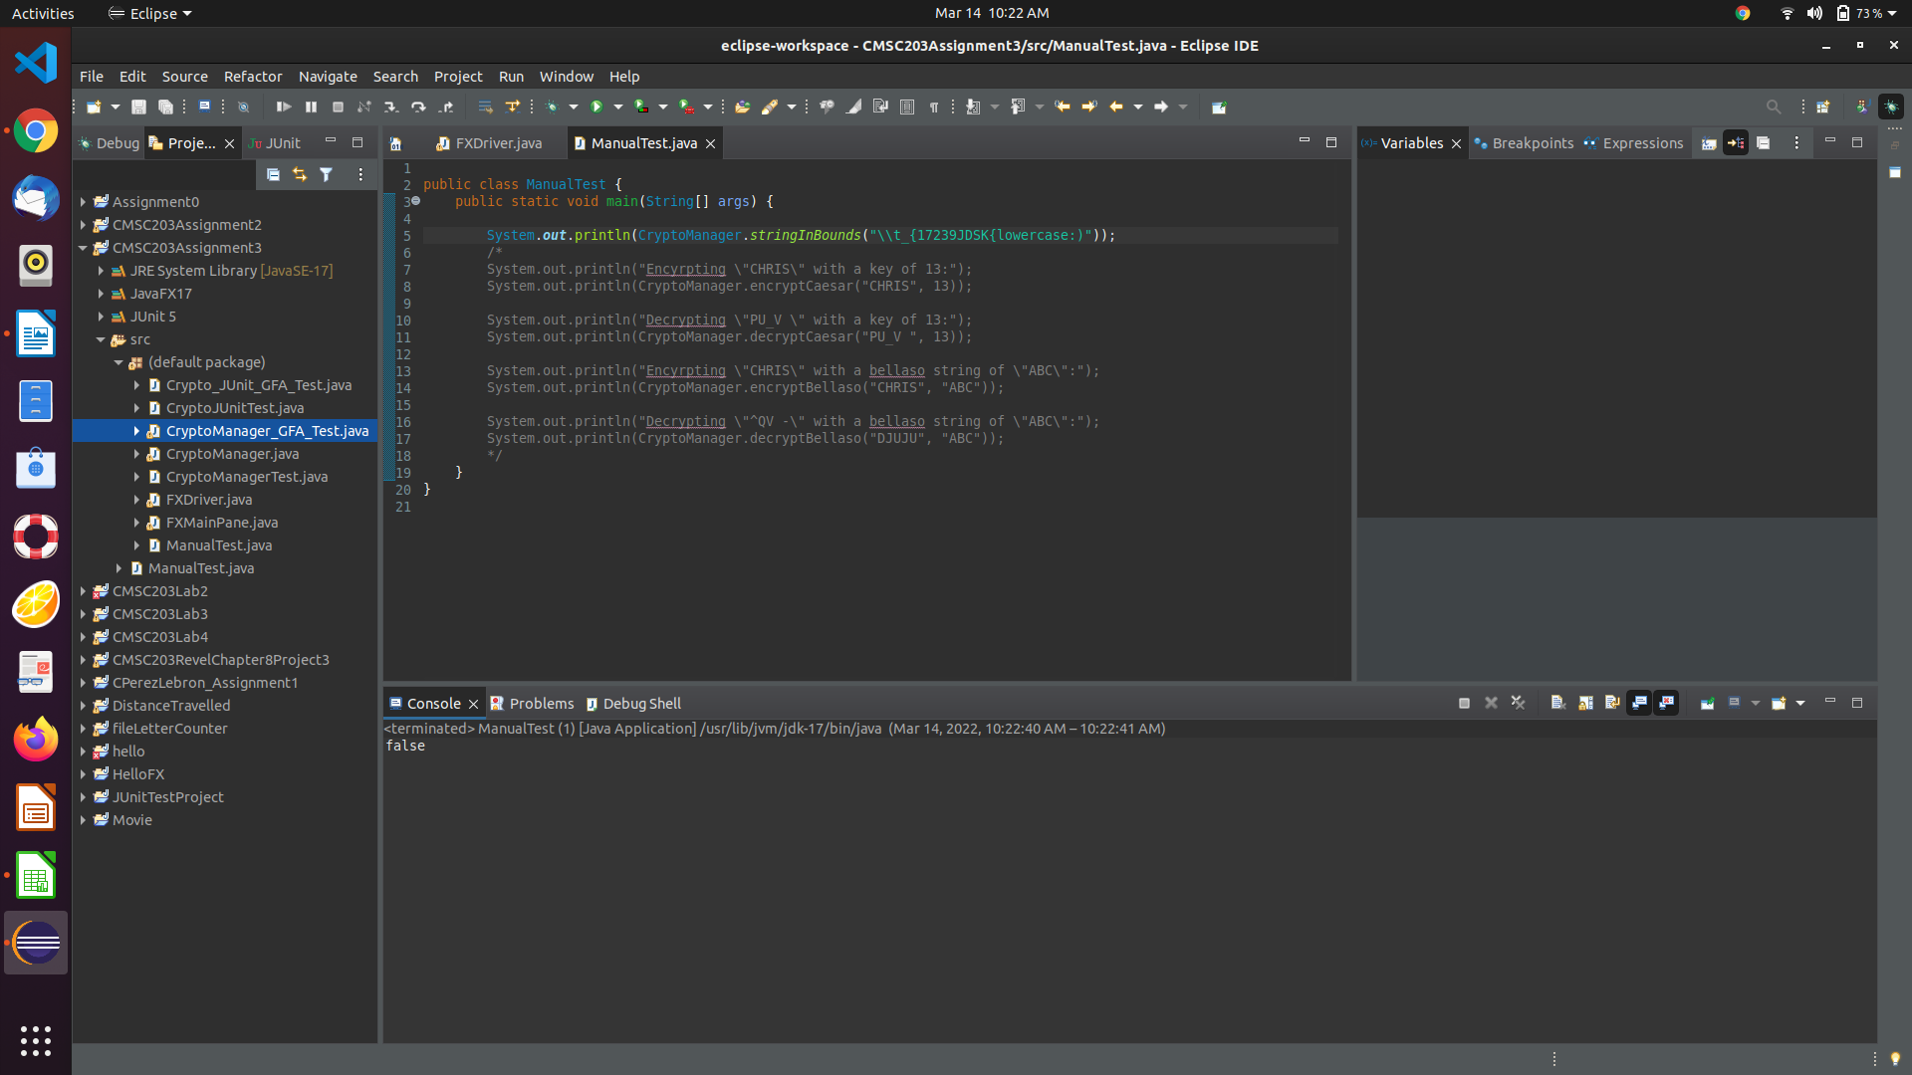As stated at the top of the screenshot portion input validation is not implemented in the GUI and you stated adding it to the encryption/decryption methods was optional. So, it is not possible to test validity via the GUI.

**Lessons Learned** <Provide answers to the questions listed above>**:**

Write about your Learning Experience, highlighting your lessons learned and learning experience from working on this project.

What have you learned?

This is the first time I’ve implemented a cipher in code. I was familiar with the caesar cipher but not the bellaso cipher. I had never done specific character manipulation in this manner so the project was slightly challenging. That made it much more engaging and rewarding. Up to this point the assignments felt like “practice” this felt like an actual application of knowledge. I really enjoyed this assignment. I hope that we will get more challenging assignment but also working with input/output files sooner or later.

What did you struggle with?

My code as designed passed all tests provided however the gui allows me to input invalid strings. The encryption and decryption methods never specified that input had to be validated within the method. I expected the gui to call the input validation method and then, based on the boolean return, decide if the string should be encrypted. Hence, I have a dilemma on my hands. I can either chop it up to the GUI not employing the input validation method or I can call the input validation method at the beginning of every encryption / decryption method and return a error string if invalid.

Given that the assignment description clearly states that the encryption methods should simply encrypt, the decryption methods should only decrypt, my code passes all testing provided, and the GUI screenshots do not show what SHOULD occur when invalid strings are inputted into the GUI: I am going to chop it up to lack of implementation of the input validation method in the GUI driver.

What would you do differently on your next project?

I wouldn’t do anything differently I would just like to revisit this and use the cryptomanager in correlation with a output file to store passwords. It would be cool to try and implement some very low level login, logout, and user creation program using caesar cipher. Whilst also taking note of the done sides in its security. I also wonder how the caesar cipher and bellaso cipher can be improved by prefixing a unique user seed to each password. That would be a very interesting part two assignment to this assignment. I will probably try that on my own time during the summer!

What parts of this assignment were you successful with, and what parts (if any) were you not successful with?

I was able to get through all of it. The pseudocode was very challenging because I was not sure what the results of character manipulation would be since I hadn’t done it at all prior to this assignment. So, I had to run little tests along the way to ensure that character subtraction did what I thought it did etc.

Provide any additional resources/links/videos you used to while working on this assignment/project.

N/A

**Check List:** <Provide answers to the column Y/N or N/A >**:**

|  |  |  |  |
| --- | --- | --- | --- |
| **#** |  | **Y/N** | **Comments** |
|  | **Assignment files:** |  |  |
|  | * FirstInitialLastName_ Assignment#_Moss.zip | **Yes or No** |  |
|  | * FirstInitialLastName_Assignment#.docx/.pdf | **Yes or No** |  |
|  | * Source java files | **Yes or No** |  |
|  | **Program compiles** | **Yes or No** | **yes** |
|  | **Program runs with desired outputs related to a Test Plan** | **Yes or No** | **yes** |
|  | **Documentation file:** |  |  |
|  | * Comprehensive Test Plan | **Yes or No** | **yes** |
|  | * Screenshots related to the Test Plan | **Yes or No** | **yes** |
|  | * Screenshots of your GitHub account with submitted Assignment# (if required) | **Yes or No or N/A** |  |
|  | * UML Diagram (if required) | **Yes or No or N/A** | **n/a** |
|  | * Algorithms/Pseudocode (if required) | **Yes or No or N/A** | **yes** |
|  | * Flowchart (if required) | **Yes or No or N/A** | **n/a** |
|  | * Lessons Learned | **Yes or No** | **yes** |
|  | * Checklist is completed and included in the Documentation | **Yes or No** |  |