**YCS12**

**Data Dictionary**

**Pos. =** 25 **Variable =** s1q7a **Variable label =** s1q7a Number of GCSEs at Grades A*/A-C

This variable is *numeric*, the SPSS measurement level is *scale.*

Value label information for s1q7a

Value = -9 Label = Not answered

Value = -7 Label = Not applicable

**Pos. =** 26 **Variable =** s1q7b **Variable label =** s1q7b Number of GCSEs at Grades D-G

This variable is *numeric*, the SPSS measurement level is *scale.*

Value label information for s1q7b

Value = -9 Label = Not answered

Value = -7 Label = Not applicable

**Pos. =** 27 **Variable =** s1q9 **Variable label =** S1Q9 Qualifications excluding GCSE obtained in Years 10 and 11

This variable is *numeric*, the SPSS measurement level is *ordinal.*

Value label information for s1q9

Value = -9 Label = Not answered

Value = 1 Label = Yes

Value = 2 Label = No

Value = 3 Label = Item not applicable

Value = 4 Label = Not answered (9)

**Questionnaire**

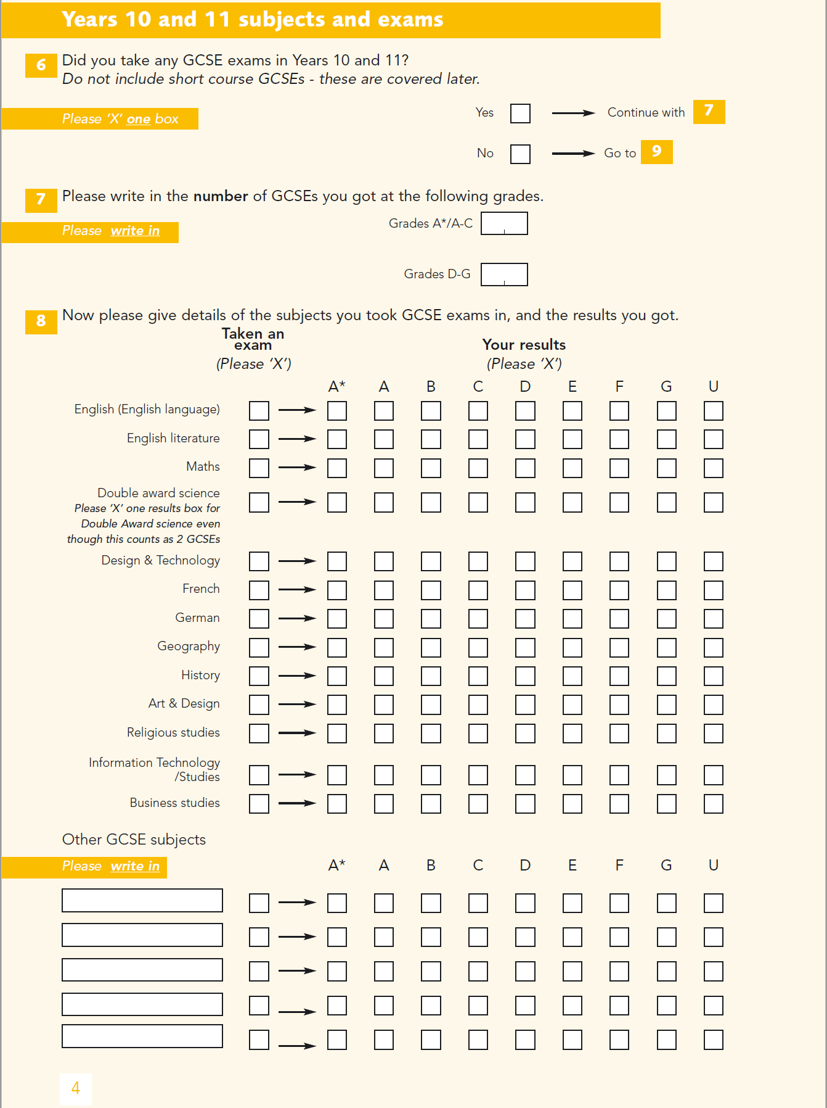

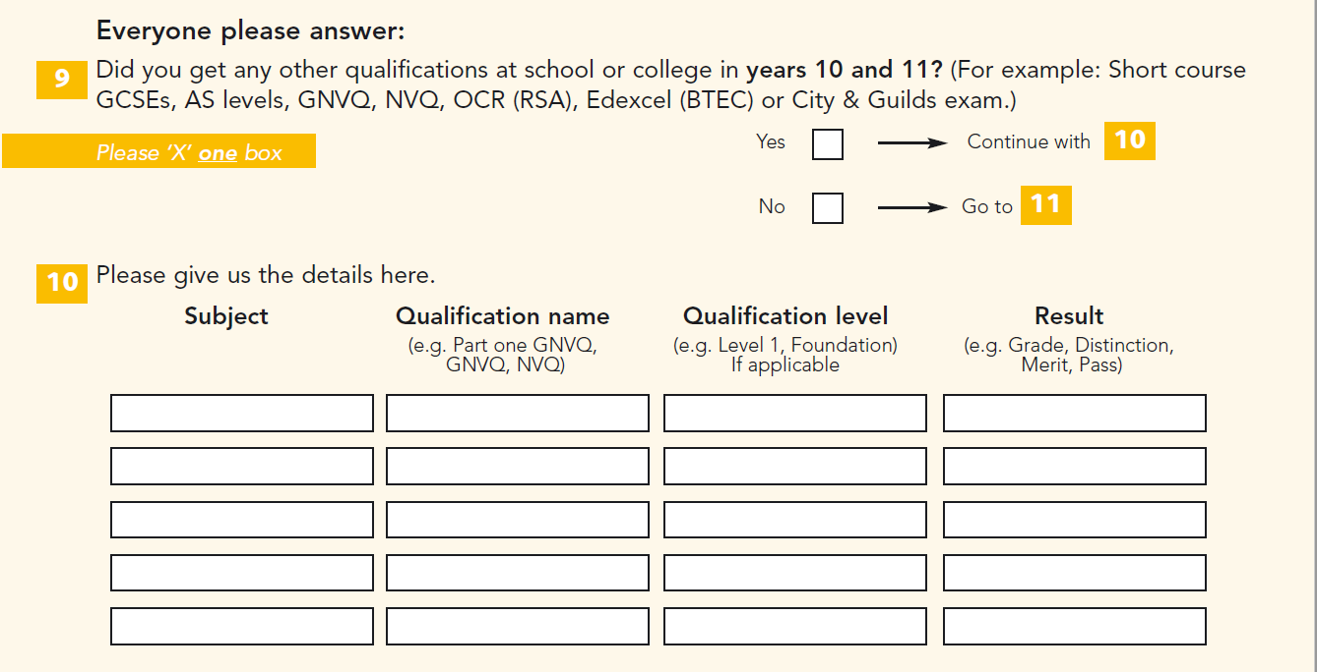

The YCS12 data deposited with the UKDS as SN5830 does not have GCSE subject level information.

**YCS13**

**Excerpt from ‘6024ycs_13_s1_s2_s3_s4_quick_start_user_guide.docx’**

The YCS13 data deposited with the UKDS as SN6024 does not have GCSE subject level information.

