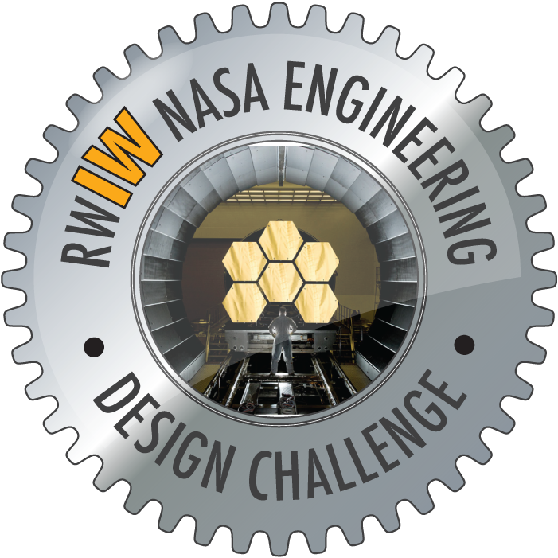


RealWorld-InWorld (RWIW) NASA Engineering Design
Challenge – James Webb Space Telescope – InWorld Mentor

[ MENTOR Banner across badge ]

The earner of this badge has mentored a student team, guiding them to create a virtual world Knowledge Space that includes:
- Refined RealWorld design solutions for either the sunshield or mirror assembly for the James Webb Space Telescope.
- 3D models of James Webb Space Telescope and prototype design solution.
- Engineered solutions and 3D models depicting ways to use the technology of the design in a new solution.
Related Activities:
Step into the role of an explorer in Moonbase Alpha, a 3-D immersive NASA exploration game: http://www.nasa.gov/offices/education/programs/national/ltp/games/moonbasealpha/index.html

Mentor a team of students appling their engineering skills to protect astronauts in the NASA Exploration Design Challenge:
www.nasa.gov/education/edc

Current Activity:
RealWorld-InWorld NASA Engineering Design Challenge website:
http://www.nasarealworldinworld.org/

[ GEAR ] EFFORT: This InWorld mentoring badge required a minimum of 30-40 hours.

[TINY – at bottom] Center for Educational Technologies at Wheeling Jesuit University
Home of the NASA-sponsored Classroom of the Future

