Jana L. Williams Educational Foundation

Mount Barclay. New Community, Lower Margibi County Liberia

Grade **Three (3)** First Marking Period **Social Studies** Test.

Name_______________________ Date_____________ Score_______%

Part I: Multiple Choices. Shade the letter that bears the correct answer. (20pts. 2pts each)

1. A group of people to whom we are related is called A. Community B. Mother C. Father D. Family
2. A place that protect us from bad weather or danger is called A. Shelter B. Clothes C. People D. Families
3. There are how many basic needs of man? A. 3 B. 4 C. 2 D. 1
4. Things that children wish for examples are: watch, phones etc. is called A. Needs B. Bags C. wants D. Food
5. A very large kind of family where the man has more than one wives is called A. Nuclear family B. Extended family C. Single parent family D. Polygamous family.
6. In Liberia, most people belong to which kind of family A. Big or Extended family B. small family C. Polygamous family D. none of these
7. The big man(Head) of the community is called the community A. pastor B. father C. Chairman D. benchman
8. People who live nearby in a neighborhood are called A. Neighbors B. friends C. Caretaker D. Chairman
9. Anything we eat or take in to help our body grow strong and healthy is called A. Shelter B. wants C. Needs D. Food.
10. Things that we need every day, which we cannot live without is called A. Car B. Phone C. Basic needs D. Wants

Part II: Fill in the blank spaces with the correct word(s) to complete the statement. (15pts, 3pts each)

1. The basics needs of man are _______________, water, _______________ and ____________________
2. The kind of family where either of the parents have died is called ____________________ parent _________________
3. Anything we wear to cover our body is called ____________________
4. The head of the community is called the community __________________
5. The smallest unit of a society is called ____________________

Part III: Essay. Answer the following questions correctly. (25pts, 5pts each)

1. List the four kinds of families discussed in your note.
2. List the four (4) basic needs of man.
3. What is a family?
4. Name the members of the Nuclear(small) family
5. List the members of the extended family.

Jana L. Williams Educational Foundation

Mount Barclay. New Community, Lower Margibi County Liberia

Grade **Three (3)** First Marking Period **Science** Test.

Name_______________________ Date_____________ Score_______%

Part I: Multiple Choices. Shade the letter that bears the correct answer. (10pts. 2pts each)

1. The layer of gasses surrounding the earth which we breath is called A. Atmosphere B. Water C. Hydrosphere D. none of these
2. The part of the earth the support life, all living things on earth such as plants, animals and people is called A. Hydrosphere B. Atmosphere C. Biosphere D. all is correct
3. Food chain always begins with green plants as what? A. Producer B. Consumer C. sun D. moon
4. Plants make their own food with the help of ______ giving energy to it. A. man B. woman C. sun D. moon
5. Animals that eat only plants to survive are called A. Carnivores B. Omnivores C. consumer D. Herbivores
6. Food chain continues with animals as A. Producer B. Consumer C. Father D. Sun
7. Animals that eat both plants and animals are called A. Decomposer B. Producer C. energy D. Omnivores
8. The water potion of the earth is known as what A. Biosphere B. Hydrosphere C. atmosphere D. Geosphere
9. The sources of energy for all food chain is called A. Sun B. Moon C. Consumer D. None of these
10. Animals that eat other animals to live are called A. Carnivores B. herbivores C. Omnivores D. Producers

Part II: Fill in the blank spaces correctly. (15pts. 3pts each)

1. A ____________ _____________ shows how energy moves from one living thing to another.
2. A food chain always begins with green plants as _____________________ and it continues with animals as ___________________
3. The sources of energy for all food chain is called _____________________
4. Animals that eat both plants and animals are called _____________________
5. Living things that eat producer or other consumer to get energy are called _______________

Part III: Essay. Answer the following questions correctly. (25pts)

1. What is food chain?
2. Name the four major sphere of the earth
3. List all the parts of a food chain.

Jana L. Williams Educational Foundation

Mount Barclay. New Community, Lower Margibi County Liberia

Grade **Three (3)** First Marking Period **English** Test.

Name_______________________ Date_____________ Score_______%

Part I: Multiple Choices. Shade the letter that bears the correct answer. (20pts, 2pts each)

1. There are how many parts of speech? A. 6 B. 7 C. 5 D. 8
2. The central idea or belief in a short story is called A. Theme B. plot C. author D. Setting
3. To listen to and tell a story, you firstly listen for the main _____ A. Idea B. Author C. Setting D. none of these
4. The time and place where the story takes place is called what? A. author B. Setting C. Plot D. Home
5. A group of words put together to make a complete thought is known as A. Noun B. Sentence C. Pronoun D. Verb
6. Every sentences begins with what? A. Period mark B. Small litter C. Capital letter D. question mark
7. A sentence that ask question and ends with a question mark is refers to as A. Interrogative sentence B. Declarative sentence C. Noun D. All is correct
8. Oh! The tree has fallen. Is an example of which kind of sentence? A. Imperative sentence B. Verb C. Pronoun D. Exclamatory sentence
9. There are how many kinds of sentences? A. 5. B. 3 C. 4 D. 2
10. The word used in place of a noun called be terms as what? A. Noun B. Pronoun C. Verb D. adverb

Part II: Fill in the blank spaces with the correct word to complete the statement. (10pts)

1. A person or sometimes even an animal who take part in the action or a short story is called _____________________________. (3pts)
2. A narrative that is engaging, entertaining, and age-appropriate is called _____________________________ (3pts)
3. A disagreement or argument among characters that relates to the central conflict is called ____________________________. (4pts)

Part III: Essay. Answer the following questions correctly. (20pts. 10pts each)

1. Name the eight parts of speech correctly. (10pts)
2. Name the four(4) kinds of sentences with one example each

Jana L. Williams Educational Foundation

Mount Barclay. New Community, Lower Margibi County Liberia

Grade **Three (3)** First Marking Period **Mathematic** Test.

Name_______________________ Date_____________ Score_______%

Part I: Multiple Choices. Shade the letter that bears the correct answer. (10pts)

1. A collection of object that have the same characteristics is called A. Bar B. Fraction D. Set
2. A part of a whole is called A. Fraction B. Set C. Bar
3. The answer for subtraction is called what? A. Difference B. Sum C. Product
4. An operation in which we combine numbers together is called A. Multiplication B. Addition C. Division
5. Fraction has how many parts? A. 2 B. 3 C. 1
6. In addition, the numbers we add are called A. Sum B. addition C. addends
7. The top part/number of a fraction is called what? A. Denominator B. Numerator C. Bar
8. What do we use to name a set according to your note? A. Capital letter B. Capital city D. Small letter
9. Choose the correct symbol used to represent union set. A. D B. n C. u
10. A union of two rays with common vertex is called A. Angle B. Vertex C. Ray

Part II: Essay. Show Work. (40pts. 8pts each)

1. Write the 4 and 6 times table clearly
2. A.If set A= {a, b, c, d} and set B= {a, b, e, c, f, g}. Fine AUB

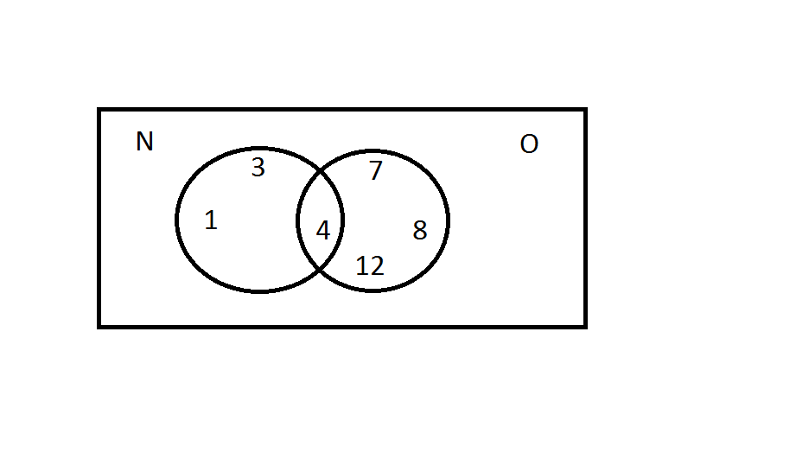Find the intersection of sets N and O in the diagram

1. What is the fractional part of these figures below?



1. Add the following. (addition)
2. 48 B. 49 C. 68 D. 108

+ 24 + 46 + 76 + 208

1. Do subtraction correctly
2. 76 B. 45 C. 80 D. 84 E. 300

* 23 -21 - 70 - 63 - 100

Jana L. Williams Educational Foundation

Mount Barclay. New Community, Lower Margibi County Liberia

Grade **Three (3)** First Marking Period **RME/Bible** Test.

Name_______________________ Date_____________ Score_______%

Part I: True or False. Circle True if the statement is right and false if it is wrong. (14pts, 2pts each)

1. God made birds to fly above the earth across the expense of the heavens. True or False.
2. On the 6th day, God said, “let there be light” and there was light. True or False.
3. God called the dry land water. True or false.
4. God made the Heavens on the 2nd day. True or False
5. God said to Adam and Eve to be fruitful and multiply. True or False
6. On the 3rd day, God made two great light. One to rule the day and the other to rule the night. True or False.
7. Genesis 1:1 says, “In the beginning, God created the man and woman. True of False

Part II: Essay. Answer the following question with complete sentence(s) (36pts, 6pts each)

1. According to Genesis 1:1, what happened in the beginning?
2. Name the things that God made on the First day.
3. When God did made Heavens?
4. How God did called the darkness and the light that He made?
5. How God did called the dry land and the water that was gathered one place?
6. What is the name of the man and the woman that God made?

Jana L. Williams Educational Foundation

Mount Barclay. New Community, Lower Margibi County Liberia

Grade **Three (3)** First Marking Period **WRITING SKILLS** Test.

Name_______________________ Date_____________ Score_______%

Part I: Fill in the blank spaces with the correct word to complete the statement. (10pts, 2pts each)

1. Letters that starts from the imaginary (middle) line and cross the bottom line are called ___________________ letters.
2. The English alphabet is consist of ____________ letters.
3. The small letters are divided into ______________ parts
4. Letters that touch the top line and also touch the bottom line are called __________________ letters
5. Letters that start from the imaginary (middle) line and hit the bottom line are refer to as _________________ letters.

Part II: Essay. Answer the follow questions. (40pts, 10pts each)

Directions: Write perfectly, observing your tall, short and falling letters and writing them clearly.

1. List all the thirteen (13) short letters.
2. List the seven (7) tall letters correctly.
3. List the six (6) falling/tail/hanging letters.
4. Write Aa to Zz clearly.

Jana L. Williams Educational Foundation

Mount Barclay. New Community, Lower Margibi County Liberia

Grade **Three (3)** First Marking Period **Spelling Skills** Test.

Name_______________________ Date_____________ Score_______%

Directions: Choose the correct letter from **column B** and place it on the blank spaces provided to each of the questions in **column A** after reading them correctly.

**Column A**

1. _______ (verb) to become pregnant.
2. _______ (verb) to expel gas from the stomach.
3. ­­­_______ (noun) a holiday taken by newly married couple.
4. _______ (noun) an unmarried man of a marriageable age.
5. _______ (verb) to clap one’s hands or shout after performance to show approval.
6. _______ (noun) the owner of a business, especially school.
7. _______ (verb) to praise.
8. _______ (noun) a child who has lost both parents.
9. _________(noun) to make or form something out of nothing
10. _________ (noun) a time taken from work devoted to rest.
11. _________ (noun) a liquor or brew containing alcohol as the active agent.
12. ________ (adjective) to be very tired.
13. _______ (verb) to force someone to do something.
14. _______ (verb) to look angry.
15. _______ (noun) a building or sets of buildings where goods are produce.
16. ________ (noun) a person who make or repairs shoes.
17. ________ (noun) a foreigner or stranger.
18. ________ (verb) to call attention to.
19. ________ (noun) someone who sell or offer sale from place to place.
20. ________ (noun) anything that happen suddenly or by chance without an apparent cause.

**Colum B**

* A. Belch
* B. Proprietor
* C. Creation
* D. Compel
* E. Advertise
* F. Conceive
* G. Frown
* I. Applaud
* J. Alcohol
* K. Orphan
* L. Cobbler
* M. Bachelor
* N. Monger
* O. Vacation
* P. Alien
* Q. Commend
* R. Exhausted
* S. Factory
* T. Honeymoon
* U. Accident.

Jana L. Williams Educational Foundation

Mount Barclay. New Community, Lower Margibi County Liberia

Grade **Three (3)** First Marking Period **Health Science** Test.

Name_______________________ Date_____________ Score_______%

Part I: Fill in the blank spaces with the correct word to complete the statement. (15pts, 3pts each)

1. The living thing that bacteria feed on is called ____________
2. Helpful bacteria help to protect us from _______________ bacteria
3. Tiny organism s that cannot be seen with our naked eyes are called ____________________
4. The two main types of bacteria are _______________ bacteria and ________________ bacteria
5. Helpful bacteria are also called ____________________ bacteria.

Part II: True or False. Circle true if the statement is right and false if it is wrong. (15pts. 3pts each)

1. In order to see bacteria we must use the instrument called light bulb. True or False
2. There are two (2) main types of bacteria. True or False
3. Harmful bacteria are also called resident bacteria. True or False
4. The bacteria that feed on the host is called parasite. True or False
5. Helpful bacteria lives in our mouth, intestines and our skins. True or false

Part II: Essay. Answer the following questions. (20pts, 10pts each)

1. What are bacteria?
2. Name the two main types of bacteria.

Jana L. Williams Educational Foundation

Mount Barclay. New Community, Lower Margibi County Liberia

Grade **Three (3)** First Marking Period **Reading & Comprehension** Test.

Name_______________________ Date_____________ Score_______%

Part I: Essay. Answer the following questions. (25pts, 5pts each)

1. What were some of the things that John had that Philip did not have?
2. How did John get the money for his sneakers?
3. Where did John and Philip find the sneakers?
4. Why do you think Philip return John’s money?
5. Who is the author of the book “Now Philip is happy”?

Part II: Oral reading. From page 1 to 15. (25pts)

Jana L. Williams Educational Foundation

Mount Barclay. New Community, Lower Margibi County Liberia

Grade **Three (3)** First Marking Period **Reading Skills** Test.

Name_______________________ Date_____________ Score_______%