9pixels Java task

9pixels_task is a Spring MVC application using MySQL database. In order to use the application you have to download Postman (https://www.postman.com/downloads/).

Open and Run Project in Intellij IDEA

As usual you get started by cloning the project to your local machine:
https://github.com/siderischristos/9pixels_task.git

Now that you have cloned the repo:

- Open the project up in Intellij.

- If you use default username and password for MySQL
username: root,
password: root
you skip this step,
if not go to the application.properties file
(C:\PathToApp\ninepixels\src\main\resources\application.properties)
and at lines 2,3
spring.datasource.username=root
spring.datasource.password=root
replace “root” with your username and/or password.

- Install Maven. On the upper right side of the app screen click on maven and then ninepixels, Lifecycle, install.
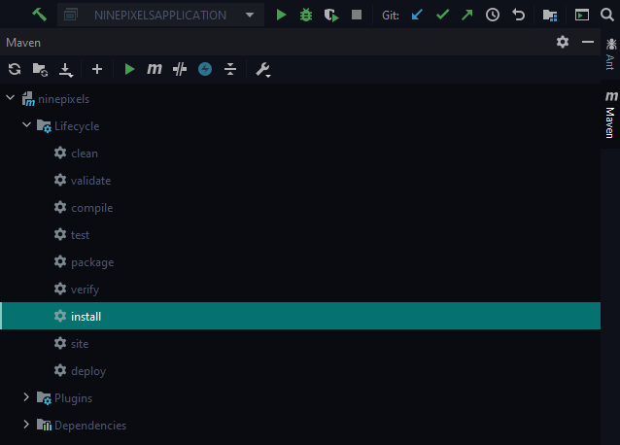

- If you have already a table with the name “9pixels” in your database you have to go again in application.properties file and at the first line
spring.datasource.url=jdbc:mysql://localhost/ 9pixels ?createDatabaseIfNotExist=true&autoReconnect=true&useSSL=false
replace 9pixels, as you see above, with a table name you do not have in use.

- If you have the server port “8080” already in use, in the same file (application.properties) at line 7 replace server.port = 8080 with a port you do not have in use (example: 8081) and replace it in the next steps.

- After you finish the Maven installation go to the NinepixelsApplication file
(C:\PathToApp\ninepixels\src\main\java\com.task.ninepixels\ NinepixelsApplication)
and run the main class.

- Open postman.

- Create a new POST request with Request URL: http://localhost:8080/register

- Add a header with key “Content-Type” and value “application/json”
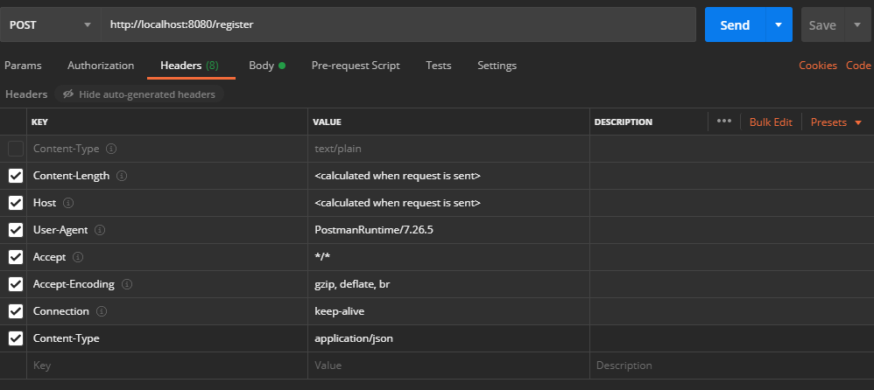

- Go to “Body” choose “raw” and type the following:
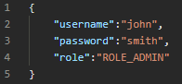

- Send the request.

- You created a user with username: “john”, password: “smith” and role of admin.

- As you see the password is encrypted
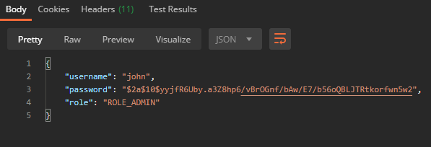

- Now you have to create a new POST request.
Open a new tab in Postman and in the Request URL field type
http://localhost:8080/authenticate

- Repeat step 9.

- Go to “Body”, click on “raw” and type the username and password as follows

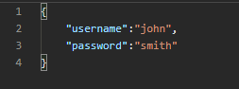

- Send the request.

- The response must be a token which expires in five hours from the moment it has been created.

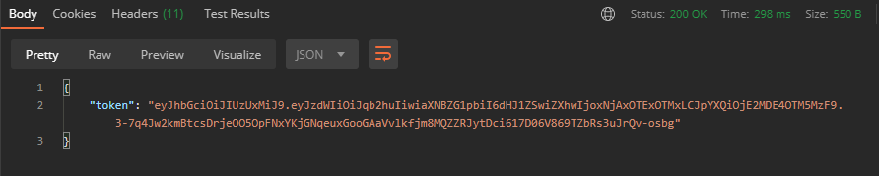

- Copy the token.

- In your browser visit https://www.jsonwebtoken.io/

- Paste the token. In “Payload” tab you can see the username of the user you created and that his role is an Admin, as follows:

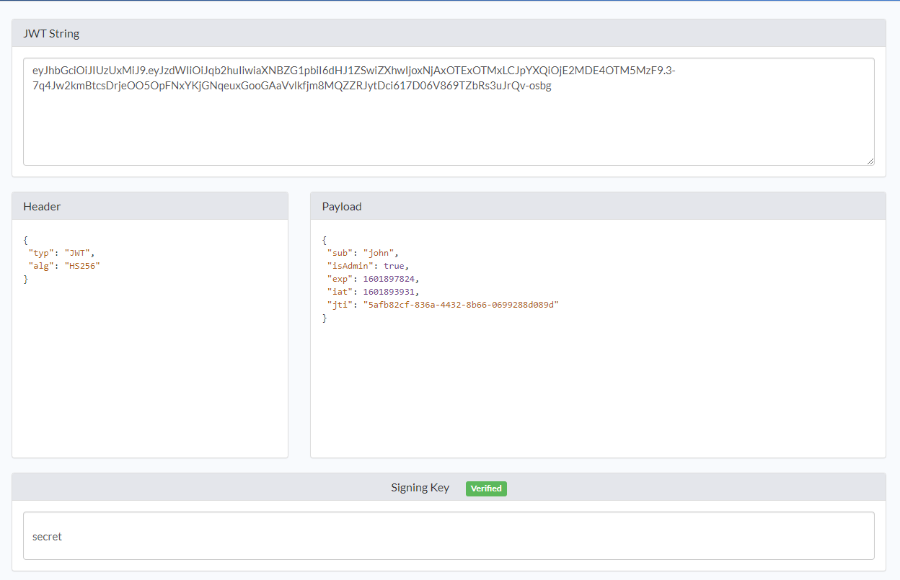

- Now go back to Postman and create a new GET request. Type the URL:
http://localhost:8080/helloadmin

- Go to the Type dropdown list and choose “Bearer Token”.

- Paste the Token in the field “Token”.

- Send the request.

- You see the page “Hello Admin”.

- If you create a user with the role of Admin you have access to both admin’s and user’s page.
Repeat step 22 with the URL: http://localhost:8080/hellouser
Repeat steps 23, 24, 25.
You see the page “Hello User”.
- You can create a user with the role of a user. In step 10, in the 4th line instead of “ROLE_ADMIN” you type “ROLE_USER” and change the username and password.

- If your user is not an admin, he/she will not be able to see the admin’s page with the given token.

- The application uses create-drop schema method, so each time it starts you have to create a new user. In order to save the users in database go to the application.properties file (C:\PathToApp\ninepixels\src\main\resources\application.properties) and replace line 4 with the following:
spring.jpa.hibernate.ddl-auto=none

