nbody — Benchmark Report

Overview
nbody is a pyperformance benchmark: a gravitational N-body simulation of five bodies (the sun, Jupiter, Saturn, Uranus, and Neptune), written in pure Python, from the Computer Language Benchmarks Game.
Each benchmark loop calls advance() 20,000 times, computing pairwise gravitational forces between all 10 body pairs and updating positions and velocities, with report_energy() called before and after to check that total system energy is conserved.
Baseline result: 483 ms +/- 4 ms (pyperf mean +/- std dev).

Initial Analysis
Call-graph profiling showed _PyEval_EvalFrameDefault (the interpreter loop) at 29.40% self-time, the single largest hotspot. Two concrete bottlenecks stood out below it:
1. Expensive pow() calls for a fixed exponent. __ieee754_pow_fma (1.08% self) is called from advance()'s r2 ** -1.5 and report_energy()'s r2 ** 0.5. CPython has no special case for a constant float exponent, so ** always dispatches to the general pow() path instead of a cheaper multiply-plus-sqrt. binary_op1 (3.37%), the largest non-eval-loop hotspot, is the generic operator-dispatch layer every arithmetic op in the loop goes through.
2. Per-operation float boxing. Every scalar float operation allocates a new boxed PyFloat object and frees the old one, since Python floats are immutable heap objects. PyFloat_FromDouble (2.51%) plus float_mul/float_add/float_sub (4.82% combined) plus float_dealloc (2.01%) adds up to about 9.3% of total runtime spent purely creating and destroying temporary float objects, on top of list_ass_item, list_ass_subscript, and validate_list (4.17% combined) from writing results back into the position and velocity lists.
Corroborating data: 2.32 instructions per cycle and a low 3.3% cache-miss rate (much better than pyflate's 7.0%) confirm the bottleneck here is not memory locality -- nbody's working set is tiny and stays cache-resident. The cost is the sheer number of interpreter-level operations and object allocations per unit of math performed, also reflected in about 86K page-fault and minor-fault samples in the software-event report.
nbody/original/run_benchmark.py, lines 80-93 -- advance()'s inner pair loop: the pow() call for bottleneck 1 (line 85) and the float arithmetic plus list writes for bottleneck 2 (lines 82-93):
80 for (([x1, y1, z1], v1, m1),
81 ([x2, y2, z2], v2, m2)) in pairs:
82 dx = x1 - x2
83 dy = y1 - y2
84 dz = z1 - z2
85 mag = dt * ((dx * dx + dy * dy + dz * dz) ** (-1.5))
86 b1m = m1 * mag
87 b2m = m2 * mag
88 v1[0] -= dx * b2m
89 v1[1] -= dy * b2m
90 v1[2] -= dz * b2m
91 v2[0] += dx * b1m
92 v2[1] += dy * b1m
93 v2[2] += dz * b1m

nbody/original/run_benchmark.py, lines 101-106 -- report_energy()'s matching pow() call:
101 for (((x1, y1, z1), v1, m1),
102 ((x2, y2, z2), v2, m2)) in pairs:
103 dx = x1 - x2
104 dy = y1 - y2
105 dz = z1 - z2
106 e -= (m1 * m2) / ((dx * dx + dy * dy + dz * dz) ** 0.5)

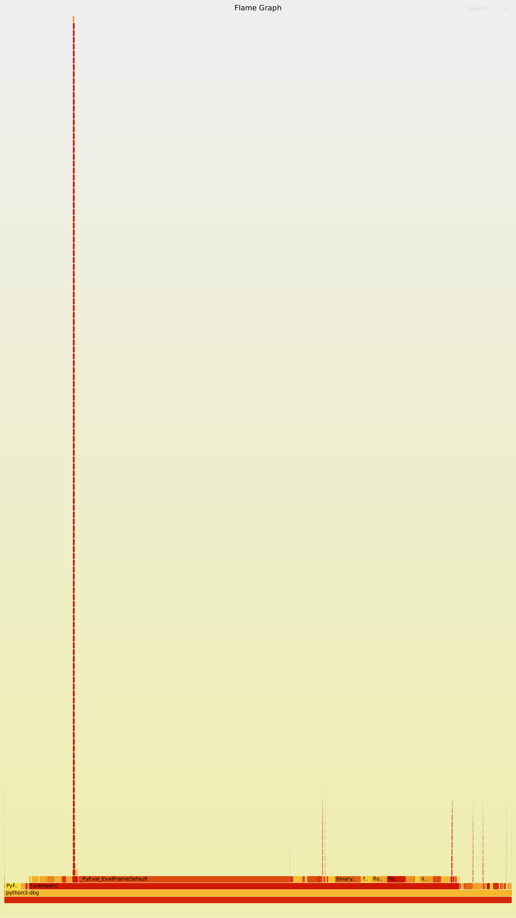
Baseline flame graph. Because nbody is pure Python end to end, the graph is dominated by deep, recursive interpreter-loop towers, with the float-boxing and pow() functions as thin towers underneath.

Optimizations Made
Four optimization attempts were implemented, each targeting a hotspot from the profile, and each measured with a full calibrated pyperf run against the 483 ms +/- 4 ms baseline.
Attempt | Change | Result | Verdict
1. numpy vectorization | Replaced per-body Python lists with numpy arrays, vectorized the pairwise force computation | 848 ms (75% slower) | Regression
2. sqrt() instead of ** | Replaced r2 ** -1.5 and r2 ** 0.5 with a sqrt()-based formula | 495 ms +/- 2 ms (2.5% slower) | Regression
3. Flattened index-based iteration | Replaced nested-tuple destructuring with integer indices into flat tuples | 579 ms +/- 2 ms (20% slower) | Regression
4. Manual loop unrolling | Unpacked each body's position once per timestep, wrote out all 10 pairwise force computations and 5 position updates explicitly | 439 ms +/- 2 ms (9.1% faster) | Only attempt to beat baseline

Root causes: numpy's per-call and scatter-add overhead dominates for a system this small (5 bodies, 10 pairs) -- vectorization needs many more elements to pay off. Calling sqrt() carries its own call overhead that costs about as much as the generic pow() dispatch it replaced. The flattened-index version backfired because it increased the number of subscript operations per pair compared to the original's single destructuring assignment. Loop unrolling won because it removed per-pair loop-control and tuple-destructuring overhead directly, without adding any new call or allocation.
All four attempts were independently verified correct by comparing report_energy() output against the original.

Before/After Comparison
Comparing the baseline against Attempt 4 (loop unrolling), the only one of the four that beat it:
Version | Mean +/- std dev | Speedup
Original | 483 ms +/- 4 ms | --
Optimized (unroll) | 439 ms +/- 2 ms | ~1.10x (~9.1% faster)

Hardware counters (perf stat):
Metric | Original | Optimized | Change
Instructions | 260,503,357,966 | 243,990,614,558 | 6.8% fewer
Cycles | 107,660,144,120 | 99,971,763,683 | 7.7% fewer
IPC (insn/cycle) | 2.42 | 2.44 | about the same
Cache-miss rate | 2.83% | 3.25% | slightly worse
Branch-miss rate | 0.49% | 0.49% | unchanged

The cache-miss rate got slightly worse because unrolling the loop into 10 explicit pairwise blocks makes the function body larger, adding a little instruction-cache pressure. What matters is that total instructions and cycles both dropped by 7-8% for the same amount of work, and wall-clock time confirms the net win.
Unlike pyflate's optimization, no hotspot disappears here. Every function from the original profile is still present in the optimized one, generally at a higher self-time share, because unrolling shrank the total amount of work rather than removing any individual operation. __ieee754_pow_fma stays essentially unchanged (1.08% to 1.64%), since unrolling never touched the ** power calls -- that was Attempt 2's target, not this one's.
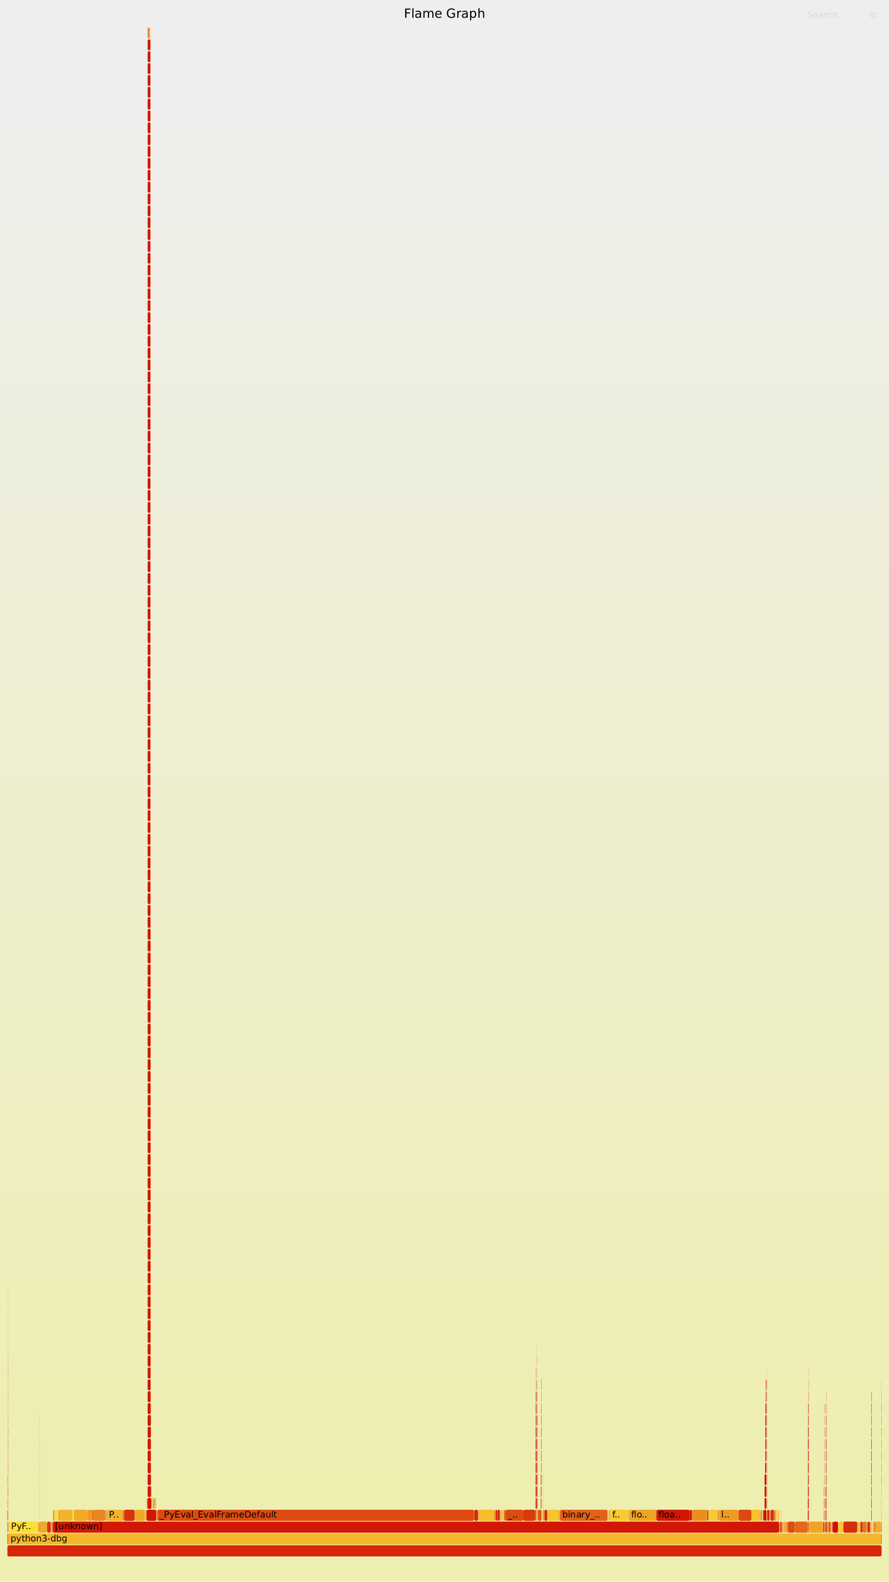
Optimized flame graph. Structurally similar to the baseline -- both pure CPython with deep recursive interpreter stacks. Total samples drop from 45K to 42K, tracking the ~9% timing improvement; this is a difference of scale, not shape.

Hardware Acceleration Proposal
Targets advance()'s pairwise gravitational-force update (lines 78-97) -- the loop responsible for essentially all of nbody's runtime, and the source of both identified bottlenecks: ~29% self-time in raw interpreter dispatch and ~9.3% self-time boxing/deallocating temporary float objects. Software's best fix (loop unrolling, Attempt 4) only recovered ~9%, since it cannot remove the object-boxing execution model itself, only reduce how often it is paid. That is precisely what dedicated hardware removes entirely.

Hardware description
The Gravity Force Pipeline (GFP): a SystemVerilog IP block that holds all 5 bodies' state on-chip and runs the entire advance(dt, n) call -- all n timesteps -- internally, without any per-timestep round trip back to the CPU. This differs from pyflate's accelerator: pyflate's HFDU streams a large, unbounded bitstream through a fixed-latency lookup, where data volume is the challenge. nbody's entire working set is tiny -- 5 bodies times position, velocity, and mass, about 280 bytes -- and stays constant for the whole call. The challenge here is call count: advance() re-enters the same 6-line pairwise computation 200,000+ times per benchmark loop, and every re-entry pays CPython's interpreter dispatch and float-boxing cost. Moving the entire timestep loop onto hardware, not just one pairwise computation, is what removes that cost.

Inputs and outputs
Control and status (memory-mapped register file, AXI-Lite style): start, done, n_iterations (32-bit), dt (64-bit IEEE-754 double).
State load and readback port: one body-field per cycle -- body index, field select (position/velocity/mass), axis select (x/y/z), write and read data (64-bit). The whole 35-double state loads or reads back in about 35 cycles, negligible next to n_iterations x 10-pair timesteps, so no DMA burst interface is needed.
Target frequency: 200-400 MHz for an FPGA prototype, matching pyflate's HFDU estimate.

Hardware architecture
Body register file: pos[5][3], vel[5][3], mass[5], all 64-bit IEEE-754 doubles -- matches CPython's float representation exactly.
10 parallel Force Lanes: one per body pair, with the pair-to-body-index mapping fixed at synthesis time -- the hardware analogue of the software loop-unrolling optimization, taken to its logical end: 10 lane instances evaluate simultaneously, not sequentially. Each lane computes dx, dy, dz to r-squared to rsqrt-cubed to mag to six velocity-delta terms, matching advance()'s arithmetic exactly. The reciprocal-sqrt-cubed step uses a standard pipelined FP IP core, declared as a black box.
Accumulate stage: each body appears in exactly 4 of the 10 pairs, fixed at synthesis time, so this is a static 4-input adder/subtractor tree per body and axis -- 15 trees total, not a dynamic scatter-add.
Integrate stage: pos[b][axis] += dt * vel[b][axis] for all 5 bodies, via one multiply and one add per body and axis.
Sequencer FSM: IDLE -> LOAD -> FORCE -> ACCUMULATE -> INTEGRATE -> (loop FORCE for n_iterations) -> DONE. The loop back to FORCE happens entirely on-chip -- software is not involved until done asserts.

Hardware/software interface
Software's role shrinks to almost nothing per timestep: it writes the initial state and dt/n into the register file, pulses start, polls or is interrupted by done, then reads back the final pos/vel. No DMA channel is needed, since the data volume (280 bytes, once) is trivial. The report_energy() calls that bracket each advance() call stay in software unchanged, since they run far less often and were not the profiled hotspot.

Acceleration justification
advance()'s bottleneck is not an inefficient algorithm -- the pairwise loop is already the correct O(pairs) approach, and three of four software attempts to speed it up within CPython made things worse. The cost is structural: every scalar float operation in CPython allocates a heap object, and every iteration re-enters the bytecode interpreter. Neither cost exists in hardware -- computing dx = x1 - x2 is a wire and a subtractor, not a heap allocation. Combined with running all 10 pairs in parallel and keeping the entire n-timestep loop on-chip, this removes both bottlenecks at their root rather than reducing their cost.
Estimated improvement: software's own best case (loop unrolling) removed about 9% by cutting redundant interpreter re-entries without touching the underlying per-operation cost. Hardware removes the per-operation cost itself and parallelizes across all 10 pairs, so the realistic ceiling is much higher -- the timestep loop's critical path becomes the force-lane pipeline depth (about 12 cycles, dominated by the FP reciprocal-sqrt-cube unit) plus a small constant for accumulate and integrate, independent of how many times advance() is called. This is an architectural estimate, not a measured one -- no FPGA or ASIC implementation was built or timed.

Block diagram
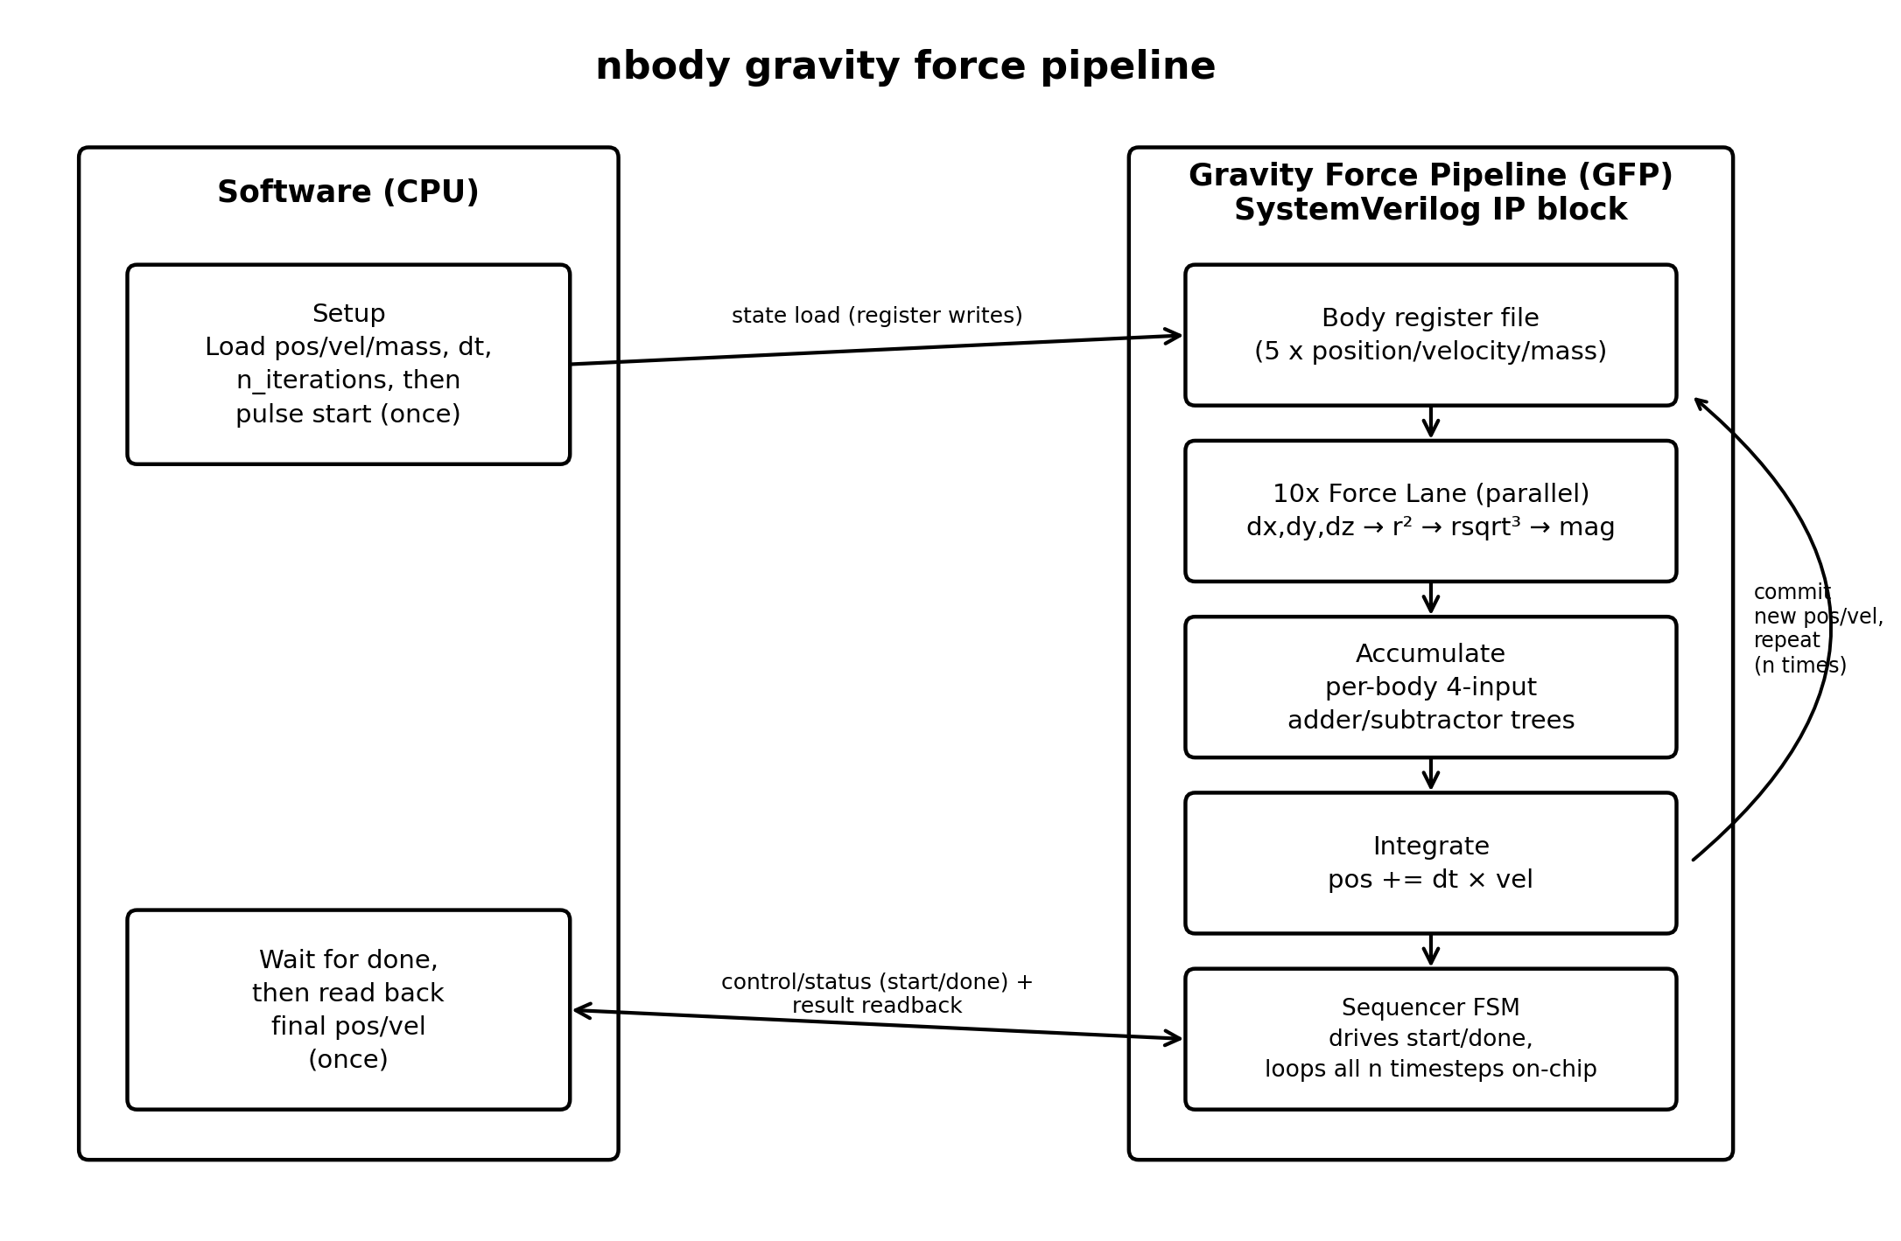
Software (left) loads the 5-body state and pulses start once per advance() call; the GFP (right) runs its register file through the force-lane, accumulate, and integrate chain, looping internally for all n timesteps before asserting done and letting software read back the final state. Compare against pyflate's block diagram, whose software side stays in the loop every block -- the structural difference between the two designs mirrors the structural difference between the two benchmarks' bottlenecks: streaming-data lookup versus call-count/interpreter overhead.

Performance, area, and power trade-offs
Performance: critical path is the force-lane pipeline depth, dominated by the FP reciprocal-sqrt-cube unit, amortized across all 10 pairs evaluating in parallel and all n timesteps running without CPU round trips.
Area: modest, dominated by the 10 force-lane instances, each containing several 64-bit FP multiply/add/subtract units plus one FP reciprocal-sqrt-cube unit. Ten parallel lanes cost 10x one lane's FP-unit area -- a real trade-off against time-multiplexing fewer FP units across the 10 pairs sequentially. Affordable at this problem size (5 bodies); a larger N-body problem would need to revisit this, since lane count grows as O(bodies squared).
Power: dominated by the 10 parallel FP pipelines running every cycle of every timestep -- higher instantaneous power than pyflate's HFDU, but for a much shorter total active time per equivalent unit of work, since there is no interpreter overhead inflating cycle count.
Trade-off made explicitly: running all 10 pairs in parallel, rather than time-multiplexing fewer lanes, trades area for eliminating sequencing overhead between pairs -- appropriate here because 10 is small; this would not scale directly to a much larger N-body problem without redesign.

Conclusion
Of four independently measured optimization attempts, only manual loop unrolling improved on baseline, and only modestly, at about 9%. This indicates the benchmark's original code, from the Computer Language Benchmarks Game, is already close to optimal for what pure CPython can do at this problem size.
The dominant remaining cost -- per-scalar float boxing and deallocation, about 9.3% of self-time -- is structural to CPython's object model for arithmetic. Removing it requires a different execution model entirely, such as a JIT or a C extension, or dedicated hardware acceleration.
Since pyflate already far exceeds the assignment's 7% improvement target on its own, nbody's contribution to this project is this small positive result plus three documented negative ones, and the resulting, well-motivated case for a hardware accelerator.

