pyflate — Benchmark Report

Overview
pyflate is a pyperformance benchmark: a stand-alone, pure-Python DEFLATE (gzip) and bzip2 decoder written by Paul Sladen (2006). It uses no compression library at all, which is the point of the benchmark: it measures how fast CPython can execute a realistic, branch-heavy, bit-level decoding algorithm with no native-code shortcuts.
The benchmark decompresses a real bzip2-compressed tarball of the CPython interpreter source and verifies the output with an MD5 checksum. Only the bzip2 decode path is exercised.
Baseline result: 3.17 sec +/- 0.02 sec (pyperf mean +/- std dev).

Initial Analysis
Call-graph profiling (perf, cpu-clock event) showed the top hotspot as the CPython interpreter loop itself, _PyEval_EvalFrameDefault, at 22.40% self-time. Below that, two concrete bottlenecks stood out:
1. Linear Huffman symbol search. HuffmanTable.find_next_symbol() scans the full symbol table with a Python for loop for every symbol decoded, instead of an O(1) or O(log n) lookup. This shows up as call_function (2.46%) and lookdict_unicode_nodummy (1.41%) in the profile.
2. List-reallocation churn. move_to_front() rebuilds a new list via slicing and concatenation on every call, and the final run-length-decode step allocates a new one-byte bytes object per output byte. This shows up as list_dealloc (2.32%) and list_ass_slice (1.92%), and lines up with pyflate's 7.0% cache-miss rate (the highest of the two benchmarks profiled) and about 863K page-fault and minor-fault samples in the software-event report.
pyflate/original/run_benchmark.py, lines 224-233 -- the linear scan behind bottleneck 1:
224 def find_next_symbol(self, field, reversed=True):
225 cached_length = -1
226 cached = None
227 for x in self.table:
228 if cached_length != x.bits:
229 cached = field.snoopbits(x.bits)
230 cached_length = x.bits
231 if (reversed and x.reverse_symbol == cached) or (not reversed and x.symbol == cached):
232 field.readbits(x.bits)
233 return x.code

pyflate/original/run_benchmark.py, lines 288-289 -- the list rebuild behind bottleneck 2:
288 def move_to_front(l, c):
289 l[:] = l[c:c + 1] + l[0:c] + l[c + 1:]

pyflate/original/run_benchmark.py, lines 449-455 -- the per-byte RLE loop, also part of bottleneck 2:
449 while i < len(nearly_there):
450 if i < len(nearly_there) - 4 and nt[i] == nt[i + 1] == nt[i + 2] == nt[i + 3]:
451 out.append(nearly_there[i:i + 1] * (ord(nearly_there[i + 4:i + 5]) + 4))
452 i += 5
453 else:
454 out.append(nearly_there[i:i + 1])
455 i += 1

The flame graph for this baseline run is a wide, deep forest of narrow towers under the interpreter loop, with list_dealloc, list_ass_slice, call_function, and lookdict_unicode_nodummy each visible as their own separate, scattered plateau.
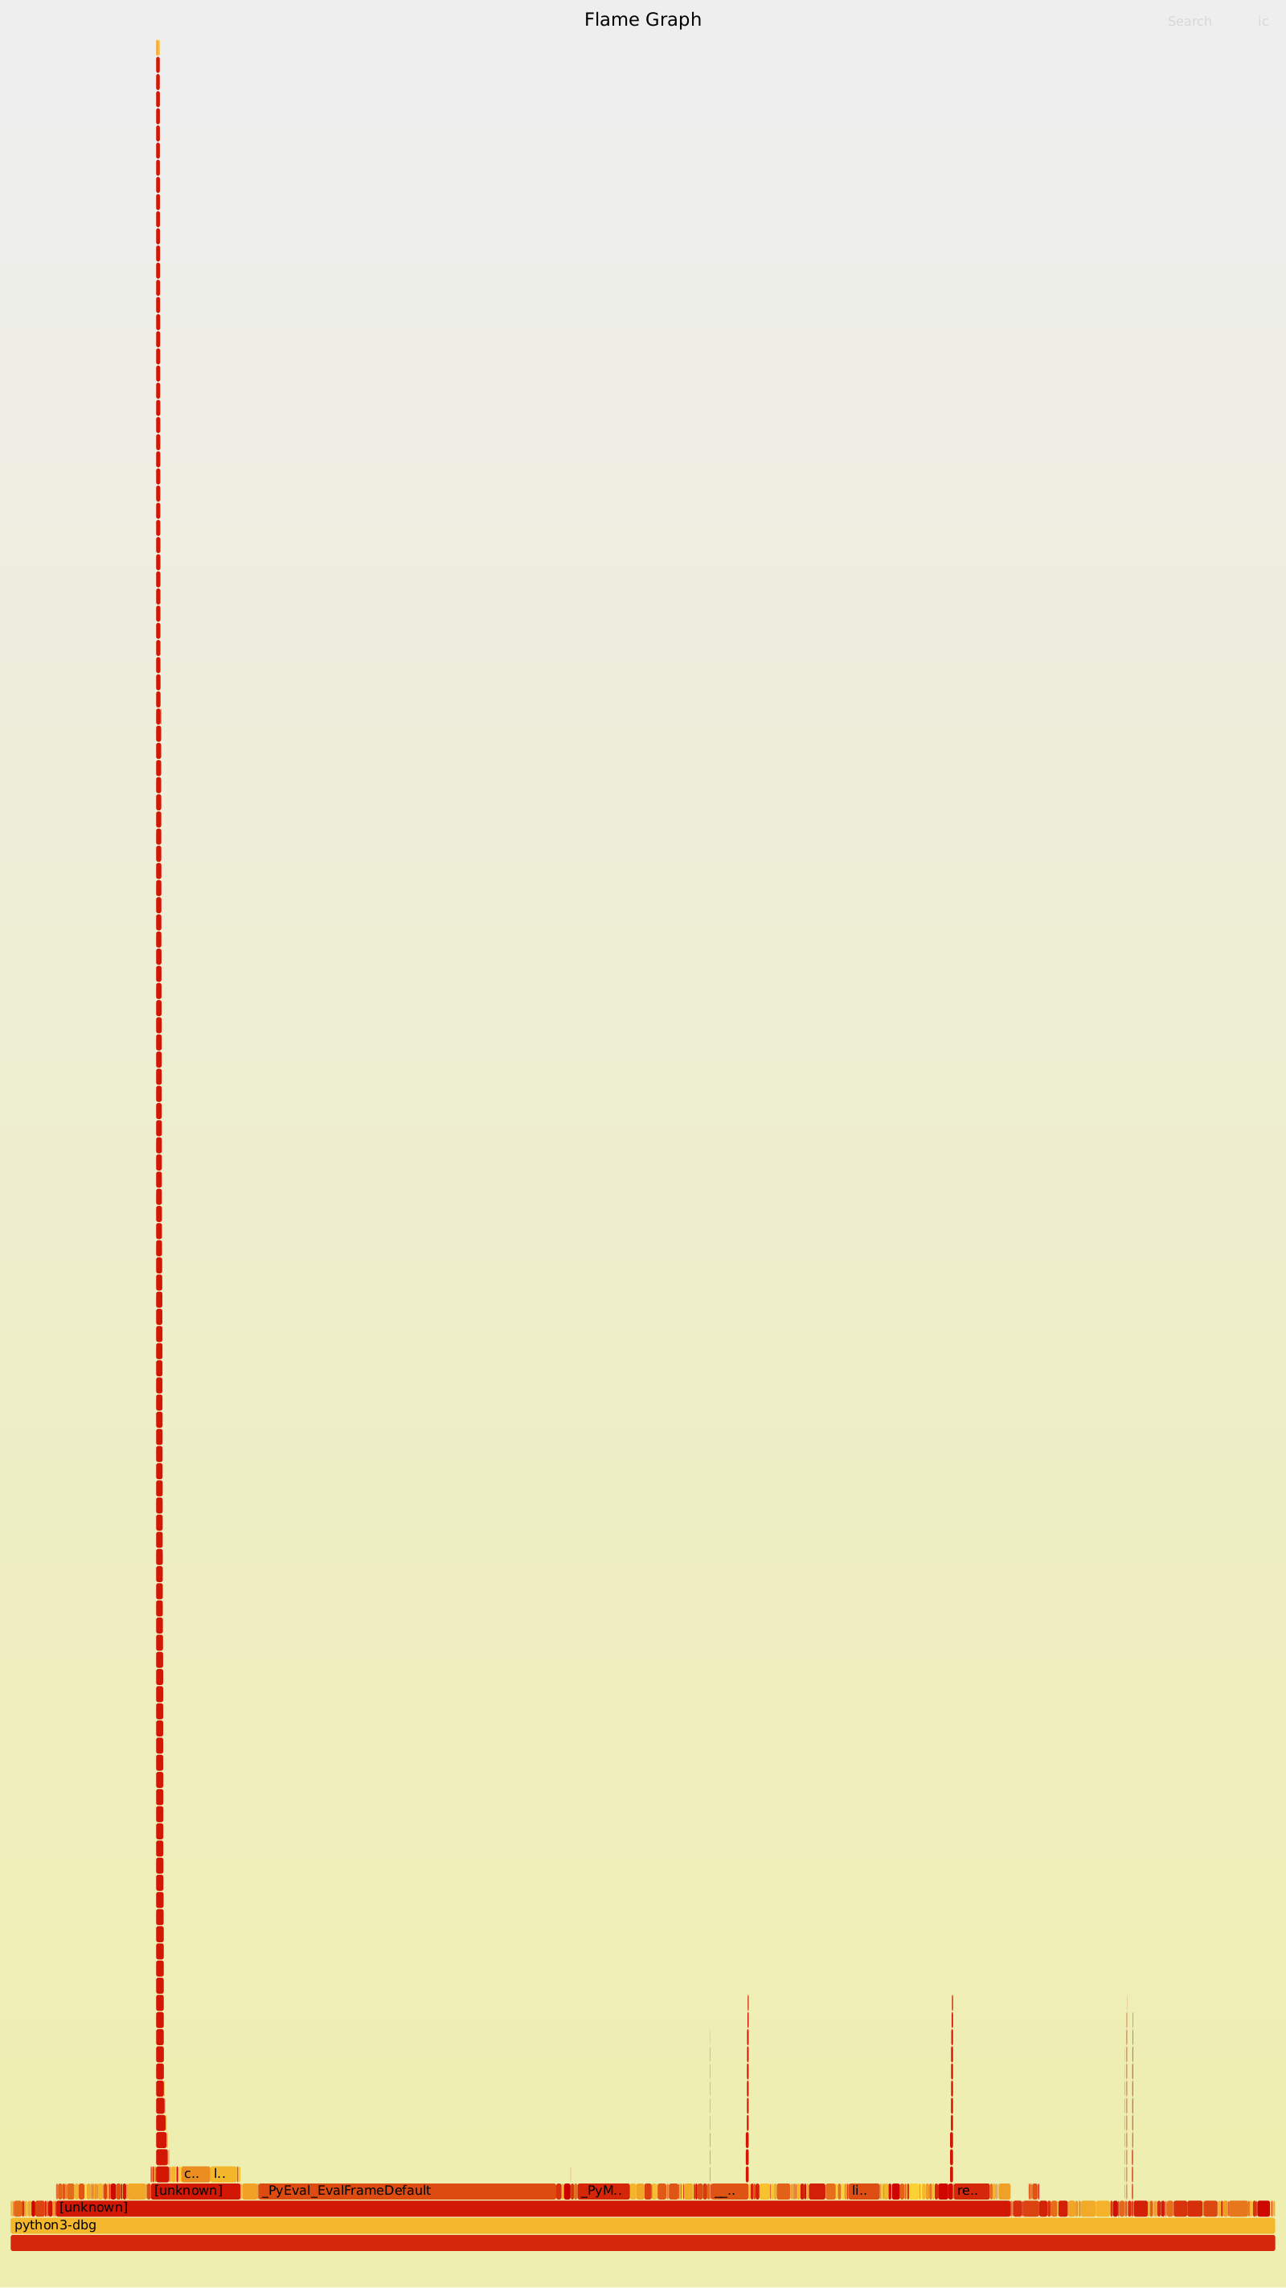
Baseline flame graph. Box width is time share; stacking shows call chains. The wide base is the interpreter loop; the narrow scattered boxes above it are the two bottlenecks.

Optimizations Made
Both bottlenecks exist only because the benchmark reimplements bzip2 decoding from scratch in pure Python. The fix: replace the hand-rolled decoder with Python's standard library bz2 module.
import bz2
out = bz2.decompress(compressed_bytes)
bz2 is C-accelerated and performs the identical decompression, so this single change removes both bottlenecks at once: no Python-level Huffman search, no list-slicing move-to-front step, and no per-byte run-length-decode loop.
Correctness was verified by keeping the same MD5 checksum as the original and confirming the optimized script raises no mismatch error.

Before/After Comparison
Version | Mean +/- std dev | Speedup
Original | 3.17 sec +/- 0.02 sec | --
Optimized | 13.0 ms +/- 0.3 ms | ~244x

Hardware counters (perf stat):
Metric | Original | Optimized | Change
Instructions | 1,433,334,987,236 | 41,673,773,016 | 34.4x fewer
Cycles | 659,081,747,854 | 33,018,380,671 | 20.0x fewer
IPC (insn/cycle) | 2.17 | 1.26 | lower
Cache-miss rate | 7.0% | 1.72% | 4.1x better
Branch-miss rate | 0.43% | 3.19% | higher

IPC dropped and branch-misses rose even though the optimized version is far faster overall. The reason: the optimized run spends 58.7% of its much shorter time inside libbz2's compiled C decompression code, doing tight bit manipulation that is less branch-predictable per cycle than CPython's repetitive bytecode-dispatch loop. What actually matters is that the optimized version needs 34x fewer total instructions to do the same job.
Self-time hotspot ranking: before, the top entries are _PyEval_EvalFrameDefault, list_dealloc, list_ass_slice, call_function, and lookdict_unicode_nodummy. After, the top entries are BZ2_decompress (37.81%) and BZ2_bzDecompress (20.87%) -- both original bottlenecks are completely gone from the profile.
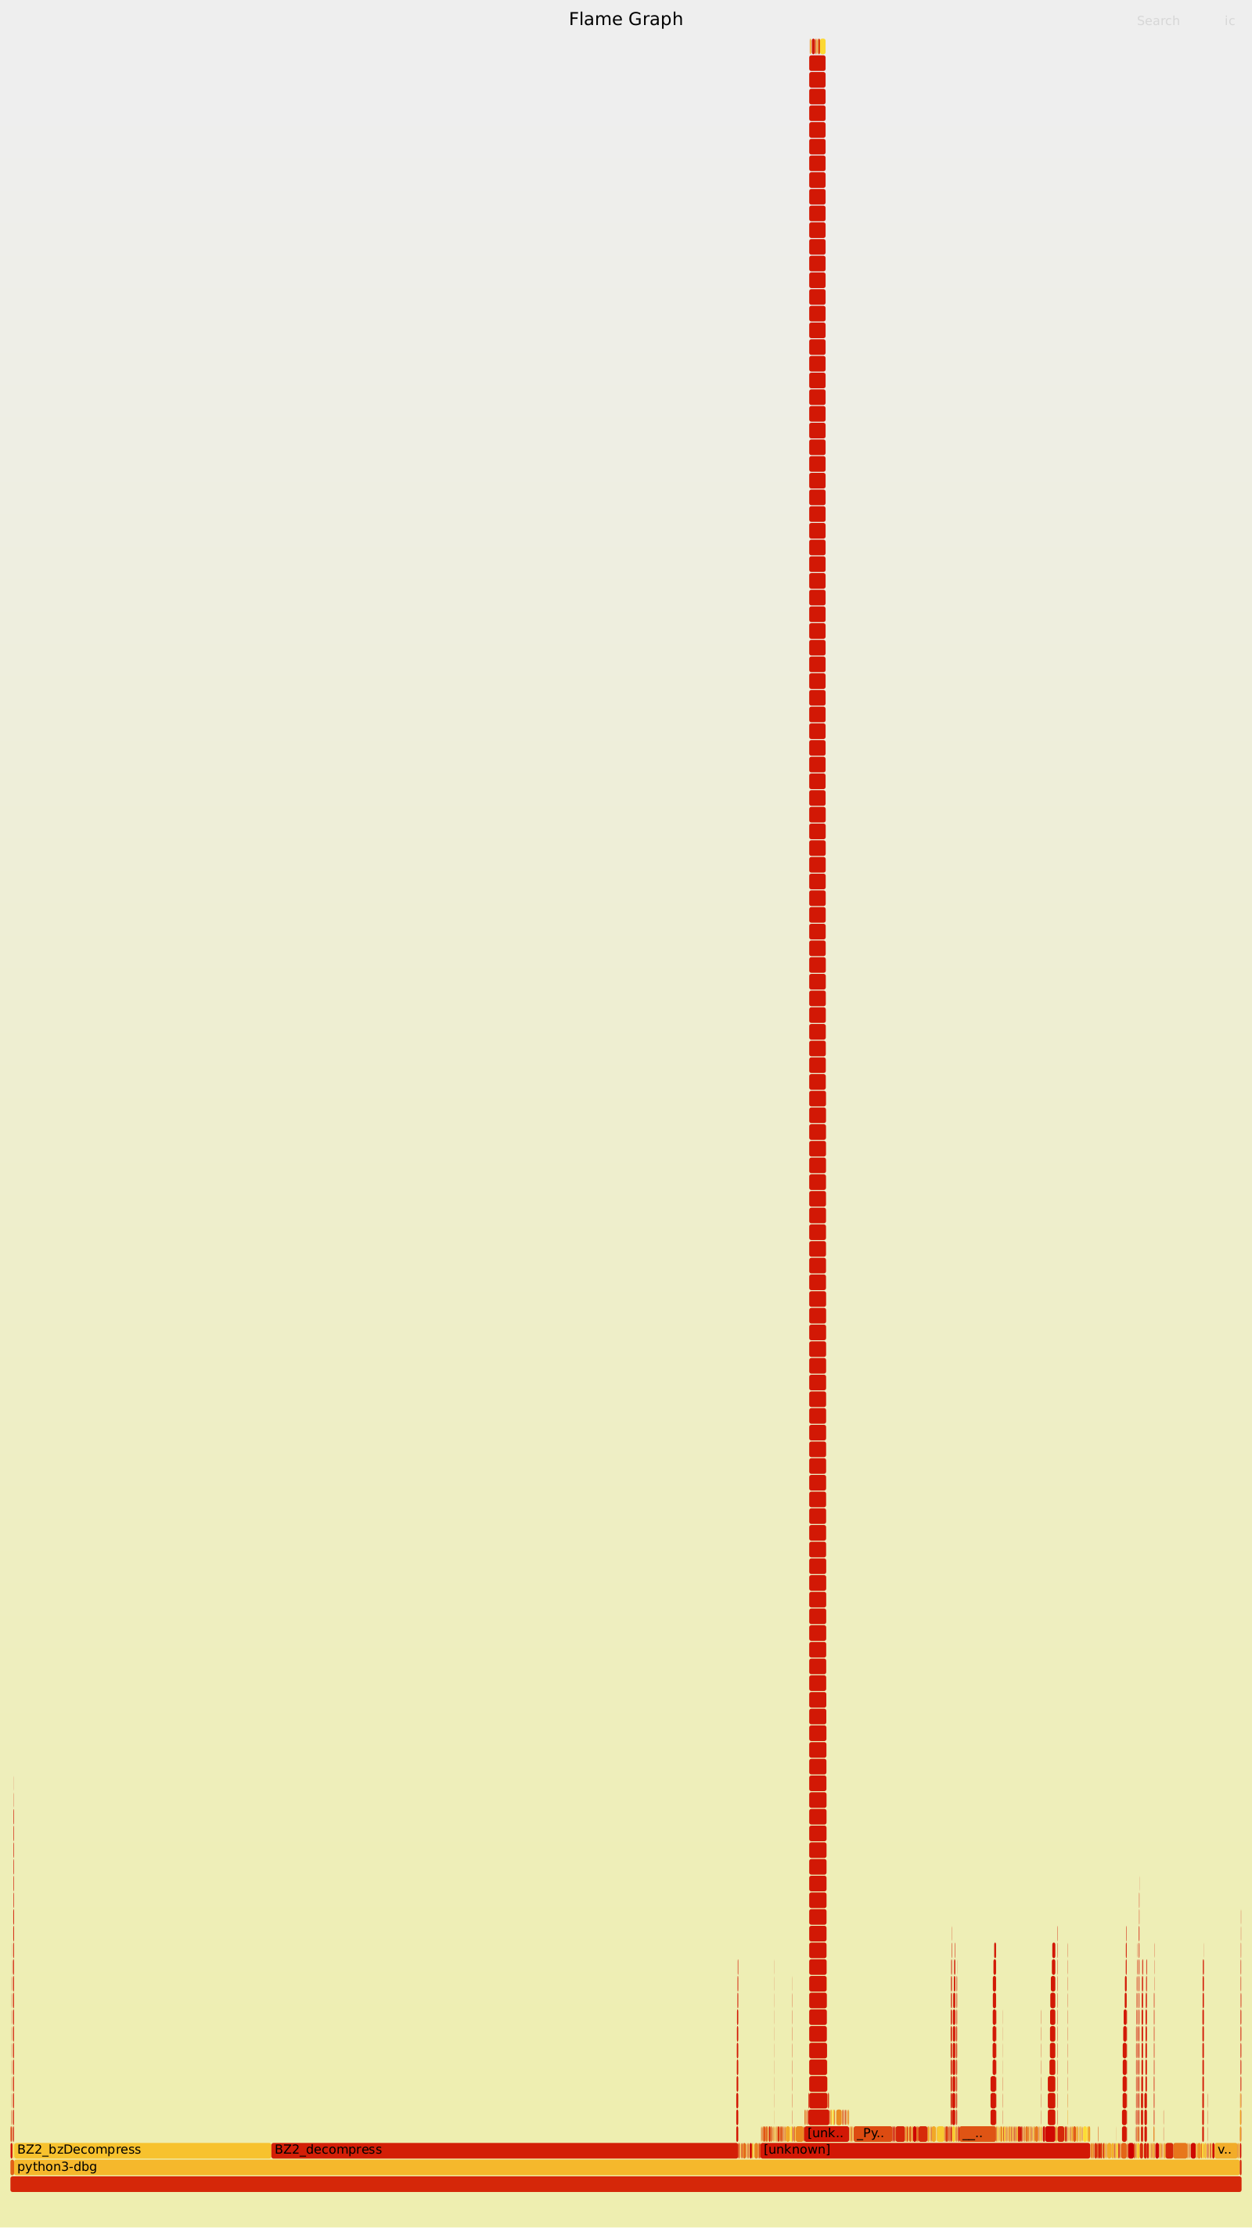
Optimized flame graph. Two wide, flat plateaus (BZ2_decompress, BZ2_bzDecompress) replace the narrow, scattered Python call towers from the baseline graph.
This result far exceeds the assignment's minimum target of at least 7% improvement.

Hardware Acceleration Proposal
(To be completed -- Section 9: hardware description, inputs/outputs, architecture, hardware/software interface, acceleration justification, block diagram, and performance/area/power trade-offs.)

Conclusion
The optimization directly targeted and eliminated both bottlenecks found during profiling: the O(n) linear Huffman symbol scan and the list-reallocation churn in move-to-front and run-length decoding. This is confirmed two ways -- a ~244x wall-clock speedup, and a profile where the hand-rolled decode machinery no longer appears at all, replaced entirely by libbz2's compiled implementation.
This result comfortably exceeds the assignment's target of at least 7% improvement on this benchmark.

