Memristors HW2

Chris Shakkour, 208157826, [christian.s@campus.technion.ac.il](mailto:christian.s@campus.technion.ac.il)

Nadi Najjar, 211610704, [nadi.najjar@campus.technion.ac.il](mailto:nadi.najjar@campus.technion.ac.il)

Contents

Question 1 – Sneak path 2

Part-a 2

Part-b 2

Question 2 – Sneak path and mitigation 2

Part-a 2

Part-b 2

Part-c 2

Question 3 – Write disturbance and mitigation 2

Part-a 2

Part-b 2

Part-c 2

Part-d 2

Part-e 2

Part-f 2

# Question 1 – Sneak path

## Part-a

## Part-b

# Question 2 – Sneak path and mitigation

Following 4x4 Joglekar’s memory array in three formats.

## Part-a: Disconnected terminals

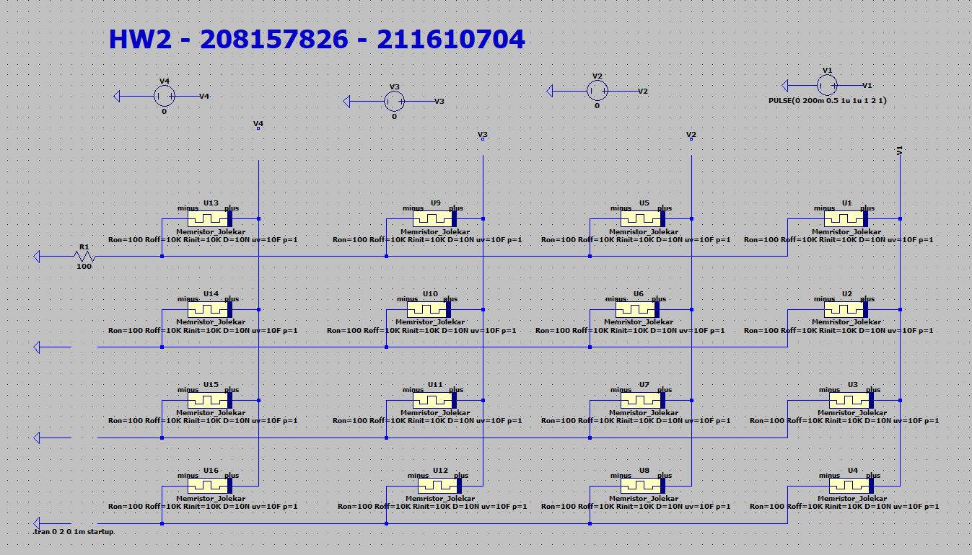

x

x

x

x

x

x

To measure the resistance on the memristor we will apply a high pulse of one second as follows:

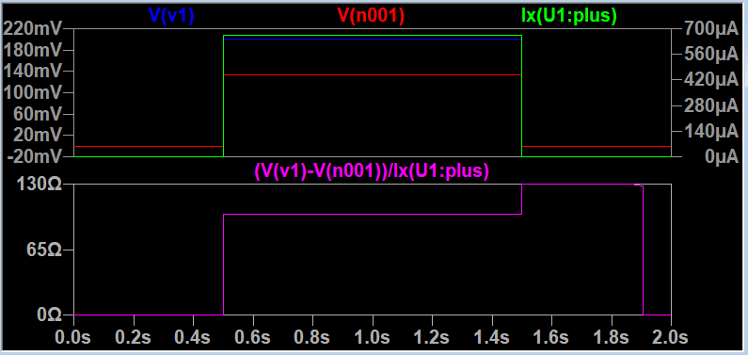

To calculate the resistance of the Memristor we divide the Voltage across the memristor by dividing both terminal voltage over the current that flows into the memristor to get the exact resistance in a point in time see example above, V(v1) is the voltage on the positive terminal, V(n001) is the voltage across the negative terminal, and Ix(U1:plus) is the current flowing thru the memristor.

1. All resistors at R_OFF

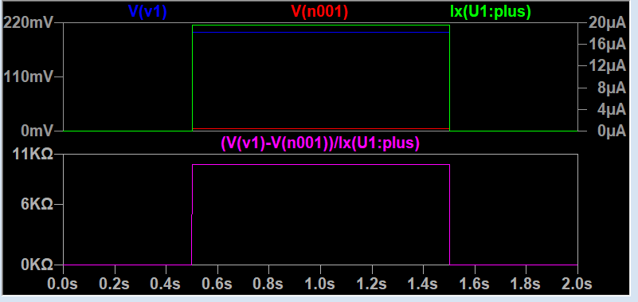

Figure : Right-top Memristor resistance pulse measurement.

1. All R_ON except the one we are reading:

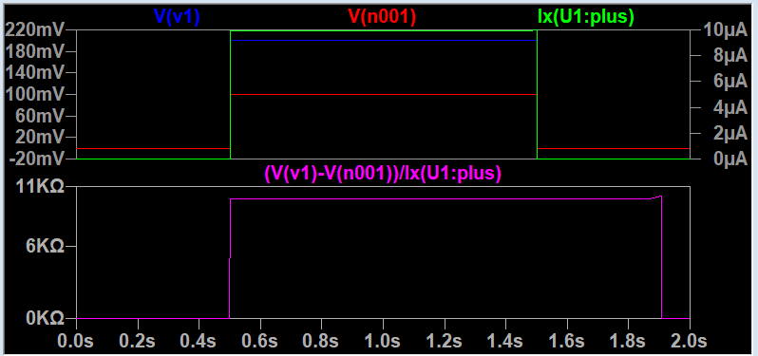

Figure 2: Right-top Memristor resistance pulse measurement.

1. All at R_OFF except the one we are reading:

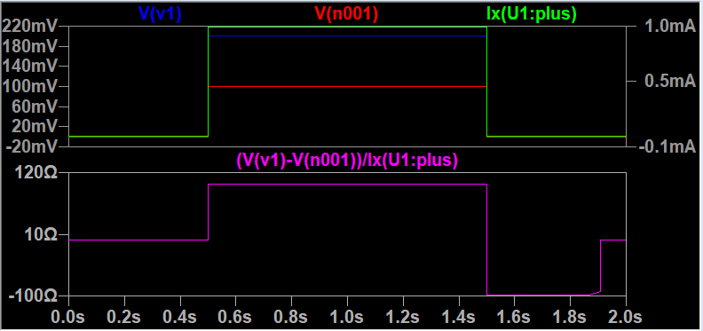

Figure 3: Right-top Memristor resistance pulse measurement.

1. All memristors at R_ON:



Figure 2: Right-top Memristor resistance pulse measurement.

## Part-b: Grounding technique

We apply a ground to all free terminals like shown below both WL and BL.

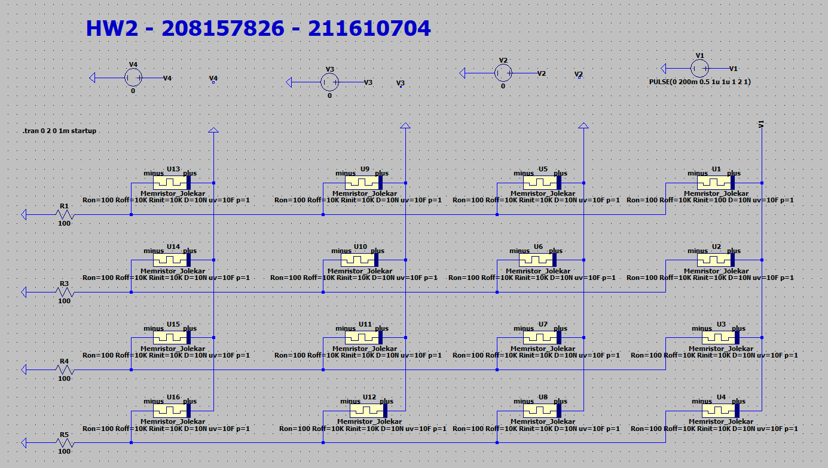

To measure the resistance on the memristor we will apply a high pulse of one second as follows:



To calculate the resistance of the Memristor we divide the Voltage across the memristor by dividing both terminal voltage over the current that flows into the memristor to get the exact resistance in a point in time see example above, V(v1) is the voltage on the positive terminal, V(n001) is the voltage across the negative terminal, and Ix(U1:plus) is the current flowing thru the memristor.

1. All resistors at R_OFF

Figure 1: Right-top Memristor resistance pulse measurement.

1. All R_ON except the one we are reading:

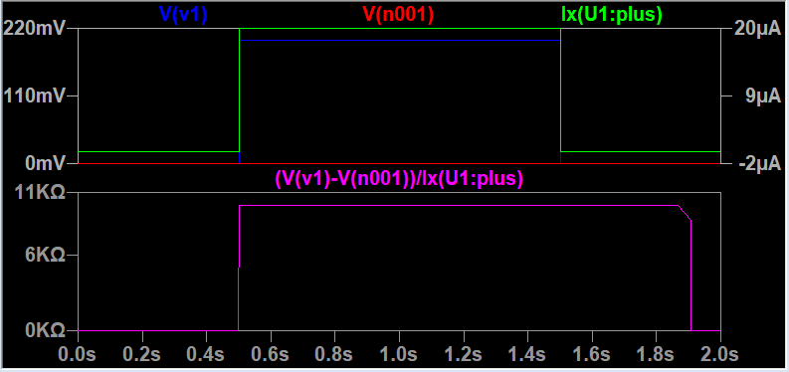

Figure 2: Right-top Memristor resistance pulse measurement.

1. All at R_OFF except the one we are reading:

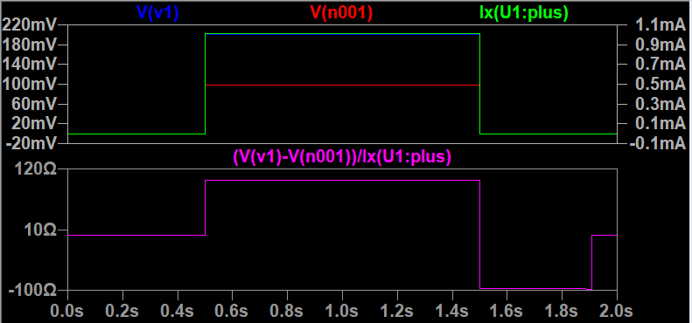

Figure 3: Right-top Memristor resistance pulse measurement.

1. All memristors at R_ON:

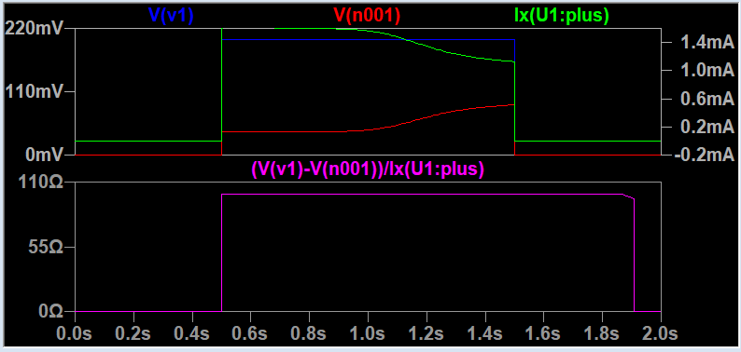

Figure 4: Right-top Memristor resistance pulse measurement.

## Part-c: Diode selector

We apply a ground to all free terminals like shown below both WL and BL.

To measure the resistance on the memristor we will apply a high pulse of one second as follows:

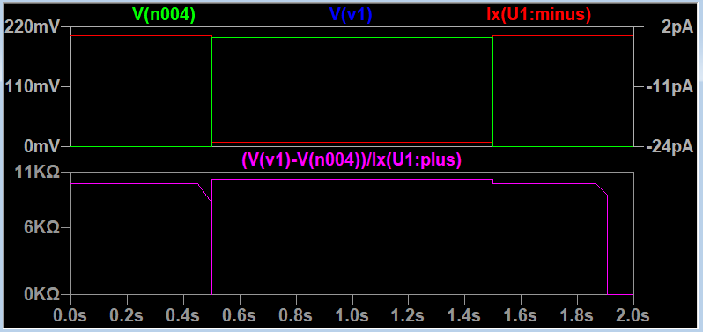

To calculate the resistance of the Memristor we divide the Voltage across the memristor by dividing both terminal voltage over the current that flows into the memristor to get the exact resistance in a point in time see example above, V(v1) is the voltage on the positive terminal, V(n004) is the voltage across the negative terminal, and Ix(U1:minus) is the current flowing thru the memristor.

1. All resistors at R_OFF

Figure 1: Right-top Memristor resistance pulse measurement.

1. All R_ON except the one we are reading:



Figure 2: Right-top Memristor resistance pulse measurement.

1. All at R_OFF except the one we are reading:

Figure 3: Right-top Memristor resistance pulse measurement.

1. All memristors at R_ON:

Figure 4: Right-top Memristor resistance pulse measurement.

# Question 3 – Write disturbance and mitigation

## Part-a

## Part-b

## Part-c

## Part-d

## Part-e

## Part-f