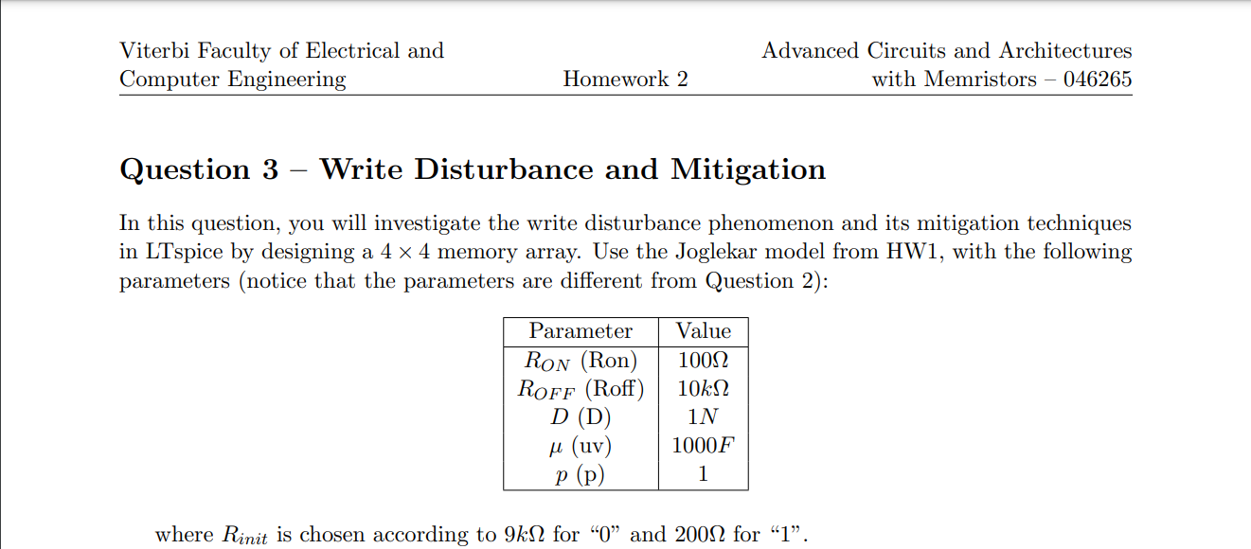



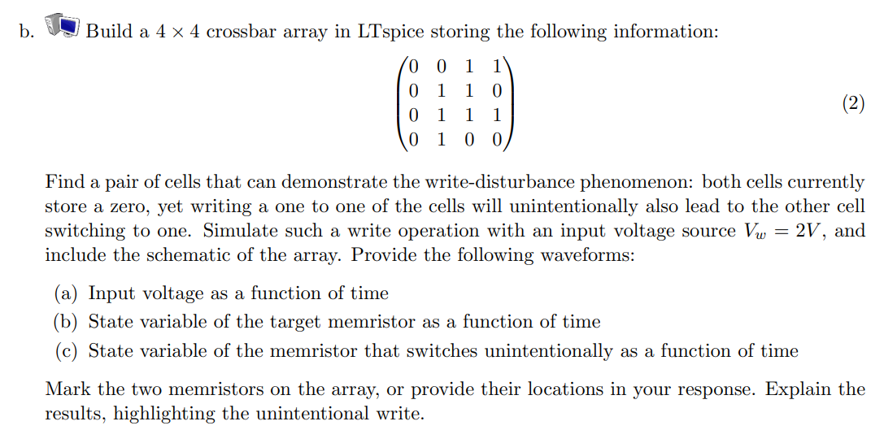

**Solution –**

Circuit Schematic :



Plot of the input voltage, state variable of U9 and state variable of U13 :

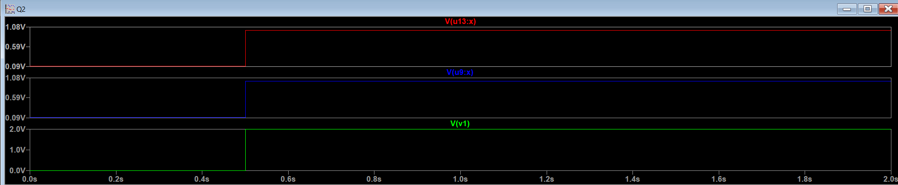

* We can see from U9 state variable that we successfully wrote the value of ‘1’ on it so we can see the transaction between 0 and 1.
* Unfortunately we can see the U13 also affected by the write procedure, since there is a sneak path that pass through U13, and from the plot of U13 state variable that we wrote the value of ‘1’ in it.



**Solution –**

Plot of the power used to switch U9 from ‘0’ to ‘1’ (blue marked line):

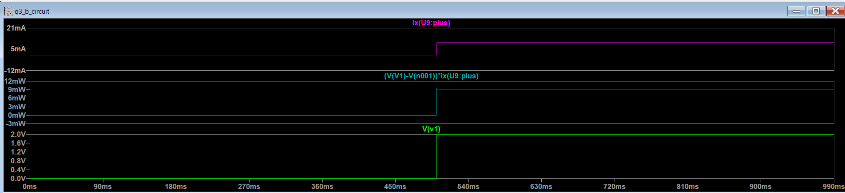

* Since the input voltage applied to U9 (for write procedure) is a pulse, we got a usage of power that looks like a pulse, before the switching its 0mW and during the switching we used about 9mW of power.



Plot of the power used in the array during the write procedure

(blue marked line):

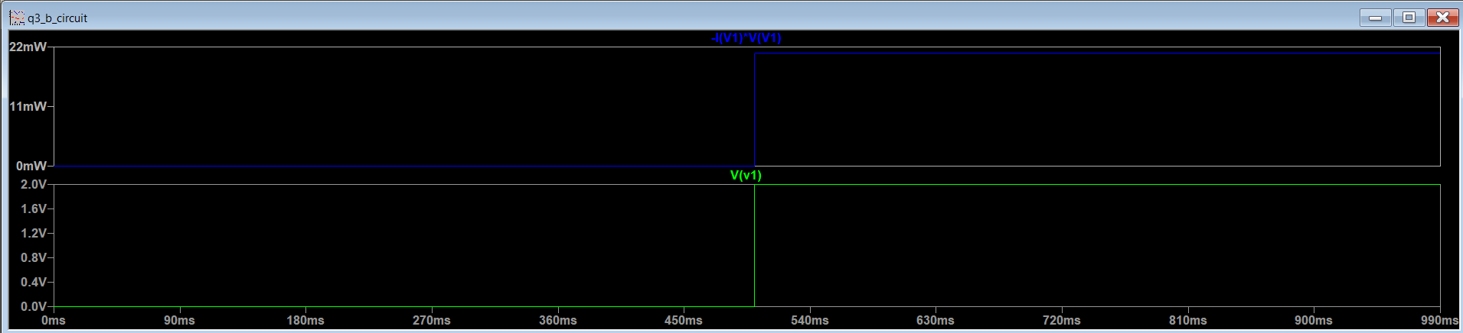

* We will get the same shape of the power used in U9 for the same reason mentioned in 3.c, but the value of the power used in the writing procedure is about 22mW, that includes the unintended write procedure done on U13 Memristor.



* The power used to switch U9 from ‘0’ to ‘1’ is 10mW and the total power wasted in the circuit is 22mW (from previous sections), so the efficiency is calculated here :

$Efficiency= \frac{P_{U9}}{P_{arr}}=\frac{10mW}{22mW}≅45\%$

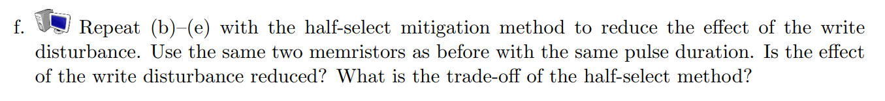

f.b plot –

f.c plot –

f.d plot –

* We can see from f.b plot (the plot of state variable of U13) that the U13 Wont be written unintentionally, so the half-select method worked successfully to prevent the sneak path the passes through U13.
* Power consumption through the write process of U9 in the array increased to almost 50mW so we got an efficiency of –

$Efficiency= \frac{P_{U9}}{P_{arr}}=\frac{10mW}{50mW}≅20\%$