Memristors HW3

Chris Shakkour, 208157826, [christian.s@campus.technion.ac.il](mailto:christian.s@campus.technion.ac.il)

Nadi Najjar, 211610704, [nadi.najjar@campus.technion.ac.il](mailto:nadi.najjar@campus.technion.ac.il)

Contents

Question 1 – Multi-level cells (MLC) 1

Part-a 1

Part-b 1

Part-c 1

Part-d 1

Question 2 – stateful logic (MAGIC) 2

Part-a 2

Part-b 2

Part-c 2

Part-d 2

Part-e 2

# Question 1 – Multi-level cells (MLC)

## Part-a

## Part-b

## Part-c

## Part-d

# Question 2 – stateful logic (MAGIC)

## Part-a

Writing down the constraints will lead to the following assumption:

$$when \left\{in_{1}=0, in_{2}=0\right\}→V_{out}<Vt_{off}$$

$$\left(1\right) V_{o}*2*\frac{R_{on}}{R_{on}+R_{on}}<Vt_{off}→V_{0}<|V_{f}|$$

$$when \left\{in_{1}=1, in_{2}=0\right\} or \left\{in_{1}=0, in_{2}=1\right\} or \left\{in_{1}=1, in_{2}=1\right\}→Vt_{off}<V_{out}$$

$$\left(2\right) 2*\left|V_{r}\right|<V_{o}<{|V}_{r}|*\frac{R_{off}}{{2R}_{on}}$$

## Part-b

We plug the numbers from the table above and get:

$$V_{0}<1.2$$

$$1<V_{o}<25$$

In the end the constraint is: $$1<V_{o}<1.2$$

We choose $V_{o}=1.1$

## Part-c

Following schematics

Source voltage in **Green**: V(n001): notice it is negative this is due to the polarity of the memristors.

Resistance of U1 in **Purple**: (V(n001)-V(n002))/I(U1)

Resistance of U2 in **Red**: (V(n001)-V(n002))/I(U2)

Resistance of U3 in **Gold**: V(n002)/I(U3)

## Part-d

0

V0

V0

$$\frac{1}{3}V_{0}$$

$$\frac{1}{3}V_{0}$$

## Part-e

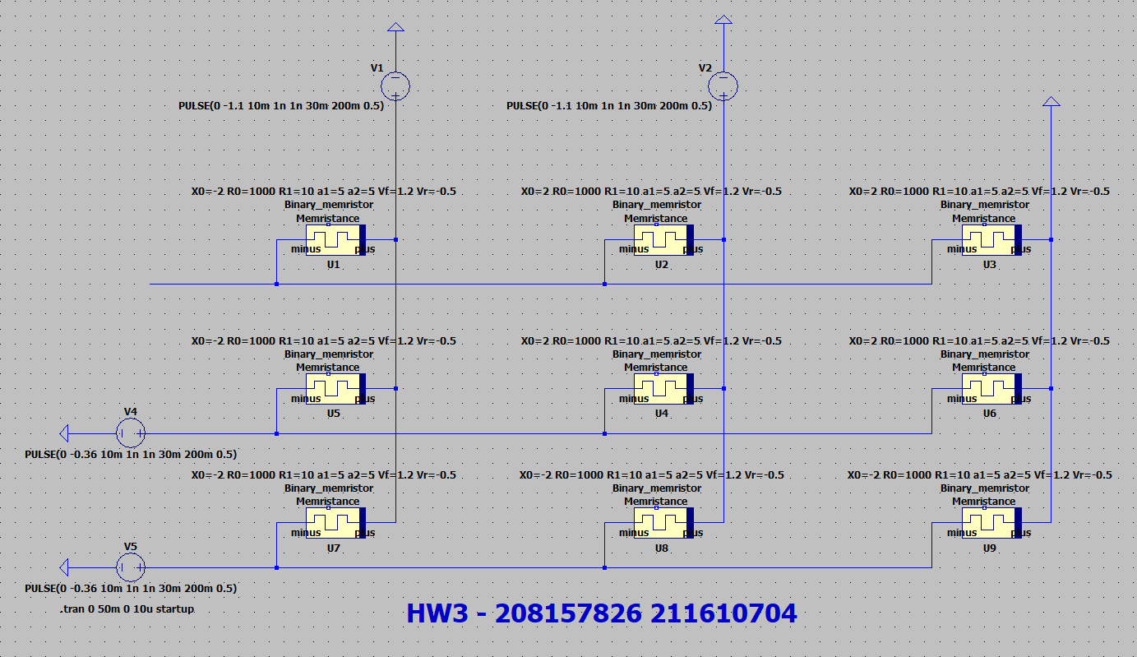

Source voltage in **Green** (V0)

Resistance of U3 in **Blue**

Resistance of U2 in **Red**

Resistance of U1 in **Cayan**

First Row memristors :

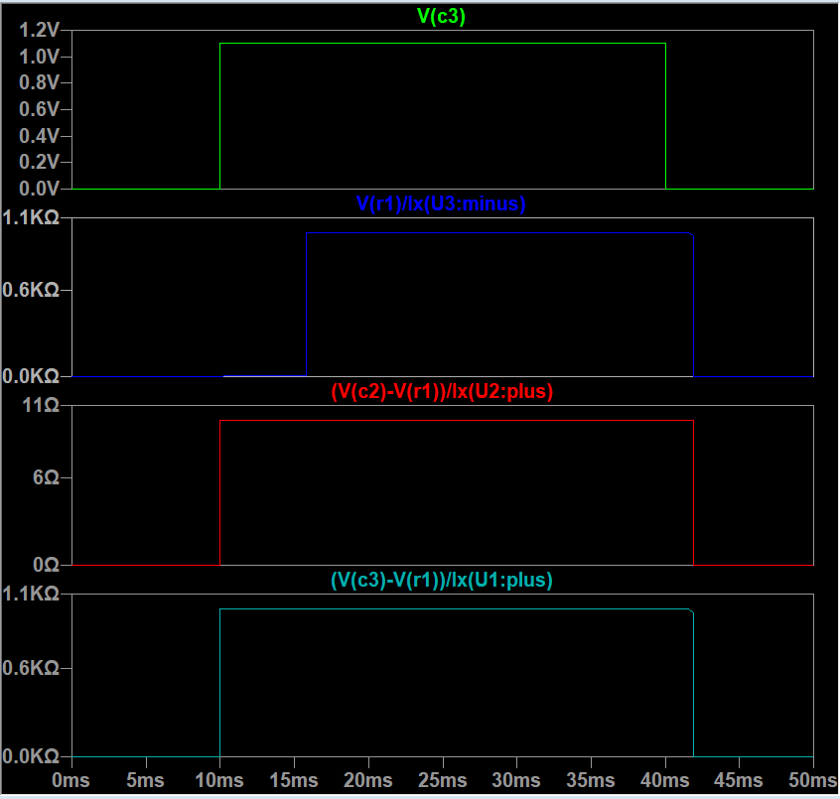

Source voltage in **Green** (V0)

Resistance of U6 in **Blue**

Resistance of U4 in **Red**

Resistance of U5 in **Cayan**

Second Row memristors:

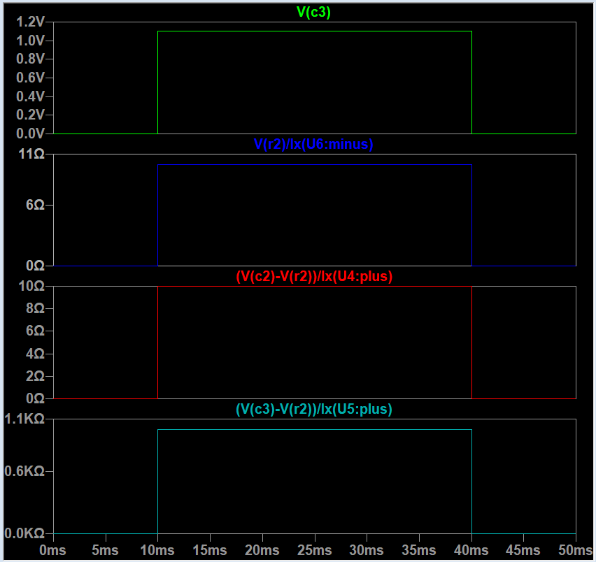

Source voltage in **Green** (V0)

Resistance of U9 in **Blue**

Resistance of U8 in **Red**

Resistance of U7 in **Cayan**

third Row memristors:

