Memristors HW4

Chris Shakkour, 208157826, [christian.s@campus.technion.ac.il](mailto:christian.s@campus.technion.ac.il)

Nadi Najjar, 211610704, [nadi.najjar@campus.technion.ac.il](mailto:nadi.najjar@campus.technion.ac.il)

Contents

Question 1 – Matrix Multiplication 2

Part a 2

Part b 3

Part c 4

Part d 4

Question 2 – Digital to Analog Converter 5

Part a 5

Part b 6

Part c 7

# Question 1 – Matrix Multiplication

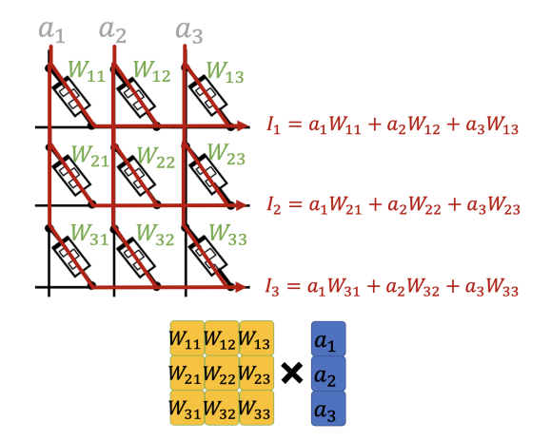

## Part a

A values are in voltage

R values are in Ohm

a1 = 1.2, a2 = 3.3, a3 = 5

R11 = 1, R12 = 2, R13 = 3

R21 = 4, R22 = 5, R23 = 6

R31 = 7, R32 = 8, R33 = 9

## Part b

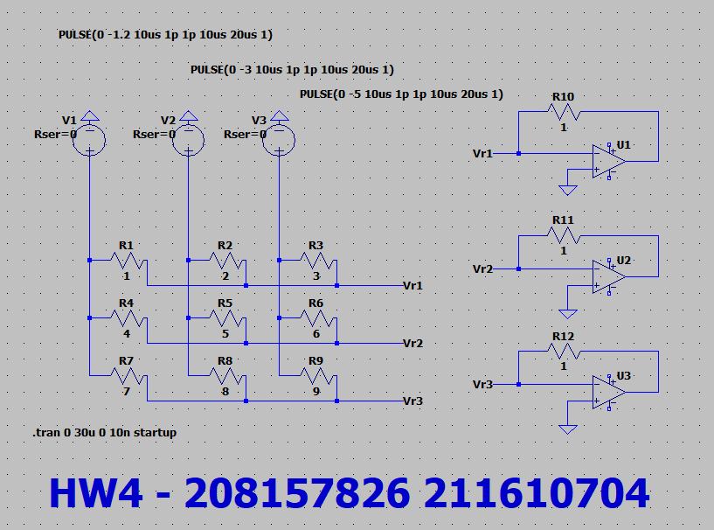

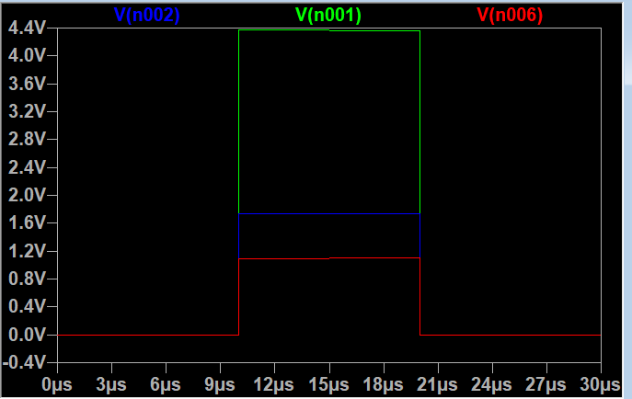

**Green** is measured at 4.3666589V and belongs to the first matrix row.

**Blue** is measured at 1.7333347V and belongs to the second matrix row.

**Red** is measured at 1.1019849V and belongs to the third matrix row.

## Part c

Ass given the voltage measure on the output of each OpAmp is $V_{out}= -Rf*I_{in}$ hence if we raise the resistance on the matrix resistors the current will drop accordingly, but we can compensate on this drop by increasing $Rf$ by the same factor. So before changing the resistance $Rf=1$ now with the increase in the resistance by a factor of 1000 the new $Rf$ is equal to 1000.

## Part d

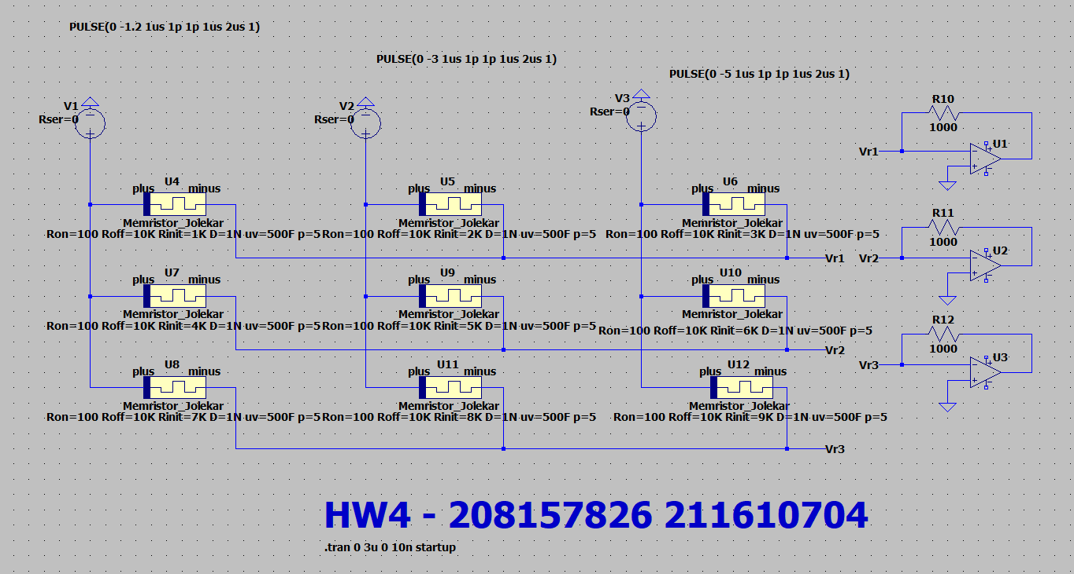

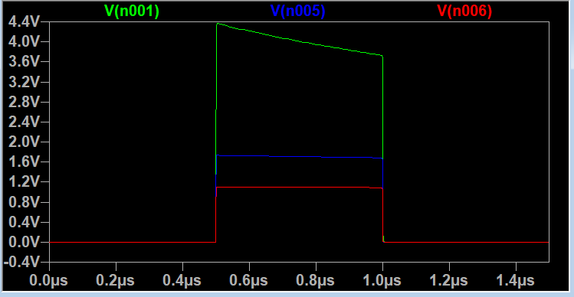

**Green** is measured at 4.3666589V and belongs to the first matrix row.

**Blue** is measured at 1.7333347V and belongs to the second matrix row.

**Red** is measured at 1.1019849V and belongs to the third matrix row.

In the beginning of the pulse denoted as t=0 we get the same results as the matrix with the resistors since the values of the memristors are at their initial value R_init, but over time current flows thru the memristors leading to a change in their memristance hence the circuit stops to behave as the normal resistors matrix, and we see a degradation in the voltage measurements.

# Question 2 – Digital to Analog Converter

## Part a

the voltage in the negative terminal is Ground since the OpAmp works hard to keep the difference between the pos and neg terminals Zero. Hence the current flowing from V_out is equivalent to the current flowing from the three channels together hence the above derivation gives V_out as a function of V0, V1, and V2

## Part b

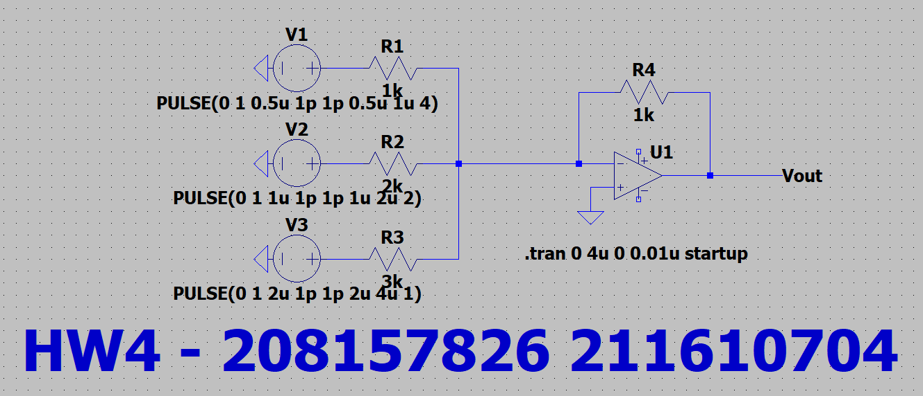

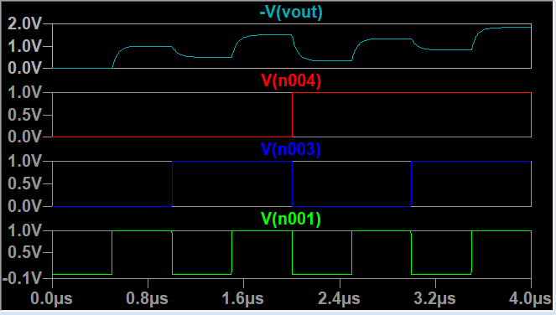

## Part c

