**Lessons 3**

**Online Activity: Cars Table:   
Screen Shots should include both SQL and ALL Available Results**

**Name: ___Chris Southey___**

1. Please show me the two ways in SQL that you can show all records and all fields?  
   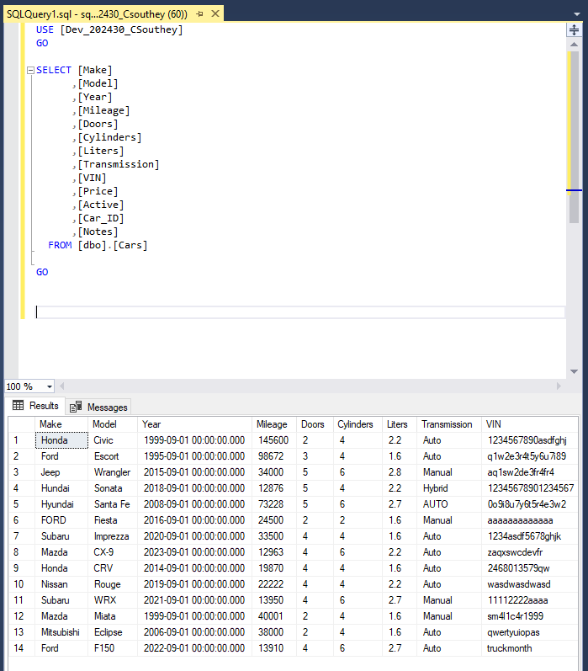  
   
2. Please display all records with the following fields: Make, Model, Year, Mileage, Price, Car_ID  
   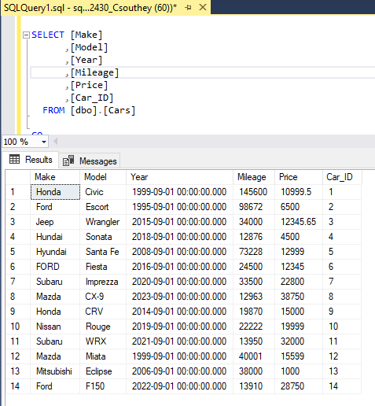
3. Same as #2, but in Ascending order by the Price field.  
   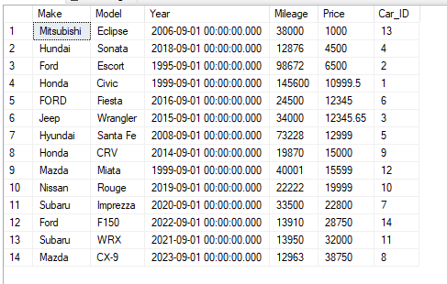
4. Same as #2, but in Descending order by the Price field.  
   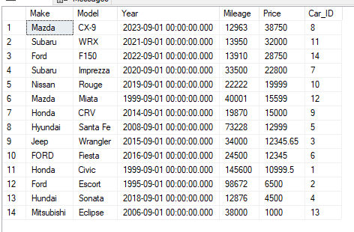
5. Limit the results to cars with Mileage less than 50,000 miles.

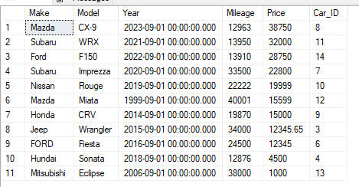

1. Limit the results to cars with Mileage that is greater than or equal to 15,000 miles AND less than 50,000 miles.  
   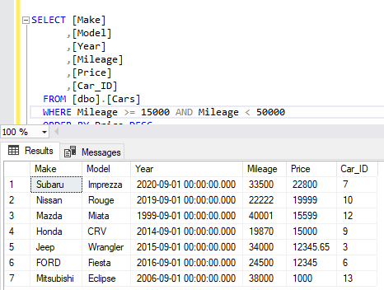
2. Display the Year field only as a four-digit year.  
   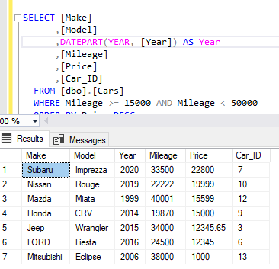
3. Display the Four-digit Year, the Make, and Model concatenated into one Car_Description field.  
   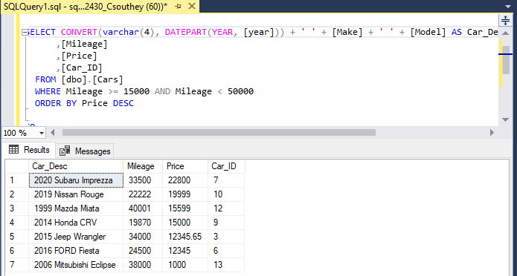
4. Calculate how old the car is in a YearsOld field.  
   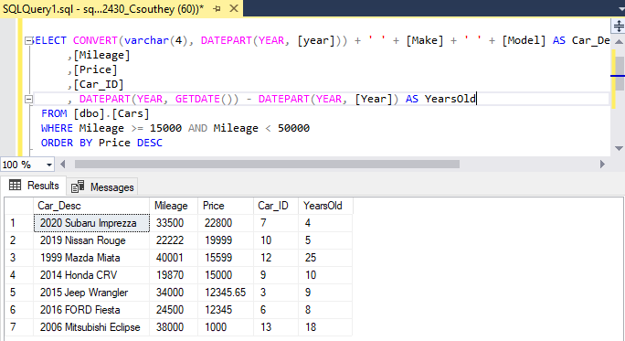
5. Same as #9, but limit the results to Cars 10 years old or less.  
   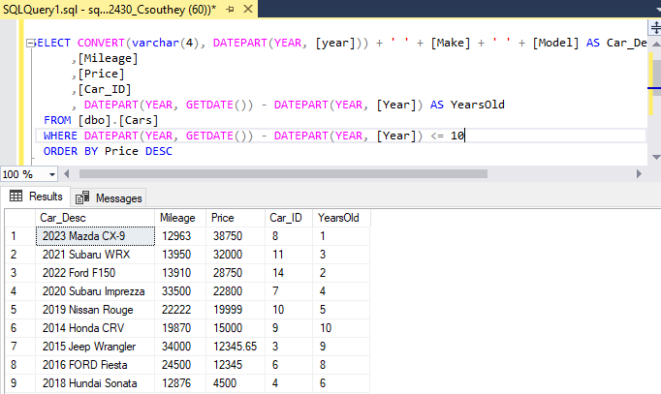
6. Continue from #10 and add a new calculated field that calculates the average miles driven per year. Try it with Cars 20 years old or less.  
   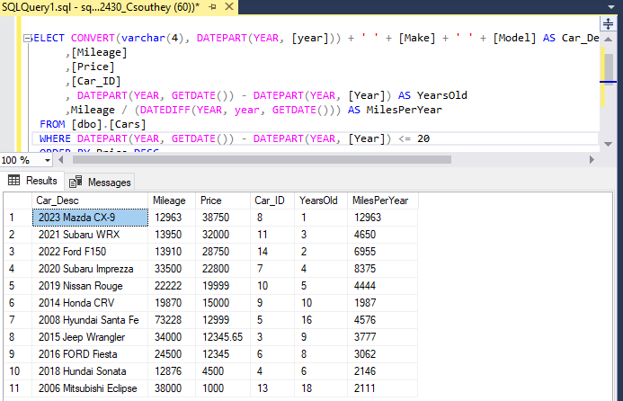
7. Make sure that you have multiple records with the same Make. Based on my sample data, you should have at least 2 Fords and 2 Hyundai’s….Maybe one misspelled? Try listing all the distinct Makes. If you see duplicates showing, checking for spelling differences and fix.  
   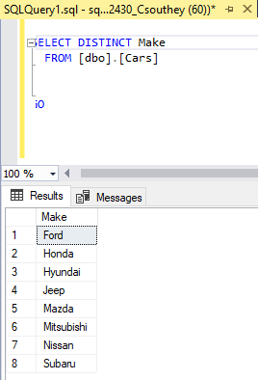
8. Try #12, but with distinct Make and Model.  
   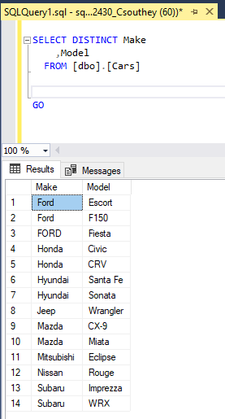
9. Pull up all fields and records, but limit it to the first/top 3 records.  
   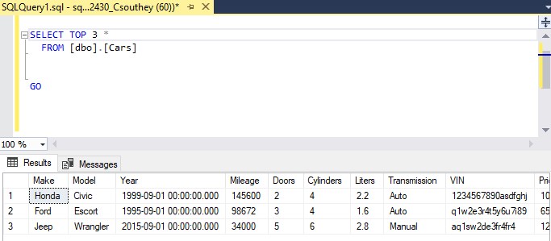
10. Pull up all fields and records, but limit it to the first/top 30% of records.  
    