**Bayesian Lesion-Deficit Inference**

**with Bayes factor mapping Toolkit**

**Manual v1.0a– 2022/11/04**

**Introduction**

This set of R scripts is intended for Bayesian lesion-deficit inference (BLDI) and adapts Bayesian inference via the Bayes factor for the framework of voxel-based lesion-symptom mapping and disconnection mapping. For reference, see Sperber, Gallucci, Smaczny & Umarova – “Bayesian lesion-deficit inference with Bayes factor mapping: key advantages and where lesion data still cause problems”.

**Software & installation**

The toolkit is based on R language and was written in R 4.2.1 with the BayesFactor package 0.9.12-4.4 in Windows 10. The **BayesFactor and the RNifti packages are required** and can be downloaded for example in the R main window under Packages/Install packages. Make sure that the selected repository is “CRAN”, pick a CRAN mirror close to your location and search for the packages across the list. Several sub-dependencies of the packages will be installed automatically when installing the packages.

The toolkit does not require installation; it is merely a simple collection of scripts. Just **copy all scripts into the same folder** and it should work.

**Requirements**

Bayesian lesion-deficit analysis requires a **behavioural or cognitive post-stroke measure** (from now on termed “behavioural score”) and **normalised pathological imaging data**. Most likely, you might want to map binary lesion maps. Commonly, lesion maps indicate lesioned voxels by a “1”, while all other voxels receive a “0”. However, many other 3D imaging data could also be used with the scripts, for example, disconnection maps (as in Foulon et al., 2018 or Griffis et al. 2021), lesion-network maps (as in Boes et al., 2015), perfusion maps, continuous maps of voxel-wise lesion probability, fractional anisotropy maps, and so on. However, note that the manual and terminology in BLDI mostly mention only lesions for simplicity. Whatever type of imaging you use, **all images must be NIFTI files (.nii extension) that were normalised to the same imaging space and have the same resolution**. The scripts will terminate if this is not the case and give a warning. Besides 3D maps, an additional script for the analysis of symmetric matrices – like parcel-to-parcel disconnection matrices (as in Griffis et al. 2021; see Sperber et al., in press) – is included. All imaging files should be placed in the same folder.

If instead disconnection matrices are analysed, (dis)connectivity matrices are required. As most (dis)connection measures are continuous, this option is only available with general linear models. In the accompanying paper, disconnection matrices from the LQT Toolbox (Griffis et al. 2021) that indicate the per cent disconnection between each pair of brain parcels, named ‘xxx_ percent_parcel_SDC.mat’ were used. The BLDI scripts also work with any other matrix output of the LQT toolbox and also with other measures with the same data format, including disconnection matrices from the NeMo (Kuceyeski et al., 2013) and BCB (Foulon et al., 2018) tools. The scripts should also accept non-symmetric data. With different platforms, the file format of such data can differ. To provide a flexible interface, the default BLDI toolkit requires disconnection data in space-separated .csv files. Make sure that the structure is the same as in the example files provided in the toolkit! A Matlab script to convert the output of the LQT into .csv files is provided in the utility scripts folder of BLDI.

The **behavioural score must be listed in a .csv-file of a specific structure** with the name of the imaging file (without extension!) in the first column and the behavioural score in the second column. If included, up to two covariate variables can be placed in the next columns. The default script expects a .csv file with “;” (semicolon) separators. If desired, the separator can be changed in the main script (e.g. to space). A .csv-file can be generated, for example, from data in R with the function “write.csv2” or from MS Excel via “Save As” from a data sheet by selecting CSV (comma delimited) .csv format. Make sure that the structure is the same as in the example files provided in the toolkit! If you include measures with decimals, use “.” as a decimal separator. Warning: MS Excel can create such files, but might fail to open a .csv file with an error message. If you want to view the contents of a .csv file in Windows, you can use a text editor instead, such as the Windows default text editor or Notepad++.

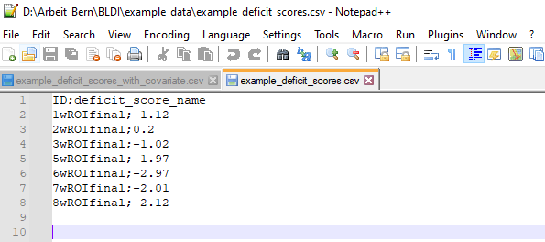

Example .csv behaviour file opened in Notepad++. The Corresponding file to the first lesion has to be named 1wROIfinal.nii – the toolkit will then automatically assign the behavioural measure to this lesion map.

In many lesion-deficit tools, the polarity of the behavioural score is relevant. Does a high score in the variable indicate a high symptom severity (e.g. severe aphasia) or high performance (e.g. good performance in a language assessment)? The first reason is that significance tests are often computed one-sided. This is not the case for the Bayesian tests in the BLDI scripts. Another reason might be the interpretation of the resulting map. Does a significant cluster in the statistical map imply that lesions are associated with more or less deficit? In almost all situations, we expect that lesions cause more severe deficits, for which it might be reasonable to assume that results indicate just this. If, however, you have good reasons to expect paradoxical effects, additional information might be required. Advanced R users might alter the BLDI scripts to include additional voxel-wise information, such as the Pearson correlation between the voxel-wise damage status and the deficit. Another option is to create an additional map with a VLSM tool that maps the direction of effects, such as NiiStat (https://www.nitrc.org/projects/niistat). In conclusion, the polarity of data is usually not an important consideration in BLDI and so far not considered in the scripts. BLDI only compares two hypotheses: h0 - there is no association between the imaging variable and the behavioural score versus h1 - there is an association.

**Usage**

The toolkit is a simple collection of scripts. The analysis starts with the execution of the BLDI_Main_Script_xxx.r file. For the different kinds of analyses, different Main Script files for either voxel-wise mapping with t-tests, voxel-wise mapping with general linear models, or (dis)connection matrices are available.

The analysis is set up within the main analysis script. There is a section of lines marked by several "#" and commented as the section for user input (see highlight in Figure below). All analysis parameters are set within this section, including the path to lesion data. This manual explains the meaning and impact of the parameters to be chosen in this section.

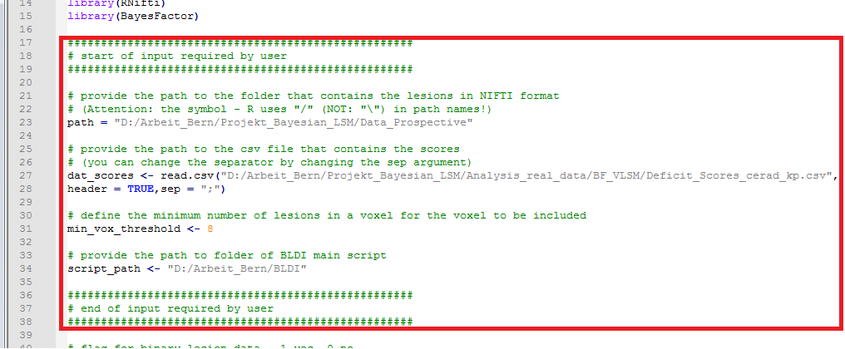

For the data to be accessible for the BLDI scripts, they need to be set up as described in the previous section. A set of example data included in the toolkit serves as an illustration. After setting up all parameters within the script, it should be saved and can be executed in the R environment via File 🡪 Source R Code (see below).

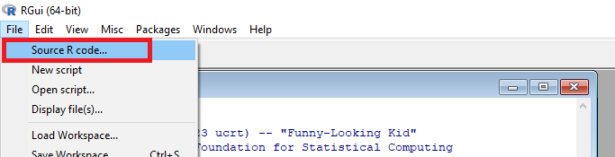

***T-Tests versus General Linear Models (GLM)***

In the accompanying paper, both BLDI with t-tests and with GLMs were performed. T-tests are appropriate with binary lesion information, where they compare all patients with a lesion in a voxel against all patients without one. GLMs are more flexible. They can be used in situations in which t-tests are appropriate, but also many more. Hence, the use of GLMs is most often advisable.

***Covariates***

Bayesian lesion-deficit inference with general linear models allows for the inclusion of covariates into the design, such as confounding variables. Following the proposed syntax for model comparison in the section on GLMs in the manual of the BayesFactor package (https://cran.r-project.org/web/packages/BayesFactor/vignettes/manual.html#glm), i) a model with an intercept and the covariates and ii) a model with an intercept, the covariates, and the voxel-wise lesion status is computed. The Bayes factor then compares the full model to the model without the lesion status, i.e. if the voxel's lesion status still explains variance beyond the variance already explained by the covariates.

The BLDI scripts automatically include variables that are provided in the 3rd and 4th columns of the .csv file as covariates. The output of the script will inform you if covariates are included. Currently, the inclusion of covariates is hard-coded so that only a maximum of 2 covariates (of which one may be lesion size for voxel-wise data) can be included. The inclusion of more covariates is possible but requires changes to the script.

The decision to include a covariate should be elaborated and well-explained. The inclusion of variables that are not confounding variables can affect the results in an unintended way. This could either lead to artefacts or mask away actual anatomo-behavioural associations (Sperber et al., 2020). In the accompanying paper, these unwanted effects were illustrated for lesion size, which cannot be identified as a generally valid covariate (Sperber, 2022). For more general information on the selection of covariates, see Wysocki et al., 2022.

***Adaptive lesion size control***

The voxel-wise BLDI main script with Bayesian GLMs includes the option to include *adaptive* lesion size as a covariate. Set the flag for adaptive control of lesion size in the main script to 1 to automatically read out the lesion size of each lesion and include it as an additional covariate. In this case, lesion size is computed based on maps after binarisation at >0 (i.e. all values >0 become 1), and the number of these voxels with values >0 is summed up as lesion size. The binarisation should not affect maps that are already 1-0 binary. The application of this procedure to continuous data might not necessarily make sense. The default option applies adaptive lesion size control as described in the accompanying paper. In detail, only voxels for which evidence for h1 is found (BF > 3) are corrected for lesion size. Voxels in which the uncontrolled analyses did not find any evidence or evidence for h0 are unaffected.

If common (non-adaptive) lesion size should be desired, it can be computed externally and included as a standard covariate in the .csv-file. In the utility scripts, an R script to compute lesion size is provided.

Please mind that correction for lesion size is not a generally appropriate procedure, but it might improve statistical results depending on the situation. For more information and practical guidance, see Sperber (2022).

***Minimum overlap voxel threshold***

The anatomy of lesions defines where in the brain we can perform meaningful anatomo-behavioural inference. If we could compare the effects of a drug on blood pressure against a placebo in a between-subjects design with 100 subjects, we would likely divide the sample into two equal groups of 50 subjects, of which one group gets the drug and the other group the placebo. However, we would intuitively not believe the results of a study that compares the effects of the drug in a study that compares 98 with 2 subjects. Statistical tests on unequal groups can occur in lesion-deficit inference. In most lesion samples, most voxels are only affected by a small proportion of patients. With the selection of a threshold situations with extremely unequal groups are prevented in lesion mapping. This threshold excludes voxels from the analysis that are less often damaged than x patients. The threshold, however, is arbitrarily chosen. Values between 3 and 10 are often found in the literature and no objective criterion exists (yet) to select the best value. Note that the smaller this threshold, the more extremely unequal groups can become. If one group is extremely small, a single outlier might quickly drive the results. Therefore, the threshold requires us to compromise between the extent of the tested brain area and the validity of the results. A lesion overlap can help to decide on a threshold

With continuous imaging data, the BLDI scripts only include voxels that have values > 0 in at least x patients. In the disconnection analysis, only parcels that have values > 0 in at least x patients are included. Warning: not only voxels that are rarely or never damaged are problematic, but also voxels (or other imaging features) that are always damaged or, more generally, imaging features that have no variance. Obviously, it makes little sense to model a variable that provides no variance.

***Binary data flag***

The user input in GLMs. includes a flag for binary lesion data. If set to “1”, this flag ensures that the lesions images are binarised (all values >0 are set to 1) when they are loaded into the workspace. This flag is set to 1 in the script for BLDI with t-tests as a t-test can only work with binary lesion data. With GLMs, this flag can be set to 1 when the lesion data are supposed to be binary. More than once, I accidentally worked with lesion data that were not binarised as 0-1 maps (i.e. 0 = intact voxel; 1 = lesioned voxel), but, due to data conversion of a lesion map unknowingly stored in 8-bit, as 0-255 maps. If only a few images contain such errors, these can completely mess up results. With the flag set to “1”, any such inconsistencies are prevented. However, make sure to set it to 0 when you work with continuous data!

**Output**

The output of BLDI is saved in the main folder. It includes a Bayes factor map and a log(Bayes factor) map. The latter might be better suited for visualisation, as evidence for h0/h1 is symmetrically represented around 0, and as the potentially very large Bayes factors in favour of h1 are much smaller after logarithmisation. The output of the voxel-wise analysis is a brain image in NIFTI (.nii) format, and the output of a disconnection analysis is a .txt file with a symmetric matrix of Bayes factors. As Bayes factor are always larger than 0, a value of 0 indicates elements that were not included in the analysis. In addition to the Bayes factor maps, a .txt file is created to protocol the analysis parameters and provide some additional information.

**Computational Performance**

The scripts were written and tested on a home PC with an AMD Ryzen 5 3600 with 3.59GHz and 16GB RAM. In the first beta implementation, the RAM was a bottleneck when full lesion imaging data were loaded for 300 patients. With the current script architecture, the execution was not limited anymore by RAM and even allowed the parallel execution of 6 instances of R running BLDI. Only very large samples at a high resolution should still provide memory errors. In such cases, down-sampling of the imaging resolution or changes in the script into multiple sub-analyses of the brain space should solve possible issues.

However, inference with Bayesian tests is still time-intense and can take up to several hours. To make the script run smoothly, no progress output is provided as soon as the Bayesian analyses start. Hence, if R appears to be unresponsive, it might simply run the analyses for a long time. With 100 unilateral stroke patients, the computational time ranged from about 1 to 2 hours.

**Useful software and further reading**

In the field of lesion-deficit inference, many tools exist to accomplish each step of the study pipeline. Preferences largely vary across labs and partially also reflect preferences on several aspects of the methodology. If you are new to the field and do not have strong preferences yet, the following suggestions could guide you through the realisation of a lesion-deficit study. Please mind, though, that many alternative tools and competing methodological conventions exist.

De Haan & Karnath (2018) provide a good overview of the typical pipeline in lesion mapping, including lesion delineation, spatial normalisation, and interpretation of statistical maps. The book by Pustina & Mirman (2022) provides the most extensive introduction to the lesion-deficit topic to date and includes many useful tutorials. It also includes chapters that cover lesion delineation and spatial normalisation. Sperber et al. (in press) provide an overview of lesion-deficit inference with indirect disconnection measures, review available toolboxes, and included tutorials on the analysis and interpretation of results in lesion-disconnection inference. Besides the Lesion Quantification Toolkit (Griffis et al., 2021), the Nemo Toolbox (Kuceyeski et al., 2013; meanwhile also available as webtool!) and the BCB Toolkit (Foulon et al., 2018) can estimate indirect disconnection measures from lesion maps.

For tipps on the visualisatiuon of disconnection data, see the manual of the Lesion Quantification Toolkit (Griffis et al., 2021), the supplementary in Sperber et al. (in press), or the manual of the BrainNet Viewer (https://www.nitrc.org/projects/bnv/). In the accompanying paper on BLDI, we used SurfIce (https://www.nitrc.org/projects/surfice/) to visualise edge-and-node plots and created colourmaps in Matlab (e.g. function colormap.m; similar colormap/heatmap functions are also available with R or Python).

MRIcron (https://www.nitrc.org/projects/mricron) is a simple, but very useful tool when working with 3D images. It can create overlap plots, can be used to manually trace lesions on scans, provides handy functions for data conversion and modification, and can visualise brain maps. Of note, it also includes a Batch function to convert lesion maps in .roi or .voi format into NIFTI format, which is used by the BLDI scripts. MRIcroGL (https://www.nitrc.org/projects/mricrogl) is the successor of MRIcron with the ability to create 3D plots. SurfIce (https://www.nitrc.org/projects/surfice/) is similar to MRIcroGL, but can visualise disconnection data. The Brain Net Viewer (https://www.nitrc.org/projects/bnv/) is a powerful tool in the visualisation of connectivity data and provides an educational manual for anybody working with brain connectivity data.

**Contact & Support**

For questions, feedback, and suggestions contact Christoph Sperber (christoph.sperber.neuro[at]gmx.de).

I hope the toolkit is helpful and I’m happy to receive feedback! – Chris

**References**

Boes, A.D., Prasad, S., Liu, H., Liu, Q., Pascual-Leone, A., Caviness, V.S., Fox, M.D., 2015. Network localization of neurological symptoms from focal brain lesions. Brain 138, 3061–75. https://doi.org/10.1093/brain/awv228

de Haan, B., Karnath, H.-O., 2018. A hitchhiker’s guide to lesion-behaviour mapping. Neuropsychologia 115, 5–16. https://doi.org/10.1016/j.neuropsychologia.2017.10.021

Foulon, C., Cerliani, L., Kinkingnéhun, S., Levy, R., Rosso, C., Urbanski, M., Volle, E., Thiebaut de Schotten, M., 2018. Advanced lesion symptom mapping analyses and implementation as BCBtoolkit. Gigascience 7, 1–17. https://doi.org/10.1093/gigascience/giy004

Griffis, J.C., Metcalf, N. V., Corbetta, M., Shulman, G.L., 2021. Lesion Quantification Toolkit: A MATLAB software tool for estimating grey matter damage and white matter disconnections in patients with focal brain lesions. NeuroImage Clin. 30, 102639. https://doi.org/10.1016/j.nicl.2021.102639

Kuceyeski, A., Maruta, J., Relkin, N., Raj, A., 2013. The Network Modification (NeMo) Tool: Elucidating the Effect of White Matter Integrity Changes on Cortical and Subcortical Structural Connectivity. Brain Connect. 3, 451–463. https://doi.org/10.1089/brain.2013.0147

Pustina, D., Mirman, D, (2022). Lesion-to-symptom mapping. Springer: New York, NY. https://doi.org/10.1007/978-1-0716-2225-4

Sperber, C., 2022. The strange role of brain lesion size in cognitive neuropsychology. Cortex 146, 216–226. https://doi.org/10.1016/j.cortex.2021.11.005

Sperber, C., Griffis, J., Kasties, V., in press. Indirect structural disconnection-symptom mapping. Brain Structure and function.

Sperber, C., Nolingberg, C., Karnath, H., 2020. Post‐stroke cognitive deficits rarely come alone: Handling co‐morbidity in lesion‐behaviour mapping. Hum. Brain Mapp. 41, 1387–1399. https://doi.org/10.1002/hbm.24885

Wysocki, A.C., Lawson, K.M., Rhemtulla, M., 2022. Statistical Control Requires Causal Justification. Adv. Methods Pract. Psychol. Sci. 5, 251524592210958. https://doi.org/10.1177/25152459221095823