a) Explain regression
You are a data science instructor. Explain linear regression to an analytics student and give one brief practical example. Give 5 bullet points that summarize the main concepts.
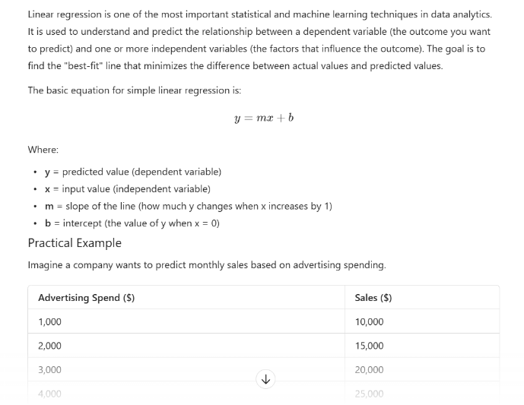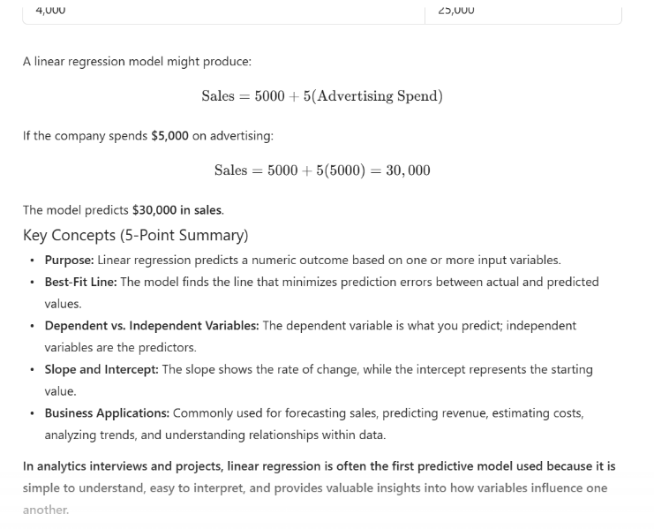

This prompt is stronger because it gives a more detailed response and the constraints kept it limited to a brief description. There was not much to read, and the information given was still able to explain regression well. Also provided were an example to reference and key bullet points at the end to summarize.

b) Help me understand SQL
Act as an expert in Data Science. I am a beginner in SQL and would like a step-by-step guide using plain English. I do not want all the concepts at once, so just a brief introductory summary is welcome.
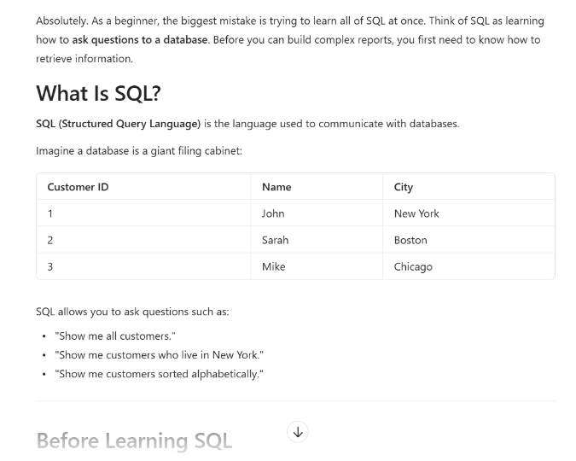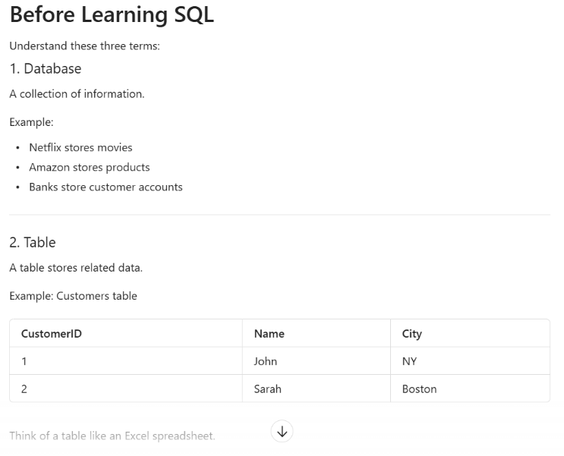
This revised prompt is better because it gives a step-by-step guide as to learn SQL and its fundamental. It treats you as a beginner in coding, imagining that you have no basis and need to learn from scratch. It explains in detail how to begin and where to start your SQL journey. It also gives you an understanding of what SQL is used for and how it is used with examples to help steer a learner in the right direction. It also remembered that I did not want a wall of information, so it condensed the explanation as best it could.

c) Create a dataset
Create a small dataset with 12 rows representing number of fruits grown. Include the columns Months, Fruits, and number grown. Use fictional but realistic numbers between 10 – 100. Format the output as a clean table. 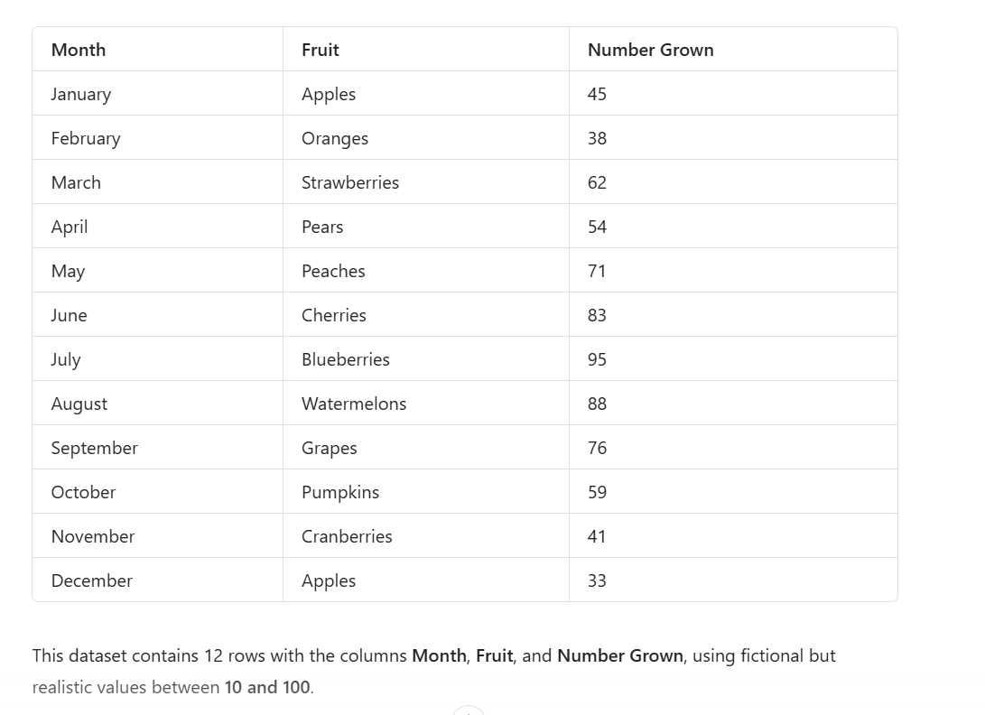

This prompt is stronger since it gives the AI a format to work with rather than just a random dataset. With the original prompt, AI would need more prompting to get the specific categories, or it would give information that may not even be necessary in the dataset someone is looking for. The possibilities are endless with random generation, so instead of repeated prompt iterations, a more detailed prompt gives a better structure and instructions to follow.

