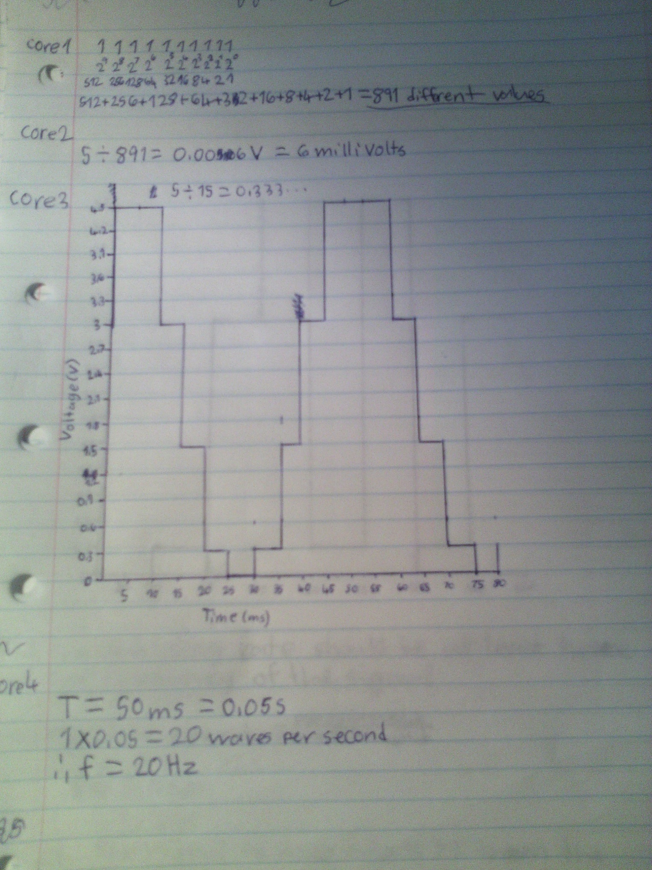
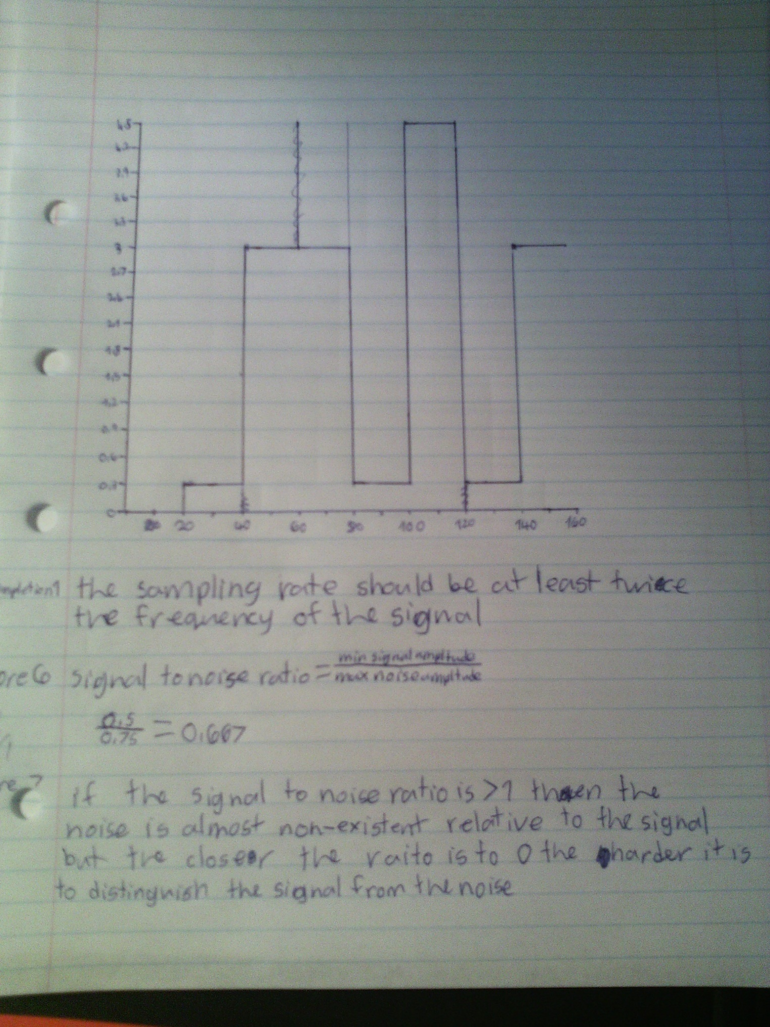
core 8
#include <stdio.h>
#include <time.h>

extern "C" int InitHardware();
extern "C" int ReadAnalog(int ch_adc);
extern "C" int Sleep(int sec, int usec);

int main(){
InitHardware();
int adc_reading;
adc_reading = ReadAnalog(0);
printf("%d\n", adc_reading);
Sleep(1,000000);
adc_reading = ReadAnalog(2);
printf("%d\n", adc_reading);
Sleep(1,000000);
adc_reading = ReadAnalog(4);
printf("%d\n", adc_reading);
Sleep(1,000000);

return 0;
}

completion 2
recived
4
3
0

completion 3

core 9
#include <stdio.h>
#include <time.h>

extern "C" int InitHardware();
extern "C" int ReadAnalog(int ch_adc);
extern "C" int Sleep(int sec, int usec);

int main(){
InitHardware();
int adc_reading;
int i = 0;
while(i <= 5){
adc_reading += ReadAnalog(0);
printf("%d\n", adc_reading);
i += 1;
Sleep(0,500000);
}
if(i = 6){
adc_reading /= 5;
printf("%d\n", adc_reading);
}
return 0;
}

completion 4
#include <stdio.h>
#include <time.h>

extern "C" int InitHardware();
extern "C" int ReadAnalog(int ch_adc);
extern "C" int Sleep(int sec, int usec);

int main(){
InitHardware();
int adc_reading;
int min = 0;
int max = 10000000000000000;
int reading = 0;
int halfRange = 0;
int i = 0;
while(i < 5){
reading = ReadAnalog(0);
adc_reading += reading;
if(reading > max){
max = reading;
}
if(reading < min){
min = reading;
}
printf("%d\n", "reading"+adc_reading);
i += 1;
Sleep(0,500000);
}
if(i = 6){
adc_reading /= 5;
printf("%d\n", "avrage reading"+adc_reading);
halfRange = max - min;
halfRange /= 2
printf("%d\n", "half range"+adc_reading);
}
return 0;
}

