University of Plymouth

School of Engineering,
Computing and Mathematics

COMP3000
Computing Project
2025/2026

CyberTrack – A security-focused geofencing solution.

Chris Catlin

10859463

BSc (Hons) Computer Science (Cyber Security)

Contents
1 Introduction 3
2 Background, objectives & deliverables 4
2.1 Background 4
2.2 Existing solutions & analysis 5
2.2.1 radar.com 5
2.2.2 Woosmap 5
2.3 Key objectives 6
2.3.1 API Functionality 6
2.3.2 Android app integration 6
2.3.3 Dashboard 7
2.4 Minimum viable product (MVP) 7
3 Legal, Social, Ethical and Professional issues 8
3.1 Legal 8
3.2 Social 8
3.3 Ethical 9
4 Project management 10
4.1 Timeline / Sprint management 10
4.2 Repository management 11
4.2.1 Code standardisation 11
4.2.2 Commit rules 11
5 Design and Architecture 12
5.1 High-level design 12
5.1.1 Package diagram 12
5.1.2 Database design 13
5.2 Platform evaluation 13
5.2.1 Database 14
5.2.2 Web server and .NET layer 14
5.2.3 Key storage 14
5.2.4 Android app 14
5.2.5 Maps API 14
5.2.6 Identity provider and authentication 15
5.3 Encryption system 16
5.3.1 Homomorphic Encryption 16
5.3.2 Homomorphic Encryption Schemes – CKKS vs BFV 17
5.3.3 Android SEAL integration 18
5.4 RBAC System 19
5.5 Wireframes and UI draft 21
5.6 Risk Assessment 0
5.6.1 Pre-Mitigation Risk Assessment 0
5.6.2 Risk Mitigations 0
5.6.3 Post-Mitigation Risk Assessment 0
6 Development 0
6.1 CI/CD 0
6.2 API Development 0
6.2.1 API Structure 0
6.2.2 Receiving and processing encrypted data 0
6.2.3 Authentication and authorisation flow 3
7 End-project report 6
7.1 Testing 6
7.1.1 Unit testing 6
7.1.2 Integration testing 0
7.1.3 User acceptance testing (UAT) 1
8 Reflection 0
9 Conclusion 1
10 Reference/Bibliography 2

WORD COUNT: 10000

GitHub Repository

Introduction
Most modern organisations rely heavily on IoT devices to manage and track physical assets in real time. These devices are commonly embedded into systems such as delivery fleets, warehouse scanners and industrial monitoring equipment, where continuous location reporting supports automated processes. One of the most widely used techniques for structuring this kind of behaviour is geofencing, in which virtual boundaries are defined, and the system responds when a device enters or leaves a specific area.
Although geofencing is now a standard feature on many commercial platforms, its widespread use raises an often-overlooked issue of trust in how location data is handled. In most systems, raw GPS data is transmitted from a device to an external server, where it is processed and compared against geofence rules. Even when data is encrypted in transit, it must eventually be decrypted somewhere to perform calculations.
For many use cases, this is acceptable, but larger organisations may have concerns about the privacy of their data. Location data can reveal common patterns, internal layouts, and resource movement. Because of this, some organisations prefer to avoid third-party geofencing services entirely and instead build internal systems where they retain full control over data handling.
However, building and maintaining geofencing infrastructure in-house requires specialist IT teams and engineers to deploy the equipment. This, along with ongoing maintenance and scaling costs tied to primary business operations, creates a conflict-of-interest gap between convenience and control over data.
CyberTrack is designed to explore an alternative approach to this problem. Instead of focusing on replacing geofencing itself, it removes the privacy concerns of traditional geofencing services by stopping the exposure of raw location data in a readable form. If the only required output is a simple state (such as inside or outside a boundary), then the system should not necessarily need direct access to unprotected coordinates.
The remainder of this report builds on this idea by reviewing existing systems, identifying their limitations, and presenting the design and implementation of CyberTrack as an approach to reducing unnecessary exposure of sensitive location data while retaining functional geofencing capabilities.

Background, objectives & deliverables

Background
Typical geofence systems work in a relatively standardised way. A device sends its GPS coordinates to a server at regular intervals, and the server checks those coordinates against a set of predefined boundaries. If the point is inside a geofence, an event is triggered, such as an alert or a status update.
The main issue with this approach isn’t the logic itself, but what must happen for it to work. The raw location data must be sent off the device and processed somewhere else. Even if data is encrypted during transmission, it normally needs to be decrypted on the server to be used in geofence inclusion calculations.
This is why many large companies end up building their own internal geofencing systems. It gives them full control over how the data is handled and stored. The downside is that it shifts the problem from just using a service to building and maintaining one. That adds cost, complexity, and ongoing maintenance work to a company which is unlikely to be IT-centric.
There are already commercial platforms like Radar and Woosmap that provide geofencing as a service. They offer features such as APIs, real-time tracking, and flexible geofence configuration. However, they still rely on the same basic model of processing raw location data in a trusted environment controlled by the provider.
Although a data breach would likely result in fairly insignificant financial penalties for large geofence service providers, there may be severe knock-on effects for affected businesses. Even if the service provider itself is secure, the fact that sensitive data must be exposed during processing is enough to lead some companies to avoid using those services altogether.
However, if geofence checks could be performed without decrypting the location data, the need to trust a third party in the same way would be reduced. It would also make cloud-based systems more realistic for organisations that currently avoid them.
CyberTrack explores that idea by implementing homomorphic encryption to retain data privacy during processing. Instead of changing what geofencing does, it focuses on how the data is handled during those decisions, aiming to retain the useful parts of geofencing while reducing unnecessary exposure of sensitive information.

Existing solutions & analysis

radar.com
Radar is a very customisable geofencing solution, offering both polygon and circular geofences with an accuracy of up to 5m. This solution is on the more accurate end of the geofence spectrum, which is especially useful for monitoring mobile IoT devices that are valuable but easy to steal if left unattended. Another key feature of Radar is its API, which customers can use to collect data to monitor and manage their own systems. This is a highly desirable feature for large organisations such as supermarkets or retail chains which utilise many mobile devices, from scan-as-you-shop handhelds to tablets for stock management. This solution promises a high level of security and privacy. Still, it requires the location to be transmitted back to the server, even if the customer only needs a true/false flag indicating whether the device is in a geofence. This small but quite important oversight could lead to some customers not wanting to use the product due to privacy concerns, such as tracking (employee) movements within specific areas. This could be concerning for industries that could be exploited by leaked location data within sensitive areas, such as the defence sector, where, in the event of an attack, employees could be tracked to their places of work within a site, information that state-funded hackers would find extremely valuable. Although this is an extreme scenario and some solutions allow tracking to be turned off in selected areas, there is a lack of solutions that offer both a highly configurable privacy setup and the ability for companies to access data via an API.

Woosmap
Woosmap’s USP is time-based geofencing, which is extremely useful for delivery companies to estimate a time-based delivery radius for their customers, much like the systems used by Deliveroo or Uber Eats. As a result, Woosmap’s primary target audience is medium-scale delivery companies that lack the infrastructure or resources to develop their own solution. While very beneficial for customer experience, time-based tracking is also an enormously effective measure against attacks that aim to broadcast fake GPS locations to mask suspicious behaviour, such as a vehicle being stolen or tampered with. Woosmap also lacks the configurability of other solutions, only allowing customers to use the time-based features for less security-focused reasons. This is not an inherent flaw to their intended customers, but it is a missed opportunity from a cybersecurity perspective.

Key objectives
Each component is designed with a clear separation of responsibilities, allowing the system to remain modular and easier to maintain.

API Functionality
The most complex component of the project is the API. It handles authentication, authorisation, and GPS calculations. As the core component of the project, this section is expected to be the most complex and time-consuming. It will handle data from the database, dashboard and Android app, meaning a wide variety of endpoints will be created to support all required functionality. The API will perform the following:
- Perform RBAC – The API needs to ensure users of the system are registered and authorised to view/modify features within their own organisation by using the database, which will store access levels and subscriptions to organisations.
- Perform homomorphic comparisons – The API will be receiving data from the Android app, which will contain homomorphically encrypted data. This data needs to be compared with the geofences it is associated with to determine whether the device is inside a given geofence.
- Serve data back to the user – The API is responsible for all data visible on the web-based dashboard, such as the users page, where user privileges can be modified by the root user of the organisation, or the map page, where users can view all active geofences and tracked devices.
- Manage JWT’s and user authentication – The API is responsible for issuing signed JWT’s that correspond to a given user’s Google Account to allow them to access the system.
- Effectively handle communication with many concurrent users and devices to avoid bottlenecking at the most used component of the system

Android app integration
Although a significantly smaller component of the system, the Android app has nearly equal functional importance to the API. It is the client-side software that allows the entire system to function. The Android app needs to:
- Allow a user to register a device by communicating with the API and storing its own device ID to identify itself to the system.
- Handle local encryption of location data using the Microsoft SEAL library to homomorphically encrypt outbound data using the public key served by the API.
- Efficiently communicate to the user when they are being tracked and stop tracking immediately when the device is removed from the organisation
- Consistently perform location checks at a given interval without interrupting other services on the device while also prioritising battery lifespan in order to reduce operational downtime

Dashboard
The dashboard, although entirely unnecessary to the system's core functions, is a very important part of the project's design. Without a clear and effective UI, users could accidentally misconfigure devices and geofences, causing operational issues in a commercial environment. The dashboard needs to be simple enough for a basic user to understand, but also comprehensive enough to allow full configuration of the geofencing system by root users and admins. The dashboard needs to:
- Clearly define which areas are accessible/inaccessible by certain levels of users in order to prevent data breaches or misconfiguration incidents.
- Have a quick learn page system, where inexperienced users can easily pick up how to operate CyberTrack
- Provide documentation for the API in the case of users wanting to integrate CyberTrack into existing systems
- Provide clear instructions on how to register a device with an organisation using the Android app
- Be accessible at all times so that organisations can fall back on manual checks if their API integration fails

Minimum viable product (MVP)
The MVP, expected before Christmas 2025, will include a functional database, an API layer, and an Android application. This makes the project functionally viable without a user interface, meaning customers could hypothetically interact with the software via their own systems using the provided API endpoints. This level of implementation will be challenging to demonstrate without a UI to present data neatly. Still, test data will be added to the database to enable a reasonable demonstration of the web application's flow. Functionality in the Android app will also be severely hindered, as certain functions may need to be hard-coded in real time to run without a proper UI. The key features to be demonstrated during this MVP will be:
- User authentication with the Identity Provider (Google) alongside browser authentication cookie storage.
- A comprehensive set of working database-interacting endpoints.
- Functional endpoints to receive encrypted GPS data.

Legal, Social, Ethical and Professional issues

Legal
Even though CyberTrack does not directly identify individuals, location data can still be subject to strict legal protections depending on how it is used. Under frameworks such as the General Data Protection Regulation (GDPR), location information is often treated as personal or sensitive data, meaning organisations are legally responsible for how it is collected, processed, and stored. Failure to handle this correctly can result in significant penalties, so the system is designed with compliance in mind from the outset.
A key legal requirement is to ensure that data is collected only for a clear and necessary purpose. CyberTrack avoids gathering unnecessary information and instead focuses only on what is required for geofence operations. This reduces the legal risk associated with excessive data retention or misuse. The system also ensures that organisations using it are aware of what data is being processed and why, supporting transparency obligations under data protection law.
Access control is another important part of the legal design. Only authenticated and authorised users can interact with the system, reducing the risk of unauthorised access to sensitive location data. Data in transit between components is also protected to reduce the risk of interception. These measures ensure the system aligns with legal expectations around security, accountability, and responsible handling of data within organisational environments.

Social
From a social perspective, the main concern is trust. Even in systems that only track IoT devices, users are often cautious about anything involving location data, particularly when it relates to workplace operations or asset movement. If a system feels opaque or overly intrusive, organisations are less likely to adopt it, regardless of its technical capabilities.
CyberTrack is designed to avoid this issue by not exposing unnecessary detail to end users. In many cases, a simple “inside or outside geofence” result is more useful than full location visibility. This reduces the feeling of constant monitoring and makes the system easier to accept in a real organisational environment.
Another social factor is usability. If a system is too complex or difficult to interpret, it can lead to mistakes or misuse, even when the underlying technology is secure. For that reason, CyberTrack focuses on straightforwardly presenting information so users can quickly understand device status without needing technical knowledge. This helps build confidence in the system and supports wider adoption across different types of organisations.

Ethical
The ethical considerations in this project focus on limiting unnecessary exposure of information and ensuring the system is used responsibly. Even though CyberTrack does not track individuals, device location data can still indirectly reveal sensitive operational patterns, such as how equipment is deployed or how a site is structured.
As a result, the system is designed around the principle of data minimisation. Rather than always exposing full location data, it can instead return simplified results when detailed information is not required. This reduces the risk of overexposure and ensures that users only see what is relevant to their task.
Another ethical concern is data retention. Storing large volumes of historical location data can pose unnecessary risk, especially if the data is ever accessed improperly. CyberTrack therefore avoids retaining more information than is needed for its core functionality.
Access control also plays a key role here, ensuring that only authorised users can view or interact with device data. This helps prevent misuse, whether intentional or accidental, and ensures the system is being used in a way that aligns with its intended purpose.

3.4 Professional
From a professional standpoint, the system is designed to reflect good software engineering practice, particularly in terms of structure, clarity, and maintainability. Given that CyberTrack is intended to simulate a real-world organisational system, it must behave predictably and reliably.
The system is divided into clear components, each responsible for a specific area of functionality. This separation of concerns makes the system easier to understand and reduces the risk of tightly coupled logic that is difficult to maintain or extend later on. It also allows individual parts of the system to be developed and tested independently.
Consistency is another key focus. Shared conventions are used throughout the project to ensure code remains readable and future changes can be made without introducing unnecessary complexity. This is particularly important in a system where multiple services interact.
Finally, the design avoids unnecessary over-engineering. Instead of adding complexity for its own sake, the system prioritises clarity and practicality, ensuring it can be realistically maintained or extended in a professional environment beyond the scope of the project.

Project management

Timeline / Sprint management
Jira Gantt Chart
The project used a Gantt chart to organise sprints and track progress. The chart was created at the start of the project to outline the main phases of design, development, and testing. This helped give a rough structure to the timeline and made it easier to see how long each part of the project should take.
However, as development progressed, it became clear that sticking strictly to fixed time allocations was not always possible. Some areas, particularly around encryption and API design, took longer than expected due to their complexity and limited documentation. Because of this, the Gantt chart was used mainly as a guide rather than as something to strictly follow.
Tasks were grouped based on functionality, such as completing a set of API endpoints or integrating encryption into the Android app. This made it easier to focus on one area at a time and maintain consistent progress, adjusting priorities if a component fell behind the others. If something took longer than expected, other tasks could be shifted without causing major delays, thanks to the generous initial time allocation for each section.

Repository management
To ensure the cleanliness and readability of all aspects of the project, the following rules will be implemented to make the project easy for others to understand and to allow it to be improved without having to trace function calls or similar common debugging steps that many programmers encounter. This has been divided into code and commit rules, which will be followed from the beginning of the project.

Code standardisation
- All variable/function/object/file names will be in (lower) Camel case and should be descriptive enough not to require a comment to explain their purpose.
- A header will precede any function/method/class to explain what it does, what inputs it takes, and the output.
- If statements and loops will be written in the simplest ways possible, while maintaining efficiency.

Commit rules
- All commits that are not a branch merge or exceed 1 line changed require a title of what was changed and a description of how it was changed
- Any commits that may belong to a longer debugging process should be titled as Bug Fixing: *Insert Issue Here*
- A single commit should not require more space than the small GitHub Desktop description box to encourage frequent saving of work instead of large, infrequent commits.

Design and Architecture

High-level design

Package diagram
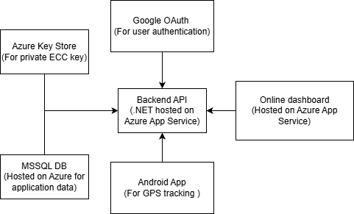

Each major component of the system is shown above. Google OAuth, Azure Key Vault and the database are all critical to the application's functionality, but they are secondary to the completely bespoke parts (API layer, Android app, dashboard). The heart of the project is the API, which handles everything from homomorphic encryption (data processing and decryption) to RBAC and user/device management. This is where most of the programming will occur, as it is by far the most complex component. The Android app is the second most important component because it encrypts raw GPS location data. Although users could create their own Android application to use with the system, there is little to no configuration available on the “client” side. The web dashboard is intended for individual users or small- to medium-sized businesses that lack the means to integrate the CyberTrack API into their own systems. Large businesses likely have more complex needs for location data and geofence calculations, so the API can be used by anyone to pull data into existing systems or to create a custom interface, if they wish. Although the online dashboard isn’t essential to the application's functionality, it greatly benefits both the development and testing of the system as a whole.

Database design
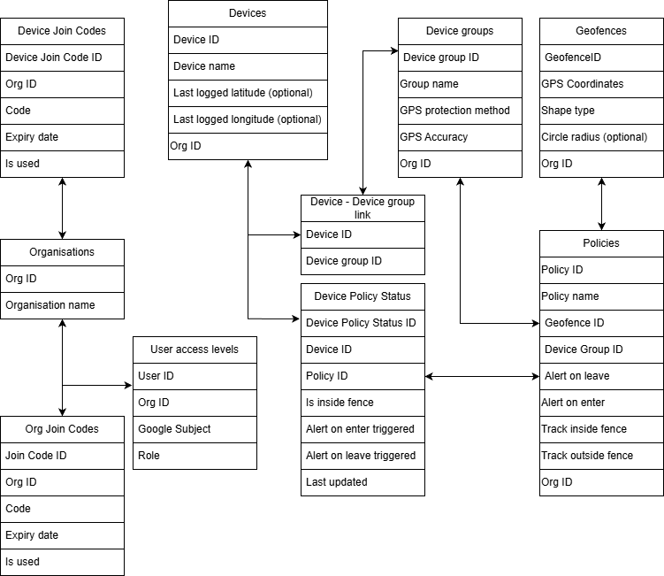

Platform evaluation
During the design phase of this project, several hosting platforms were evaluated, including Azure and AWS. Due to the financial limitations of this project, any cost would have to be subsidised through a student subscription or free trial. This narrowed the options; however, Azure was the best overall solution for the project's requirements because it offered $100 of student credit. Most small services used in the project will be free of charge, but a balance will be required if any resources are used in excess.

Database
The database selected is the free tier of MSSQL Server. This has some minor drawbacks, including a storage limit and periodic offline periods to save resources. The storage limit is very unlikely to cause issues for a university project, as the cap is 32 GB; however, if any issues arise if CyberTrack is used commercially, the fix would be to switch to a paid subscription. The resource-saving offline feature is inconvenient for development, as it takes 2-3 minutes to wake the database; however, the same logic applies to this issue as to the previous one regarding the fix.

Web server and .NET layer
Both the web server and the .NET layer will be hosted on Azure Web App Service, which is free. Hosting both components inside a single service reduces the complexity of authentication and development. It also has the added benefit of ensuring that both components are active and inaccessible simultaneously, meaning the website is accessible only when its API counterpart is active.

Key storage
Once again, Azure Key Vault is free, except when you exceed certain rate limits ($0.15 per 10,000 transactions). This is unlikely ever to be charged against the $100 of student credit. Still, even if it were, it would be largely insignificant and, once again, could be moved to a different Azure subscription for a commercial deployment.

Android app
After some research into the mobile IoT market, Android is commonly used as the operating system due to its ease of development and modularity. GPS tracking and encryption are essential in geofencing applications, and there is a wide choice of libraries available for these key processes on the Android platform, allowing more freedom and control over how the endpoint app functions.

Maps API
Although using Google Maps was a likely candidate at first, it is a rate-limited service. This rate limit is high enough that it is not a concern during development, but it does require payment information to generate an API key. Leaflet, an open-source mapping library, was the final choice for this application because it offers a comprehensive feature set, including the ability to load arrays of GPS coordinates onto the map for visualisation, which would be useful here. Although it does not provide a satellite view, the trade-off is offset by its ease of use.

Identity provider and authentication
While Entra ID (specifically Entra External ID) may be the obvious choice for an application hosted primarily on Azure, a few key limitations arise. In the university Entra (different to Entra ID) tenant, students are not permitted to create a new Entra External ID due to insufficient permissions. Standard Entra ID can be used, as it does not incur any cost; however, it is an internal solution meant for managing business users and does not provide any form of signup, making it unfit for use in this application. Creating a new Entra tenant is not feasible due to the upfront cost of buying a Microsoft Entra ID License, which costs £4.60 per user per month. Instead, Google OAuth was chosen as the most suitable path forward after some experimentation, since most people have a Google account, reducing inconvenience for the end user. OAuth is also widely documented, making implementation easier. There is a cap of 49,999 monthly active users for the service to remain free; however, this is very unlikely to be reached during development and can be paid for in the future for large-scale commercial use.

Encryption system

Homomorphic Encryption
Homomorphic encryption is a type of encryption that allows data to be processed without first decrypting it. In a typical geofencing system, data is decrypted before any calculations are performed, exposing the raw location data during processing. Homomorphic encryption avoids this by allowing computations to be performed directly on encrypted data. The results of these calculations also remain encrypted and can only be decrypted by someone with the correct key. In this project, Microsoft SEAL is used to implement this idea, enabling secure operations such as addition and multiplication on encrypted values to enable geofence calculations without sacrificing privacy or security.
This is particularly well-suited to geofencing because it handles IoT device location data, which can still be sensitive even when not directly tied to individuals. Location data can reveal useful but sensitive information about how an organisation operates or where its assets are located. By keeping everything encrypted during processing, the system reduces the risk of exposing raw location data at any point, whether it is being sent between components or handled on a server. This aligns well with the overall goal of protecting data while still allowing useful computation.
One of the main advantages of homomorphic encryption is the level of privacy it provides. Since data never needs to be decrypted during processing, the chance of sensitive information being exposed is greatly reduced. This is especially useful in distributed systems where data moves through multiple services, as it would if an organisation were to utilise CyberTrack’s API directly. It also helps support data protection requirements by keeping information secure throughout its entire lifecycle. However, there are drawbacks. The biggest issue is performance, as homomorphic encryption is much more computationally expensive than standard encryption methods. This can result in slower processing times and higher resource usage, which is a concern for both resource-limited IoT devices and the server infrastructure running CyberTrack, where processing costs can scale with CPU usage. It also adds complexity to the system and limits the range of operations that can be performed efficiently.
Even with these limitations, homomorphic encryption is a strong fit for this project because it strikes a good balance between security and functionality. It enables meaningful processing of sensitive data without ever exposing it in its raw form, which is perfect for the privacy requirements of an IoT-based tracking system.

Homomorphic Encryption Schemes – CKKS vs BFV
Although homomorphic encryption itself is already complex, there are two different “schemes” within the Microsoft SEAL library, which is the most widely used library for homomorphic encryption:
- Brakerski / Fan-Vercauteren (BFV)
- Cheon-Kim-Kim-Song (CKKS)
Both schemes function in practically the same way but have trade-offs due to their design. CKKS was specifically designed to work with floating-point numbers (such as GPS coordinates) and is primarily used for machine learning and statistical operations. In contrast, BFV is more suited to whole numbers and Boolean logic. Despite the initial instinct to use CKKS for its ability to perform floating-point calculations, it introduces slight randomness into the encryption process to prevent identical data from producing the same ciphertext. Although the chance of this affecting typical floating-point comparisons is low, GPS coordinates are highly sensitive to change. They would be inappropriate to implement in a system where false positives for leaving a geofence could become very common.
Instead, BFV will be used as it retains accuracy during encryption. However, because it does not support floating-point numbers, GPS coordinates and distances must be scaled by 10^10 to ensure that, regardless of the number of decimal places, calculations can still operate on the ciphertext. This has no real drawback other than having to reverse the amplification when presenting the data on a map. BFV is also faster than CKKS for single operations, as CKKS was designed for high throughput to speed up the processing of encrypted datasets.
Since the system only needs to compute a binary outcome indicating whether a device is within a radius, BFV will be used, as it is better suited to the application's needs.
Luckily, running SEAL on a .NET server is relatively simple because GitHub Workflows can compile it on each deployment. Integration between the C# and C++ (SEAL runs on C++) code is relatively simple using a “wrapper”, which is effectively just an API between two languages. This is not so simple to do on an Android device, however.

Android SEAL integration
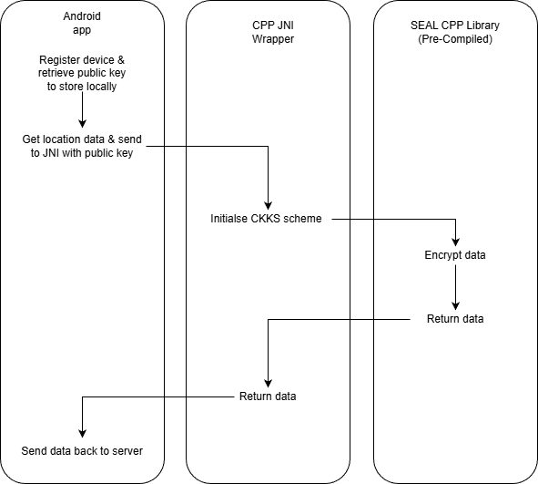

To use Microsoft’s SEAL library on an Android device, it must be precompiled as a .a or .so static library and then imported into the project. Since most (but not all) Android devices run on ARM architecture, native C++ libraries like SEAL must be cross-compiled using the Android NDK to ensure compatibility. Using static linking simplifies the deployment of the library because all dependencies are bundled into a single library, rather than requiring many libraries to be downloaded and compiled at runtime. The compiled library cannot be used directly from Java files inside the app. Instead, a JNI (Java Native Interface) bridge serves as the API between the two. This enables encryption operations to be invoked from the Android application layer.

RBAC System
Role-based access control is essential to any multi-user system, allowing privileged users access to certain features that others should not have. CyberTrack will use 4 classes of users within its RBAC system and have the following escalation rules:
- Root user – User who created the organisation. This user privilege cannot be edited. Has the power to elevate and remove other users to and from the Administrator role
- Administrator – Can add and remove standard users from the “Elevated Privilege” role
- Elevated Privilege
- User
With these four roles, there are a variety of role-specific actions, meaning that interaction with the CyberTrack interface (both through the dashboard and directly via the API) can be performed from a range of accounts with varying levels of access to prevent abuse of internal organisational privileges. The following tables show the differing access levels among the account types.

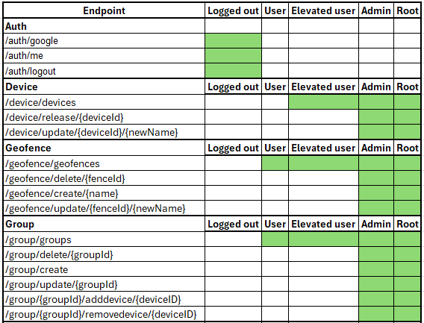

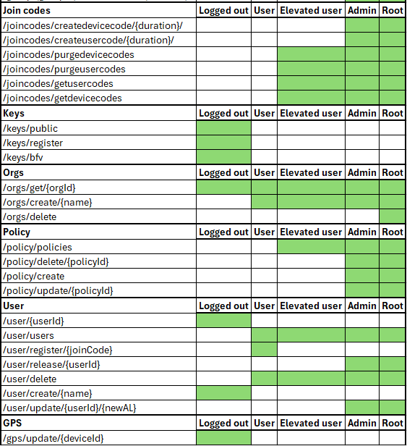

The Root user account is designed to be used only for initial setup and creating Administrators. From there, the administrator accounts can be used to create user join codes to invite further users to the organisation. Administrators have the same privileges as the Root user but cannot “dethrone” the Root or delete the organisation. Elevated users can see the exact locations of devices if the device is location-tracking enabled, while standard users can only see device status updates. This model is not intended for use with the UI, as a real-world setting would only need a single user to view device locations, but it is aimed at situations where CyberTrack will be implanted into an existing system using the API, where an organisation uses different levels of user accounts to ingest data into their own systems appropriately.

Wireframes and UI draft
Before starting dashboard development, it was important to have a rough design style in mind to ensure consistency across the site. Having a mixed design style in both theme and functionality can lead to user confusion, with inconsistencies perceived as lazy design choices. With so many features available in the API, an easy-to-understand UI layout is essential to help new users navigate the service's menus. Some basic wireframe diagrams were drafted prior to finalising design choices, as it is often impractical to have concrete designs in mind while developing an application in an agile manner, as previous assumptions or design choices may not work in practice.

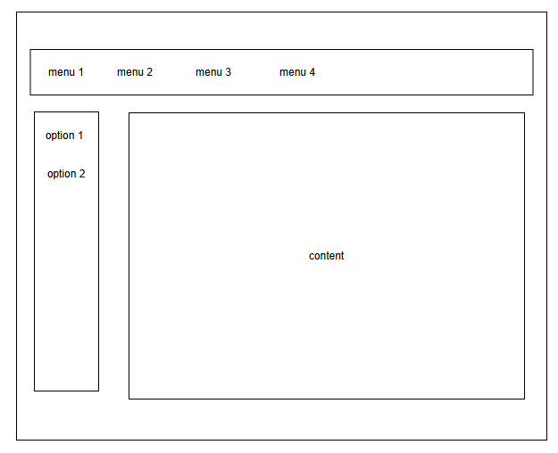

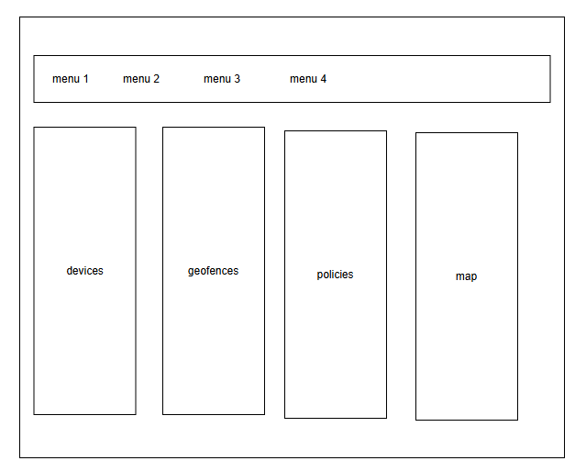

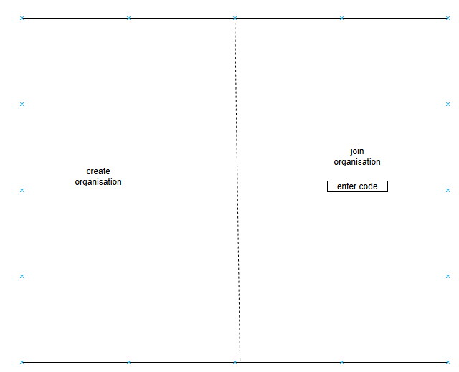

Risk Assessment

Pre-Mitigation Risk Assessment
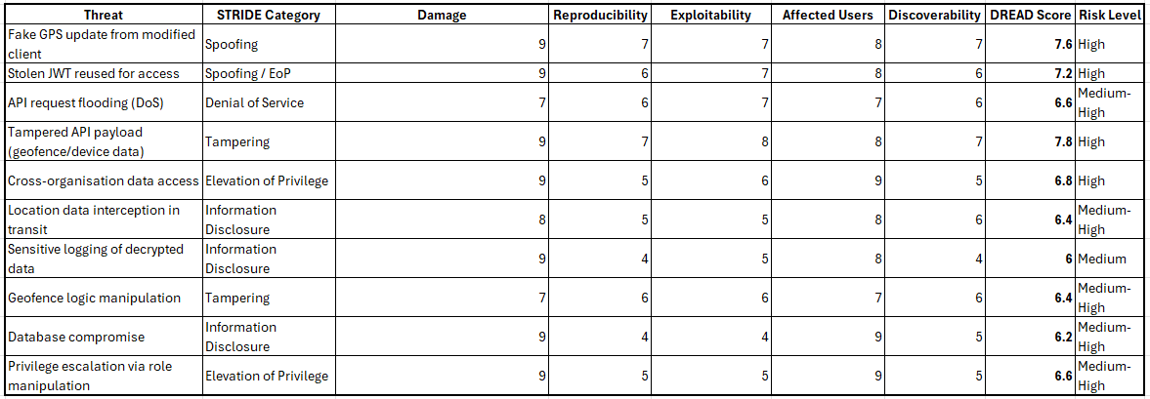
Building any publicly accessible application will always carry risks of data breaches or misuse. A STRIDE/DREAD risk assessment has been performed to identify the 10 most prevalent risks in CyberTrack if it were deployed without any security or privacy considerations. The highest risk threat would be tampering with an API payload sent from a device, as this would imply the attacker has full control over a device running the CyberTrack Android app. In a real-world scenario, although unlikely, this could be done to mimic legitimate device movement while an attacker commits a crime, i.e., stealing an organisation's vehicle or equipment. This would be extremely damaging to any trust organisations place in CyberTrack. To mitigate against these threats, the following will be implemented.

Risk Mitigations

Fake GPS updates from modified client
To reduce the risk of this threat, authentication hashes will be included in the GPS updates. These hashes will be created using a key derived from the server's X and Y public keys, and the device's own X and Y private key pair, which then encrypt the payload to act as a checksum. This will reduce the likelihood that an attacker can spoof a GPS update.

Stolen JWT reused for access
This is a commonly used threat vector in computer systems. The only way an attacker could obtain a JWT is by first gaining access to the user's computer. This would already be a massive security compromise, since the attacker could target the user’s CyberTrack account. However, to prevent repeated attacks, CyberTrack JWTs have a 1-day expiry, meaning the attacker would have only 24 hours of access to the user’s CyberTrack account.

Tampered API payload
This is a similar threat vector to 7.2.2.1, and can be mitigated in the same way. Although there are ways to get around Message Authentication Codes (MACs), it isn’t feasible to spoof GPS location updates sent so regularly.

Cross-organisation data access
Although simple, a highly effective measure of denying access to any organisation outside of the registered user’s has been implemented within the wider RBAC system. This will not allow any user to access any data outside of their own.

Location data interception during transit
Location data will be homomorphically encrypted during transit and at rest, which not only enhances security during processing but also significantly helps prevent Man-In-The-Middle (MITM) attacks. BVF encryption can provide 128-bit security, meaning there are 2^128 possible decryption keys, making it highly unlikely that anyone could read the data if they intercepted it.

Sensitive logging of decrypted data
Although this could be a concern in some scenarios, data is logged for debugging purposes only through the browser, meaning the available logs are essentially the same data the user is viewing in the UI. Data is only decrypted when presented on the map, meaning it is in raw format anyway. Data is always encrypted during processing and at rest, meaning logged GPS coordinates are never readable.

Geofence logic manipulation
An attacker could technically attack the geofence configuration itself to spoof the presence of a device inside a geofence by modifying the radius to include an area of their choosing. This would mean a device could report that it is still within the allowed bounds when it is actually outside them. This can easily be mitigated by once again utilising the RBAC system implemented in CyberTrack.

Database compromise
Database compromise would typically be catastrophic. This is mostly mitigated against by encrypting the most valuable stored data: GPS coordinates. However, attackers could use the compromised database to infer the scale and value of an organisation's assets by identifying device names. Although a breach would still be bad, no real damage would result.

Privilege escalation via role manipulation
Poorly configured RBAC or non-existent systems could allow a user to change their own account type within an organisation, enabling them to do anything within it. To prevent this, the implemented RBAC system does not allow any user to change their own user privilege. Also, it does not allow any user to change another's privilege to a level equal to or higher than their own, preventing an attacker from traversing accounts to gain higher system privileges.

Post-Mitigation Risk Assessment
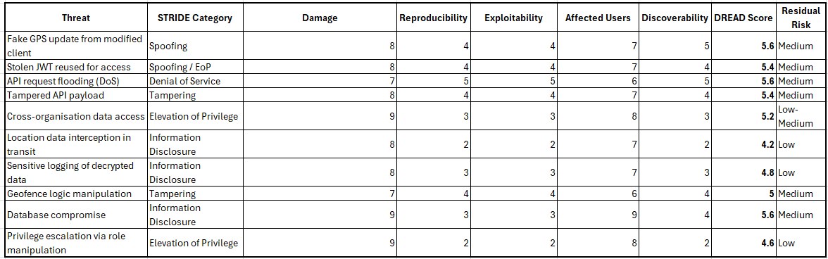
Following the implementation of appropriate risk mitigation measures, the higher-severity risks have been reduced to an acceptable level. It is never possible to eliminate all risk to a computer system, so risk mitigation is more about bringing risks down to a level that users can willingly accept. Risks also increase and decrease over time with system updates, so if CyberTrack were to continue development, more risk assessments would be needed to align with added features and project modifications.
Active threats such as DOS attacks are largely an issue that cannot currently be addressed further due to the limited resources of a student project, but in a commercial environment, such threats could be easily mitigated by purchasing more server instances or, even better, by hosting the service across multiple geographic regions.

Development

CI/CD
To aid with the development process, a CI/CD pipeline is being used to automate deployment to the Azure server. This means that any commits made to the GitHub repository are immediately deployed via GitHub workflows, allowing them to be tested. This saves considerable time compared to developing and deploying the app locally upon completion. Although in a commercial environment there would be separate production and development deployment servers, this is not necessarily the best approach for a 1-person development team. If the application were to gain traction and attract active users, setting up a dedicated development server would be relatively simple, given the automated workflow approach used.

API Development

API Structure
The API is implemented in .NET/C #. This approach is highly modular and allows for very easy maintenance and modification. Each unique API path (i.e.,/gps or /geofences) has its own C# file, dedicated to all API subfunctions such as /devices/getinfo or /devices/release. Having so much functionality dependant on the API means that the expansive amount of code required needs to be easily navigable. Shown below is the full API documentation for each endpoint, including methods, inputs, returns, status codes and their purpose. All endpoints require a valid signed JWT cookie to be present in the browser to work, except for/auth/google, which issues the JWT. This endpoint works by receiving a Google authentication token, verifying it, then signing the Google Subject (unique identifier for each Google user) to store in the browser. Each endpoint has been tested during the development phase to ensure no unexpected error codes are returned to the user.

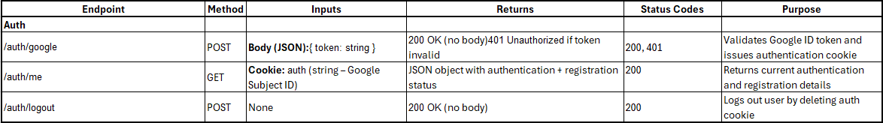
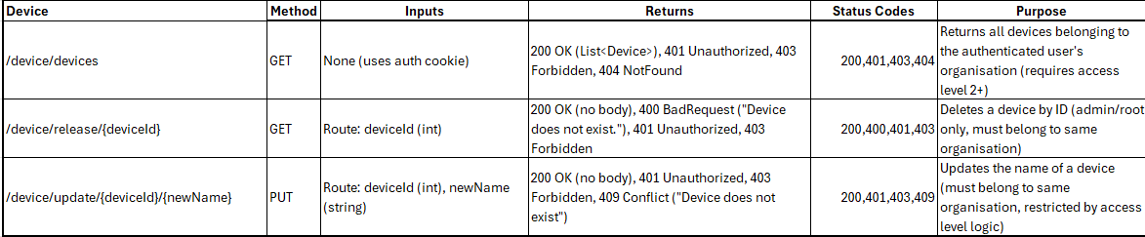

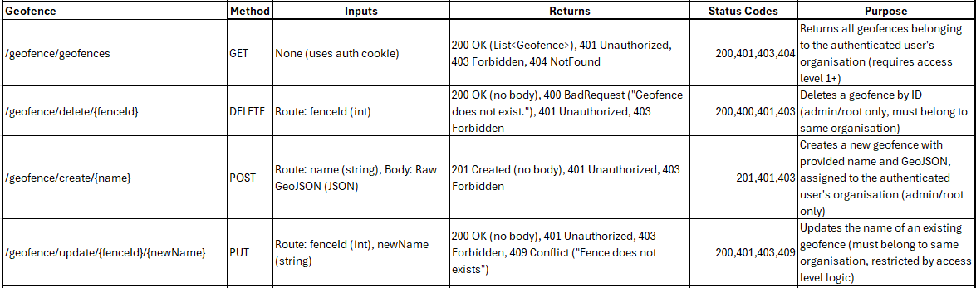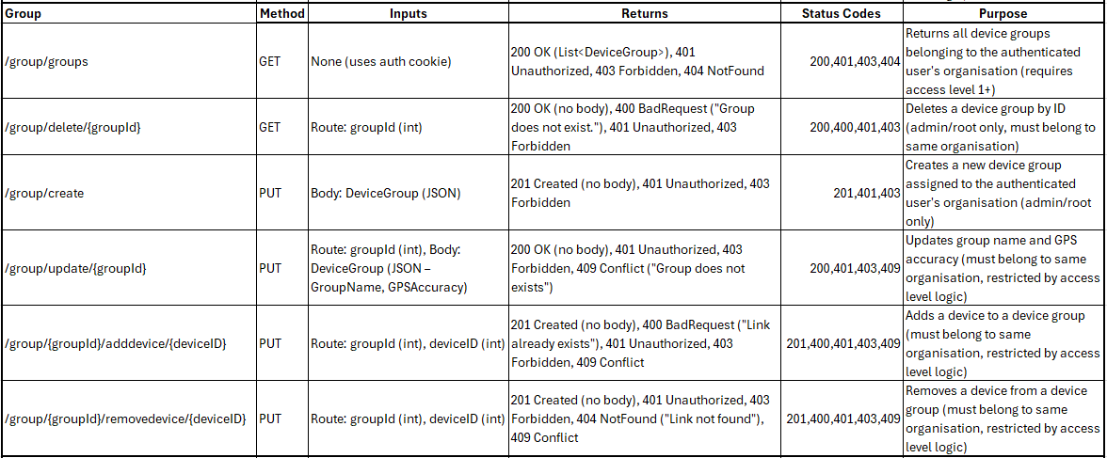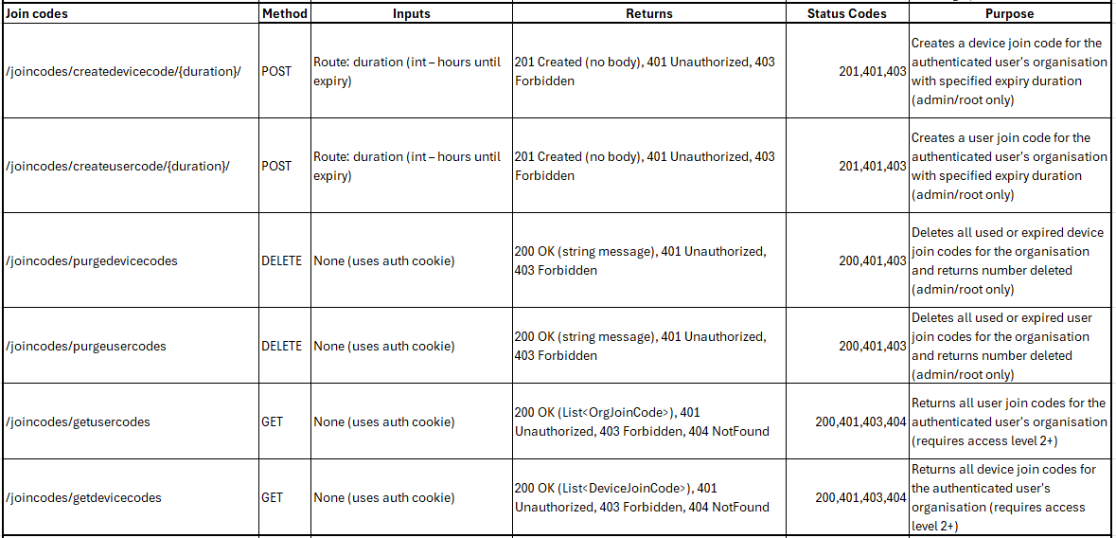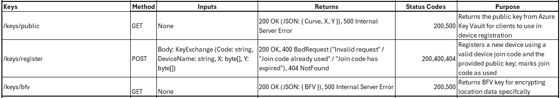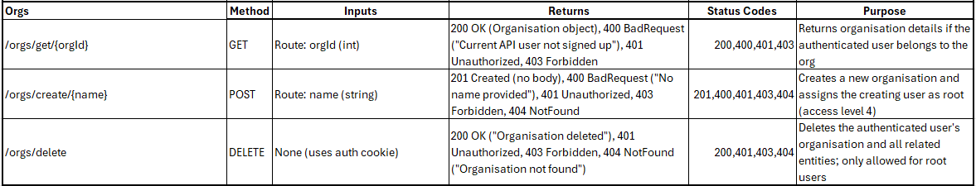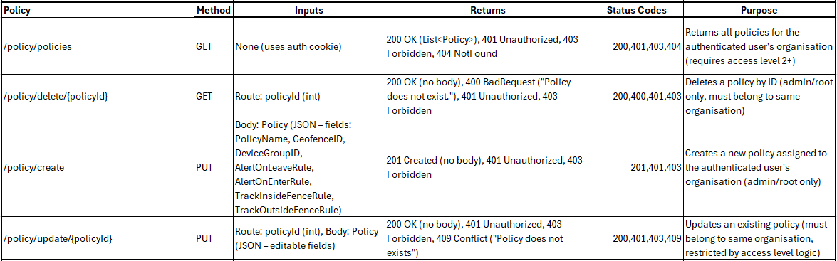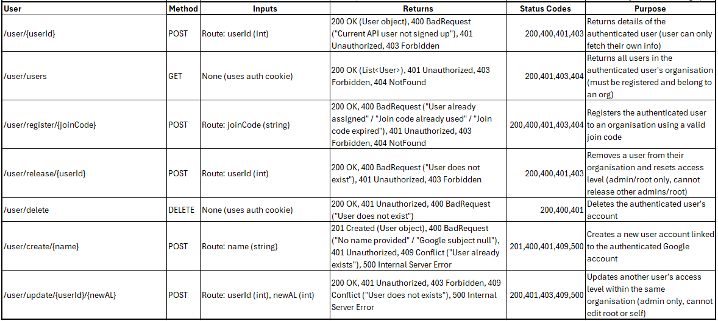

Receiving and processing encrypted data
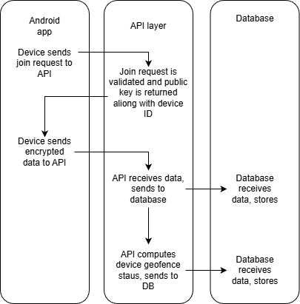

Encrypted data is received by the API over the /gps/update endpoint from the Android app. Inside the sent data is a signature to verify that the device is who it says it is, along with the homomorphically encrypted X and Y coordinates. This is processed by the API, which fetches all device groups the device belongs to and all policies associated with those groups. It then iterates through all the applicable geofences and updates the device policy status accordingly. If tracking is enabled for the device group, the location will be saved in encrypted form in the database to be viewed by a user later. This will be decrypted on demand and sent to the dashboard.
Alternatively, privacy-conscious configurations, where location tracking is disabled everywhere, will only be viewable on a device status page, indicating whether the device is inside or outside the geofence, never revealing a location. To add extra privacy to this configuration, a device’s location will never be updated unless the device has just moved into or out of a geofence, meaning that even if the homomorphic encryption keys were compromised alongside the database, no live location would be available for an attacker to use maliciously.
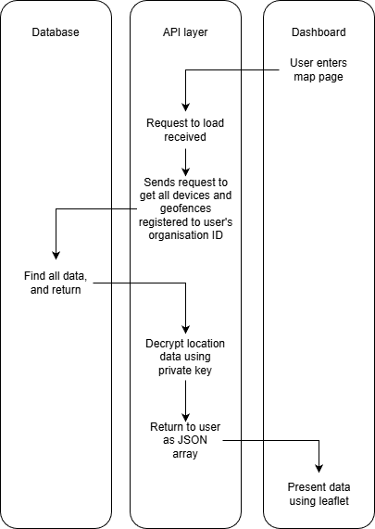
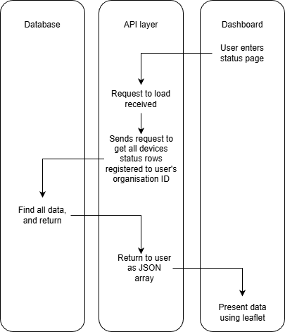

Authentication and authorisation flow

Authentication
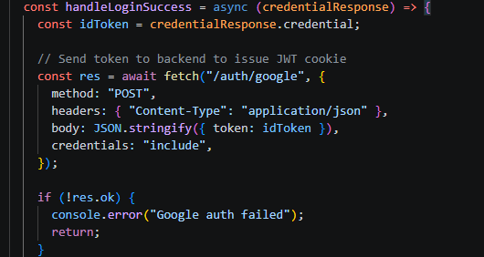
Before accessing any of CyberTrack’s API endpoints, the user has to first log in with google to register an account in the CyberTrack database. This is done using Google’s OAuth’s API. The front-end dashboard prompts the user to log in with Google. Once this is complete, the front end sends the OAuth token to the API for verification.
Following this, the auth/google endpoint verifies if the login token was signed by Google. If it was, a CyberTrack issued JWT is sent back to the browser as a cookie. This JWT is made up of the Google Subject, which is then “protected” (encrypted) using the .NET DataProtector.
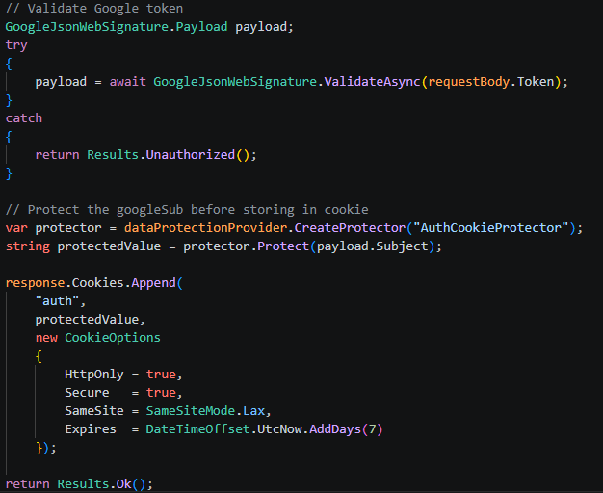

Authorisation
The implementation of the RBAC system has to be done properly to ensure no escalation of privilege attempts are successful. This includes everything from input validation to zero-trust access. Every time an API endpoint is called, a new CurrentUser class is initialised.
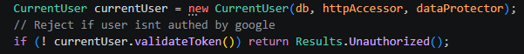
This object retrieves the JWT from the user's browser (if present) and validates it with the DataProtector class to ensure the user actually exists and that the JWT was issued by CyberTrack.
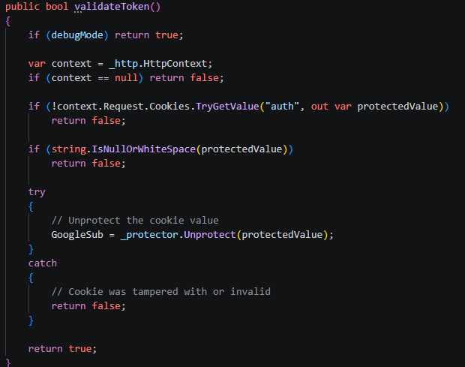
If the JWT is valid, the user’s information can be fetched from the database, and further RBAC checks can be made.
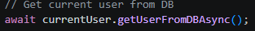

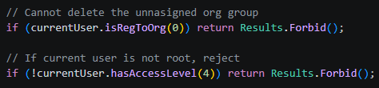
In this example of the /orgs/delete endpoint, the API first verifies that the user is actually registered to a real organisation (since unregistered users are given the OrdId 0 as a placeholder). If the user is registered to an organisation, it then checks if they are the root user of the organisation. Only after both of these checks are completed, the function begins recursively deleting all items with the user’s OrgId.

To prevent privilege escalation within the system, input validation is performed on the user/update endpoint to ensure that no malicious code is inserted into the database. First, declaring the new access-level variable as an integer and then wrapping the code in a try/catch block prevents non-integer values from being passed to the API. The endpoint then checks whether the user performing the action is in the same organisation as the user being escalated, and then ensures that the target user is not the same as or higher in privilege than the user performing the action. Finally, it is checked whether the user is attempting to escalate their own access level and whether the user is an admin. Only once all of these checks have been completed successfully is the target user's access level changed.
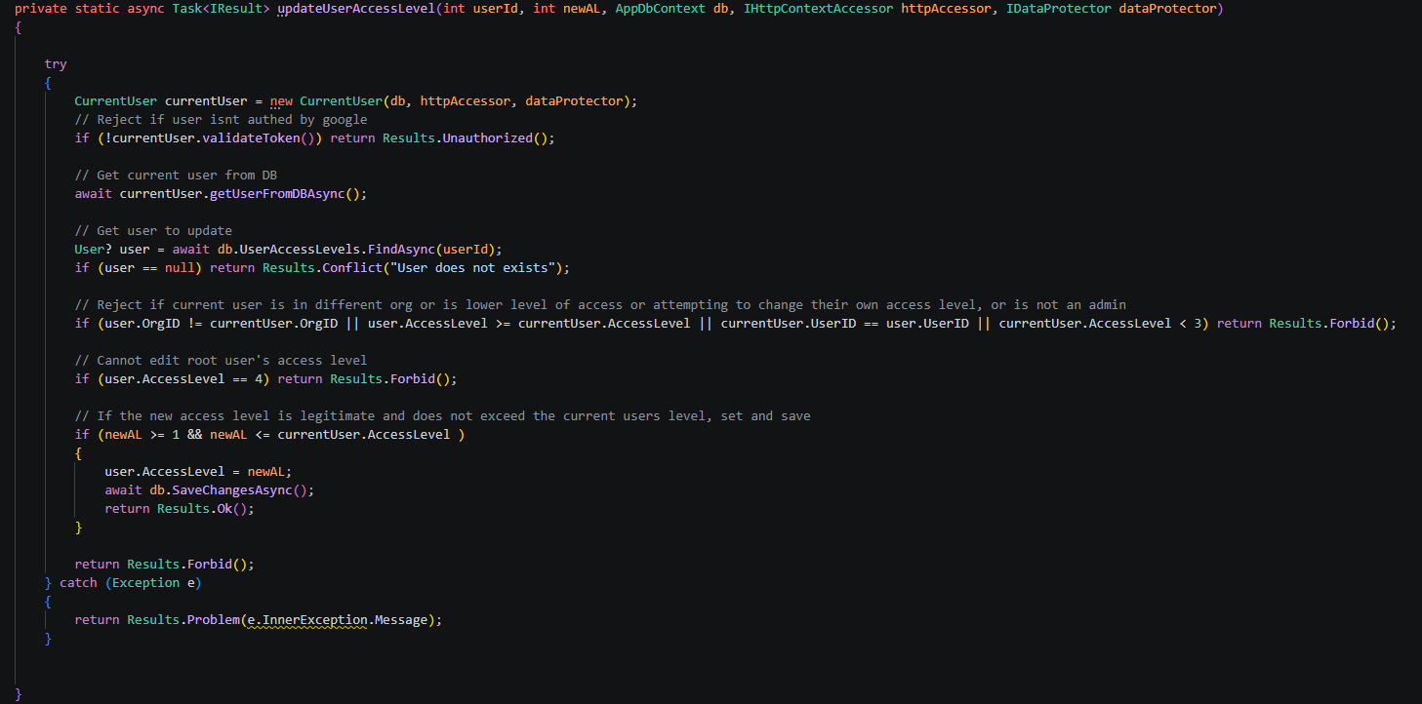

End-project report

Testing

Unit testing
Unit testing will be conducted less formally than other testing due to the project's agile nature. It would be infeasible to complete a formal unit test for each component of each service in the full application due to the sheer volume of code that is modified as more efficient source code is developed or old code is deprecated and replaced. Instead, each “unit” (function or class) will be tested during development for unexpected outcomes or errors. Any anomalous results were patched immediately after testing, as evidenced by the large quantity of “Bug Fix: …” commits to the GitHub repository. This was an effective way to mitigate major system integration bugs when the larger system components (API, Dashboard, Android app) were finally coupled.
One formal unit test was performed on the API to verify that RBAC was implemented correctly. This was essential to test, as the one-line access-level checks in the API were easy to miss but could lead to mass deletion and leakage of location data, and even cross-organisational damage, which would be completely unacceptable. The expected outcomes were defined during the API design phase, when access levels for each endpoint were introduced. This made it easier to implement during development, but did not negate the need for formal testing. The table below presents the results of RBAC testing, including cross-organisational tests to ensure users cannot manually request data from other organisations via the API.

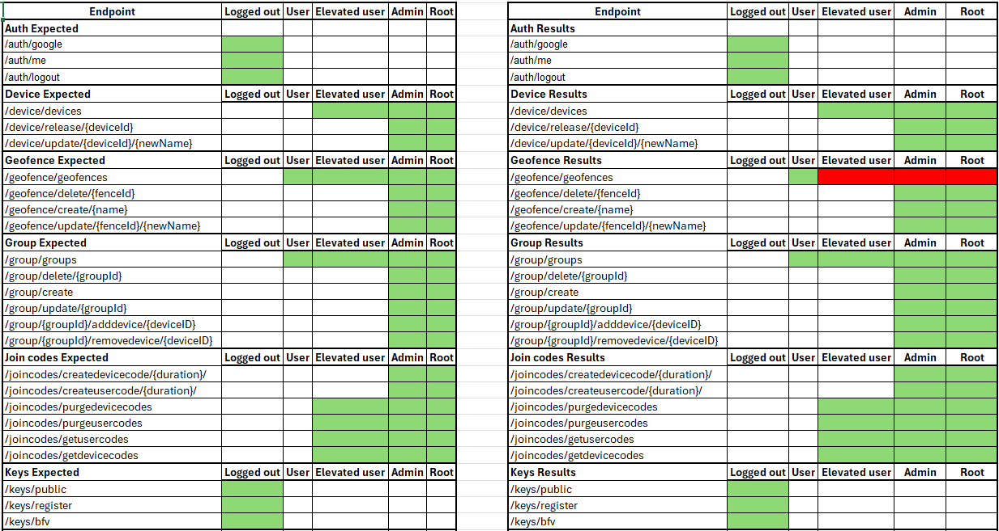

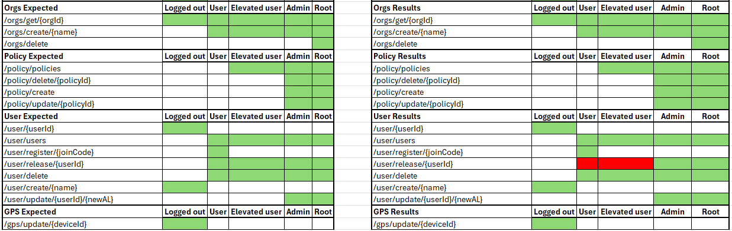
The results from the unit testing were mostly positive, with all endpoints behaving as expected, apart from the geofence/geofences endpoint, which, on review, was due to a simple mistype. This wouldn’t have affected any security or privacy aspects of the system, but would have prevented all users but the base user from viewing geofences. This error was caused by checking whether the user's access level was equal to 1, rather than greater than or equal to 1. Although insignificant, errors like these highlight the importance of unit testing to ensure that unexpected results do not make it into the final version of a system.

To remedy this error, a new function was created inside the currentUser class to perform comparisons. This improves code clarity and reduces the likelihood of similar mistakes in the future.
The only other unexpected result was an overlooked feature: all users should be able to access the users/release endpoint to leave an organisation manually. This feature was never implemented in the dashboard before testing, once again highlighting the need for unit testing. To enable this functionality, the user/release endpoint had to be reworked to include a statement allowing any user, other than the root user, to leave an organisation.
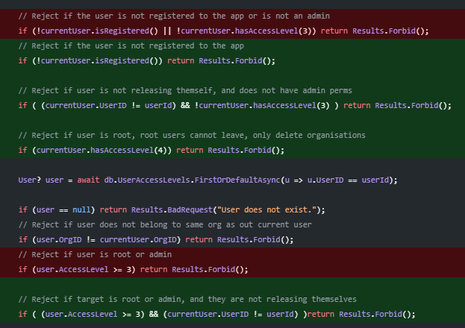
The above modifications were made to prevent a base user or elevated user from being stuck inside an organisation. While making these changes, it was also decided that a root user should never be allowed to leave an organisation to prevent an organisation from existing without a root. Instead, the root user must delete the organisation. It was considered whether having an option to hand over organisational ownership would be a better route, which would also raise additional security concerns. An attacker with access to a root account is far easier to deal with (changing the Google password) than an attacker who transfers root to their own malicious account that no one can remove from the organisation, which would ultimately lead to manual database editing to revert the changes, or having to create a new organisation and set up new geofences/policies.

Integration testing
Integration testing was the most important aspect of this project, as it ensured that each part of the system interacted with one another as expected. Bugs found during this testing could require significant effort to diagnose and fix due to the many interacting components. For example, a failed /gps/update API call could be from the server not receiving the request correctly, the Android SEAL library failing to encrypt data, or the Android API class failing for an unknown reason. However, due to the informal unit testing, errors like these were very infrequent. Testing was performed via the online dashboard, iterating through a list of key system functions that require communication among the 3 core components (API, dashboard, Android app). The following table was used to set expectations and to record results.
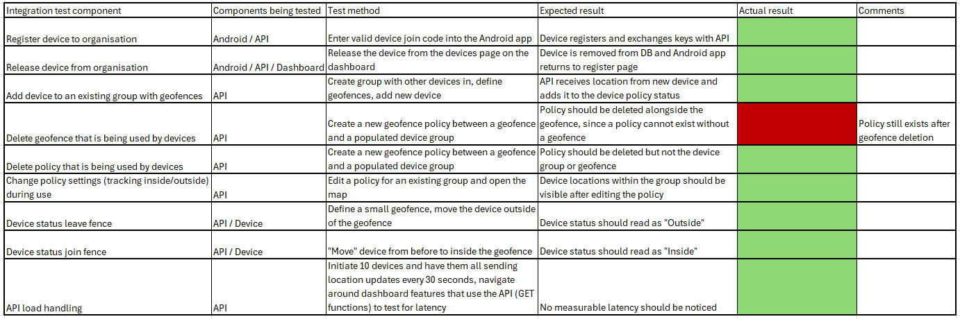
As shown, 8 out of the 9 tests passed successfully. Only a single test failed, which tested a one-to-one entity relationship: one policy belonging to one geofence. When the geofence is deleted after being linked to a policy, the policy still exists. This is an issue since a policy acts as the link between a device group and geofence, so the system tries to iterate through a list of devices and compares it against a geofence, only for the geofence to not exist, which causes the system to falsely report all devices as being “outside” of the geofence, due to the existing logic that defaults the isInsideFence variable to false. This could cause major issues if CyberTrack were implemented in another dependent system, as all devices registered under that policy would simultaneously report being outside a fence. If the devices had tracking enabled, this wouldn’t be too problematic, as a manual review would reveal that it is clearly a bug. But with tracking disabled in an automated system, this bug could easily escalate into a larger problem. To fix this, policies are now automatically deleted if either the geofence or the device group they belong to are also deleted.

User acceptance testing (UAT)

Test design
Because CyberTrack is inherently complex software, users must be confident in their ability to operate it to avoid mistakes that could lead to catastrophic data breaches or loss. To measure user confidence and the application's ease of use, 2 rounds of testing will be conducted, with 10 or more participants in each round. To measure quantifiable change between rounds, the same set of people will be asked to repeat the test after bug fixes or system improvements are made. This will provide comparable scores between the two rounds, with the goal of high average scores for each question and a positive increase in scores between rounds of testing. Before entering the survey, participants are presented with a consent form to record their scores for analysis and are informed that no personal data will be captured during testing, to reduce the likelihood that any personal bias or leniency will be reflected in the scores. This will hopefully result in a low variance across participants' scores. User acceptance testing can be highly subjective, as participants included in testing may have a wide range of technical confidence, so it is helpful to analyse even the most anomalous results, as it can highlight features which may improve or require more description to cater to a less technically confident user demographic in a real-world deployment of the system.
Only the dashboard was tested by participants. This choice was made, as asking participants to test the Android app, which has a single input field, felt largely unnecessary. While technically possible, asking participants to test the API integration with an external system is not a realistic measure of improvements needed within the system itself and is more representative of the API documentation provided.
To assess a highly subjective quality metric, a scale system will be used to gauge the confidence in each major aspect of the dashboard application. In this survey, there will be 5 questions:
- A 1-10 scale of how easy the app was to navigate.
- A 1-10 scale of how easy it was to create a Geofence, Device Group and Policy
- A 1-10 scale of how easy it was to create new Device and User Join Codes
- An open-ended question to express opinions about the UI flow.
- An open-ended question to express opinions about any bugs or missing features.

To guide users, a set of tasks was provided to ensure some consistency in the user experience. Users were first provided with the link to the website, and were asked to do the following:
- Create an account and create a new CyberTrack Organisation
- Create a new Geofence
- Create a new Device Group
- Create a new Policy, linking the Geofence and Device Group
- Create a new Device Join Code
- View your Geofence on a map
- Create a new User Join Code
- Delete the Policy you created
- Delete the Organisation
This is not an exhaustive list of features available on the dashboard, but it provides a good measure of user confidence while not taking up too much of the participants time.

Testing Results – Round 1
Once at least 10 participants had completed the survey, the results were processed to determine whether any changes were needed to improve the system. A total of 11 responses were collected in the first round of testing, yielding fairly consistent opinions. Overall, most participants found the app's navigation satisfactory with an average score of 7/10.
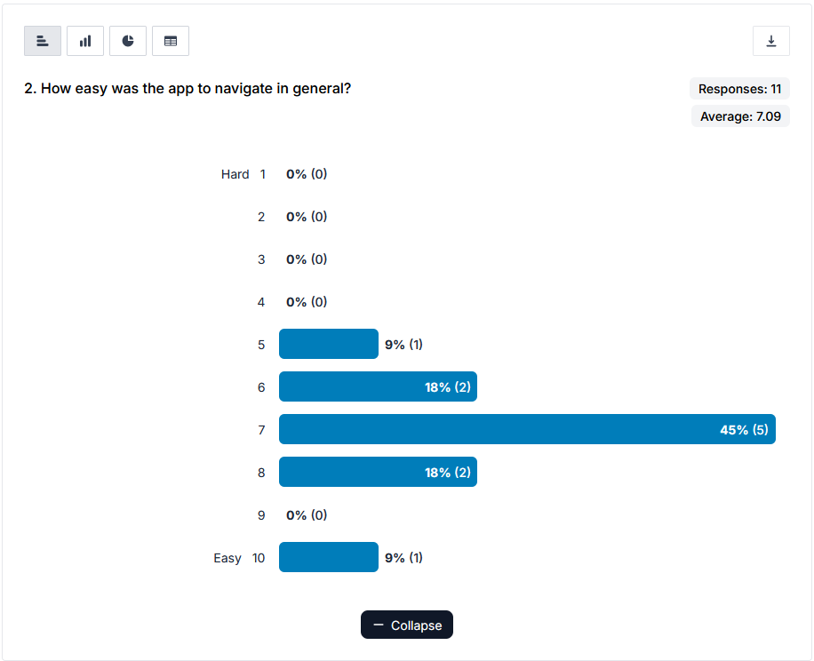

No scores fell below 6 for the ease of use of the application's primary functions. The average score of 7.6 reinforced that this UI implementation was successful and that people generally understood how to utilise the most important features of the dashboard.
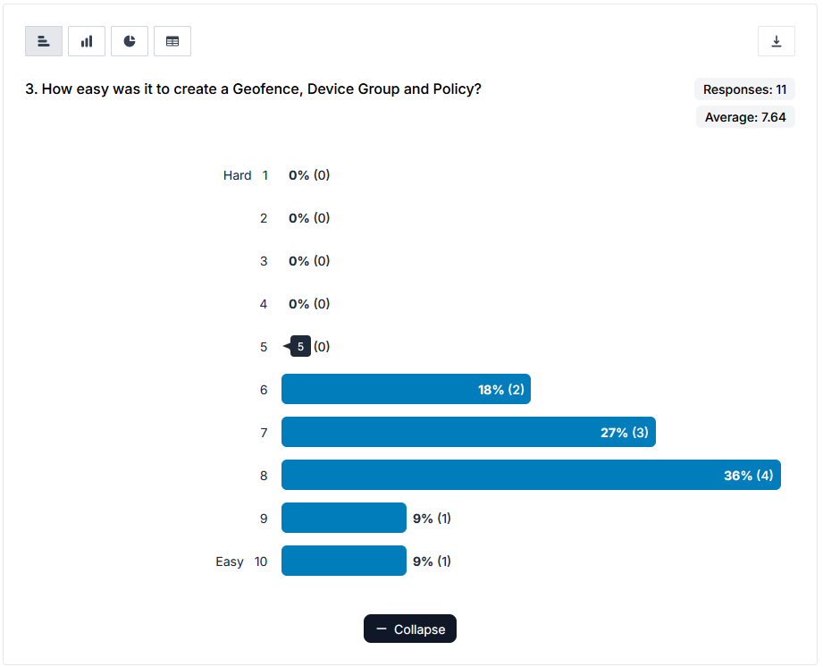

Scores, however, took a decline when participants were asked about the ease of use of the join code section, with an average score of 4.45. This section was highlighted for review before testing due to its slightly bizarre labelling under “organisation”, as it didn’t fit elsewhere. As a result of this testing, the join codes will be moved under a more appropriate tab name to clear up any further confusion.
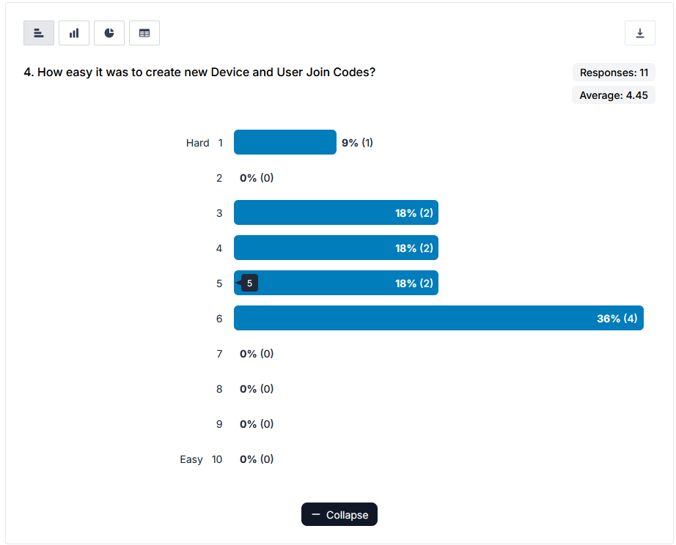

The two open-ended questions were mostly used to highlight the aforementioned issues with placing the join codes within the organisations tab, with all 9 responses across the two questions including some variation of comment suggesting moving them.
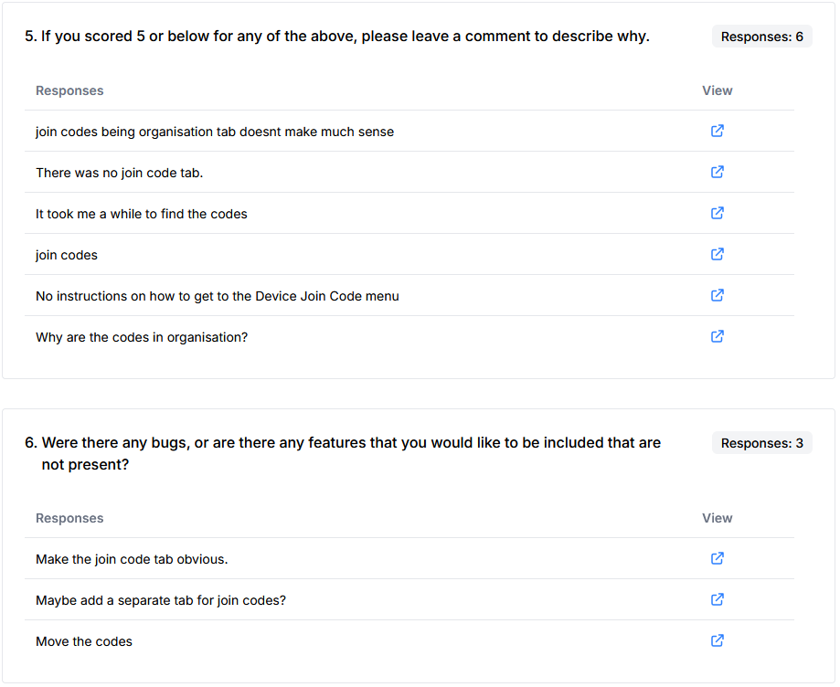

Post-testing improvements
After receiving the conclusive feedback that the Device and User Join Codes sections needed to be moved, a restructure took place. Prior to testing, the organisation tab looked like this:
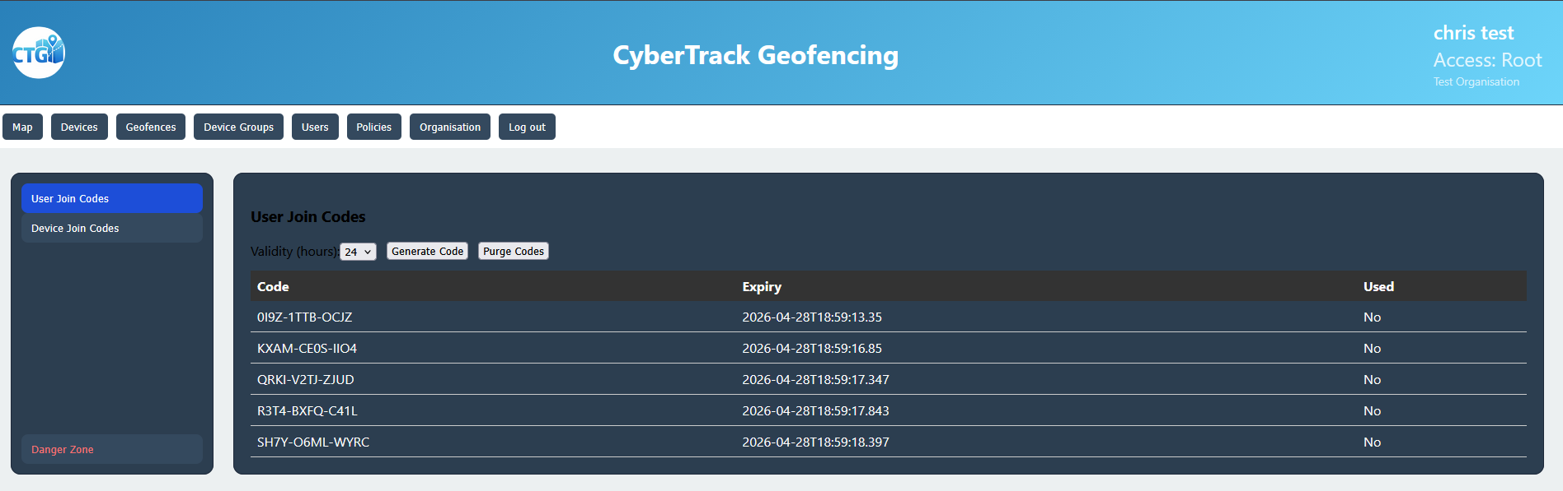
This layout is understandably confusing, as the only organisational function within this page is the “Danger Zone” used to delete the organisation. This has since been moved to its own section, labelled “Root User Menu”, and the previous “Organisation” tab has been relabelled to “Join Codes”. The same sidebar menu selector is still used, as it provides consistency across all aspects of the application's UI.

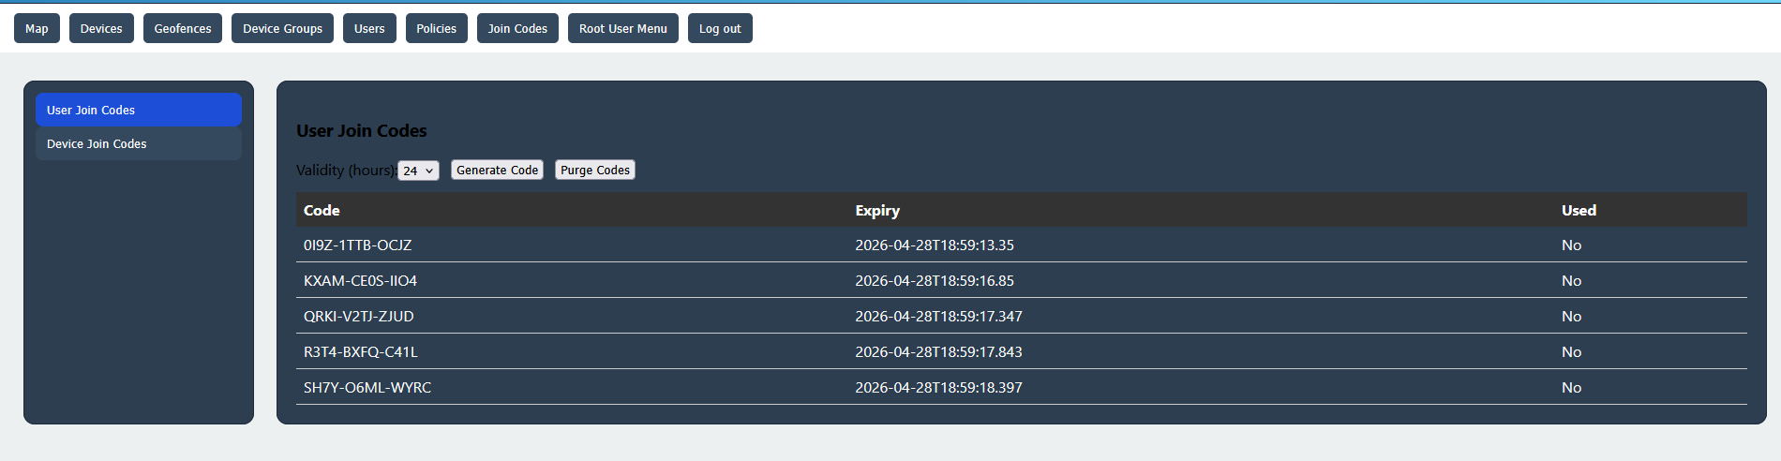
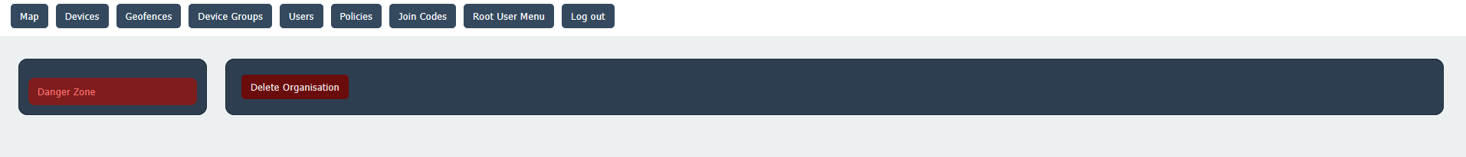
Although the “Root User Menu” tab currently has only a single item, keeping the sidebar is an intentional choice, as it allows for further expansion if more root-specific features are added.

Testing Results – Round 2
Following the improvements mentioned above, a second round of testing was conducted to identify any remaining weak points in the dashboard and to assess whether the changes helped new users navigate the app. Question 1 received a similar response to the first round of testing, with an average score of 7.36. This was expected, as only 2 changes were made between testing rounds.
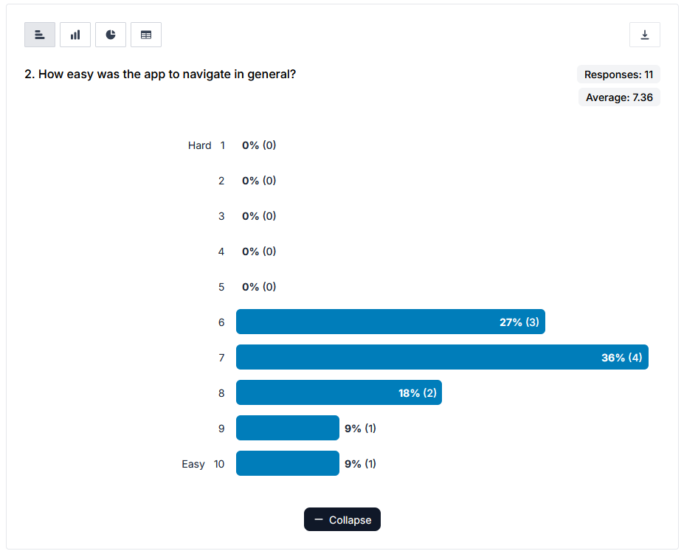

Question 2 also had a similar response to the first round, which makes sense, as nothing was changed relating to this question. The consistency of results is a positive sign because the testing participants varied between the two rounds, indicating the first round of testing was not an anomalous result.
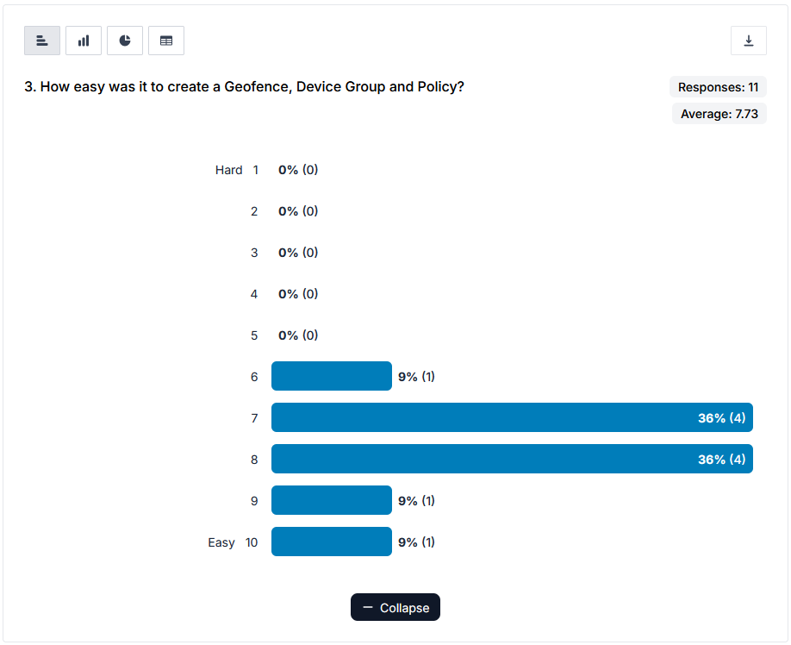

Question 3 saw a dramatic improvement compared to the first round of testing. The improvements made a measurable difference over the 4.45 average score. The second-round average was 7.73, similar to Question 2, suggesting that the changes were more than satisfactory in clearing up any confusion.

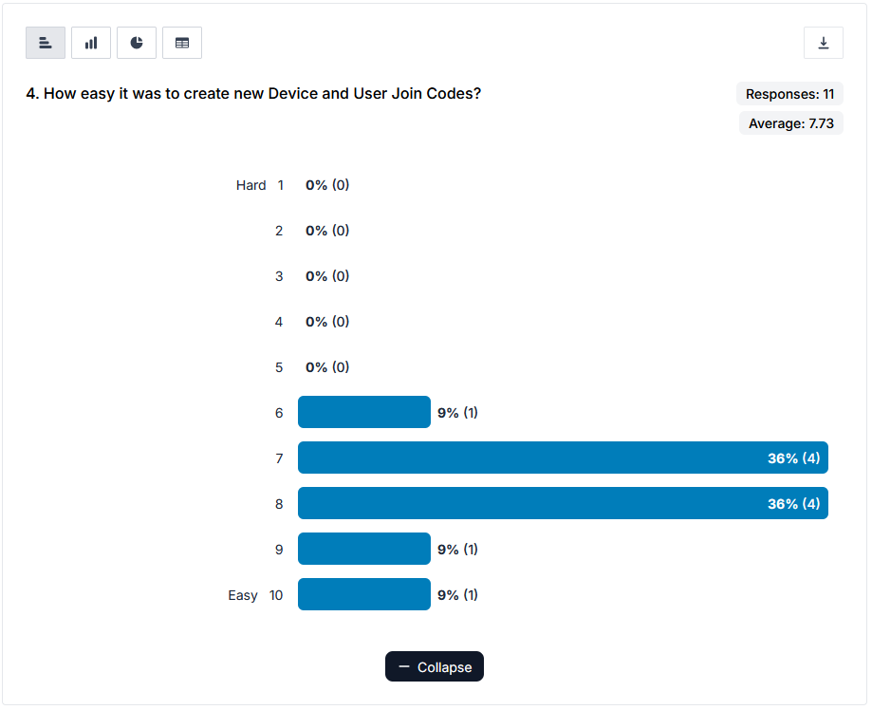

Previously, the two open-ended questions received many responses, all related to the Device and User Join Code menu. However, only one response was received in this round, and it concerned the size of the buttons in the Join Codes section, which had gone unnoticed until now because they had been left at the default. As a result, the buttons in the Join Codes menu have been updated to use the same CSS class as the others, maintaining a consistent visual standard.
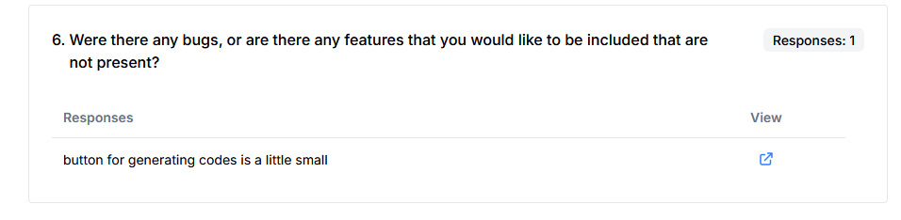

Reflection
Overall, the project went mostly as planned, with only one feature not implemented as originally planned. Original designs and discussions included functionality to allow the user to select both the GPS accuracy level and the GPS protection method (homomorphic, standard, none, etc.). During implementation, it became increasingly clear that using multiple forms of encryption would be largely unnecessary, as there isn’t really any compromise in only providing homomorphic encryption. Due to the API's highly modular design, it would be possible to implement in the future and would be a very easy feature to market in a commercial environment, with separate pricing for each type of encryption, but it is not necessary to call the project complete.
One major criticism about the project is the CI/CD process. Although automation is extremely helpful and reduces manual work in deploying code to a server, the GitHub Workflow structure could have benefited from further development. Building the API and React files for deployment to Azure took roughly 3 minutes per commit. This was inconvenient, but manageable. When the Microsoft SEAL library was added, the time increased to 9 minutes because upstream dependencies were copied and compiled on each commit. This became frustrating to wait for, especially when patching small bugs which needed to be tested multiple times. In retrospect, the more efficient approach would have been to precompile the SEAL library as a DLL, similar to how it was imported into the Android app. This would have kept the 3-minute commit time and enabled faster bug fixing towards the end of the project. An even more efficient method would have been to separate the API and React files into separate branches, so each could be deployed separately, further reducing deployment times.
Another key improvement that was considered is full database encryption. Although it's a mostly overkill feature that would drastically increase CPU usage, it would be sensible to at least encrypt the device policy status and geofence tables. Currently, with only location data encrypted, if an attacker had access to the database, it would be very difficult but possible to determine whether a device is within a geofence. It would also be possible for the attacker to manually insert their own malicious geofence to narrow down the device's location by waiting for device updates and reading the device policy status tables to determine whether the device is inside or outside the attacker's geofence. Although this attack method is highly speculative, it does provide potential attackers with a weaker path than obtaining user access credentials or brute-forcing location data.

Conclusion
The implementation of homomorphic encryption in a geofencing system has not yet been done commercially. Although CyberTrack is a student project with a limited budget and timeframe, its successful integration of homomorphic encryption into an IoT management system supports the argument that this type of encryption will become more widely used as company location data increases in value and scale. Although there are drawbacks, such as increased computational complexity in the encryption/decryption process, constant advancements in mobile device processing power mean that wider integration of this technology is most definitely a viable option for future geofencing solutions and IT systems as a whole.

References/Bibliography
https://radar.com/
https://www.woosmap.com/en-gb
https://www.microsoft.com/en-us/research/project/microsoft-seal/
https://www.researchgate.net/publication/375738637_A_Comparative_Study_of_BFV_and_CKKs_Schemes_to_Secure_IoT_Data_Using_TenSeal_and_Pyfhel_Homomorphic_Encryption_Libraries

