Introduction
Security Operations Centres (SOCs) play an essential role in modern organisations by providing continuous monitoring, detection and response to cybersecurity threats. Security Information and Event Management (SIEM) platforms are critical for enabling SOC analysts to correlate events and identify malicious behaviour, alongside supporting incident responses.
Splunk is one of the most widely adopted SIEM tools that supports logging and search-driven analysis, making it extremely valuable for SOC teams. This investigation follows a workflow closely aligned with standard incident-handling methodologies used by SOC analysts, guided by a set of questions that provide a template for the analysis.
This coursework presents a complete end-to-end SOC investigation using Splunk and the BOTSv3 dataset, simulating a realistic business network under a cyberattack.

SOC Roles & Incident Handling Reflection
During the investigation

Installation & Data Preparation
Splunk Enterprise was installed on a Hyper-V Windows 10 VM. Although Splunk is commonly deployed on Unix-based servers in production SOC environments, it provides equivalent SIEM functionality across supported operating systems. The Windows-based deployment used in this investigation did not affect data ingestion, indexing, or investigative capability.

Guided Questions
(Pictures require zooming in, screenshots are also available in the GitHub repo.)

Q1: IAM Users Accessing AWS Services
Investigation Objective:
To begin the investigation, it is helpful to know what users are accessing Frothly’s AWS services, regardless of the intent. This is so that any future activity can be referenced against the list of known users to note behaviours to be reported or questioned.
Methodology:
To get a list of users who requested access to an AWS service, a query was built to search for AWS CloudTrail logs (which capture all AWS account activity) and isolate the userIdentity field using the stats feature.
Query:
Result:
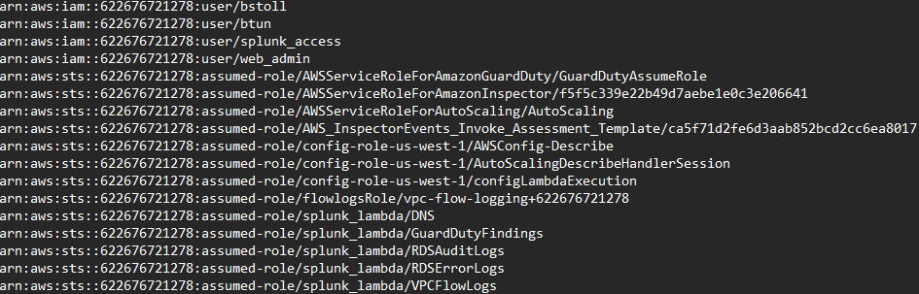
Screenshot:
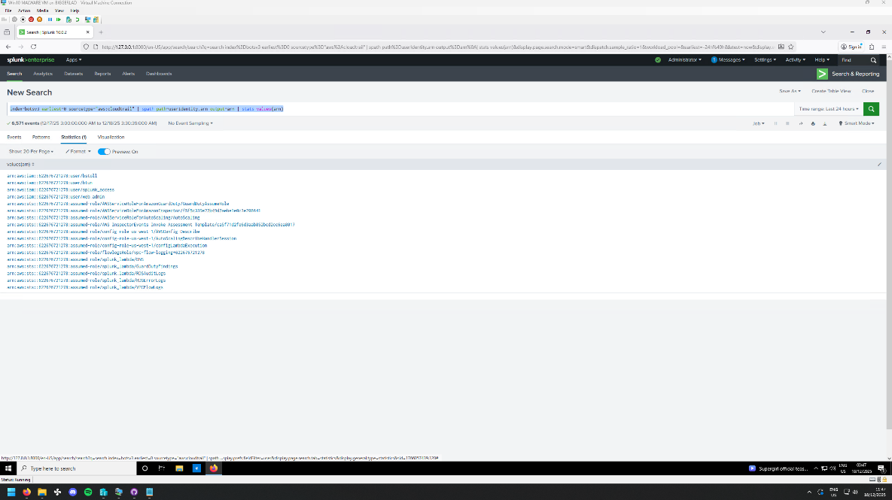

Findings:
The result of this query returns only four real user accounts, with the rest being assumed-role service accounts used by software for automation. The accounts that are more interesting to this investigation are bstoll and btun, user accounts that could be compromised, and web-admin, which likely has escalated privileges, so could be helpful to an attacker once they have a way in to Frothly’s AWS services.

Q2 API Activity Avoiding MFA
Investigation Objective:
Attackers often avoid MFA-enabled accounts for simplicity, as human complacency is likely to aid an attack chain, with an employee turning off security measures due to it being “inconvenient”. Finding users who circumvent these security measures is always a valuable step to narrow down the search for suspicious activity.
Methodology:
To isolate AWS API requests that avoid MFA, Splunk is used to search for any AwsApiCall event which has a null JSON field of userIdentity.sessionContext.attributes.mfaAuthenticated. Using the SPATH flag extracts the JSON from the log event, allowing Splunk to access individual fields and enabling this search.
In addition to searching for all MFA-avoiding API events, using stats to expose AWS users and event names helps paint a picture of what is happening, rather than analysing a long list of somewhat abstract logs.
Query:
Results:
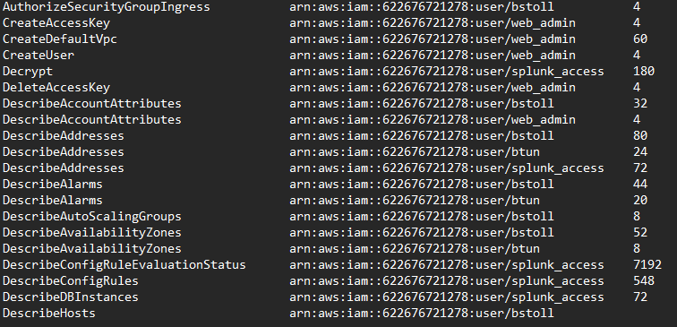
Screenshot:
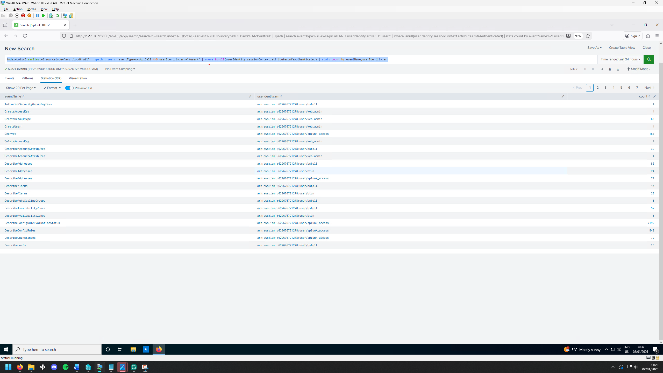
Findings:
The results indicate that bstoll performs several actions without MFA, including “AuthorizeSecurityGroupIngress”, which modifies AWS firewall rules. Allowing such actions without MFA poses a potential risk, as compromised credentials could allow an attacker to change network access. The observed modification opens only a single port (11211), suggesting the activity is likely legitimate. From a SOC perspective, monitoring privileged actions performed without MFA remains essential, as enforcing MFA reduces the risk of misuse in the event of credential compromise, which is becoming increasingly likely with the rise of more advanced and frequent phishing attacks.

Q3 Finding Web Server CPUs
Investigation Objective:
Older generations of Intel CPUs are prone to attacks such as Spectre and Meltdown, which exploit failed CPU branch predictions to exfiltrate data. This poses a risk when the CPU is handling sensitive data such as keys or tokens, which will remain in cache even after a failed prediction, allowing the attacker to exfiltrate data and elevate access using the stolen secrets. Although this is highly complex to pull off and requires the attacker to have access to a server with privileges to run code, it can be very effective at collecting data while remaining undetected.
Methodology:
The “hardware” source type returns hardware data from applicable hosts. Although this could be narrowed down further, there were very few results, so it was unnecessary.
Query:
Results:
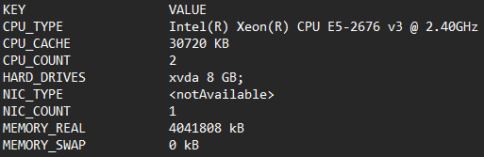
Screenshot:
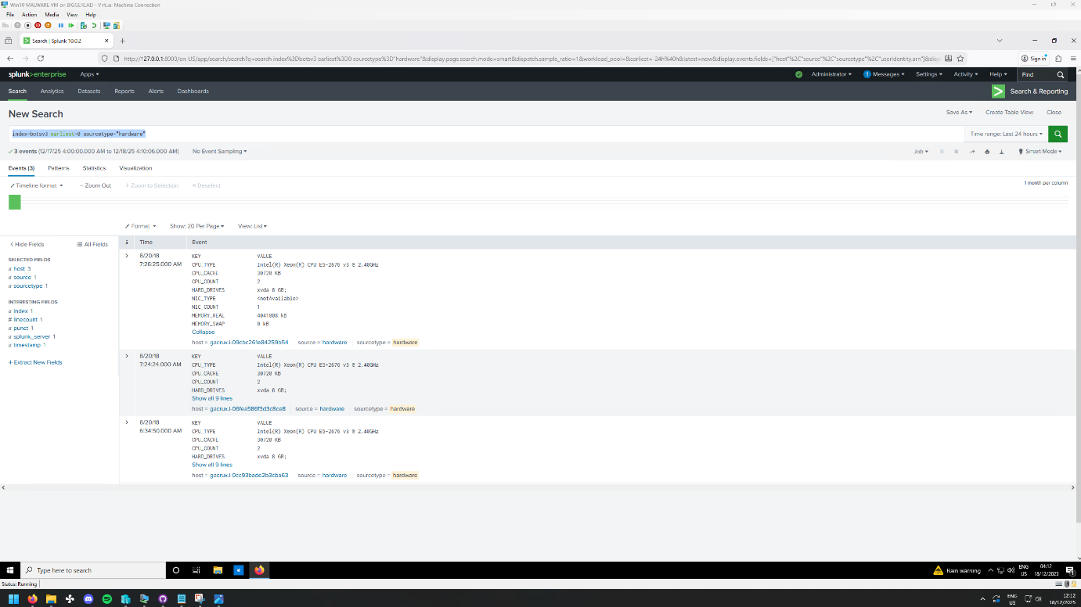
Findings:
After searching for known CVEs for this CPU, it was found that this CPU is susceptible to side-channel cache attacks utilising speculative execution (Spectre). This is particularly relevant, as attacks using this method are extremely unlikely to be detected by logging software because of its low-level nature. The only sign for this kind of attack occurring is abnormal CPU performance metrics after a user accesses the system, which is highly specific and complex to measure what “abnormal” CPU load is.

Q4 S3 Bucket Public Accessibility
Investigation Objective:
Making an S3 bucket publicly accessible is a significant risk, as it can expose sensitive data or even allow unauthorised modification or deletion of stored objects. Identifying when a bucket was made accessible is helpful from a SOC perspective, as it enables analysts to focus on following events in detail, determining whether it was intentional, and checking whether any further incident response is needed.
Methodology:
To find a log of a public bucket, the PutBucketAcl event name can be used to isolate events that set permissions on an S3 bucket. From there, further analysis can be done to identify logs that show permissions are set to “AllUsers”, the AWS indicator of public access.
Query:
Results:
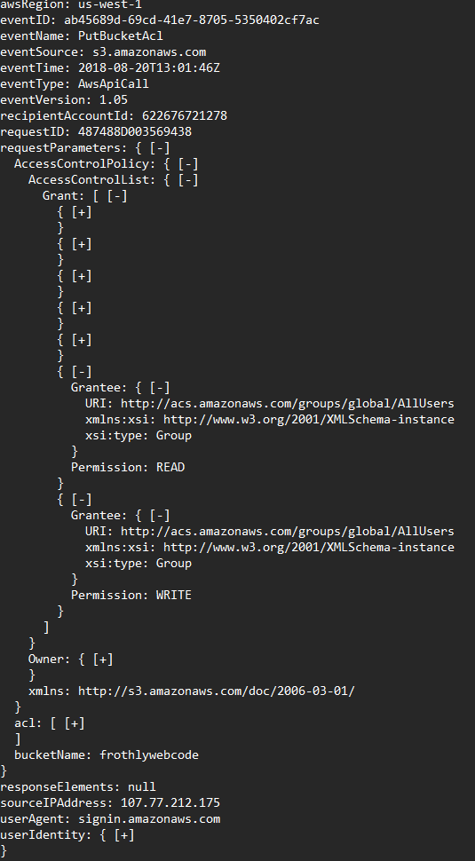
Screenshot:

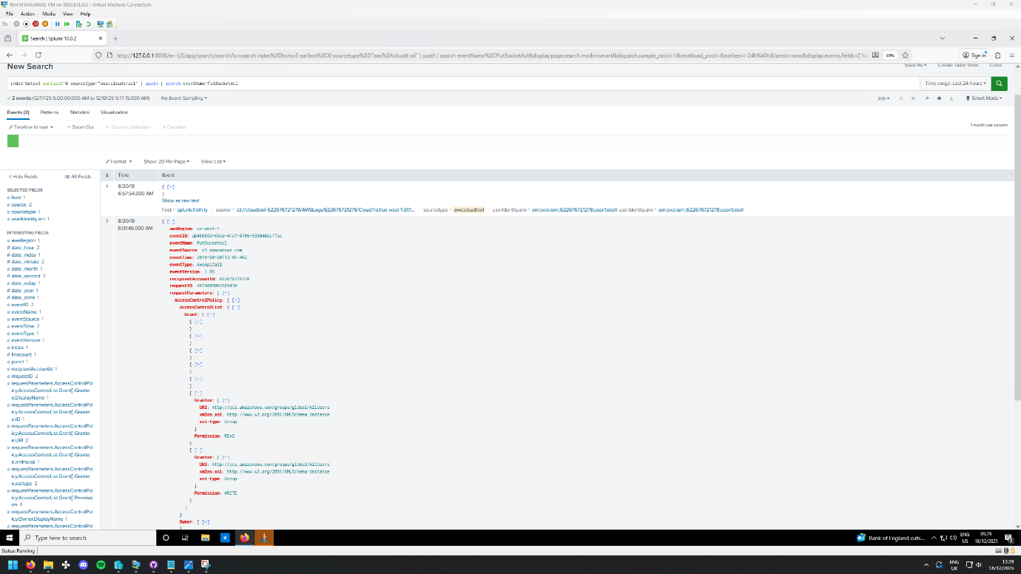
Findings:

The permission change occurred at 06:01, granting public read and write access to the S3 bucket. This action took place outside typical business hours, which may warrant further review. While the change could be legitimate, additional investigation would help determine whether the action was authorised, whether it was performed directly by user bstoll, and whether any follow-up activity occurred as a result.

Q5 Bud’s Username
The individual referred to as “Bud” corresponds to the IAM username bstoll, one of two AWS users previously identified. This mapping is confirmed by examining the userIdentity.arn field in the CloudTrail logs, which records the permissions being modified. This account should be monitored for additional activity to determine whether any unexpected or unauthorised actions were taken. Notably, bstoll has performed previous actions without MFA, which increases the potential risk of credential misuse and supports prioritising this account for ongoing SOC monitoring.
Screenshot:
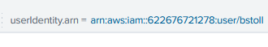

Q6 Publicly Accessible S3 Name

Q7 Text File Upload

Q8 FQDN of an Endpoint Running a Different Windows OS Edition

Conclusion and References

