2018 NC Open Pass Partner Prospectus

# Greetings!

You are invited to become part of the Triangle’s most exciting and influential communities on civic technology – NC Open Pass.

Forward-thinking technologists, government officials, and community advocates regularly convene to exchange ideas, explore solutions, and identify best practices to improve the way our community can work together. We meet regularly to share ideas and work on projects affecting our community. Throughout the year, we hold conferences to energize, innovate, and improve our quality of life through technology.

Whether your priority is building your business with local government; supporting tech innovation for social impact; connecting with top coders, designers, and entrepreneurs; or raising the visibility of your products - partnering with NC Open Pass is a way to achieve your goals while practicing corporate, social responsibility.

Partnerships are the way we are able to continue to make progress and gather this unique community of forward-thinkers and doers. The NC Open Pass Co-chairs and planning teams all volunteer their time and energy to create these events and work toward outcome-based goals with our community partners.

We look forward to working with you to explore what type of participation will best meet your goals and we thank you for your support.

*Chris Mathews*

Open Raleigh Brigade Captain, NC Open Pass Co-chair

[christhedba@gmail.com](mailto:christhedba@gmail.com)

*Jason Hibbets*

Open Raleigh Brigade Captain, NC Open Pass Co-chair

[jhibbets@gmail.com](mailto:jhibbets@gmail.com)

Zach Ambrose

Open Raleigh Brigade Captain, NC Open Pass co-chair

[zambrose@ambrosestrategy.com](mailto:zambrose@ambrosestrategy.com)

# 

# 

# About NC Open Pass

Open Raleigh Brigade launched a new initiative in 2016 called [NC Open Pass](http://ncopenpass.com/). It’s a partnership between North Carolina brigades and the first state-wide open data competition, NC DataPalooza. NC Open Pass brings together the following events:

* **NC Open Pass DataJam** (March 3-4, International Open Data Day) - Uniting communities through open data is everyone’s business. It goes to economic opportunity, government transparency, and quality of life. This year will be holding a data jam around affordable housing where data analysts, policy people, and non-profits will dig into available data to better understand the triangle’s affordable housing situation.
* **NC Open Pass Community Action Day** (June 9) is a time for public innovation – to brainstorm creative solutions to community problems.
* **NC Open Pass National Day of Civic Hacking** (August 11) - A national, coordinated effort bringing together urbanists, civic hackers, government staff, developers, designers, and community organizers to make their community better. This years event will have a virtual component with all NC Brigades who are part of the Open NC Collaborative.
* **NC Open Pass Civic Camp** (September 21-22, formerly CityCamp NC) - An annual event bringing citizens, government, academia, and businesses together to openly innovate and improve our quality of life through technology.
* **NC Open Pass DataPalooza** (November 8, formerly NC DataPalooza) - An open data competition to catalyze positive community and economic impact with coaching and cash prizes.

*We will also be offering registrations to regional events outside of the Triangle planned by brigades in Asheville, Charlotte, and Greensboro as they are announced.*

# Reach the most influential people in civic and government technology

* Leaders in government innovation
* Talented, socially-minded developers, designers, data scientists, and UX experts
* Cutting-edge government startups and entrepreneurs
* Civic-focused foundations, philanthropists, journalists, and investors

# NC Open Pass Audience

As an organization, NC Open Pass regularly reaches people in government, communities across the state, and across diverse civic-focused companies. Each of our events and conferences grows that reach even more.

# About Civic Camp

NC Open Pass Civic Camp (formerly CityCamp NC) is an annual event that brings citizens, city/county/state government, academia, and businesses together to openly innovate and improve our quality of life through technology. The vision for NC Open Pass Civic Camp is to bring civic technology-focused groups together for an annual “gathering of the civic tech tribe.” 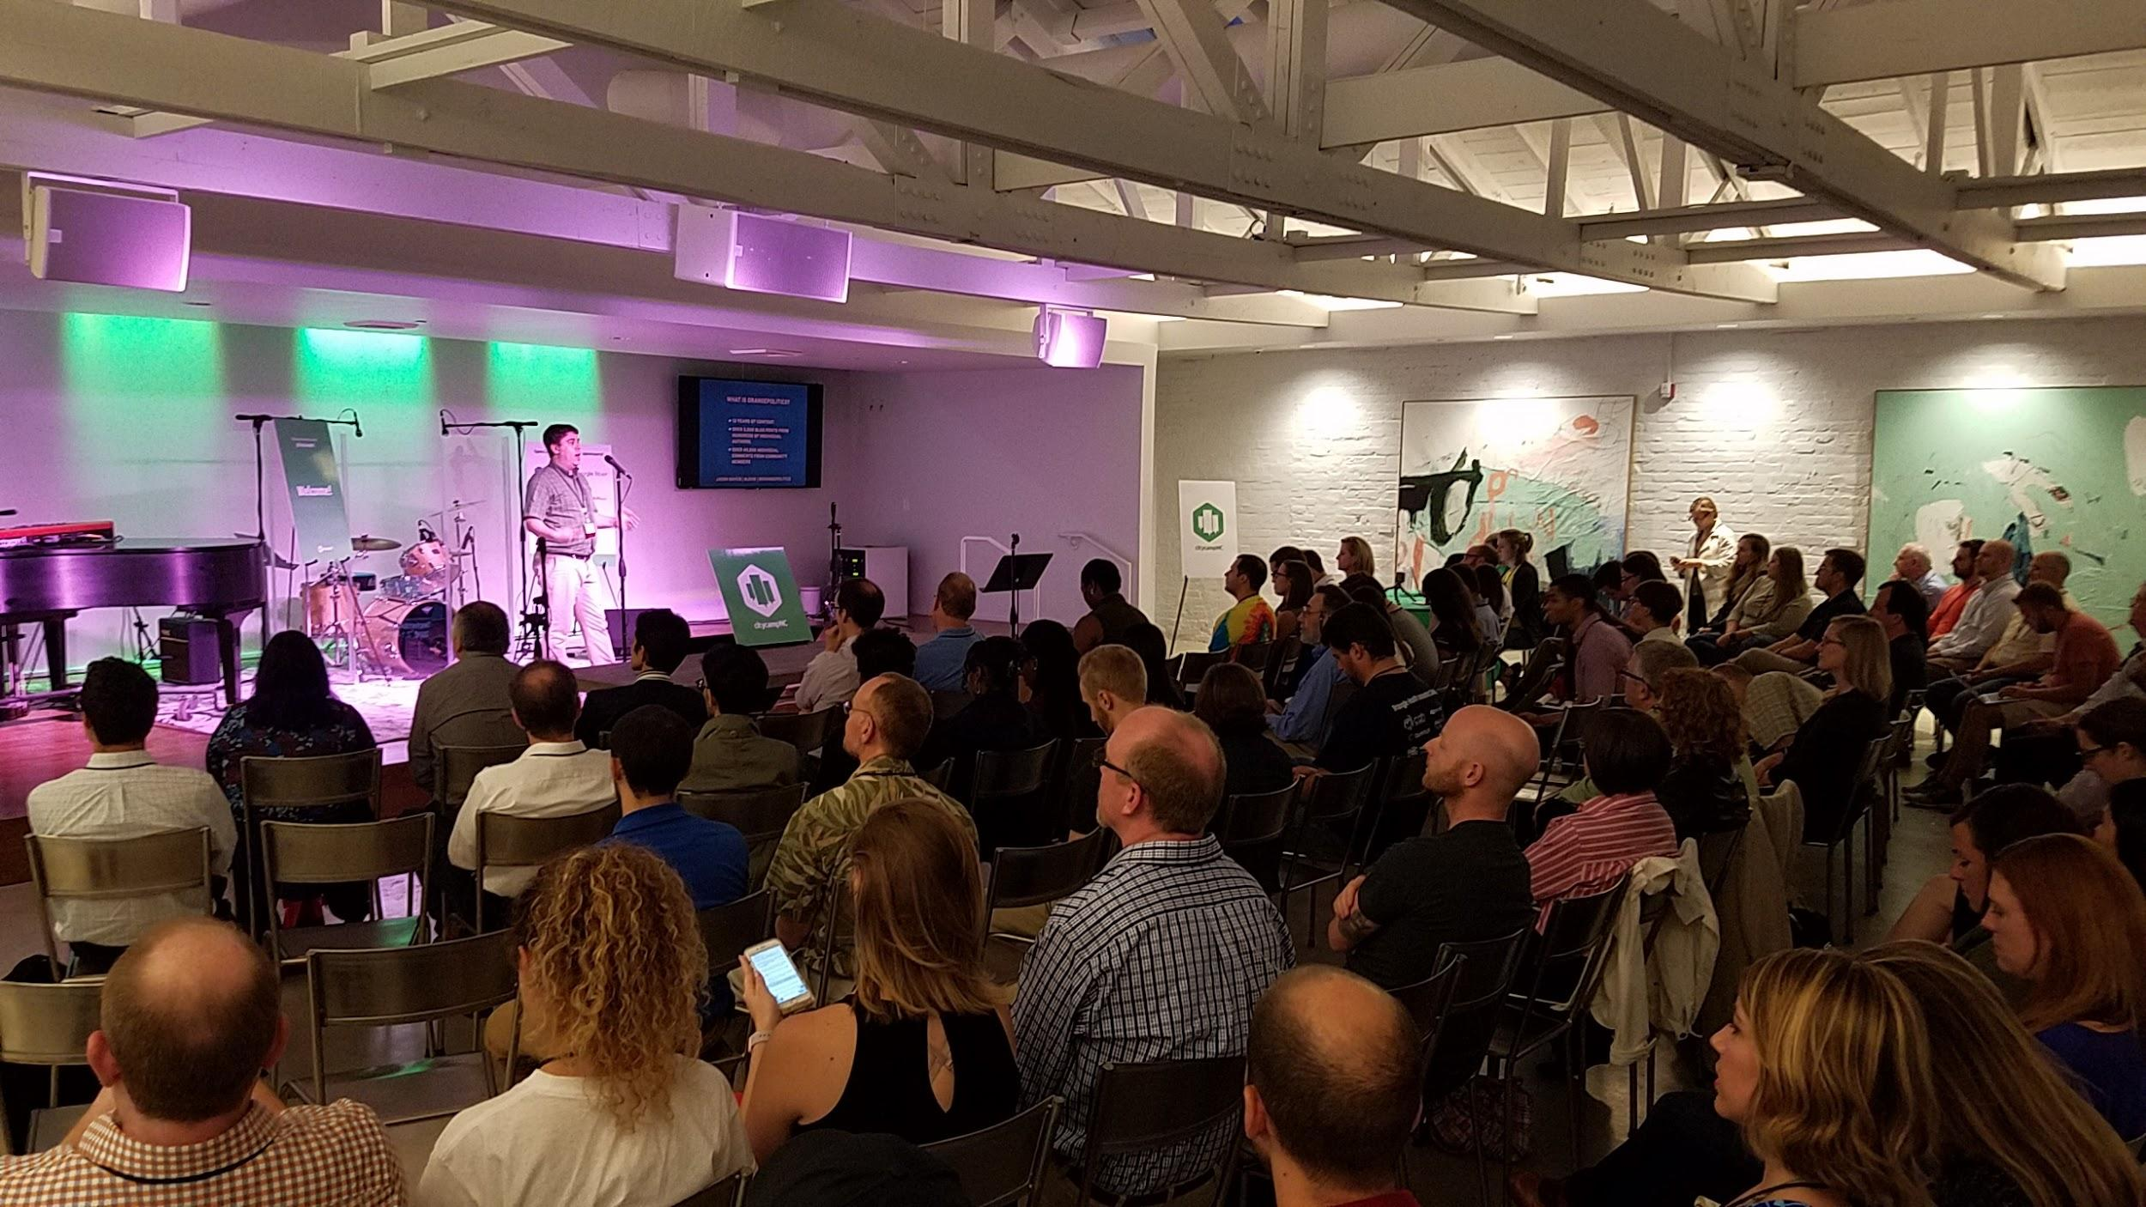

The seventh annual CityCamp NC, held on September 28-30, 2017 was a huge success. Over 200 people joined us for 2½ days to listen to talks, attend workshops, and improve our community. The 2017 event included participation from Code for Asheville, Code for Cary, Code for Durham, Code for Greensboro, and Code for Raleigh.

2018 has several things in store as to innovate and grow the civic tech presence in the community. Attendees will continue to gain access to NC Open Pass that combines the premier civic innovation events around the Triangle, including Open Data Day, National Day of Civic Hacking, Civic Camp, and DataPalooza. NC Open Pass is also expanding to include other regional events from brigades in Asheville, Charlotte, and Greensboro as they are announced.

# About DataPalooza

[DataPalooza](http://ncdatapalooza.com/) is an open data competition that connects local entrepreneurs with relevant, clean data drawn from national, state, and local resources to develop applications and solutions that catalyze positive community and economic impact.

Past winners included the Downtown Raleigh Parking App, who partnered with North Hills Development and received seed funding from the City of Raleigh to implement their open data parking solutions.

The event is a 8-week competition that starts at Civic Camp and ends with the DataPalooza finale. Teams form during the Civic Camp hackathon and during the open enrollment period. Then over the course of 8 weeks, they refine their projects and compete for the chance to be one of three teams that pitch at the finale.

* Kick-off on September 22 – ideation and hackathon at Civic Camp
* 7-week DataPalooza competition – build a scalable startup idea using open data
* Finalist selection on October 22 – teams demo and compete at All Things Open
* Final pitch day on November 8– Top three teams pitch to win seed funding

DataPalooza features a robust set of usable open data that can be manipulated by local entrepreneurs. We increase collaboration around open data and stimulate significant economic and community development by connecting entrepreneurs to useful data. Finally, we help position North Carolina as a hotbed of open data, research science, and entrepreneurial activity.

North Carolina innovators are ready to create positive impact and economic development using open data. You can help us sustain their work by sponsoring NC Open Pass. Your financial and in-kind support help us offer events, mentorship, and seed funding to turn ideas into scalable companies.

Be where government decision-makers and doers convene.

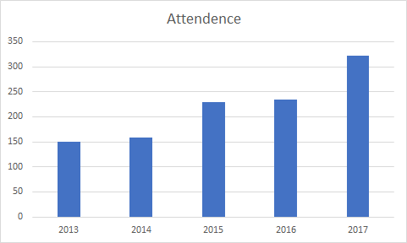

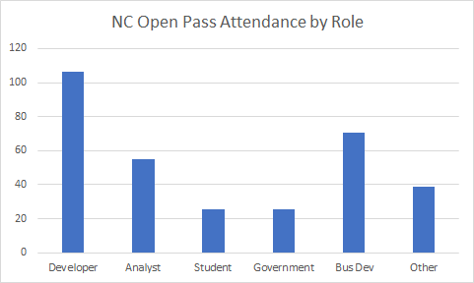--

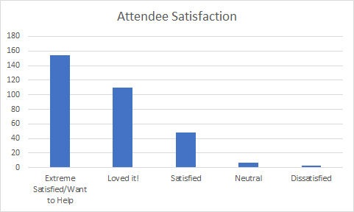

# 

# Press Coverage

* [Talking tech ecosystem, blockchain, picking a startup winner at NC DataPalooza (+ video)](http://wraltechwire.com/talking-tech-ecosystem-blockchain-picking-a-startup-winner-at-nc-datapalooza-video-/17113388/)
* [Three finalists to pitch for $5K prize in NC DataPalooza](http://wraltechwire.com/three-finalists-to-pitch-for-5k-prize-in-nc-datapalooza-/17087684/)
* '[Are We Represented' app takes top prize at CityCamp event](http://wraltechwire.com/city-camp-nc/16990298/)
* [City Camp-NC Open Pass to focus on open data and economic development](http://wraltechwire.com/city-camp-nc-open-pass-to-focus-on-open-data-and-economic-development/16971811/)
* [Tech event CityCamp NC begins Thursday in Raleigh](http://www.ncbiznews.com/tech-event-citycamp-nc-begins-thursday-in-raleigh/)
* [7 Years of Civic Tech in the Triangle](https://www.exitevent.com/2017/09/7-years-of-civic-tech-in-the-triangle/)

Event Partnership Levels

# NC Open Pass Partnership levels

|  |  |  |
| --- | --- | --- |
| **NC Open Pass**  **Partner for all events** | **Diamond**  **$10,000** | **Platinum**  **$5,000** |
| Custom slide for slideshow at all events | ✔ |  |
| Logo in thank you email to participants for all events | ✔ |  |
| NC DataPalooza judging panel member | ✔ |  |
| Company name in press releases for all events | ✔ | ✔ |
| Opening remarks at Civic Camp and DataPalooza | ✔ | ✔ |
| Logo on website and event materials for all events | ✔ | ✔ |
| Display table for materials at all events | ✔ | ✔ |
| Option to host a 50-minute breakout session at Civic Camp (must pitch session like all attendees) | ✔ | ✔ |
| Banner placed in registration area | ✔ | ✔ |
| Announced and thanked at all events | ✔ | ✔ |
| 20 NC Open Pass tickets (unused passes can be converted to scholarships) | ✔ |  |
| 10 NC Open Pass tickets scholarships (to a group of your choice) | ✔ |  |
| 10 NC Open Pass tickets (unused passes can be converted to scholarships) |  | ✔ |

# Civic Camp Partnership levels

|  |  |  |  |  |
| --- | --- | --- | --- | --- |
| **Civic Camp**  **September 2018** | **Gold**  **$2500** | **Silver**  **$1000** | **Bronze**  **$500** | **Supporter**  **$250** |
| Logo on event website and materials | ✔ | ✔ | ✔ | ✔ |
| Logo on event slide showing partners | ✔ | ✔ | ✔ | ✔ |
| Announced and thanked at event | ✔ | ✔ | ✔ | ✔ |
| Inclusion in social media | ✔ | ✔ | ✔ | ✔ |
| Logo on event banner | ✔ | ✔ | ✔ |  |
| Company name in press releases for event | ✔ | ✔ |  |  |
| Display table for materials at event | ✔ |  |  |  |
| Option to host a 50-minute breakout session at Civic Camp (must pitch session like all attendees) | ✔ |  |  |  |
| Place gift or literature at registration table |  | ✔ |  |  |
| 8 Civic Camp tickets | ✔ |  |  |  |
| 6 Civic Camp tickets |  | ✔ |  |  |
| 4 Civic Camp tickets |  |  | ✔ |  |
| 2 Civic Camp tickets |  |  |  | ✔ |

In-kind Partnerships

Please inquire about in-kind Partnerships opportunities for venues, advertising, rental equipment, food and beverage, etc.

# 

# DataPalooza Partnership levels

|  |  |  |  |  |
| --- | --- | --- | --- | --- |
| **DataPalooza**  **September 2018 - November 2018** | **Gold**  **$2500** | **Silver**  **$1000** | **Bronze**  **$500** | **Supporter**  **$250** |
| Logo on event website and materials | ✔ | ✔ | ✔ | ✔ |
| Logo on event slide showing partners | ✔ | ✔ | ✔ | ✔ |
| Announced and thanked at event | ✔ | ✔ | ✔ | ✔ |
| Inclusion in social media | ✔ | ✔ | ✔ | ✔ |
| Logo on event banner | ✔ | ✔ | ✔ |  |
| Company name in press releases for event | ✔ | ✔ |  |  |
| Display table for materials at event | ✔ |  |  |  |
| Opportunity to delegate a participant as a final judge | ✔ |  |  |  |
| Display signage at the event | ✔ | ✔ |  |  |
| Place gift or literature at registration table |  | ✔ | ✔ |  |
| Opportunity to sponsor a meal with logo signage at serving area |  |  | ✔ |  |
| 8 DataPalooza VIP tickets (November 2018) | ✔ |  |  |  |
| 6 DataPalooza VIP tickets (November 2018) |  | ✔ |  |  |
| 4 DataPalooza VIP tickets (November 2018) |  |  | ✔ |  |
| 2 DataPalooza VIP tickets (November 2018) |  |  |  | ✔ |

In-kind Partnerships

Please inquire about in-kind Partnerships opportunities for venues, advertising, rental equipment, food and beverage, etc.