This week’s discussion of “Things” is focused on how people focus their attention. Within the readings of #37-44, “Things”, from the book “100 Things Every Designer Needs to Know About People”, I will be looking closer and elaborating upon #40 “Attention Is Selective” and #42 “Well-Practiced Skills Don’t Require Conscious Attention” (Susan M. Weinschenk, 2020).

Starting with “Thing” #40, “Attention Is Selective”, this shows that people can be very distracted in situations, and it can be very difficult to hold their attention if not involved. The book explains that depending on what a person is focused on will drive what they may or may not gravitate toward. This makes sense, as if you are absorbed in something, the world may seem to vanish around you, which is described in #38 as a flow state. Some examples of where in design you would want to be careful about distractions would be a form, maybe for purchase or shipping details. Visual distractions will shift one’s attention and it can be a frustrating experience for the user. Here is an example of a basic shipping form from formsite.com.

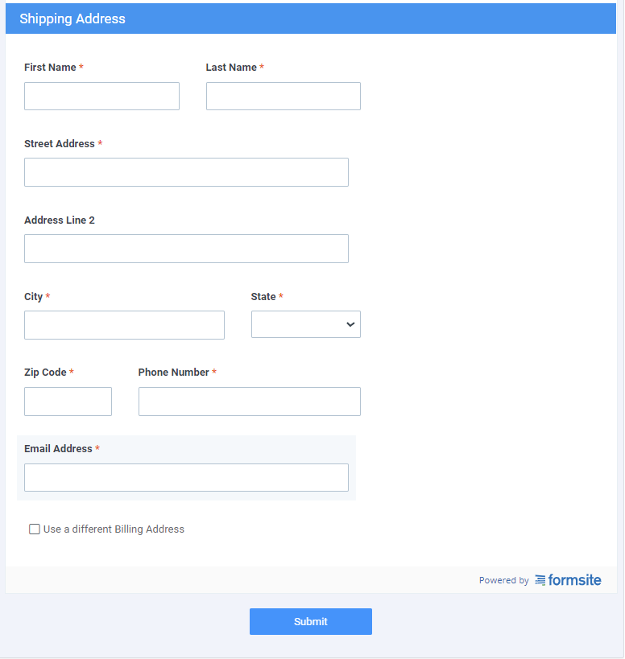

Now here is an example of a form that I added images of danger that draws attention. This would make the experience of filling the form out a bit more of a nuisance, especially if you are afraid of snakes. This example is just a still image, so if you incorporate video it makes for even more of an annoyance.

Now let’s move onto the second “Thing” I will be discussing this week, “Well-Practiced Skills Don’t Require Conscious Attention”. This one really makes me think about the times when you drive somewhere and once there you question, “How did I get here?”. If you have been driving for years, the menial and repetitive task of driving becomes second nature. The examples in the book refer to this similar feeling but when avid musicians are asked what they think about when playing an instrument. When it comes to UI design, when a user gets into a rhythm (flow state) or is performing a repetitive task, make sure to plan with that in mind. A great example of something to incorporate is an undo feature. This is very important for tasks where one may make a mistake based on this repetition. Another way to handle this is to only commit upon completion, this helps as well but someone in that flow state could still proceed past the commit before realizing the mistake. It really comes down to what you are solving for and how much of an issue this error in entry would cause, and what way(s) can it be remedied if/when it does occur.

# References

Susan M. Weinschenk, P. (2020). *100 Things Every Designer Needs To Know About People.* New Riders; 2nd edition.