**Chris Tornow**

**CSD-340 Web development with HTML and CSS**

**04-07-2023**

**Front-end Style Guide**

Selected Color palette

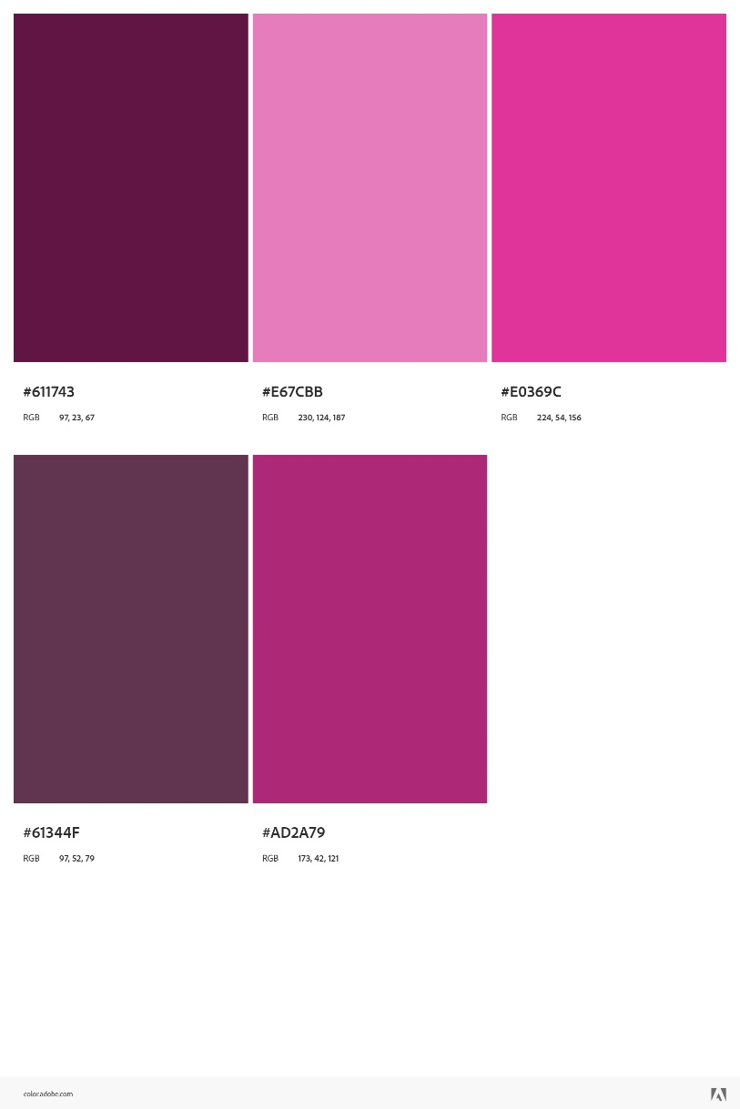

/* Color Theme Swatches in RGBA */

.bioSite-1-rgba { color: rgba(97, 23, 67, 1); }

.bioSite-2-rgba { color: rgba(230, 124, 187, 1); }

.bioSite-3-rgba { color: rgba(224, 54, 156, 1); }

.bioSite-4-rgba { color: rgba(97, 52, 79, 1); }

.bioSite-5-rgba { color: rgba(173, 42, 121, 1); }

Selected Font Style

sans-serif typeface

Note: You will need to create your own style guide from the examples provided under the “Resources” section.

**Wireframes, sketches, or prototypes**

The created wireframes were made in Justinmind desktop application.

Home page wireframe

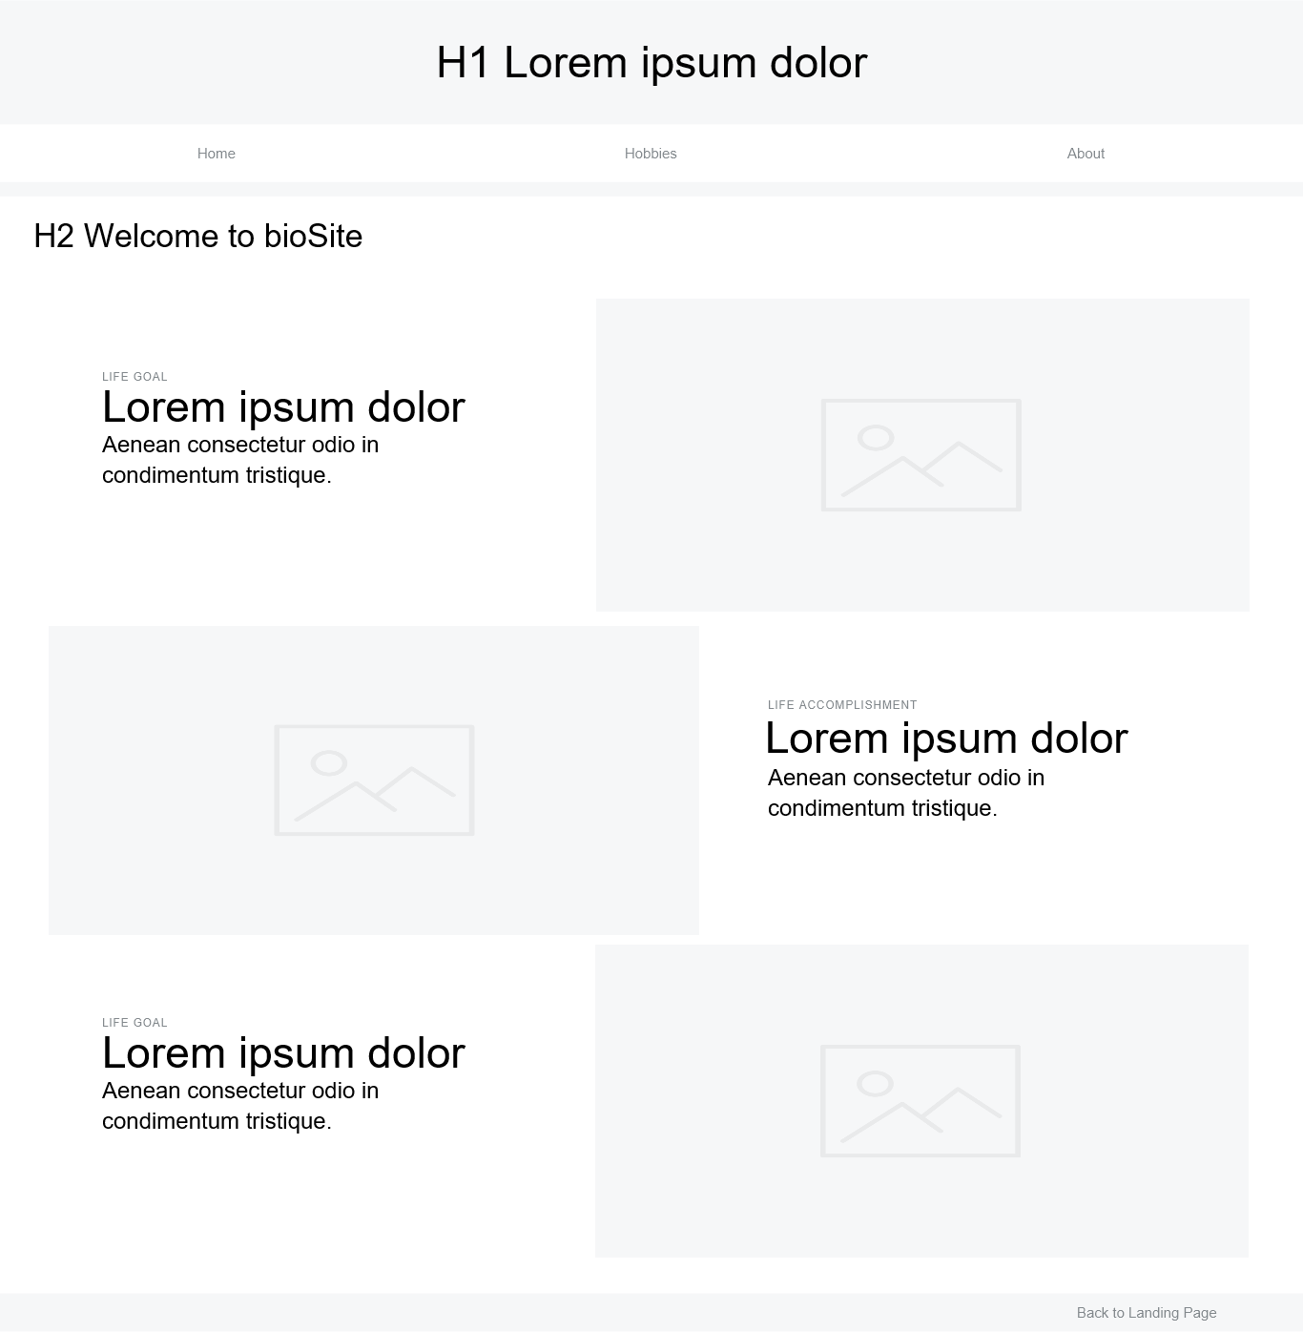

Hobbies page wireframe

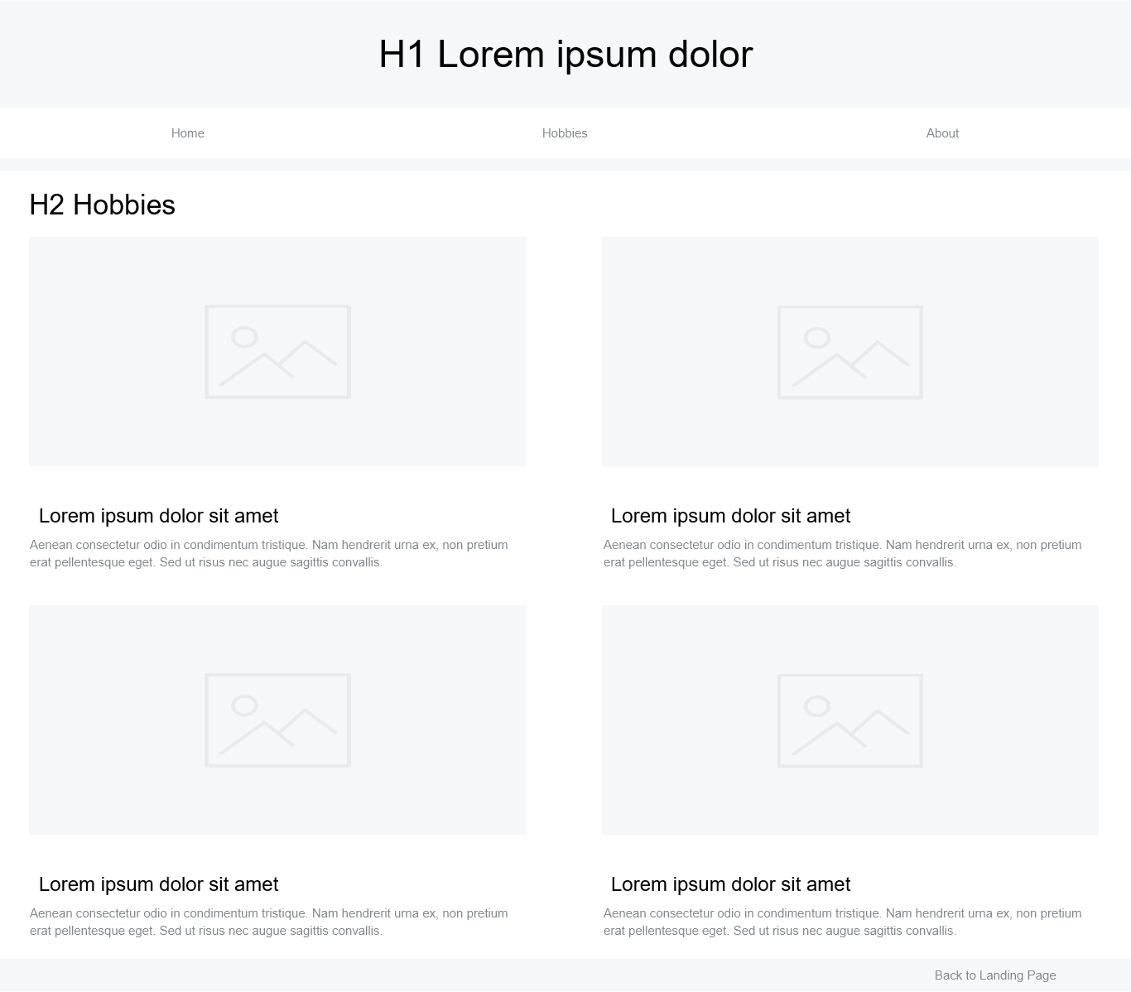

About page wireframe

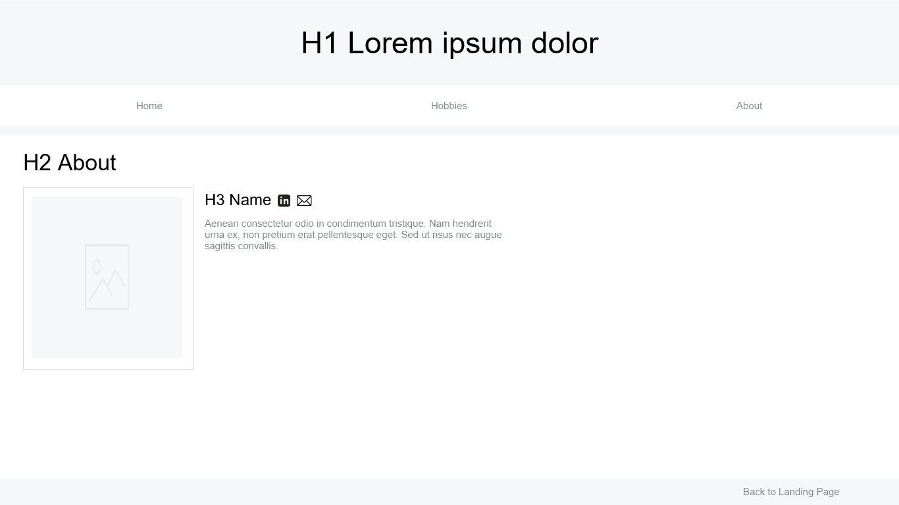

Note: The deliverables here are wireframes, sketches, and/or prototypes of the proposed design. Outcomes from this task will be compared against the final submission and they must match.

**At least one completed interview of the subject (the document must contain a minimum of 10 interview questions and responses from the subject).**

1. What are some hobbies of yours (need 3)?
   1. Watching House Hunters and crime shows
   2. Reading books
   3. Family time
2. What are some goals that you have in life (need 2)?
   1. Be the best mother and wife I can be
   2. Raise a child that is kind and respectful
3. What is an accomplishment you have made in your life that you are proud of (need 1)?
   1. Starting a family (has a 2-year-old)
4. Do you have any animals?
   1. No
5. What is your favorite fast-food restaurant?
   1. Jollibee
6. If you could travel anywhere in the world right now, where would it be?
   1. Philippines
7. What is your favorite season?
   1. Spring, because I love the weather, beautiful flowers and I was married in Spring
8. If you go to a coffee shop, what do you order?
   1. Mocha Latte
9. What is the most beautiful place you have ever seen in person?
   1. Half Moon Kay beach, want to take daughter here maybe this year
10. Do you think good people can do bad things?
    1. Yes
11. Where is your favorite place to shop?
    1. Ross
12. Have you ever been in a food fight?
    1. No
13. Who knows you best?
    1. Myself, but in second would be my husband
14. What gives you hope?
    1. Faith
15. What is your definition of success?
    1. Being happy and content with what one has

**One page (minimum 250 words) document containing a short bio of the subject**

This is a formalized write-up of the subject and will be used in the final project

This should be the outcomes from the interview and research you conducted on the subject and their hobbies

This will be added to the About page, in a later module.

A wife and mother of a beautiful little 2-year-old girl. She is the light of my husband’s and I’s lives and is everything that we could ever wish for. Having a family has always been a dream of hers and she feels wholehearted life fulfillment ever since beginning this family trio. She loves spending days with her husband and child, whether taking a drive in her favorite season, spring, or grabbing a mocha latte at the local coffee shop, she loves the presence of the family. The place she would go right now, if she could, would be the Philippines, which is the home of Jollibee, her favorite fast-food restaurant. The most beautiful place she has ever personally seen is Half Moon Kay in the Bahamas. Ever since her husband and her went there in 2018, they have always wanted to return. They are hopeful that maybe this is the year, but with their daughter to share the experience of sights, smells and the feeling of beach sand between their toes.

This amazing wife does believe that good people can do bad things in life, yet she still has faith, which gives her hope. Since her primary definition of success in life is being happy and content with what one has, she has definitely already achieved this great success. You couldn’t ask for a better mother and wife than her. She is dedicated to family and a lovely person with an outstanding perspective on life.

Even though she has already completed her life goals and achievements, there are still things that she would love to do in her life. She wants to continue being the caring and loving wife and mother that she has consistently already embodied, but there is a possibility that a playful food fight may be in her future. This is something she has never done, but with a toddler child, the chances of this occurring have moved into a high probability range. She seems like the playful mother that would use that opportunity to bond and perhaps create a teaching moment as well. This mother is one that anyone could wish for, food fight or not, and her husband is proud of her beyond words.

**The images you intend to use in the final project**

3 Images should be related to the subject's hobbies

* This will go under the hobby page, in a later module, and should include a small write-up explaining their relevance. Remember, you are trying to build a story/timeline for visitors to follow

3 images should be related to the subject’s goals, personal accomplishments, or embellishments

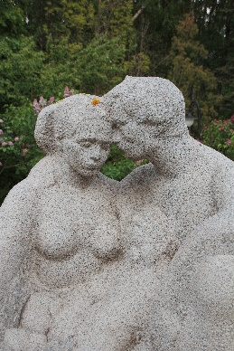  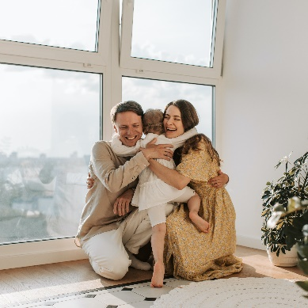

* These will go on the landing page, in a later module, and should include a small write-up explaining their relevance. Remember, you are trying to build a story/timeline for visitors to follow

1 image should be a portrait of the subject

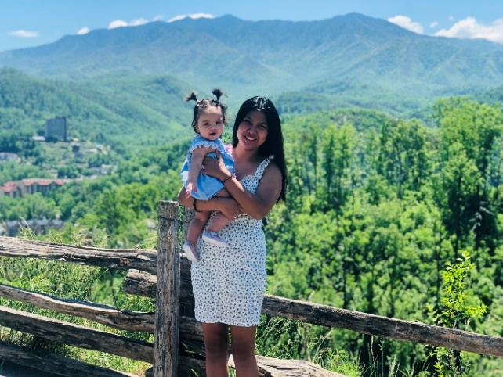

* This image will be added to the About page, in a later module, above the formalized 250-word write-up