BrainBay - User Manual
Version 2.8, Jan. 2026
Author: Christoph Veigl, webpage: http://brainbay.lo-res.at

Contents:

1. Introduction 3
1.1 Possible Applications 4
1.2 Functional features of BrainBay 4^

2. Installation and System Requirements 5
2.1 Directory Structure 5

3. Main Menu and Status Bar 6
3.1 Options and Application Settings 7
3.2 Status Bar and Session Control 8
3.3 Tools menu: Color Palette Editor 9
3.4 Tools menu: Tone Scale Editor 9

4. Creating Designs 10
4.1 Inserting, Tagging and Deleting Elements 10
4.2 Connecting Elements 10
4.3 Displaying a Connection 11
4.4 Setting Signal Ranges and Description 11

5. Using Design-Elements 12

5.1 Signal Sources 12
5.1.1 EEG- and Biosignal Amplifiers 12
5.1.2 Signal Generator 15
5.1.3 Constant 15
5.1.4 EDF-Reader 15
5.1.5 File-Read 16
5.1.6 Generic BLE Receiver 17
5.1.7 Generic UDP Receiver 17
5.1.8 Key-Capture 18
5.1.9 TCP-Receive 19
5.1.10 Camera (Webcam) 20
5.1.11 Skindialog 21

5.2 Processing Elements 22
5.2.1 Averager 22
5.2.2 Comparator 22
5.2.3 Correlation 23
5.2.4 Counter / Display 23
5.2.5 Debounce 23
5.2.6 ERP - Detector (Pattern Recognition) 24
5.2.7 Expression Evaluator 25
5.2.8 Filter 25
5.2.9 FFT (spectral analyser) 26
5.2.10 Integrator 27
5.2.11 And, Or and Not 27
5.2.12 Matlab Transfer 29
5.2.13 Magnitude 29
5.2.14 Mixer 30
5.2.15 Sample and Hold 30
5.2.16 Standard Deviation 30
5.2.17 Threshold / Meter 31

5.3 Signal Targets 32
5.3.1 AVI – Player 32
5.3.2 Com- Writer 33
5.3.3 EDF- Writer 33
5.3.4 File – Write 34
5.3.5 Oscilloscope 35
5.3.1 OSC-Sender 36
5.3.2 Keystrike 36
5.3.3 Particle Animation 37
5.3.4 Midi Output 38
5.3.5 Mouse Controller 39
5.3.1 Shadow 40
5.3.2 Sound Player 40
5.3.3 TCP – Sender 41
5.3.4 Media Player 42
5.3.1 Volume 42

5.4 Other Elements 43
5.4.1 Documentation 43
5.4.2 Ballgame 43
5.4.3 Button 44
5.4.4 Speller 44
5.4.5 Sessiontime 45
5.4.6 SessionManager 46

6. Example Designs 47
6.1 A design for Alpha / Beta – Neurofeedback 47
6.2 Heartbeat-Feedback from a multichannel EDF-recording 50
6.3 A design for Muscle-Feedback and –Rehabilitation 51
6.4 Controlling a movie using an external Reed-Switch 53
6.5 A Camera - Mouse application with clicking functions 54

Introduction

This manual provides information and instructions for setup and usage of BrainBay, an Application for Biofeedback, Neurofeedback and Human Computer Interaction.

BrainBay allows the graphical design of universal configurations for realtime-processing, display, storage and opto/acoustic feedback of biosignals, bioelectric events, visual information or other sensor data.

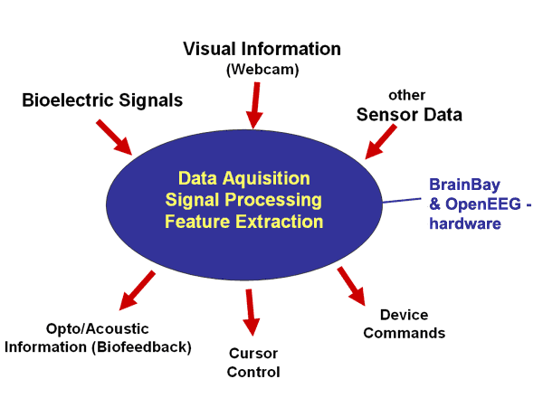

BrainBay is part of the OpenEEG - project (http://openeeg.sf.net). It supports the ModularEEG and MonolithEEG biosignal-amplifiers and other affordable off-the-shelf amplifiers. With appropriate electrodes / sensors, following vital parameters could be measured and utilized for biofeedback purposes:

- Brainwaves (Electroencephalogram, EEG)
- Heartbeat (Electrocardiogram, ECG)
- Muscle Activity (Electromyogram, EMG)
- Eye Movements (Electrooculogram, EOG)
- Blood Volume Pressure (BVP)
- Galvanic Skin Response (GSR)
- Skin Temperature
- Accelleration, control switches
- Face-position, body movements (using a webcam)

In a BrainBay Design-Configuration, these signals are connected to processing-elements for feature extraction, transformation and visual / acoustic feedback.

The following figure shows a design configuration that connects two channels of an EEG-amplifier to processing- and display-elements that provide visual and acoustic feedback of signal parameters (for details on this design see chapter 6.1) :

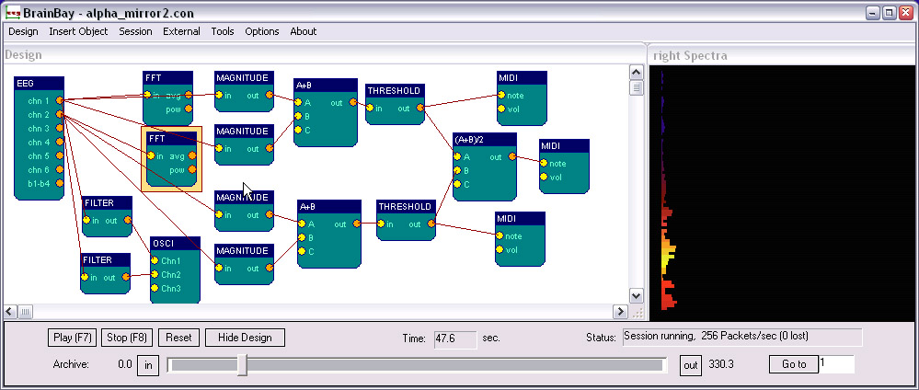

  - Possible Applications

- Biofeedback- and Neurofeedback-Therapy indications:
tension-headache, migraine, post-traumatic stress syndrome,
tinnitus, epilepsy, chronic pain, cardial arhytmia,
concentration- / learning difficulties, incontinence;

- Rehabilitation Training
muscle- workout and relaxation, posture training

- Realtime–Telemetry of Bodysignals
- Patient Monitoring
- Therapy Progress Control
- Online and Offline Data Analysis
- Human Computer Interaction, including:
control of mouse-cursor + clicking-functions,
typing via an On-Screen Keyboard,
Brain Computer Interface

Please note that the OpenEEG-hardware is not certified as a medical device, all application is done at own risk. Biofeedback should be applied by approved therapists and works best as part of a wider psychophysical treatment concept.
  - Functional features of BrainBay

- Digital Filters, FFT-Displays (Bar-Graph, Spectrogram, 3d-View)
- Math. Elements (correlation, threshold, trial averaging, expression-evaluator, ...)
- Multimedia feedback (Midi, Wav- and Avi-Playback, Bar Display, ...)
- Network transmission (using the Neuroserver framework)
- Reading and storage of archive-files in European Data Format (EDF)
- Webcam support and face-detection (for head-mouse support)
- HCI-functions (mouse control, keyboard events)

Installation and System Requirements

BrainBay uses the Windows operating system (all versions from XP to Win-10).
An (incomplete) Linux-build is available, using the Wine-compiler.
Using Wine, the standard BrainBay executable can also run under Linux.
Miniumum hardware requirement is a Pentium-II laptop- or desktop-computer.
For more complex designs and/or fast graphic displays, an OpenGL-accelerated graphics-adapter is recommended.

The installer (executable file) can be downloaded from http://brainbay.lo-res.org.
The binary and data files will be installed in the User\Appdata folder.
The source code and development files are hosted at GitHub (https://github.com/ChrisVeigl/BrainBay)

  - Directory Structure

Archives: contains signal archives in P2/P3/EDF format. These archives are used
by demo configurations and could be used for own experiments. This is the
recommended folder for storing own archive files.

Configurations: contains design-configurations (.con - files). The delivered design-
configurations shall demonstrate main functions of the application

ComputerVision: contains data for the facetracker (camera) element

Graphics: contains images for the particle generator or other processing elements

Movies: contains videos for the avi-player element (.avi files)

Patterns: contains recorded patterns for the pattern-recognition element (.erp files)

Palettes: contains sample color palettes for display elements (.pal files)

Reports: contains oscilloscope screenshot bitmaps (.bmp files) or ASCII-archives (.cvs files)

Tonescales: contains sample tonescales for the Midi-Player (.sc - files )

Network: contains executables for the Neuroserver software framework.
(http://openeeg.sourceforge.net/doc/software/NeuroServer)
These files are needed to transmit or receive edf-files via TCP/network.

Sounds: contains audio files for the audio-player element (.wav files)

Skindialogs: contains a sample skindialog for user interaction (.ini and .bmp - files)

Main Menu and Status Bar

All main functions of BrainBay can be accessed through the menu on top and the status-bar on bottom of the window. The menu provides the following entries:

Design: create a new design, load / save a design, exit application
Edit: copy / paste an element (can be used to paste to another BrainBay instance)
Insert Element: add new elements to the design
Session: run or stop the designed session
Network: start a neuroserver - service for network transmission of biosignal data
or an EDF-reader client, these are part or the neuroserver-framework.
for more information on network transmission see the TCP-read / -write -
elements (..)

Tools: editors for color-pallettes and midi-tonescales
Options: settings for application and currently active eeg amplifier (see 3.1)
About: program-version and author information

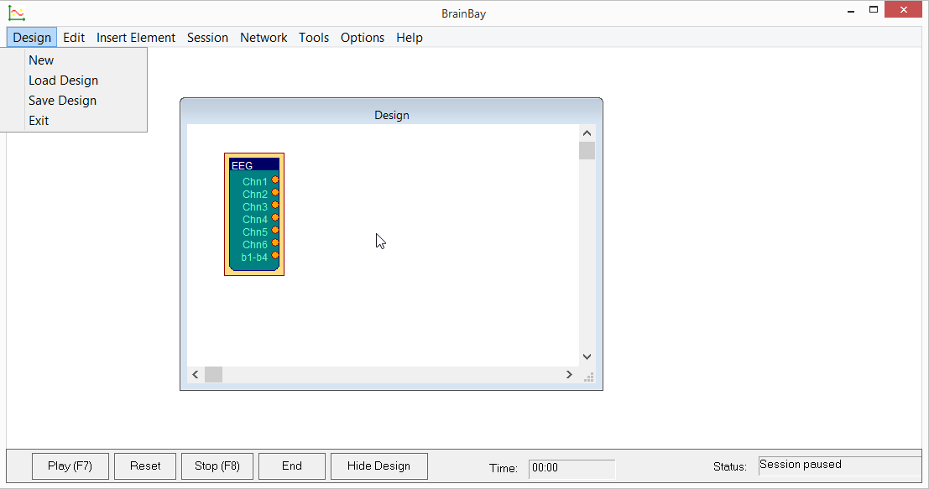

  - Options and Application Settings

The Main Menu’s Options – section offers two dialogs: the Application Settings and the Device Settings. The Device Settings will only be accessible if an EEG amplifiers has been added to the Design. The Application Settings offer several important parameters for system configuration and startup.

Application Settings Dialog:

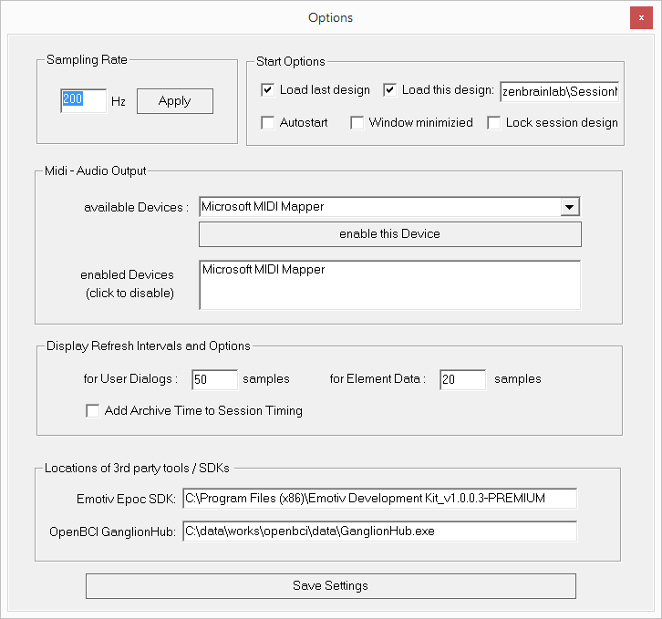
In section Sampling Rate, the sampling frequency (which also detereines the pace of signal processing) can be selected. This value should match the sampling rate of the data aquisition hardware or recorded archive file.

For example, the ModularEEG, sampling rate will usually be 256Hz.
MonolithEEG provides sampling rates up to 1200 Hz. When reading EDF-Achive files with other sampling rates, the value has to be adjusted accordingly.

The Start Options section has options for application-initialisation: If Load last design is chosen, the previously used design will be loaded automatically. Load this design allows to specify a name of a particular design configuration which should be loaded (the file name is given without the .con extension and may contain a relative path from the Configurations subfolder). If Autostart is enabled, the session starts after being loaded. Window minimized results in automatic minimisation of the main window after a session has been loaded. The Lock session design checkbox allows protection the design configuration against unintended changes by users: if this option is enabled, GUI windows can not be re-arranged and the ShowDesign button will be hidden from the status bar (note that the F5 function key will still work to display the design, see 3.2).

The Midi-Audio Output section defines the Midi-Devices that will be active within Brainbay. A Midi-Device could be a soundcard with midi-synthesizer, a wavetable software synthesizer, or external Midi-devices like keyboards, drum-computers or midi-controllers. Virtual Midi device drivers like the LoopBe1 freeware cerate virtual Midi-input and -output devices that provide a bridge to other midi-processing software running in background.

To add a Midi-Out-Device to the list, select it from the combo-box which contains all devices that are currently accessible in the system. To delete a device from the list, just click the list-entry.

In section Refresh Intervals, the update rates for screen displays are set. User Dialogs selects the refresh rate for element's parameter windows, Display Windows selects drawing update rates for oscilloscopes, FFTs or meter windows. The refresh interval is given in relation to the sampling rate: a value of 8 gives 32 updates per second when a sampling rate of 256 is used.

In the section Locations of 3rd party tools / SDKs, path settings to additional resources for specific EEG amplifiers can be defined:

- The Emotiv Epoc SDK path setting is only necessary if you want to interface the Emotiv Epoc device via the (non-free) SDK for accessing Epoc’s raw EEG data-stream. In this case, specify the correct path to the SDK (where the edk.dll file is located) so that the emotiv eeg element can be used.
- The OpenBCI Ganglion Hub is only necessary if you want to use the OpenBCI ganglion EEG device. In this case, specify the path to the GanglionHub.exe application which provides the raw data from the ganglion device. The GanglionHub is delivered as part of the OpenBCI GUI or can be downloaded seperately from the OpenBCI github page.

  - Status Bar and Session Control

The status bar at the bottom of the main window provides various information (current session time, status field) and buttons for session control. The Play and Stop - buttons or the respective hotkeys F7 and F8 can be used to start and stop the session. Reset sets the position of archive files to their beginning and the session time to 0 seconds. The End Button halts a currently running session and loads the design configuration wich has been specified in the Application Settings dialog (parameter Load This Design, see 3.1). The Hide/Show Design - button or hotkey F5 controls visibility of the design-window. The status bar itself can be hidden or displayed by pressing F6.

If there are archive-file readers present in the design configuration, the status bar extends automatically and shows the progress of the playback. In- and out points can be defined for the archive playback which is useful when particular parts of the recording shall be reviewed in more detail (see description of the EEG-amplifier and EDF-reader elements). The Loop Archive option allows to automatically reset the archive playback position to the beginning when the end has been reached (endless playback). The Fly through button processes the archive at maximum speed (this is useful to review overall session outcomes without having to wait until the real time playback finishes).

  - Tools menu: Color Palette Editor

The Color Palette Editor enables to easily create color fades and pallettes for some display elements. Currently, the color palettes are used by the FFT spectral analyser and the Particle Animator elements.

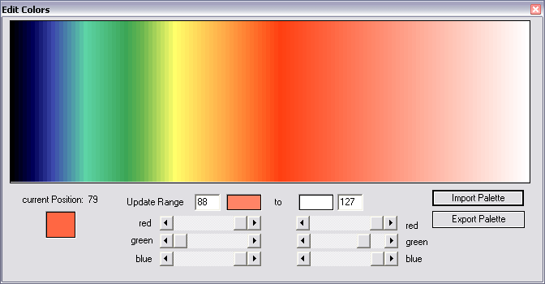

To adjust the colors, use left- and right clicks into the color-window to set the update region: A left-click sets the start and a right click the end point of the current region.
Using the smaller color selection fields or the scrollbars for RGB - composition, the color value of the start or end point can be set and a color fade from start to end is calculated. Thus, smaller regions or one big region can be created per just a few clicks. A palette consist of 127 colors. Existing palettes can be load and modified using the Import Palette button, new palettes can be saved using Export Palette.

  - Tools menu: Tone Scale Editor

The Tone Scale Editor allows the creation own Tonescales for the midi-player element like major, minor, blues etc. Sometimes it can be useful to make small scales with just two or three tones that fit together.
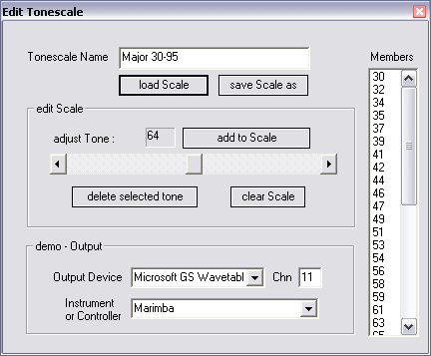
The current tone is selected with the scollbar, it will be played using the given midi-output device, channel and instrument. By pressing add to Scale, the tone is appended to the members of the tonescale.

To play the whole or parts of the scale, select a tone from the list of member and use the cursor up/down to browse the scale.

Use Load Scale and Save Scale to modify existing scales or to create new ones.

Creating Designs

The process of creating design configurations with BrainBay basically consists of the following steps:

- Insert elements to the design window
- Connect signals from an element's output port to another elements input-port
- Adjust properties in the element's graphical user dialog
- Test the design with archive-, simulation- or realtime data

  - Inserting, Tagging and Deleting Elements

The Insert Element - entry of the main menu shows up 4 groups :
Signal Sources, Signal Targets, Processing - Elements and Others;
Generally, every reasonable design will need at lest one signal source (like an EEG-Amplifier, a signal generator or a file-reader) and one signal target (like a spectral-display or an oscilloscope).
An element can be selected by left-clicking the center. The active element is drawn with a yellow border. Connections can only be drawn from the active element to other elements. The activie element can be deleted with the Del - Key of the keyboard.
By double-clicking the center of an element, its description-tag can be modified.

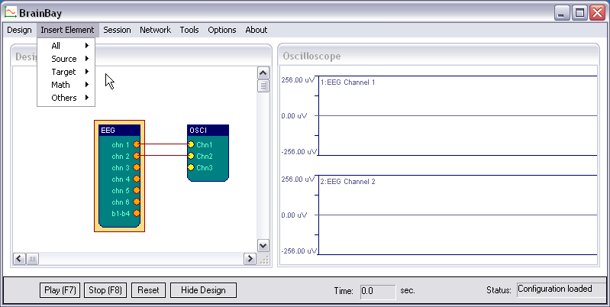

  - Connecting Elements

A connection is drawn by left-clicking an output-port of the active element and dragging the line to a free input-port of another element.
Signal-sources have at least one Output Port (orange). The above picture shows 6 output ports on the EEG-element for the channels of the EEG-amplifier and a seventh output port for the status of control switches.
Signal-targets have at least one Input Port (yellow).

  - Displaying a Connection
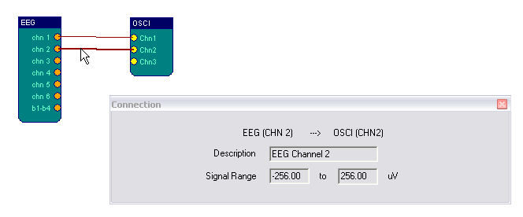
By left-clicking a connection, a dialog with information about the connection is displayed. It states the connected ports, a description of the signal and the signal-range.

  - Setting Signal Ranges and Description

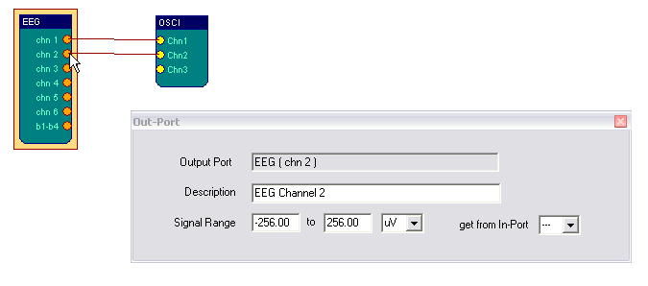
The signal-range and description of a connection can be adjusted by right-clicking an input- or output port. This opens the Input-Port-Settings or respectively the Output-Port-Settings dialog.
The description for the signal can be written into the given field.
The above example shows how to adjust the signal range of Chn2 output port of an EEG-signal source element. For elements which have input ports, the signal range of an output port can be obtained from a selectable input port. Thus, signal-ranges can be propagated to following elements.

The input-range for a specific input port can be adjusted manually or inherited from the connected output port. Adjusting the input-range can be useful for elements which define minimum/maximum settings for their functional behaviour according to the input port range (e.g. Oscilloscope display or Midi tone range).

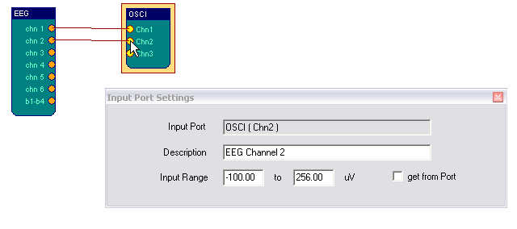
The Input-Port Dialog for the oscilloscope-element (here: channel 2).

Note: Brainbay uses a special signal value to indicate “invalid” or “out-of-range” signals – this value is called INVALID_VALUE and is represented by a constant
(-32767). See more details in the description of the logical elements And, Or and Not.

Using Design-Elements

Design-Elements (Signal Sources, Signal Targets and Processing elements) are the fundamental components for building a signal processing configuration in BrainBay. Nearly all elements have a graphical user-dialog (configuration window) to adjust their parameters. The user-dialog can be displayed by right-clicking the center of an element. In the following, the BrainBay design-elements and their usage will be described.

  - Signal Sources
    - EEG- and Biosignal Amplifiers

The supported EEG- and Biosignal Amplifiers are available in a subgroup of the Signal Source Menu. Currently, 14 different devices / protocols are supported:

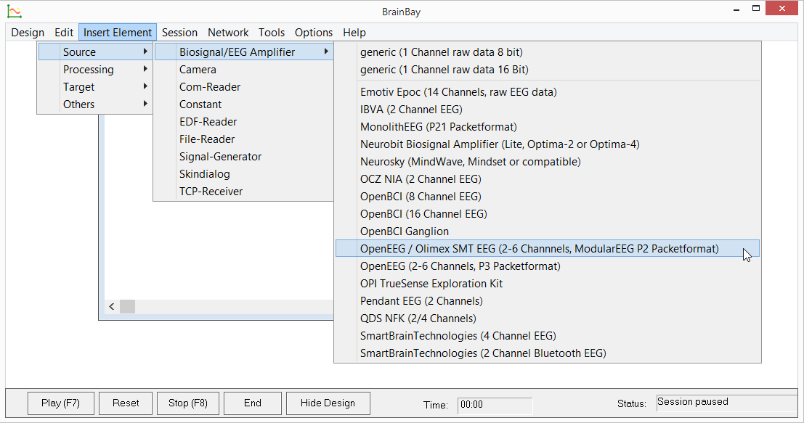

For some of the biosignal amplifier devices, different firmwares and transmission protocols exist, for example the P2, P3 and P21 firmware variants for the OpenEEG devied. Some of the protocols are bi-directional (which means that values can also be sent to the amplifier). For example, the MonolithEEG P21 is a bi-directional protocolwhich allows changing the baud- or samplingrate, setting the active channels and transmitting play/stop-commands to the device.

Additionally to providing live-data from amplifier-hardware, many of the EEG elements can record and playback archive-files: The element either works in live- or in archive mode (not both at the same time).

The following screen shot shows the OpenEEG / Olimex SMT EEG device window:
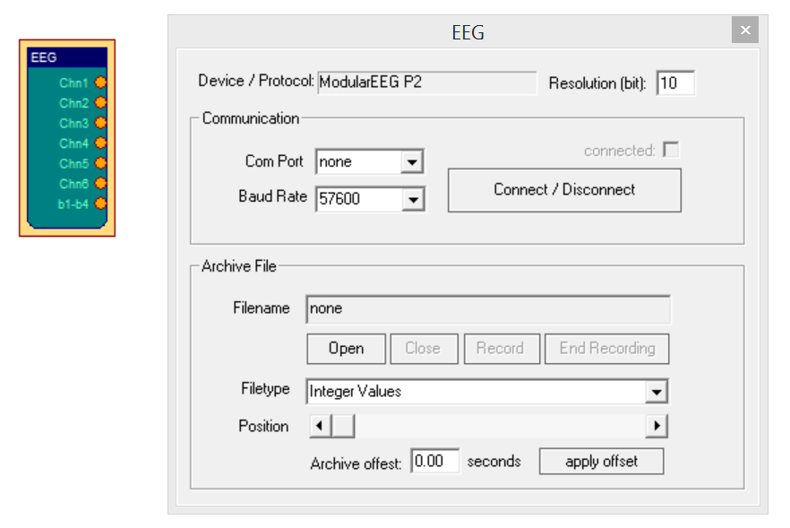

Receiving live-data from the amplifier
Adjust the samplingrate for your recording device in Options->Application Settings. Connect the amplifier to a USB-Port (or perform the necessary steps to pair the wireless connection via Bluetooth) and select the appropriate Com-Port from the combo-box in the EEG element properties. Select the baud-rate for the device and adjust the resolution (if necessary). Press button Connect/Disconnect Com Port. The connected-checkbox should indicate that the port has been connected (if not, check Com-Port and settings).
To display live-data, connect an oscilloscope-element to the output ports of the amplifier-element, press Play - button from the status bar and turn on your biosignal amplifier.

Recording live-data to an archive file:
Setup the connection to the amplifier as described above. Press button Record Archive and choose a filename and folder to store the archive. Recording starts immideately after confirming the filename (and starting the design). To stop the recording and close the file, press the button Close Recording.

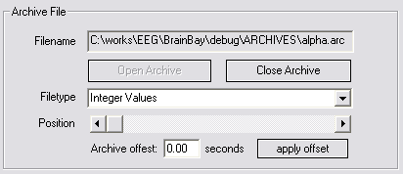

Playback of recorded archives:
Close an eventually openend Com-Port and press the button Open Archive. A dialog will appear where an archive file can be selected. The device- and sampling-rate settings will be modified according to the archive. When an archive file is opened, no live-data can be processed by the EEG-amplifier element, and the status bar extends: a slider shows the progress of playback and can be used for positioning in the archive file. The current position in sedconds is shown in the Time -Field. Use the Play-, Stop- and Reset- buttons to control playback.

With the In- and Out- buttons, a segment of the archive can be defined for looped-playback. By pressing In or Out, the current position will be set as the new start or end - point for playback. The Go to - button can be used for jumping to a specified position, given in seconds.

Only one EEG-Amplifier signal source can be active in a given design. Nonetheless it is possible to have more than one archive players active in the system, using the EDF-File Reader element. To align the position of an EEG-amplifier archive relatively to other archives, an offset for the archive in seconds can be set in the user dialog.

When the EEG-Amplifier element receives live-data from an amplifer, the sampling rate for the whole system is controlled by the output of the EEG-amplifier element. That means: when the amplifier sends 512 Packets per second, all other elements will process data at that pace.

When playing back an archive, the sampling rate will be set according to the rate of this archive, but the rate can be changed using the Options - dialog.

    - Signal Generator

The Signal-Generator element can be used to produce sinus-, rectangle or sawtooth-signals with selectable center, frequency, amplitude and phase-shift.
The signal type is selected via combo-box, the other parameters can be changed with the respective silders. The maximum amplitude (the range of the amplitude - slider) can be changed by right-clicking the output port of the element.

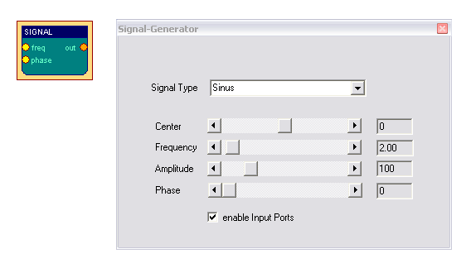
The checkbox enable Input Ports controls the accessibility of frequency- and phase- settings via input ports. Using the input ports, these settings can be modified by other elements or by a user dialog.

    - Constant

The Constant element provides a fixed value on it's output port :
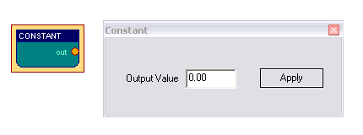

    - EDF-Reader

The EDF-Reader element can be used to read previously recorded file in European Data Format. EDF is a format for the exchange for biological signals
(see http://www.edfplus.info). The header of an EDF file stores various information about the recording: date, patient data, recording device, sampling rate, data segments, signal ranges and descriptions for the data channels.
This information is displayed in the user dialog of the EDF-File Reader element after a valid file has been opened.

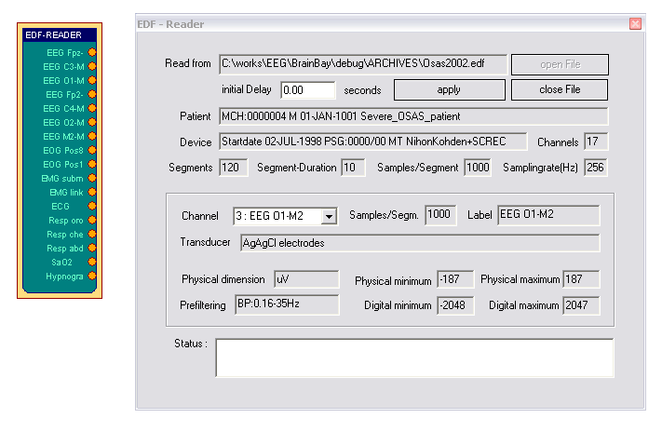
Choose a channel from the combo box to display it's information. EDF-files can have many channels. However, BrainBay's channel limit is set to 32. The signal range of the output ports is set by Physical Minimum to Physical Maximum of the corresponding channel. Similar to the EEG-Amplifier archive playback, the status bar extends when an EDF-archive has been opened successfully, to enable playback control and positioning in the archive. (see EEG-Amplifier element). The field Initial delay allows specifying an offset to align this archive file with other files for playback.

    - File-Read

The FileRead element allows reading signal channel data from ASCII- text files or raw binary files. It is the counterpart to the FileWrite element (data recorded via the FileWrite element can be replayed using the FileRead element)

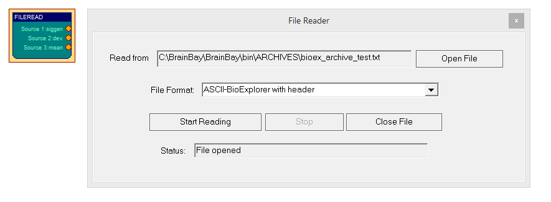
Using the File Format combo box, the type of storage and the delimiters for rows and columns can be selected. Available formats are: ASCII-Integer Values (human-readable text file) Bioexplorer File Format (including a header which makes this file compatible to the Bioexlorer application) or 1-channel 16 bit raw format (see also FileWrite element). The archive file read can be started and closed manually via the dedicated buttons in the configuration dialog.
    - Generic BLE Receiver

The GenericBleReceiver element allows connection of devices which send signal data over a BLE connection. The device is identified via it’s BLE advertising name. Furthermore, a Service-UUID and a Read Characteristic-UUID must be specified to establisch the GATT connection. Usually, a compatible BLE sender can be implemented easily using a BLE-capable microcontroller (ESP32, RP Pico W) and the NimBLE library.

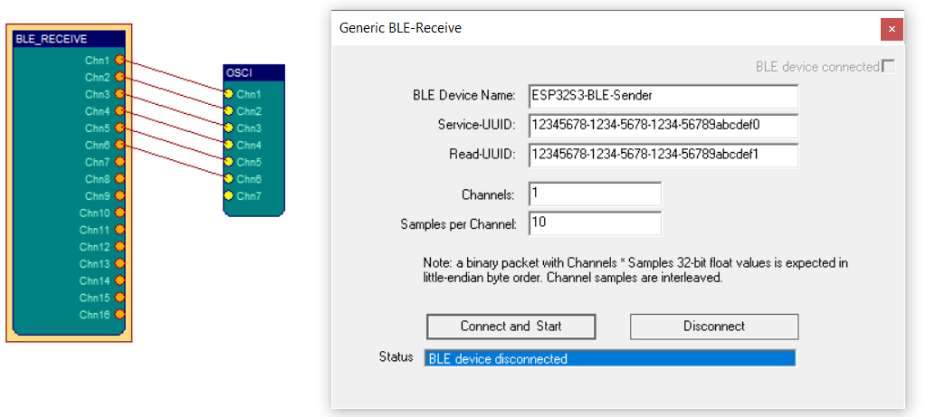

Next to the device identification parameters, two key parameters must be specified to define the structure of the expected data packets which are sent from the BLE device: the number of Channels and the number of Samples. Note that the BLE packet is expected to contain Channels * Samples single precision (32-bit) floating point values in little-endian format. The channels are expected to be interleaved. For example, using the settings Channels: 3 and Samples per Channel: 2, the data packet should be composed as:

Ch1-Sample1, Ch2-Sample1, Ch3-Sample1, Ch1-Sample2, Ch2-Sample2, Ch3-Sample2

which gives a total of 6 float values (in a 24-byte binary data packet). Thus, it is possible to keep the protocol overhead minimal and still allow an arbitrary number of channels and multiple samples in one packet, which is essential for keeping data transfers efficient, especially when using higher sampling rates.

    - Generic UDP Receiver

The GenericUdpReceiver element allows connection of signal senders that send data to a local UDP port. This could be a WiFi-capable microcontroller (ESP32, RP Pico W) connected to the same network. In the configuration dialog, the local IP address and the provided port is displayed – this information is needed for configuration of the UDP sender side. The element searches for local WiFi adpters and provides the associated IP adress if possible. If no Wifi adapter is available, the IP address of the wired LAN device is provided.

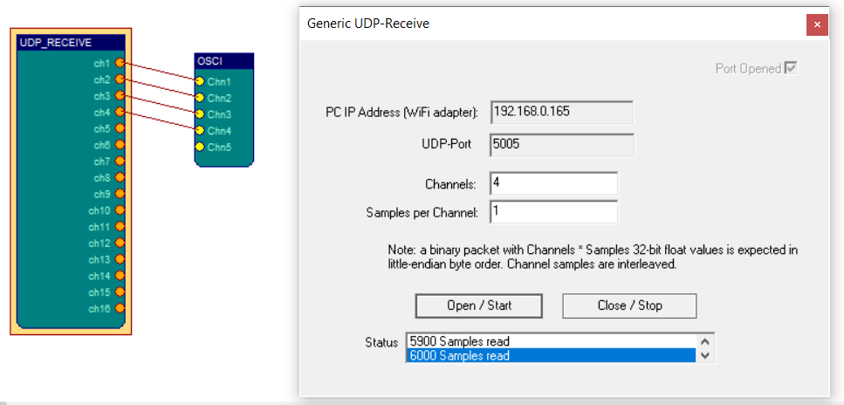

Regarding the expected data packet format, please refer to the description of the Generic BLE receiver element above, which uses the same format.
Note that UDP is a “connectionless” transport protocol without error correction – this means that samples might get lost if connection problems occur, but latency is kept low.

    - Key-Capture

The KeyCapture element outputs information about currently pressed keyboard keys. This can be useful to store triggers in the recording of a biosignal archive (for example pressing the spacebar key when starting meditation or deep breathing) – this information can be added to and EDF file or CSV file recording.

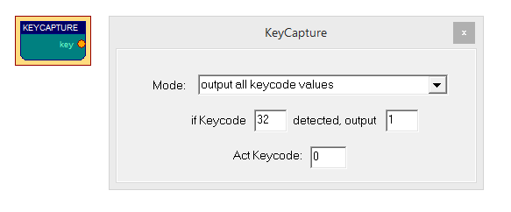
The KeyCapture element offers two modes: “output all keycode values” sends the keycode of any pressed key (for example 32 for the spacebar key), whereas “detect one keycode and output custom value” outputs an adjustable value only if a particular key is pressed – the keycode of the key and the desired value can be given in the respective edit fields. If no key is pressed, the element outputs zero. During a running session, the keycodes of currently pressed keys can be viewed in the “Act Keycode” field. Please note that the KeyCapture element only works if the main application window has the focus (is activated).

    - TCP-Receive

Similar to the EDF-Reader element, the TCP-Receive element provides EDF channel data to other elements. The difference is that the data comes from a network
connection and not from a local file. The TCP-Receive element connects to the neuroserver software framework by Rudi Cilibrasi which is also part of the OpenEEG project (see http://openeeg.sourceforge.net/doc/sw/NeuroServer). To use the TCP-Receive element, a neuroserver has to be running on a known host in the network or on the local host. Sending- and receiving clients can connect to this service. Thus, clients can send / receive live biosignal data and recorded EDF-archives to / from the neuroserver.
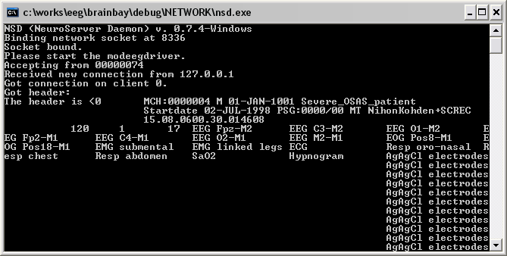
An easy way to test the TCP-Receive element is to start a neuroserver and an EDF-reading client on the local host (by using the Network- entry from the main menu) The figure shows the running service, with an EDF-client connected.

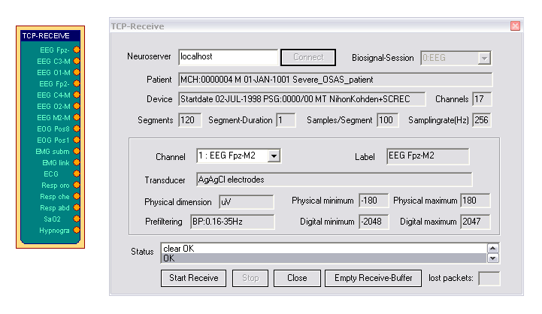

Connecting the TCP-Receive element to the neuroserver service
Enter the IP-adress of the host computer where the service is running into the field Neuroserver of the element's user dialog. (when running a local service type 'localhost'). Press the Connect - button. In case of a successful connection, the Status-listbox will show the line 'OK' and the combo-box Biosignal-Session will be filled with the available sessions from the neuroserver. Choosing one of the sessions will open the EDF-stream, display the header information and update the element's output ports. The port ranges for the output ports are obtained from the channel-information of the EDF-file.
During data reception, the progress in packets is shown in the Status-listbox of the user dialog. Use the Stop -button to bypass reception and Close to disconnect from the neuroserver.

Please take into account that there will be some delay in the transmission, depending on network bandwidth and other factors like the receive buffer for incoming values. The button Empty Receive-Buffer discards packets that are currently buffered

    - Camera (Webcam)

The Camera element can be used to process a video stream from a local camera (usually a webcam) and perform face- and movement-detection. For image- processing, the Intel Open Computer Vision library was used. (OpenCV, see http://www.intel.com/research/mrl/research/opencv )
In particular, three tasks can be performed by the Camera element:

- Record a live-videostream to an .avi - file to harddisk
- Playback of an .avi - file from harddisk
- Use a face detection - and feature tracking algorithm to output the estimated
position of the user's nose and chin. Together with the Mouse Controller -
element, this information can be used to control the cursor and clicking.

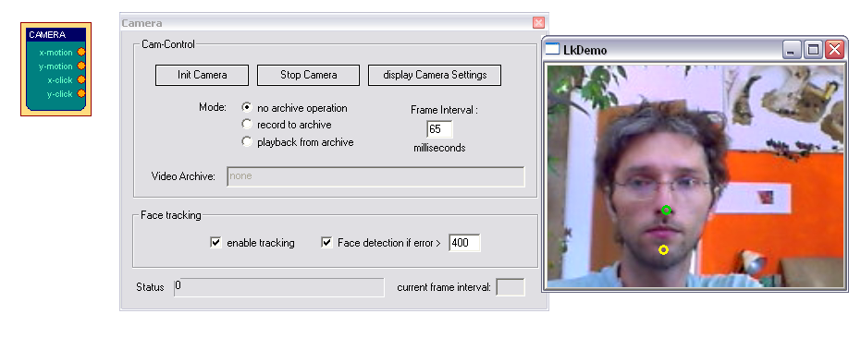To use the camera element, a webcam or another camera needs to be connected and visible to the system (installation of correct device drivers etc). After inserting the camera element into the design, the device is openend and the live-stream is displayed in a seperate window.
The capture interval can be set using the field Frame Interval of the element's user dialog. The interval has to be given in milliseconds, and should not be longer than about 65 milliseconds to get 15 frames per second. The value strongly depends on the webcam used and the overall system performance. Using a good webcam, 25 frames per second can be captured using a 1,6 Ghz machine with USB 2.0.
The button Display Camera Settings calls the settings dialog of the webcam. There, camera-specific parameters like contrast or the frame rate can be adjusted.
Three radio-buttons control the mode for the Camera-element:
'No archive operation' is usually used for feature tracking (head-mouse designs).
When 'Record to archive' is pressed, an open-file dialog can be used to choose a filename and folder for the avi-file. Then, a dialog for codec-selection appears. The codec compresses the image frames befor writing them to disk. Choose a codec that does not use much processor time ('uncompressed' is surely the fastest, but gives very large video archives, 'Cinepak' or 'Microsoft video1' are possible alternatives). After selecting the codec and starting the design, the video frames are written to the file until the Stop Camera - button is pressed, which also closes the archive file.
'Playback from archive' also displays an open-file dialog where the .avi file of a previous recording can be chosen. After starting the design, the video stream will be delivered from the archive and not from the webcam. This is also possible wehn no webcam is installed in the system.

Feature Tracking
If the switchbutton 'enable tracking' is checked, the element will perform a Haar-Cascade detection of a frontal human face on the videostream from camera or video archive file. When a face has been found, the nose and chin positions are estimated and followed by an optical flow algorithm. The coordinates of nose an chin relative to the last image are sent to the element's output port. After appropriate filter- and resize-operations, these coordinates can be used by the Mouse-Controller element to perform mouse movement and clicking operations (for details see the Camera-Mouse example design)

    - Skindialog

The Skindialog Element provides a custom draw, skinned user dialog to the design. Buttons and sliders with mouse-sensitive areas can be defined using and .ini -file and bitmap graphics. The current values of the sliders or button states are presented at the element's output port. Thus, special dialog can be draw to support users in the access or key features of a complicated design.

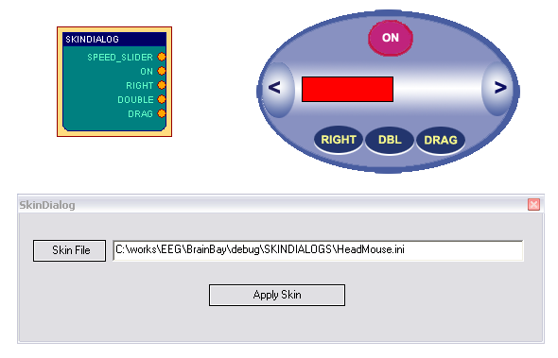

The description of the Skinned Dialog is stored in an .ini-File which contains
filenames of bitmap-graphics for the activated and deactivated dialog
and the pressed buttons. (see the skin_readme.txt file in subdirectory Skindalogs for more details)

The Skindialog object is currently in beta-stage, a more comfortable editor will be developed that allows online-adjustment of the dialog without editing the .ini file.

  - Processing Elements

As the signal source elements deliver biological data, simulated waveforms and other signals, the processing elements to perform signal adjustments, transformations, apply thresholds or combine singnals in order to get the desired parameters for the biofeedback and training processes. BrainBay currently has 19 signal processing elements which will be introduced in the following.

    - Averager
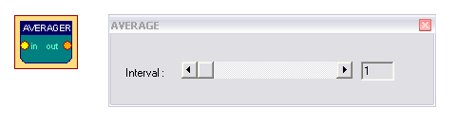
The Averager element puts out the mathematical average of the last n samples. The number of samples can be selected by the Interval scroll bar.

    - Comparator

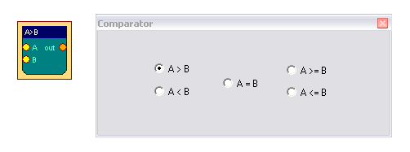
This element compares it's two input values in a way given by the user.
When the selected condition is fulfilled, the value of input A is routed to the elements output port. If not, the output of the element will be INVALID_VALUE (this is a representation of boolean false). In case one of the inputs is INVALID_VALUE, the output of the element will be INVALID_VALUE as well.

    - Correlation

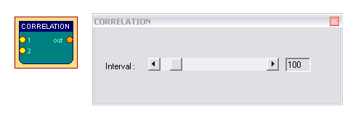
This element calculates the cross-correlation between the two signals connected to input 1 and input 2 in a selectable Interval of samples. Correlation is a measurement for the linear relationship between the two signals. The output will be between 1 (fully correllated) 0 (uncorrelated) and -1 (fully inverse correlated).

    - Counter / Display

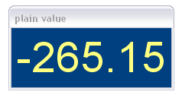
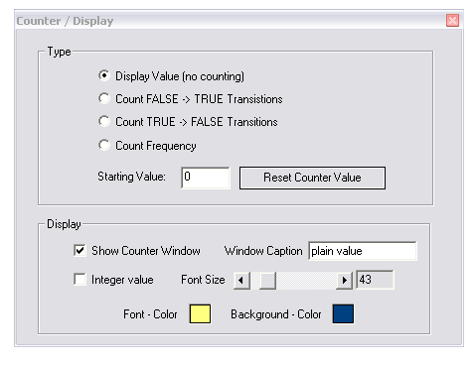

Depending on the selected type, the Counter element is used to count transitions from or to INVALID_VALUE, measure frequency of true-false transistions (in Hz) or show the plain input value without counting. The value of the counter is presented at it's output port, and, if desired, in a seperate window as an integer of float value. The counter can be set to an initial value by pressing Reset Counter Value. This reset of the value will also be done when the session is resetted using the status bar. Colors of text and background and font size can be selected in the Display- section.

    - Debounce

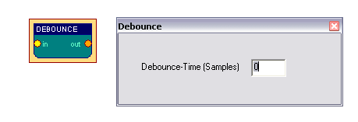

The Debounce element can suppress frequent changes to INVALID_VALUE. This could be used to constrict the generation of events when a signal is close-by a threshold level. The interval is given in samples.

    - ERP - Detector (Pattern Recognition)
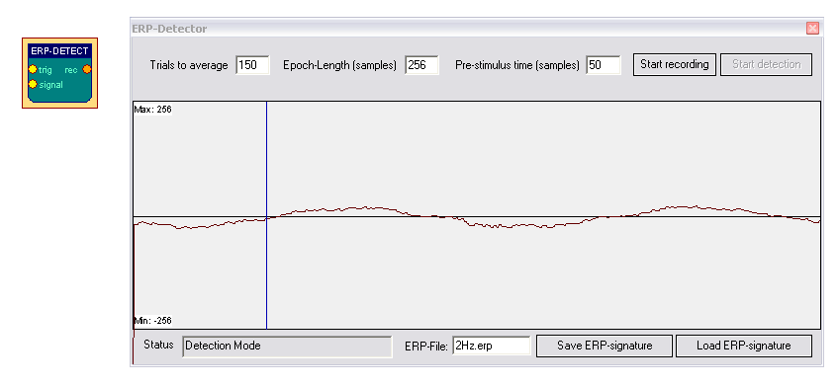

The ERP-Detect element can record and detect signal patterns in time domain. It can be used to perform trial averaging, what is a popular technique for extracting event related potentials (ERPs) from a noisy EEG signal. The Epoch-length of the trials, the pre-trigger interval and the number of trials can be written into the input fields. The display range is obtained from the signal input port. Adjust this range by right-clicking the input port.
The button Start recording activates the recording- and averaging-mode of the element. In this mode, the element waits for a TRUE value on it's trigger input port. This trigger singnal could come from a threshold - element, from an external switch-button or from a signal generator etc. After the trigger signal has been received, epoch-length samples are recorded and added to the internal buffer of the element. Then the next trigger input is awaited and the next trial is recorded. After a number of trials, the noise gets less due to the averaging process and the exctracted signal remains. This signal can be saved to an .erp file.

When the ERP-Detect element is not in it's recording state, it's continuously calculates the linear difference between the recorded signal and the last epoch length samples that came into it's singal input-port. The output-port presents the similarity with the recorded signal in percent (0-100).

    - Expression Evaluator

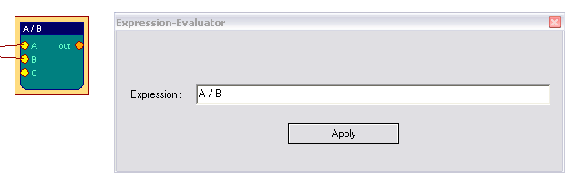

The Expression Evaluator can have up to six input ports, which automatically extend when a signal is connected. The input signals are referred to as A, B, C, D, E, F and can be combined with decimal constants, elementary functions, unary and binary operations to a mathematical expression that is evaluated when the session is running. The result of the expression is presented at the element's output port.
The evaluator implementation builds upon the open source library GNU-Libmatheval.
(see http://www.gnu.org/software/libmatheval)

Supported elementary functions are:
- exponential (exp), logarithmic (log), square root (sqrt), sine (sin), cosine (cos),
- tangent (tan), cotangent (cot), secant (sec), cosecant (csc),
- inverse sine (asin), inverse cosine (acos), inverse tangent (atan), inverse cotangent (acot), inverse secant (asec), inverse cosecant (acsc),
- hyperbolic sine (sinh), cosine (cosh), hyperbolic tangent (tanh), hyperbolic cotangent (coth), hyperbolic secant (sech), hyperbolic cosecant (csch), hyperbolic inverse sine (asinh), hyperbolic inverse cosine (acosh), hyperbolic inverse tangent (atanh), hyperbolic inverse cotangent (acoth), hyperbolic inverse secant (asech), hyperbolic inverse cosecant (acsch),
- absolute value (abs), Heaviside step function (step) with value 1 defined
- supported unary operation is unary minus ('-').
- supported binary operations are:
  - addition ('+'), subtraction ('+'), multiplication ('*'),
  - division multiplication ('/') and exponentiation ('^').

Usual mathematical rules regarding operation precedence apply.
Parenthesis ('(' and ')') could be used to change priority order.
Blanks and tab characters are allowed in string representing function;
newline characters must not appear in this string.

    - Filter

The Filter element provides digital low-pass, high-pass, band-pass or band-stop filters. A low pass filter will filter out high frequencies and let low frequencies pass the filter. A high pass filter does the opposite - it will filter out low frequencies and let high frequencies pass. A band pass filter will filter out lower and higher frequencies and let middle frequencies pass the filter. A band stop filter will filter out the middle frequencies and let lower and higher frequencies pass the filter.

The filter can have bessel- or butterworth - type. The bessel-filter has a slower roll-off in frequency domain (meaning it is less precise in attenuating around it's corner frequencies) but does not have so much ringing (overshoouting) in time domain.
The Filter Type, Filter Order and the frequency - limits for the filer can be selected in the user dialog. A higher filter order gives a sharper response in frequency domain but a longer delay in time domain. When the button Apply is pressed, the filter response in frequency domain is shown in the given display range. The display range can be adjusted be typing new values in the bottom left and bottom right fields.

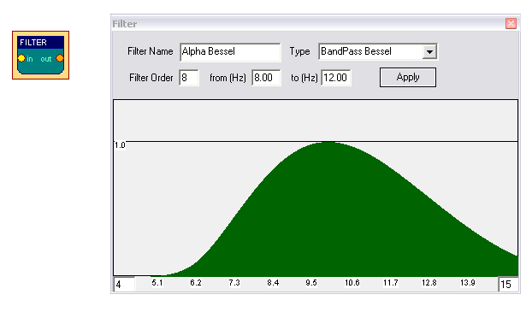

The filter shown above lets frequencies around 10Hz pass without attenuation. Frequencies below 6 Hz or above 14 Hz are attenuated heavily. For more information on the usage of filters see the design examples. The Filter - element uses the free FidLib library by Jim Peters and Tony Fisher (see http://uazu.net/fiview)

    - FFT (spectral analyser)

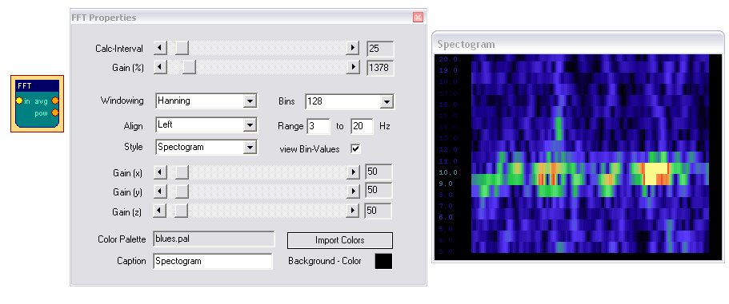

The FFT element performs a fast fourier transformation on the connected signal. This shows the frequency components that are present in the signal, just like the ear can detect the different tone-heights that are present in a sound. Using the FFT -element, the changing frequency-components of for example brainwaves can be displayed as a bar-graph, spectogram or 3d- landscape. The kind of display can be changed using the Style combo-box.
The Calc-Interval sets the number of samples that are buffered before the next transformation is done. An interval of 25 samples gives about 10 transformations per second at 256 Hz sampling rate.
The number of Bins defines the distinct frequency components (= bands). Many bins give good frequency resolution but slow reaction in time. Range selects the bands to be displayed (in Hz). Align (left, right, bottom) rotates the display.
A color palette can be used to map the intensity information to colors, what is necessary in the 2d and 3d - views (for usage of the color palettes see palette editor).

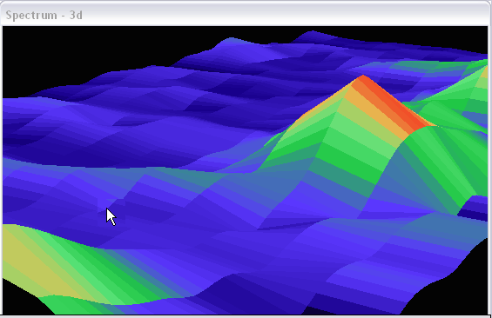
The Gain (%) amplifies or attenuates the signal before the FFT is done. The Gain(x), -(y) and -(z) affect the display and are effective in the 2d and 3d views.
When using the 3d -display, left- or right- clicking and dragging the display window will change angle or position of the view (see section design examples).
The FFT-element has two output ports: Average and Power. The first gives the average freuquency of the bands in the selected range, the second gives the average power (magnitude) of the bands in the selected range.

    - Integrator

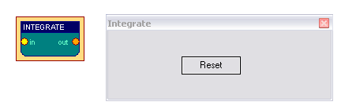

The Integrator element continuously sums the incoming values. Pressing Reset sets the buffer to zero, this is also done when starting or resetting the session.

    - And, Or and Not
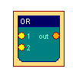
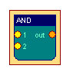
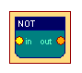

The logical And, Or and Not elements perform logical operations on the input values and output the result. BrainBay has a special signal value which is treated as “False”. This signal value (-32767) is called “INVALID_VALUE” and is created e.g. by the Threshold element when the incoming signal exceeds the positive or negative thresholds. The logical elements And, Or and Not take INVALID_VALUE at their input ports as logical “False” and all other values as logical “True”. They behave like standard logical operations:

And outputs “True” when none of its inputs is INVALID_VALUE
Or outputs “True” when at most one input is INVALID_VALUE
Not outputs “True” when the input is INVALID_VALUE

(else the elements output “False”).

The logical elements provide some flexibility how the results “True” or “False” are represented at their output port: Using the provided comboboxes in the property window, the behaviour for “True” and “False” can be selected separately which increase the flexibility and usage applications of these elements:
The output behaviour for “True” can be set to:
- value 512
- the value of input port 1
- the maximum of input 1 and input 2
- an arbitrary numeric value (which can be defined in an input field).

The output behaviour for “False” can be set to:
- INVALID_VALUE (-32767)
- an arbitrary numeric value (which can be defined in an input field)
- no output at all

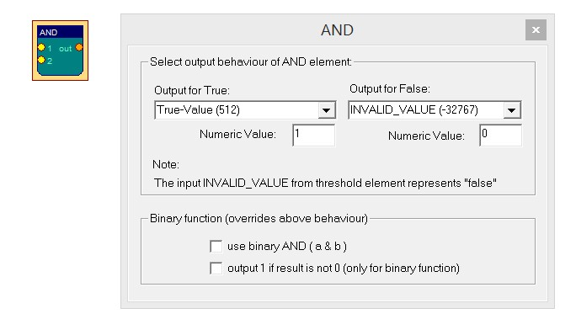

Alternatively, a “binary” operation mode can be selected for the logical elements. If this mode is selected it overrides the output behaviour selected in the above comboboxes. The binary operations perform a bitwise and ( & ), or ( | ) or xor ( ^ ) operation with the values of input1 and input2 (or with the given numeric value in case of the xor operation) – similar to the bitwise logical operation in the C-programming language.

    - Matlab Transfer

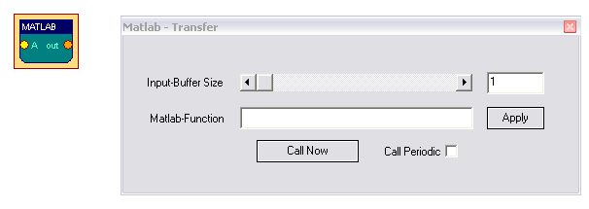

The Matlab - element can be used to transfer sample buffers to the Matlab application for further processing (see http://www.mathworks.com). Matlab is commonly used in academic and scientific signal processing. As this is a commercial application, the needed .dlls cannot be delivered with brainbay, and the Matlab-element will only work if you have a licenced version of matlab on your system.
The element can process up to six input ports named A, B, C, ...
During operation, the input values will be collected in buffers of given size. By pressing Call Now, the buffers are transferred to Matlab and can be accessed via the Matlab-variables A, B, C ... and a Matlab-function of given name will be called. The result (the ANS-variable) will be transferred back to BrainBay and presented on the output of the Matlab-element.
When Call Periodic is selected, the transfer will be done automatically when a new sample arrives, this will only work for matlab-functions with low complexity / short execution time. (Please note that this element is probably outdated, it’s correct operation needs to be verified with current versions of Matlab).

    - Magnitude

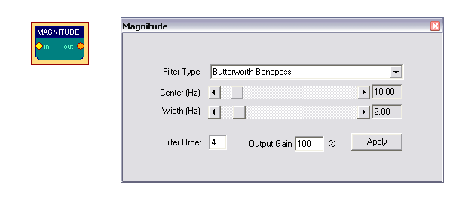
The Magnitude - element can be used to calculate the activity in a certain frequency -range of a singal. This is oftern referred to as 'power in pass-band'. The filter type the is selected via combox-box can be Bessel-Bandpass or Butterworth-Bandpass. (for more details on filters see the Filter - element or Jim Peter's FiView - application, http://uazu.net/fiview). The Center (Hz) and Half Width (Hz) - parameters adjust the pass-band, where activity shall be measured.
An Example: when you want to measure Alpha-frequencies of brainwaves in the range from 10 to 12 Hz, select a center of 11 Hz and a half width of 1 Hz for the filter. The filter order controls the 'sharpness' of the cut-off of unwanted freuqency-ranges. A higher order gives better cut-off, but the response of the filter in time will be less accurate. The Magnitude - element outputs the activity in the given passband, a gain value (in %) can be applied to amplify the output.

    - Mixer
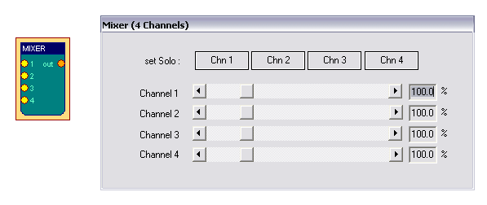

The Mixer - element can be used to merge up to four input signals into one output signal. The amplification-ratios are given with the corresponding silder-bars. Using the buttons Chn1 - Chn4, presets for solo-output of the selected channel are activated.

    - Sample and Hold

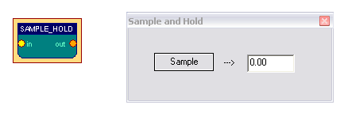
The Sample-Hold - element stores the current input-value when the button Sample is pressed. This value will be present at the output-port until another value is stored using the button.

    - Standard Deviation

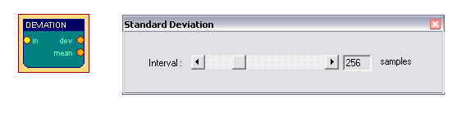
This Element calculates standard deviation and mean of n samples and puts the results to the ouput ports. The number of samples for the calculation interval can be set using the slider bar.
    - Threshold / Meter

The Threshold - element combines following useful functionalities:

- Averaging and amplification or attenuation of the incoming signal
(using the slider bars in the Preparation-section)
- Setup of fixed upper- und lower limits for the signal (thresholds)
- Generation of dynamic upper and lower limits, using a quantile, percentage of min/max or percentage of the averaged values of the previous n samples
- Calculating a baseline value for n seconds after the session starts
- Passing only rising or falling values
- Defining the output behaviour for valid or invalid values; the default behaviour is that if incoming values are not in the specified range, the element outputs
INVALID_VALUE, otherwise the signal will be passed to the output port
- Display of a Meter - window to show the current value of the signal
and the upper and lower bounds, which allows manual adjustment of the threshold value via the cursor-up / cursor-down keys

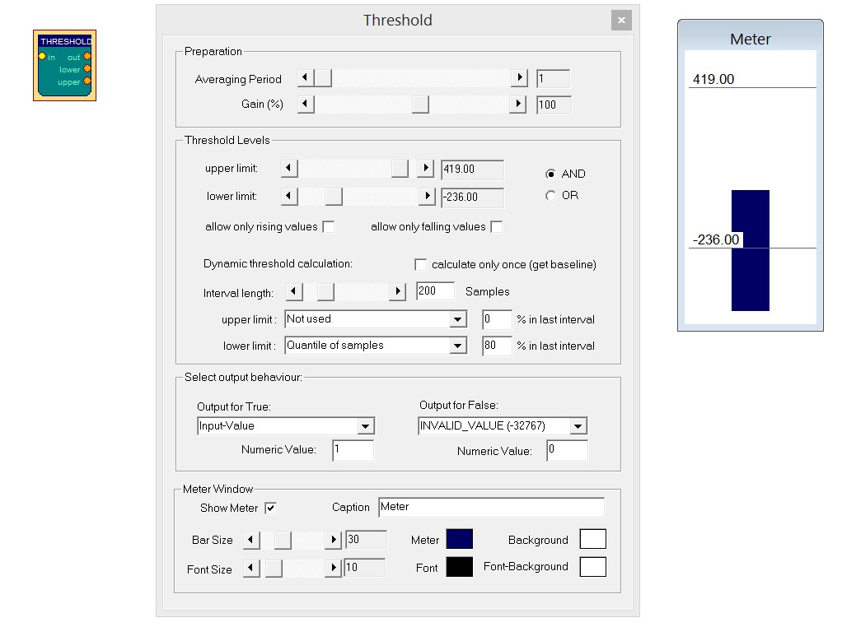

The minimum and maximum values of the upper/lower limit sliders are obtained from the input port signal range. This range can be adjusted by right-clicking the input port.

When dynamic threshold calculation is used, the upper and/or lower limits are calculated periodically from the last interval length number of samples. The calculation method can be selected from the combo boxes (quantile, % of min/max or % of mean value).

By enabling calculate only once (get baseline), the dynamic thresholds will only be calculated at the beginning of the session (please note that the inverval for the calculation of the baseline is then given in seconds - not in samples. E.g. an interval of 20 will average 20 seconds of incoming values at the beginning of the session to determine the threshold).

If rising- or falling values is selected, only progressive or regressive values will pass the threshold. In the Meter Window - section, font size, bar size, colors and caption for the meter display can be selected.
The Meter Window section allows various color and style adjustements of the meter window. If desired, the meter window could also be hidden. When the meter window is displayed and has the input focus during a running session, users can adjust the given upper threshold by pressing the cursor-up or cursor-down keys on the keyboard – thus, the threshold level can be easily adjusted on-the-fly.

The Threshold element is a useful tool for feedback-purposes, where the reaching a certain state (high activity or low activity) is desired. Combined with a Midi - element, feedback tones can be generated if a desired level is reached.

  - Signal Targets
    - AVI – Player
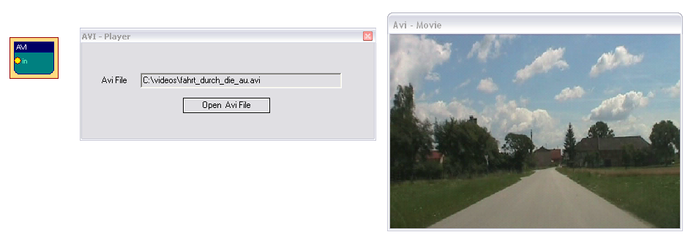

The AVI-Player element can be used to display and navigate avi-movies. The value that comes into the input-port of the element is interpreted as frame number. This frame will be shown in a seperate display window. Using rising or falling values, the movie can be watched forward or backwards. The sound of the AVI-movie will not be present at playback (use the Media Player element to include sound output). A video-codec that can decode the given avi-file has to be installed on the system to use the AVI-Player element. Please note that the MediaPlayer element is also available which provides other / additional features and supports different media file formats.

    - Com- Writer

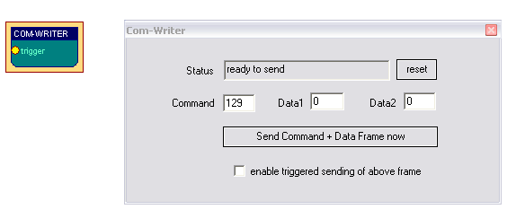

The COM-Writer element can be used to send command and data values to a connected Monolith-EEG amplifier in bidirectional mode (using P21 firmware protocol) . Using the Com-Writer, runtime options of the MonolithEEG like baud- or sampling rate can be changed and the digital I/O- ports of the MonolithEEG can be set. One command/data frame consist of three bytes that can be defined using the input fields of the user dialog. The frame is sent by pressing the button. When triggered sending is enabled by the user option, the frame will be sent every time an input different from INVALID_VALUE is received by the trigger input-port.

    - EDF- Writer

The EDF-File Writer element can be used to created a biosignal archive in European Data Format (see http://www.edfplus.info). The header of an EDF file stores various information about the recording: date, patient data, recording device, sampling rate, data segments, signal ranges and descriptions for the data channels. This information can be set using the data fields of the user dialog.
The description for the connected channels can be set using the Channel combo-box and the corresponding data fields. When all channels have been connected and labelled, the button Create File can be used to choose location and file name for the EDF file to be created.

The recording of channel data can be controlled by the buttons Start Recording and Stop Recording. After recording, don't forget to press Close File to finish the writing process and close the file.

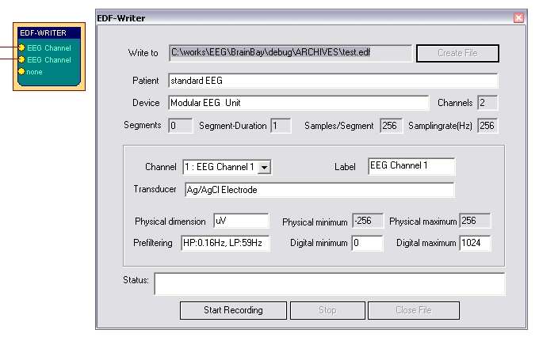

    - File – Write

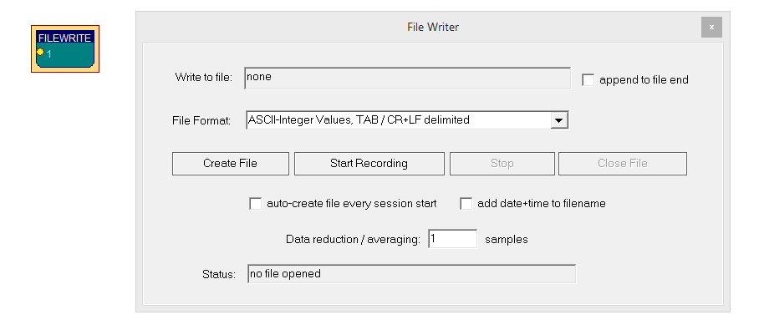

The File-Write element can be used to generate an archive file with channel values, which allows processing of the data in other applications. The File-Read element can be used to read the channel values from this archive file – usually this will be done in another design configuration.
Using the File Format combo box, the type of storage and the delimiters for rows and columns can be selected. When using ASCII-Integer Values, a human-readable text file will be generated. If more than one channel is connected to the element, the channel values will be written as columns with commas (CSV- text file) or TABs as column seperators. As delimiters for the rows, CR/LF - delimiters can be generated. These text files could be imported in Microsoft Excel or other applications for display and further processing. Further available file formats are Bioexplorer File Format (including a header which makes this file compatible to the Bioexlorer application) or 1-channel 16 bit raw format, a one-channel binary file that could be imported in a sound-processing application which supports .wav format (note that in this case only one channel will be processed).

The archive file can be created and closed manually via the dedicated buttons in the configuration dialog. Alternatively, the File-Writer element offers the feature auto-create file every session start: if enabled, the archive file will be automatically created at session start and closed at session end. To prevent overwriting previous archives, the option add date+time to filename can be used (so that unique filenames containing the creation date/time will be created).
If desired, a number of samples can be averaged before stored to the archive file – for example when a value of 1000 is entered in the field Data reduction / averaging only one (averaged) value will be written to the file every 1000 samples.

    - Oscilloscope

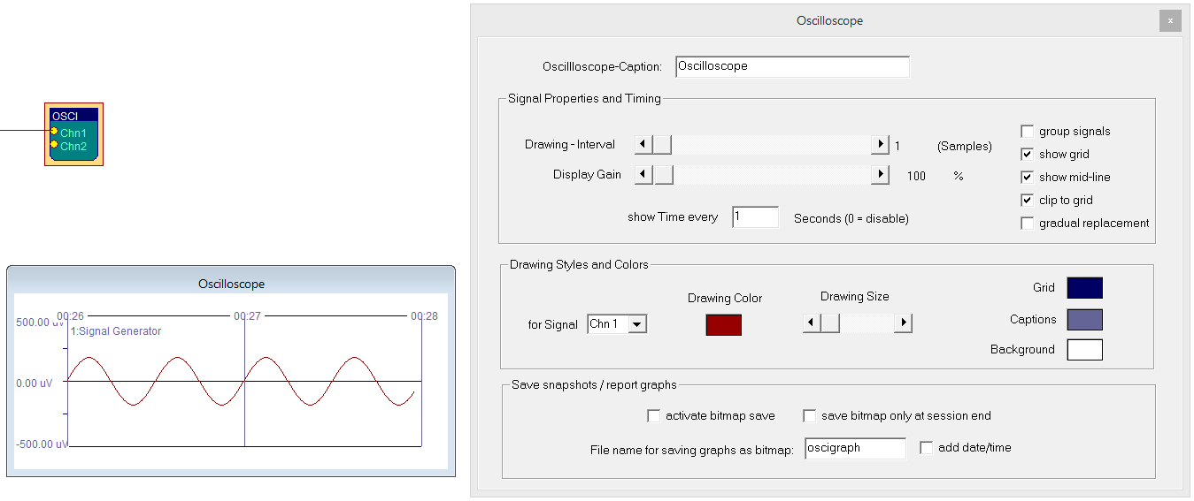

The Oscilloscope element is essential for the display and inspection of one or multiple signals. The connected signals are shown in a seperate window which can be freely resized. During runtime, a data grid showing the signal ranges and the current time can be displayed. The Drawing-Interval silder sets the display granularity for the oscilloscope: a selection of 1 will display every incoming value, a selection of 4 will display every forth value etc. The Display-Gain slider is used to amplify / attenuate all connected signals. The gain and drawing-interval settings can also be changed during session runtime by using the cursor keys if the oscilloscope window is selected (up/down for gain, left/right for interval).

If the group option is used, the connected signals will be shown in the same data grid (in this case, the signal range of the first connected channel is used for all connected signals). The settings show grid, show mid line, clip to grid and gradual replacement determine if a grid is used, when the vertical bars for time periods are inserted, how the signal traces are draw and if they are allowed to exceed their dedicated charts.
In section Drawing styles and colors, background color and individual signal colors (per channel) are adjusted using the color-picker-buttons and the signal trace width can be adjusted.

The section Save snapshot / report graphs provides allows storing the oscilloscope traces before they get removed: if activate bitmap save is enabled, a snapshot is taken of the oscilloscope window and saved under the given filename in the subfolder /Reports (.bmp will be added automatically). Optionally, date and time can be added to the filename to avoid overwriting the bitmap file.
If the option save bitmap only at session end is active, the snapshot will only be taken when the session end is signalled by the Sessiontime element. See description of the SessionManager and Sessiontime elements for how to use report graphs of oscilloscopes to show training progress.

    - OSC-Sender

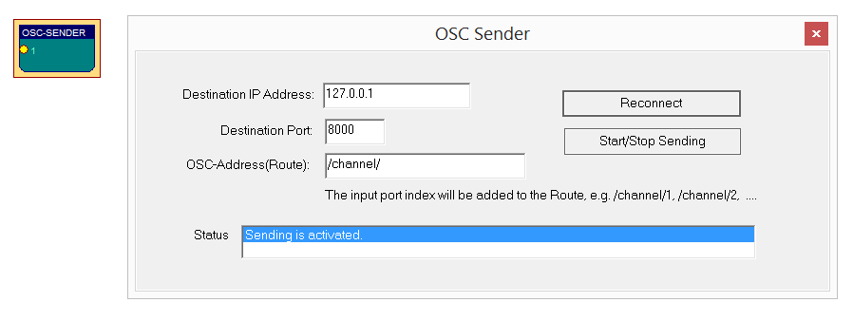

The OSC-Sender element can be used to transfer live data from Brainbay to other applications via UDP / Open Sound Control (OSC) protocol. Only a UDP server listening on the Destination IP-address / port is necessary to receive the information. Multiple signals can be connected to the OSC-Sender element. Every connected singal is transferred via a dedicated OSC route (address), which is composed of a selectabe prefix (eg. /channel/ ) and the appended channel number. Please note that every OSC route identifier must start with a slash. For details about the OSC protocoal structure see: http://opensoundcontrol.org/spec-1_0-examples

    - Keystrike

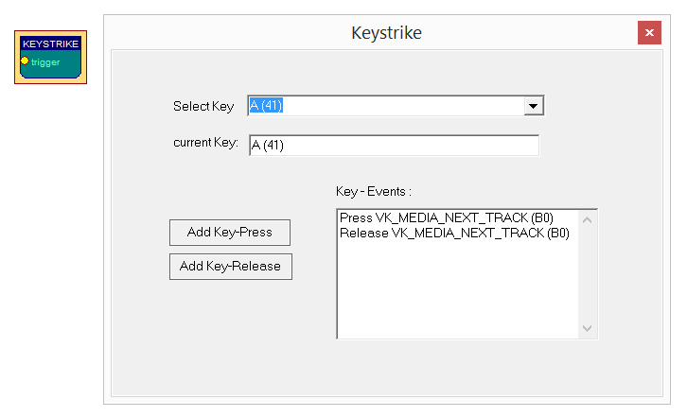

The Keystrike element allows the generation of virtual keyboard input (i.e. key press and key release events which behave like real keyboard input in most applications). The key actions can be added to a listbox. During session runtime, the key events are generated when a connected signal changes from “INVALID_VALUE” to a valid value (e.g. when a threshold value in a preceeding threshold element is reached).

    - Particle Animation

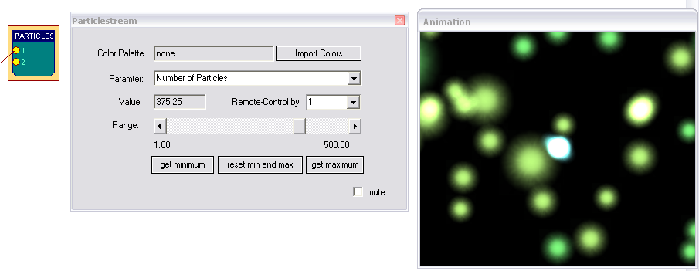

The Particle Animation element provides a graphical particle system that can be controlled using signal values from up to six input ports. The particle system can produce nice visual effects like color fountains, flames, star-flights or, in combination with signal generators, moving circles and other geometric figures in 3d. The System can be influenced by changing the current parameter using the Range silder-bar.

Parameters for the Particle System:

- Number of Particles, Generation Interval
- Slowdown, Color
- X-, Y-, Z- Position
- X-, Y-, Z- Speed
- X-, Y-, Z- Gravity
- Life Span, Randomizer

Recommended usage of the Particle System:

- select a color palette for the particles (see palette editor)
- choose one of the above parameters from the combo box and adjust it's value to gain a desired effect
- repeat previous step for other parameters, until you have the effect you like
- connect a signal to input port 1 of the element
- select a parameter that suits well to the type of feedback you want
- select Remote Control by 1, now the value of this parameter will change
according to the signal connected to input port 1.

Use the get minimum and get maximum buttons to set the current input-value as new minimum or maximum for the parameter value. This way, the upper and lower bounds for remote-controlling the paramter can be set.
When reset min and max is pressed, the min and max values will be reset to the original values for this parameter. The best results for the particle system can be gained by using an OpenGl-accellerated graphics card.

    - Midi Output

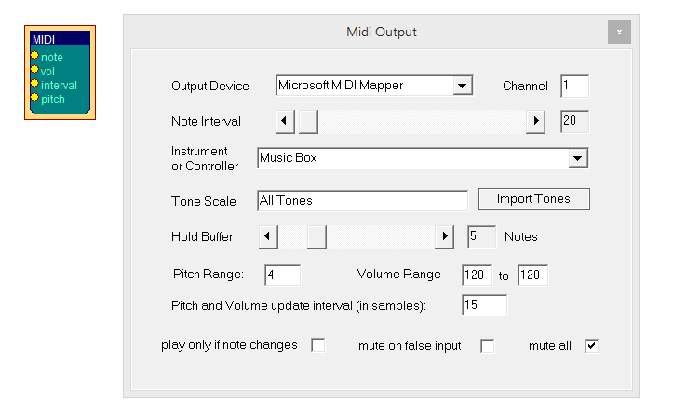

The Midi element provides Midi-Audio feedback for the connected signal. Toneheight and volume are controlled by the connected input ports. The signal range of the connected input signals is mapped to the selected volume range or tone scale (note that the range can be modified by right-clicking the input ports).
The Output Interval sets the frequency of tone generation: an interval of 1 will generate a midi tone every time a new value arrives (this is usually much too fast).
A setting of 25 gives about 10 tones per second when a sampling rate of 256 is used, which is still very accurate. The interval can be directly set via the dedicated input port as well.

The pitch input port allows adjusting the pitchwheel setting according to the incoming value and its range. The maximum span for pitch and volume can be defined via the settings Pitch Range and Volume Range respectively.

For Output Device, a desired Midi-Output device can be selected (please note that this device must be enabled in the Options Menu before).
Using Channel 1 - 16 allows multiple midi-elements with different instruments to work in parallel (while channel 10 usually selects the Drum-Set).

The combo-box Instrument or Controller selects the midi instrument or a midi-controller from 0 - 127. Using midi-controllers makes sense if an external midi-device like a synthesizer or drum-computer is connected, or a Midi-software-router to transfer the midi-commands into other running sound applications is available (for example LoopBe1 freeware bridge).

With the button Import Tones, a tone-scale which has been generated with the Tone Editor can be imported and used as a harmonic filter for the midi-notes. (see Tone Editor).

The Hold buffer sets the number of tones that will be left on at the same time.
When play only changes is selected, two consecutive notes will only be played if they are different.

    - Mouse Controller

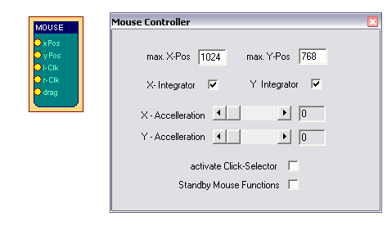

The Mouse Controller element provides an interface to the mouse-cursor and clicking functionalities. The current screen-resolution should be set as maximum X- and Y- positions for the cursor. During session runtime, the present values at the xPos- and yPos- input ports will influence the cursor position. If the x-Integrator and y-Integrator options are selected, the input values are interpreted as relative changes (Joystick mode), if not, absolute positions will be used.

A left click will be performed when a value other that INVALID_VALUE is passed to the l-Clk input port. Right-clicks and drag-clicks can be performed in the same way, using the r-Clk and drag input ports.

The option activate Click-Selector displays a seperate tool-window which allows selection of right-, double- or drag-clicks without using the corresponding input port. Thus, a right-, double- or drag-click can be performed by choosing the type of the next click in the click-selector window, and the special click can be performed with the normal left-click action. The Dwell-Time can be used to perform a left-click operation by holding the mouse cursor in a given screen-area for a given time. Thus, clicking can be performed without having a seperate control signal connected to the l-Clk port.

A useful source for the Mouse Controller could be the Camera element (feature tracking enabled). After some filtering and scaling, the estimated face positions that are put out by the Camera element set the cursor position for the mouse and give a functional head-mouse interface (see design examples).

    - Shadow

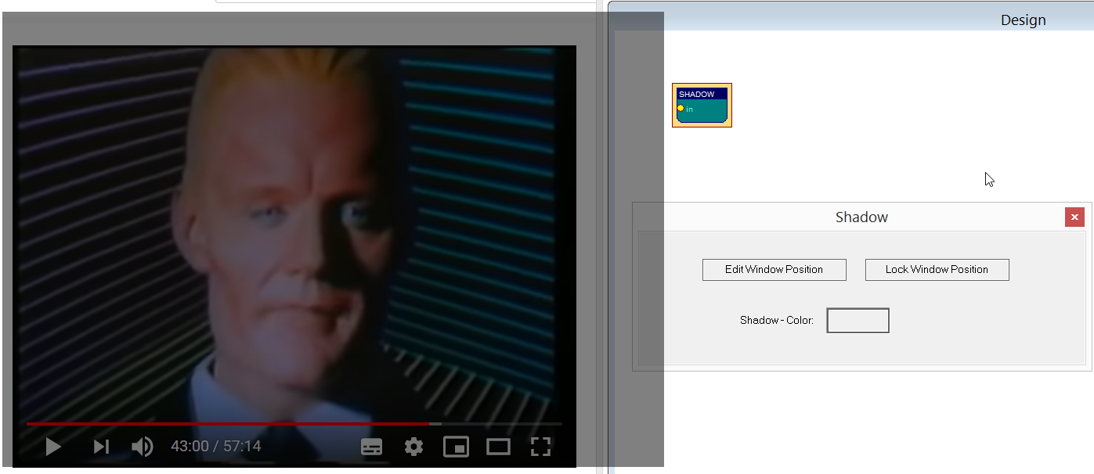

The Shadow element displays a semi-transparent window with selectable dimension and color above other windows on the desktop. The transparency / occlusion can be controlled via the input port. This can be used for feedback/reward purposes – e.g. to show a picture or moive which is displayed by another application. The shadow window is placed on top of the respective content. The input port range (right click on input port) is mapped to the transparency of the shadow window, i.e. if the minimum value is sent to the input port, the window is fully opaque, and if the maximum value is send to the port, the window is fully transparent. Please note that the window can only be moved / scaled if the edit mode is enabled in the properties, and that the transparency only works if the window is locked. So the recommended procedure is to place the window over a movie and then lock the window (and eventually save the design).

    - Sound Player

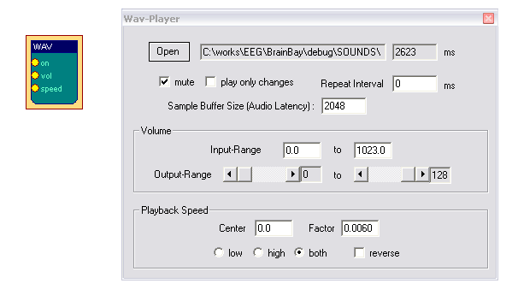
The Sound-Player element can be used for triggered playback of a short audio-file. Supported file formats include wav, mp3, voc and aiff. The file could contain sound effects or reward tones of about 1 to 20 seconds length. The element is not suited for longer music files because of long loading / conversion times (use the Media Player element for longer files). The input-ports control starting of the sound (on), the current volume (vol) and the playback speed / toneheight (speed). The sound will be played when the on input is different from INVALID_VALUE. If the option play only changes is selected, the sound will be played only once if the value of the on input-port does not change. The Repeat Interval can be used to select a minimum duration until the sound is triggered next time, thus a pause can be introduced.
The Sample Buffer Size sets the size for the internal playback buffer, this value affects the audio latency / system performance. Using values < 4096 is recommended for accurate playback.

The ranges for volume (Input-Range) and speed (Center and Factor) are obtained from the connected input signals and can be set manually by changing the values in the user dialog. The reverse option changes speedup or slowdown of the sound when the speed input values rise. The Center - value sets the value for playback at original speed and the Factor - value sets the gain for speed-changes.

    - TCP – Sender

The TCP-Sender element can be used to transfer signal channels via network, using the neuroserver software by Rudi Cilibrasi. To establish connection, a neuroserver has to be running on a known host computer in the network or on the local host. (see http://openeeg.sourceforge.net/doc/sw/NeuroServer).
The TCP-Sender element then connects to this service as a client which sends biosignal data in EDF-format.

Connecting the TCP-Sender element to the neuroserver service
As in the EDF-Writer element, the first thing to do is to fill out the descriptions for the EDF data header and channel information (see EDF-Writer element). The signal range for a specific channel is obtained from the connected input signal, it can be modified by right-clicking the input port.

To connect to the neuoserver, enter the IP-adress of the host computer where the service is running into the field Neuroserver of the element's user dialog. (when running a local service type 'localhost'). Press the Connect - button. In case of a successful connection, the Status-listbox will show the lines 'Entering EEG mode' and 'OK'.

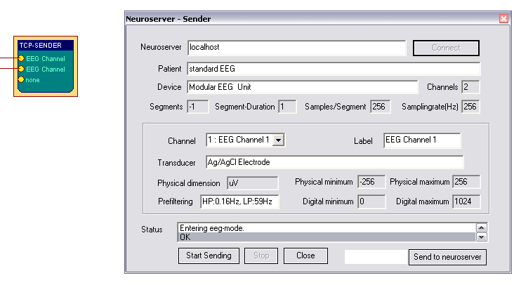

Start Sending and Stop are used to contol the data flow to the neuroserver. The button Send to neuroserver directly sends a neuroserver command written in the text field to a connected service. Use Close to disconnect from the service.

    - Media Player
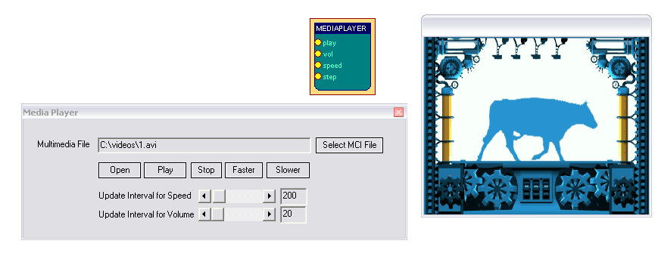
The Media Player element uses the Windows MCI interface to playback video or sound-files. AVI, WMV, WAV, MP3 and other formats could be used. After a mediafile has been selected, it is played by receiving a value different from INVALID_Value at its play input port. Volume and playback speed can be adjusted by the Vol and speed ports, where a value of 1000 sets full value or normal speed. Update Intervals for vol and speed have to be set according to system performance because these functions are time-consuming. Inputs into the step port cause a video file to step one frame forward.

    - Volume

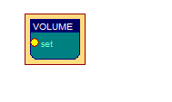
The Volume element can adust the master sound volume. This can be used to influence the sound output of other applications running in parallel. The input port range (right click on input port) is mapped to the volume, i.e. if the minimum value is sent to the input port, the volume is set to 0% and if the maximum value is send to the port, the volume is set to 100%. The Volume element can be combined with the Shadow element to control both audibility and visibility of a movie playback or computer game.

  - Other Elements

    - Documentation
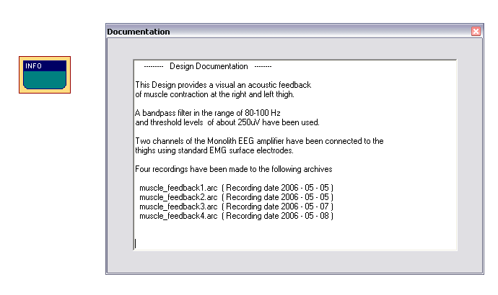
The Documentation element simply provides a text box. It can be useful to describe the overall purpose of the design, special design elements or archive files that have been recorded with this design.

    - Ballgame
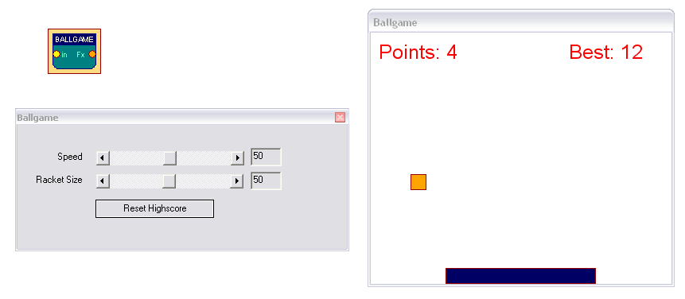

The ballgame is an example for a feedback-game, implementing a low-end version of the classic 'arkanoid' - arcade game originating in the early 80ties. The purpose of the game is to catch the ball with the moving bar (the racket). The position of the racket is contolled by the input port of the element. Racket Size and Speed of the ball can be controlled via the user dialog. The best number of hits is displayed in the game window and stored by the element.

    - Button
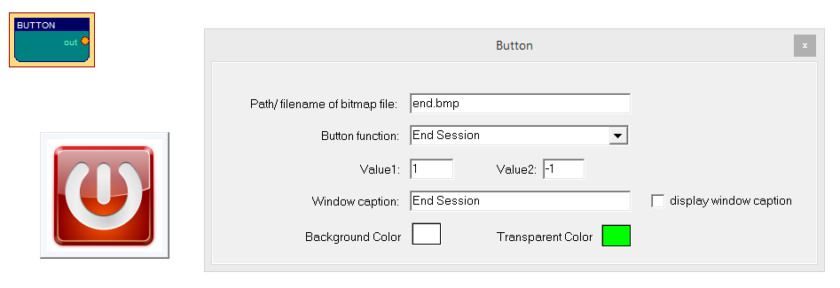

The Button element allows placement of a desired icon or symbol inside the main application window, and to select a function which shall be executed when this icon is clicked during a running session. The default file path is set to the /GRAPHICS subfolder. Alternatively, a relative filepath to other locations can be given. The file type of the graphics file must be Bitmap (.bmp, 24bit color). The functions for the button can be selected via a dropdown combo box. Supported functions for the button are:

- Start Session, Stop Session, End Session
- Send Value1 if pressed else Value2
- Send Value1 if pressed else INVALID_VALUE
- Toggle Value1 and Value2
- Send Value2 for one second, else Value1
- Display Device Settings (only available if Amplifier present in the design)
- Display Application Settings

If desired, a window caption can be displayed. If no window caption is displayed and the session is locked (see Application Settings), the button bitmap will displayed completely without frame or border.
    - Speller

The Speller element provides an experimental user interface for step-by-step selection of letters (e.g. via EMG muscle activity, eye blinks, IMU-accelerometer values etc.) for the purpose of writing and/or using a speech synthesizer.
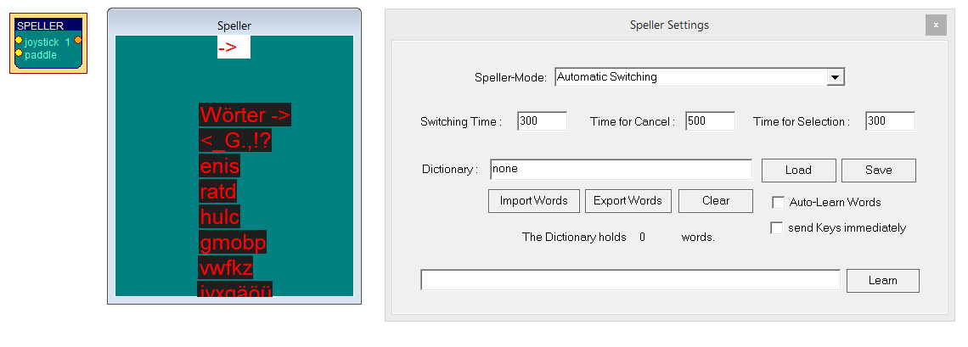
The GUI of the element shows rows with a number of letter- or word-suggestions. The rows can be automatically switched / highlighted or browsed manually (via the paddle input). When a row is selected via the incoming values of the joystick/paddle input ports, the individaul letters (or words) can be chosen in a subgrid. A dictionary of words can be specified which allows word-prediction for more efficient use. If the option se nd Keys immediately is enabled, keystrokes of written letters or words will be created on the local system.

    - Sessiontime

The Sessiontime element allows definition of the session duration in seconds. Depending on the selected options, the session can either be stopped, or a desired configuration design file can be loaded. If the countdown to zero option is activated, the element will output the remaining seconds (e.g. in order to display this value using a counter/display element). If the load next configuration option is selected, another design configuration will be automatically loaded when the sesiontime is reached. Per default, design configuration files are expected in the Configurations subfolder. A possible use case for this parameter is to switch back to a menu which is displayed using the SessionManager element.

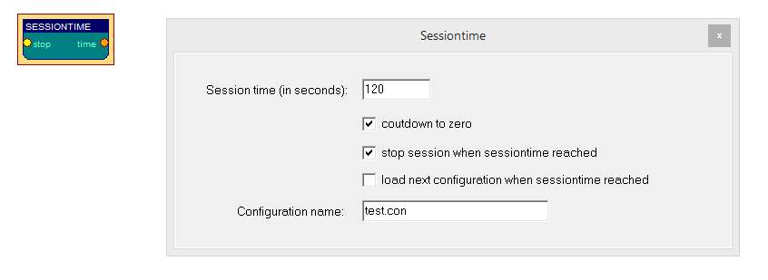

By sending values to the stop input port of the element which are different from INVALID_VALUE, a running session can be stopped.
    - SessionManager

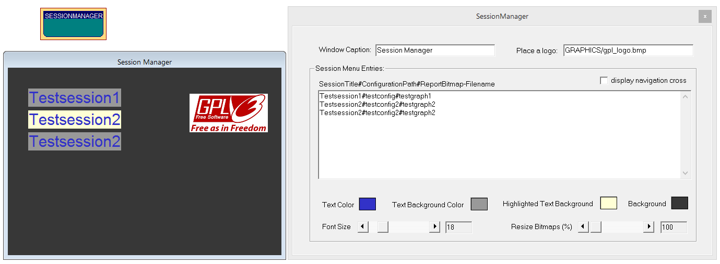

Using the SessionManager element, a number of design configurations can be provided to the user in form of a selection menu. In order to load a desired design, the entry in the list can be selected via keyboard (cursor up/down to change element, press enter to select) or via a dedicated navigation cross (which can also be used on tablets with touchscreen).

Optionally, a collection of oscilloscope report graphs which have been saved in previous sessions can be displayed. The next/previous report graph for the highlighted design can be shown by pressing the cursor keys (left/right) or by using the navigation cross.

The menu entries are composed in a listbox which holds one line per menu entry: Every line consists of 2 or 3 string items separated by a # character. The first string item represents the title of the menu entry which will be displayed in the SessionManger GUI (the session title). The second string item defines the name of the design configuration file which shall be loaded upon selection of the menu entry (given as relative path to the /Configurations subflder). The (optional) third string item specifies the name of the report graph files for this design configuration - see description of the oscilloscope element. It is expected that the oscilloscope element which generates the report graphs is configured to automatically add date and time to the filenames (to prevent overwriting previous report graphs). The extension .bmp is automatically added to the given report graph file name, the files are expected in the subfolder /Reports. If .bmp files are found, they will be displayed in the lower third of the SessionManager GUI.

The menu can be further customized in terms of font size, font color, highlighting color and background color and the report bitmaps can be resized to a given percentage of the original.

On the next page, an example of a customized menu including session report graphs can be seen.

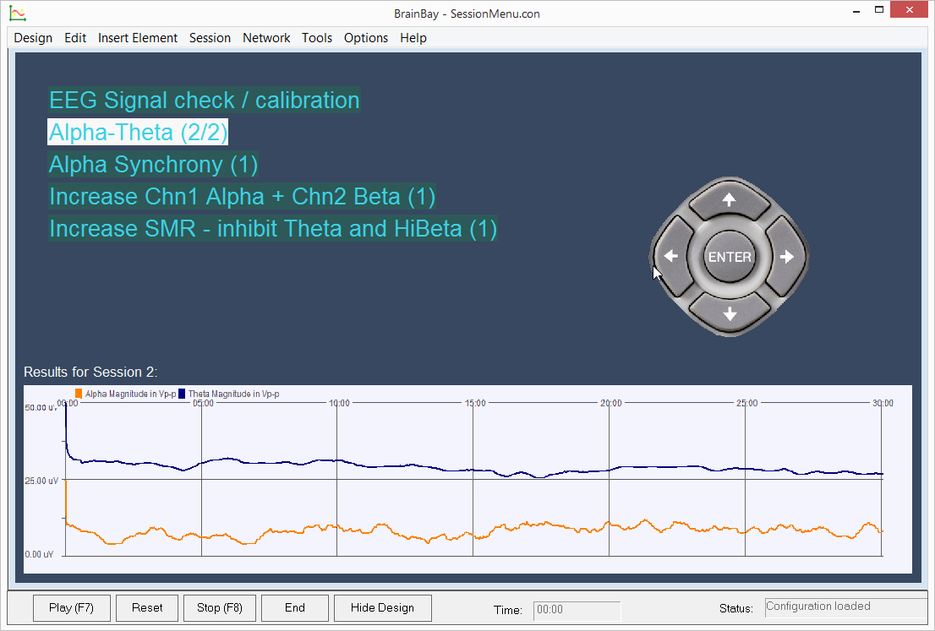

Example Designs

The following examples will show practical applications of design elements.
Three designs will be described briefly, one for neurofeedback, one for muscle feedback and a head-mouse design.

  - A design for Alpha / Beta – Neurofeedback

The following design shows realtime-processing of a two channel monopolar EEG recording. Three Silver Electrodes were mounted at C3, C4 and Cz - positions according to the 10/20 - system. The reference point was Cz. An abrasive conductive gel was used to improve electrode-skin contact. The impedance of the electrode-skin-connection was about 10kOhm. Sampling was performed by the MonolithEEG amplifier at 256 Hz, using the P2 firmware protocol and a baudrate of 56700 bits/sec.

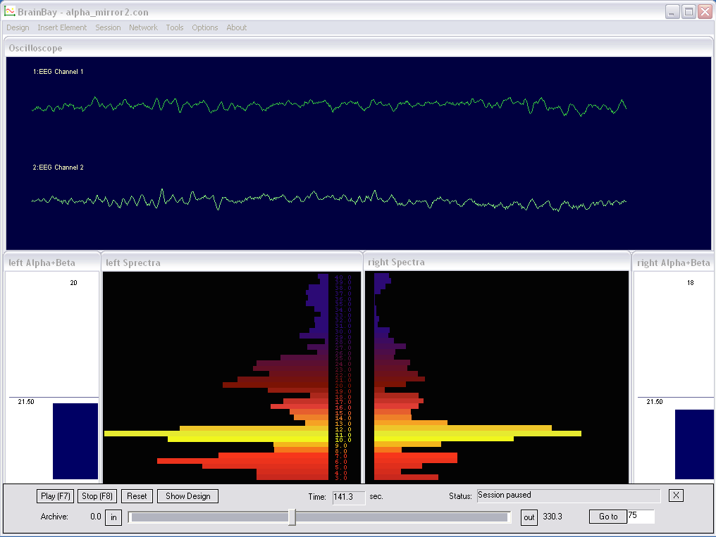

The oscilloscope window shows the EEG signals which have been 50Hz - filtered. Two FFT - spectrum analysers show the frequency spectra of the EEG signals (brain-mirror display). Magnitudes in alpha- and beta range give audio feedback via multiple midi channels. The two meter-windows show current magnitudes and thresholds for the audio-output.

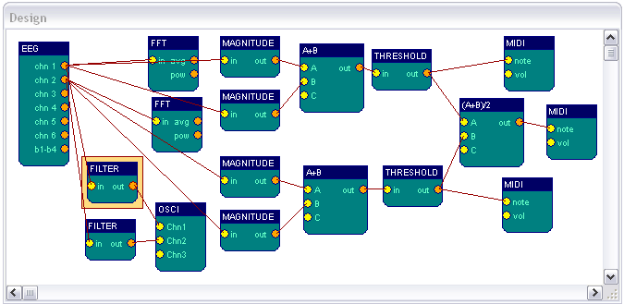

The design consists of the following elements (per channel):

- a filter of the type 'Bandstop Resonator', Bandstop-frequency=50 Hz, Order=8
- a connection to the oscilloscope, to display the filtered EEG signal
- a FFT spectral display, calculation every 10 samples, gain 250, 128 Bins,
display range 3 - 40 Hz, style: bar-graph, user-edited color palette
- two magnitude elements, using butterworth - bandpass filters in the range of
8-12 Hz and 16-20 Hz, filter order 4, gain 100 %
- an expression evaluator that adds the two calculated magnitues
- a threshold element, averager set to 223 samples, threshold set to > 21,5 uV
- a midi tone generator, using a user-defined harmonic scale and an output
interval of 70 samples.

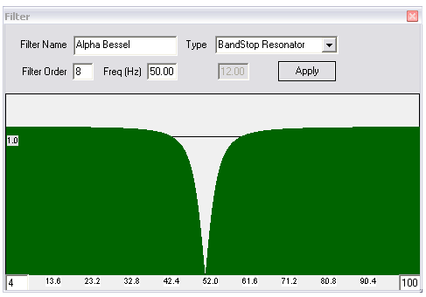

above: the frequency - response of the 50Hz - bandstop filter

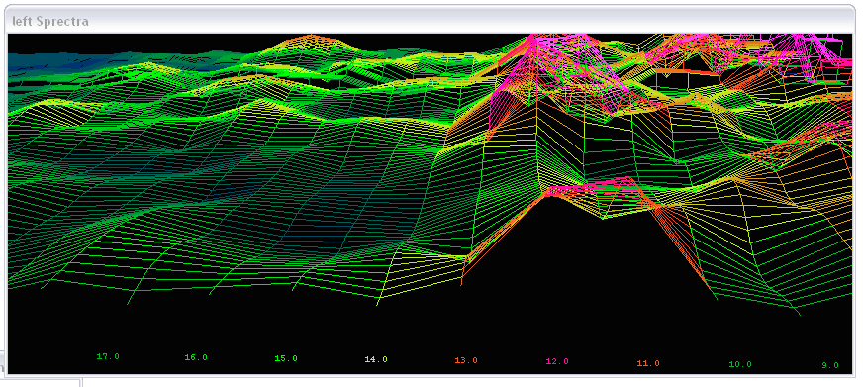
the Style parameter of the FFT-element was changed from bar-graph to 3d line-grid

  - Heartbeat-Feedback from a multichannel EDF-recording

The following extracts the heartrate from a 17-channel multimodal biosignal recording stored in an EDF-file. ECG and frequency-spectra of the contraction of the heart muscle are displayed. For calculating the heartrate, a dynamic threshold level is applied. Acoustic feedback for the heartbeat is created by three midi-generators.

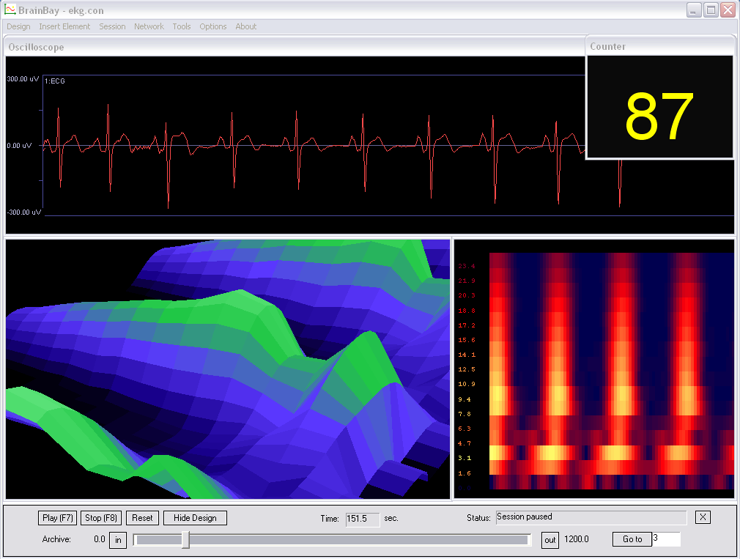

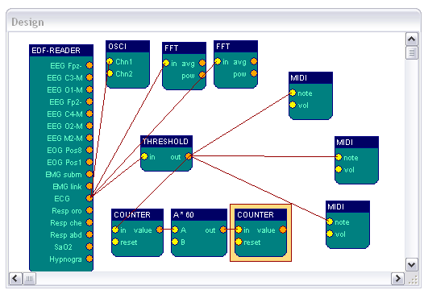
The ECG-output of the EDF-file reader source is connected to display- and processing elements. The first FFT-display is in 3d-mode, the second in moving spectogram-mode. Both FFTs use 32 bins and a calculation interval of 4 to enable fast displays. The threshold-element detects the R-wave of the QRS-complex.

The heartrate is calculated by a counter-element which counts the frequency of threshold-activation. The output of the counter (given in Hz) is multiplied by 60 using an expression-evaluator to get beats per minute. The second counter is used only as a display for the value.
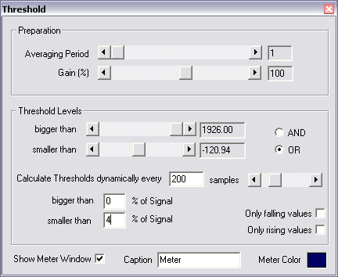
R-Wave-detection:

The R-wave in this ECG- recording is characterized by a large negative spike. This peak can be used to detect one heart-beat with a thres-hold element. A way to adapt to the variing amplitude of the heart-signal is to use a dynamic threshold: the level to pass values is set to 4% of all signal values in the last 200 samples.

For audio feedback, three midi-generators with the same type of harmonic tone-scale were used. As the detected peak of the R-wave can be very short, a fast tone output-interval is needed to recognize each heartbeat. Therefore, the output-intervals for the midi-elements were set to 1, 2 and 3, which corresponds to 100, 50 and 33 tones per second. (the sampling rate for this EDF-recording is 100Hz). The different intervals for tone-generation lead to sightly different notes which fit together because of the harmonic scale.

  - A design for Muscle-Feedback and –Rehabilitation

The following design can be used to perform muscle feedback for training and re-habilitation purposes. The example recording was done with a MonolithEEG amplifier running in P21-bidirectional mode and at 600 Hz sampling frequency. The amplifi-cation has been set to a low level, corresponding to high muscle potentials of about 500 uV. Muscle activity could be mesured using standard BlueSensor EMG surface-electrodes attached to the left and right tigh. Four electrodes used in bipolar mode give a two-channel setting.

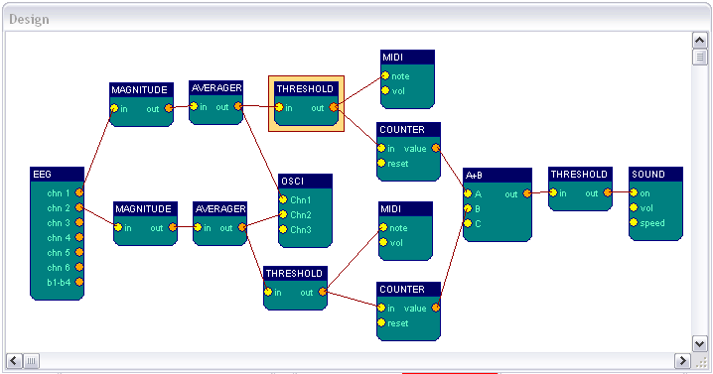

To get the muscle contractions and filter out lower-frequency noise, one magnitude-element per channel is used.
The parameters are set to a 4th-order bessel bandpass filter of 85-115 Hz range. The magnitude output is averaged for a period of 300 samples, (half a second at 600 Hz sampling freqeuncy). Thus, the fast and jumpy magnitude-value is made smoother and can be used as input for the threshold-element.
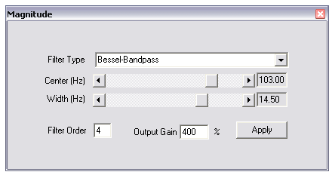

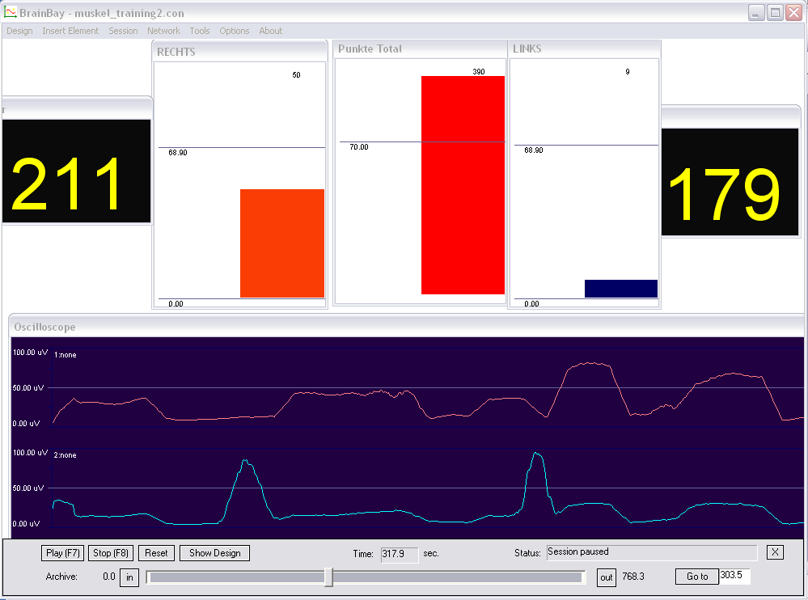

EMG-activity of two locations can be seen on the meter-displays. An acoustic signal rewards the user when a selected level of muscle-contrcation has been reached. Two counters show how often the muscles have been contracted in total. When a certain number of contractions has been performed, a sound will be played that indicates the completion of a training-session.

  - Controlling a movie using an external Reed-Switch

The following design illustrates how to use an external switch to control the frame-rate of a movie-playback. As an application of this design, a bicycle home-trainer could easily be turned into a multimedia recreation device: A magnet mounted on the turning wheel closes a reed-switch when passing; the design transforms the switching information to a desired playback speed of the movie.

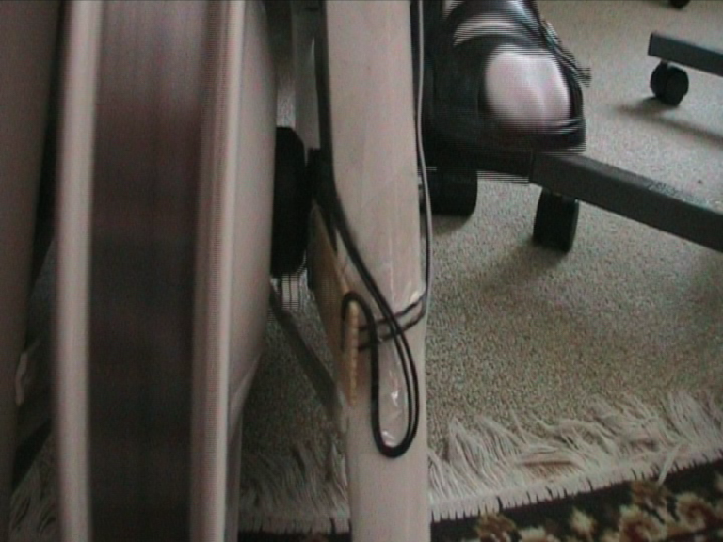
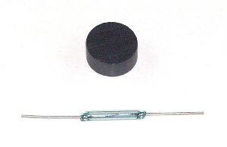

Above figures show the reed-switch & magnet and mounting of the switch on the home trainer. The switch is connected to a digital input port of the ModularEEG (4 input ports are reseverd for buttons/switches). The switch state is present at the B1-B4 - output port of the EEG amplifier element.

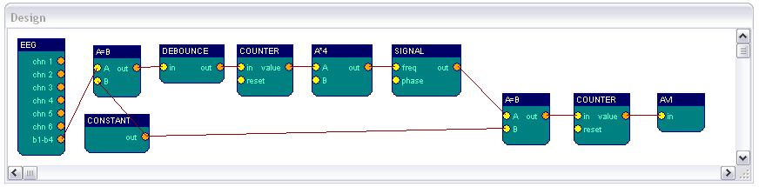

In the design, the b1-b4 output is compared with a constant value (in this case, button 2 has been connected and value 11 indicates a switching of the reed contact). The debouce-element prevents double- or triple-impulses when the magnet passes. The first counter measures the frequency of the switching pulse. It's output controls the frequency of a signal generator. Thus, the switching speed of about 1-4 Hz coming from the wheel/magnet is transformed into a frame pulse for the movie of about 5-30 frames per second. The current frame number is calculated by the second counter element and fed into the avi player element.
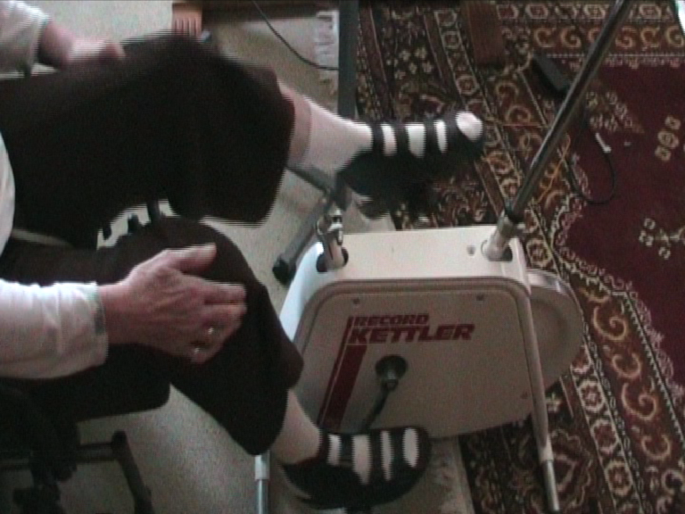
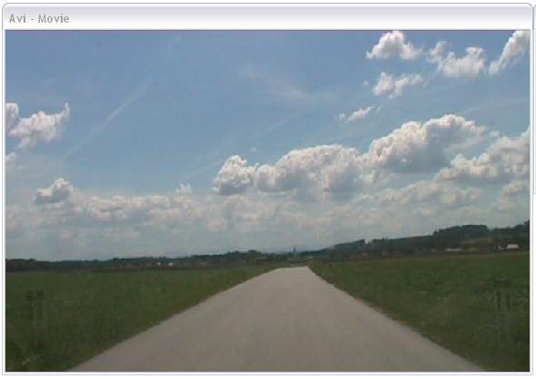

  - A Camera - Mouse application with clicking functions

This design example shows how to use the camera-element to control the mouse cursor and perform clicking- actions by head movements. With the option feature-tracking enabled, the camera - element tries to detect the user's face and extract two positions:
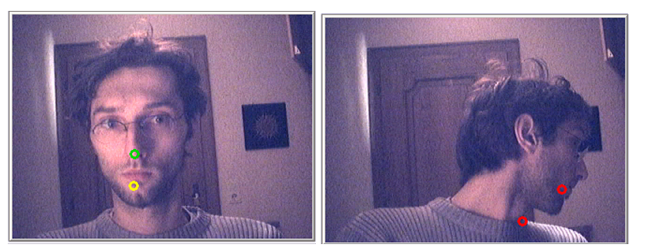
The nose is marked with a green circle and the chin is marked with a yellow circle.
When red circles appear, the tracking algorithm has lost the face and a re-initialisation of the face-tracking will be performed.
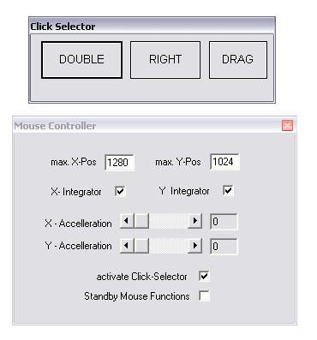
The outputs of the camera element:
x-/y-motion = relative changes of nose-position in pixels
x-/y-click = relative changes of chin-postition in pixels

This information is transformed to fit the mouse controller elemtent. Cursor position is set by the xPos and yPos inputs of the mouse - element. The nose-movement can serve these inputs, after being averaged (5-10 samples, to prevent jittering) and scaled to get the desired speed, x-direction is mirrored to fit left and right movement.

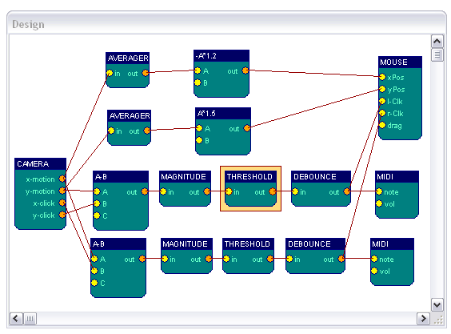
To issue left and right clicks, relative changes in the nose-chin distance are calculated by subtracting x-click from x-motion and y-click from y-motion: moving the head up and down or left or right changes nose and chin positions in nearly the same way, the difference will be near zero. Moving the chin up and down shows up in the y- difference, left and right chin movements are reflected in the x- difference. Two magnitude - elemtens with a passband from 3.5 -5.5 Hz indicate rapid chin movements in up/down or left/right direction. Threshold - elements set a level for the minimum magnitude to generate a mouse-click. The debounce - element prevents from double- or triple-clicks where they are not wanted. The clicking information is fed into the l-clk and r-clk input ports of the mouse element.

