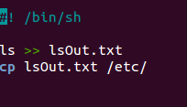

Script 1: Write files to file and copy it to the /etc/ file

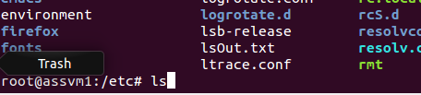

Script 1: LsOut is in /etc/

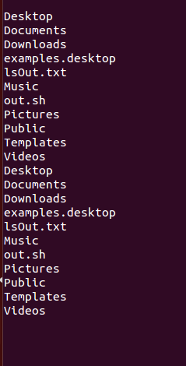

lsOut.txt Contents

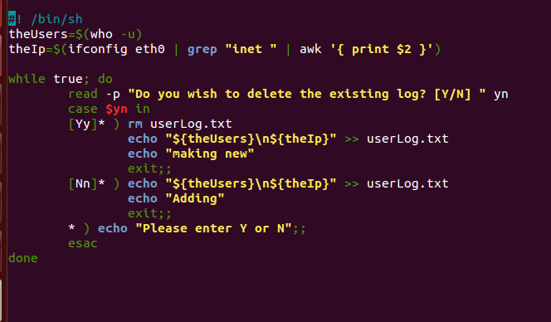

Script 2: Writes out the Logged in users and the Ip address of the machine and then promts the user to delete or add to the log document.

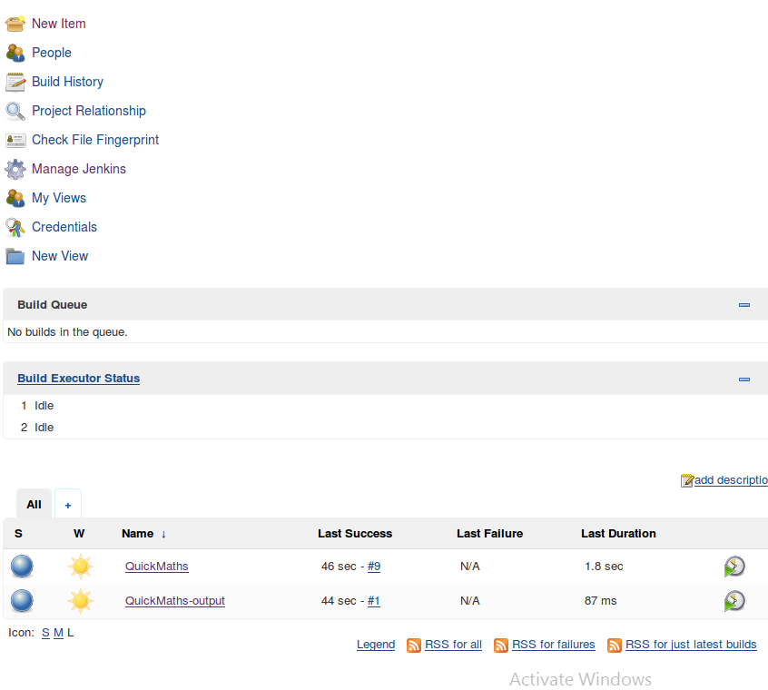

Jenkins Up and Running

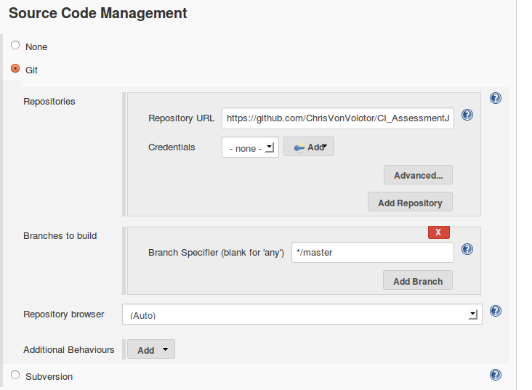

Quickmaths is configured to Github

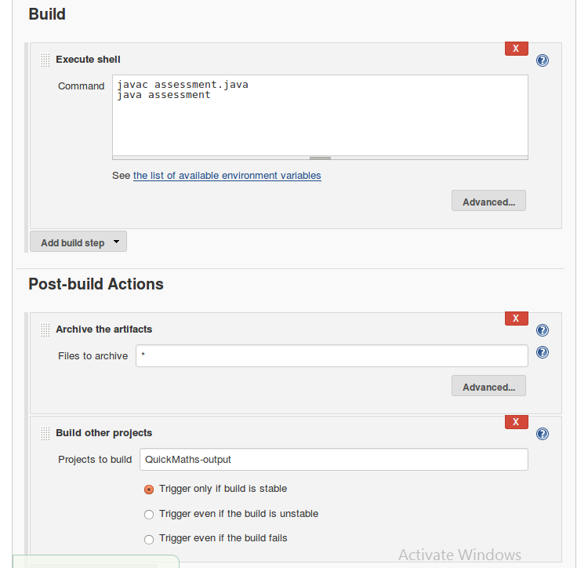

Builds the java files and then Builds he Quickmaths-output project

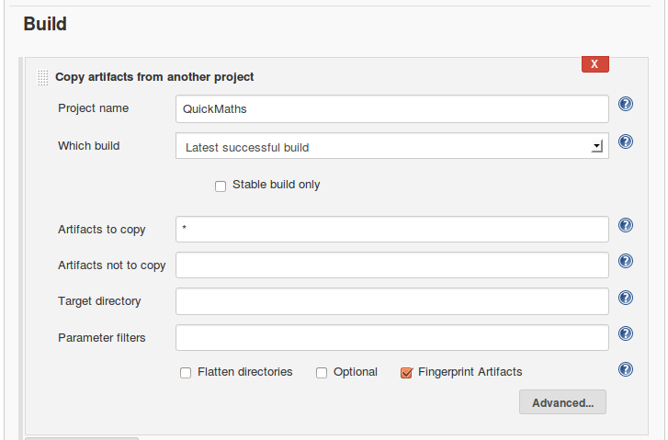

Quickmath-output copies the artefacts for storage.

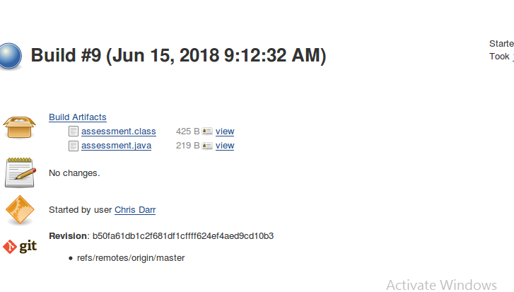

Build 9 of my maths stuff was successful

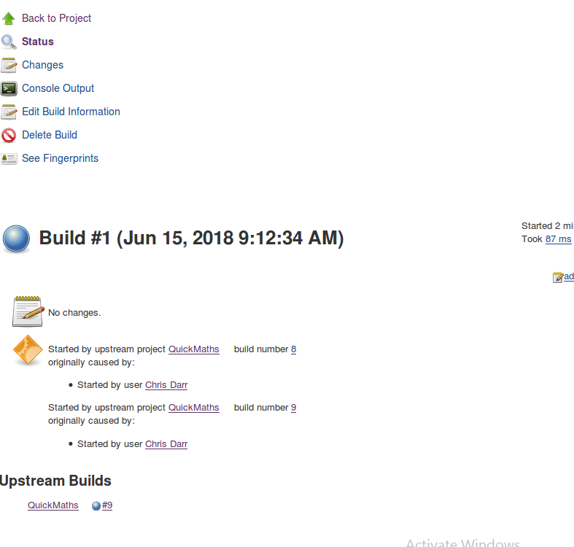

Build 9 executed build 1 of my outputs

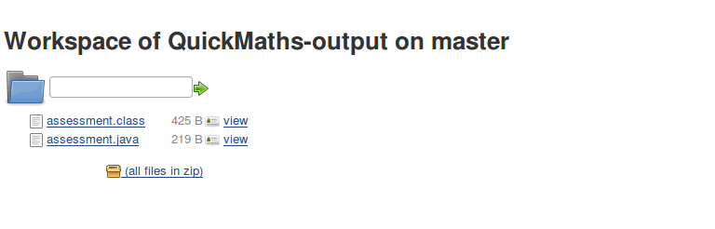

Which intern saved my Files in the output.