**Computational Decision-Making**

# Overview

**Goal: quantify the decision-making process**

**Key Idea:**

* **assign a weight Wj to each criterion j according to importance**
  + **ensure $\sum_{j}^{n}{Wj}$ = 1**
  + **higher weights = more important**
* **assign a score** Pij **for each choice i** 
  + **Pij $∈\left[0,1\right]$**
  + **Also you could normalize score Pij by making Pij = Cij/Cj (Cij is general score, Cj is the maximum score)**
* **Compute the payoff function**
  + **fi = $\sum_{j=1}^{n}{Pij*Wj}$**

# Example:



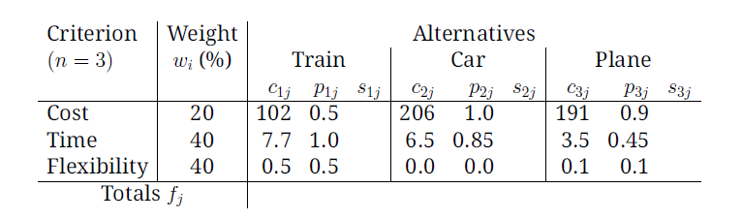

# Sensitivity Analysis:

# Study of how variations influence outcome of a mathematical model

e.g. time-sensitive criterion 0.2 0.4 0.4;

price-sensitive 0.5 0.1 0.4

# Disadvantages:

* must numerically estimate weihts and scores
* estimating may be infeasible
* criterion score are subjective
* does not generate a new alternatives

# advantages:

* ensure that you give each alternative consideration