Project Plan

Overview

* project plan includes
  + **Statement of Work**: What to do and who will do it
  + **Resource List**: who can do it and with what
  + **Work Breakdown Structure**: work allocation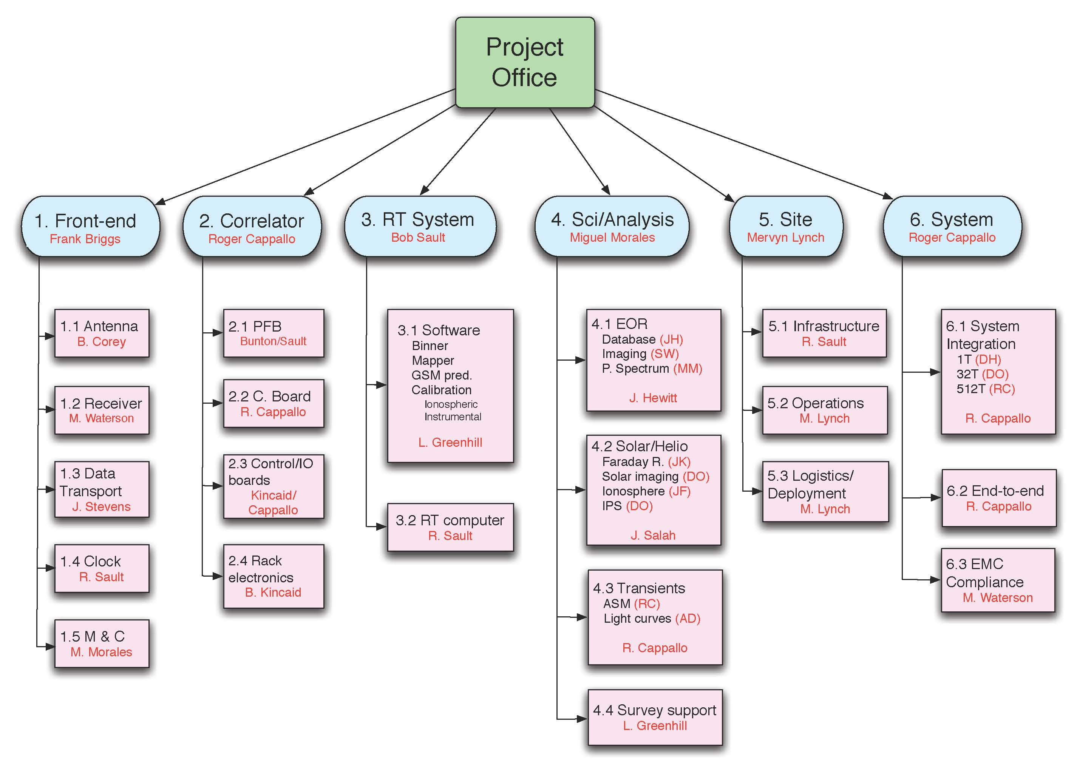
  + **Project Schedule:** when to do it
  + **Risk Plan:** what might go wrong