# Git

# Useful Resources:

1. <https://www.codeschool.com/paths/git> (learn Git by doing)

2. <https://git-scm.com/documentation> (Git Official WebSite Doc)

# Basic workflow:

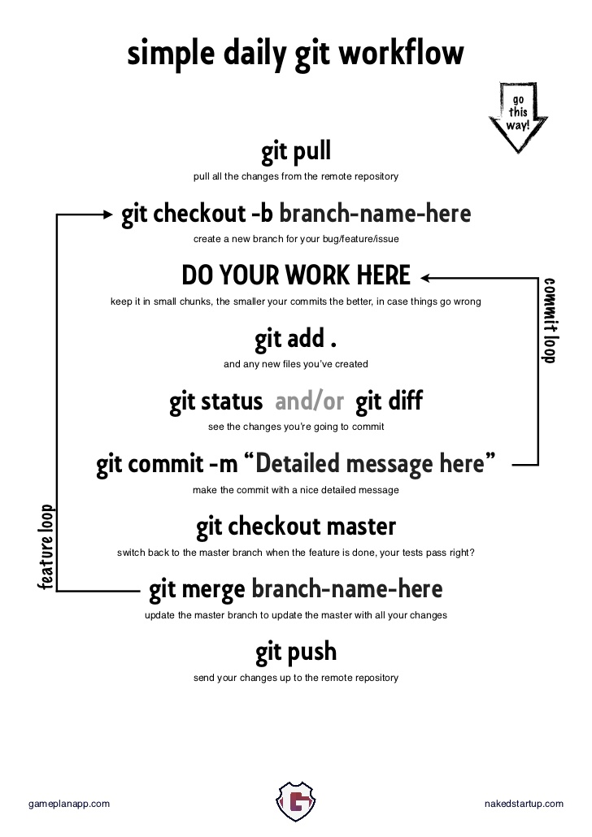

Reference: https://www.sonassi.com/wp-content/uploads/2012/07/git_daily_workflow_small.png