Software Lifecycle Models

Key idea
Iterations !
Things to avoid:
- Naïve optimism
- Organizational politics
- Trying to build a huge project all at once
- Managerial incompetence

Some SDLC
- Waterfall
- Concurrent Engineering
- V-Model
- Spiral

Waterfall –Model (bad idea)
- Each stage may not overlap

- Nobody supports it because
  - You can never build a system without a prototype
  - You never really know what you need until you see it
  - Needs change overtime
- Solution: iteration

Concurrent Engineering (aka: sashimi model)
- Don’t wait on the previous stage to finish, Start the next stage as soon as possible
-Advantages:
- less documentation
- need not be subdivided into smaller tasks
- may reveal problems earlier
-Disadvantages:
- progress is difficult to track
- poor communication might lead to disaster

The V-Model
- Take Waterfall and link the stages horizontally
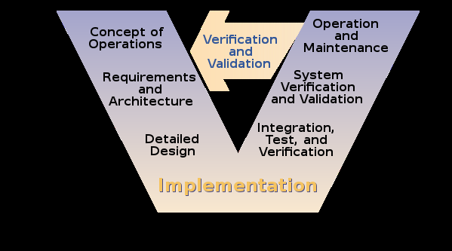
Advantage: more realistic waterfall model
Disadvamtage: the same as any other variant of Waterfall

Spiral Model
Key idea: Iterate the waterfall
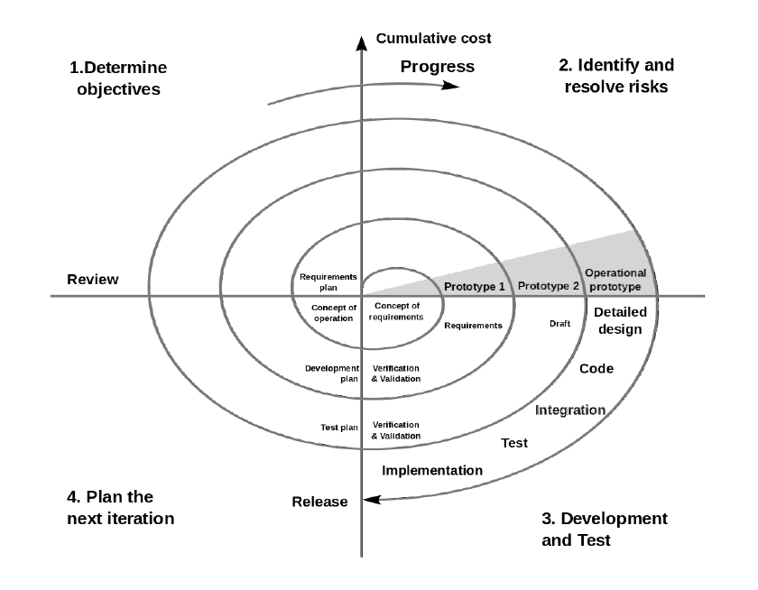

Agile Lifecycle Models
- Key: handling change on demand (incorporate change into fast iteration process)
- Agile models are always collaborative
- Benefits:
  - Good at dealing with Changes to team over time
  - Good at dealing with differences between developer experience levels

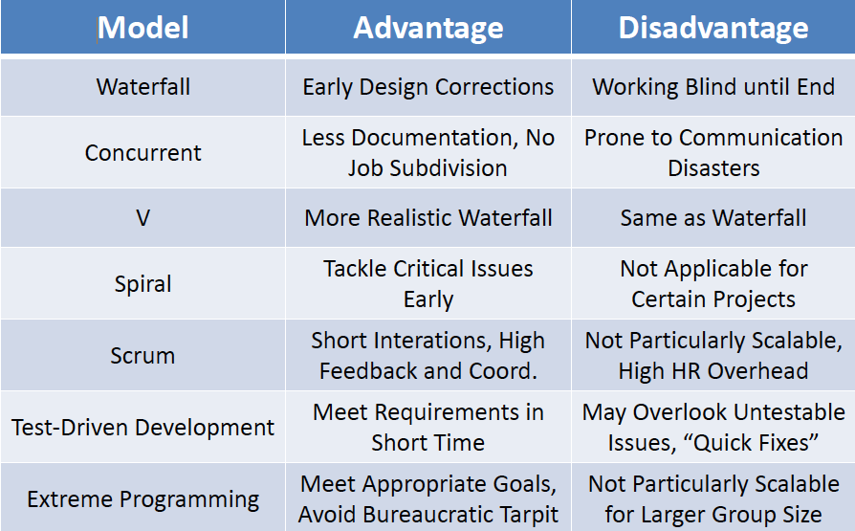

How to Choose a Lifecycle Model?
- Need to control pace of iteration:
  - Large teams, diverse stakeholder goups: slower iteration
  - Small teams, uncertain requirements, complex technologies: faster iteration
- Questions to think about:
    - Do you understand customer requirements?
    - Will you need to make major architectural changes?
    - How reliable does the system need to be?
    - How much future expansion and growth do you foresee?
    - How risky is the project?
    - Is the schedule heavily-constrained?
    - What is going to change during development?
    - How much do customers need visible progress?
    - How much does management need visible progress?
    - What experience does the design team bring?

