**ENPH 257 Thermodynamics Summary Sheet**

**Constants and Units:**

•*N*A = 6.02 x 1023 • h = 6.626 x 10-34 J s

• 5.67 x 10-8 W/m2/K4 • c = 2.997925 x 108 m/s (speed of light)

• = 8.314 J/mol/K

• k = 1.381 x 10 -23  J/K

-Latent heat of vaporization for water = 2264.705 kJ/kg = 40.81 kJ/mol

-Latent heat of fusion for water = 334 kJ/kg = 6.02 kJ/mol

- Specific Entropy of Air at Room temperature (20 C) = 6.8484 kJ / kg K

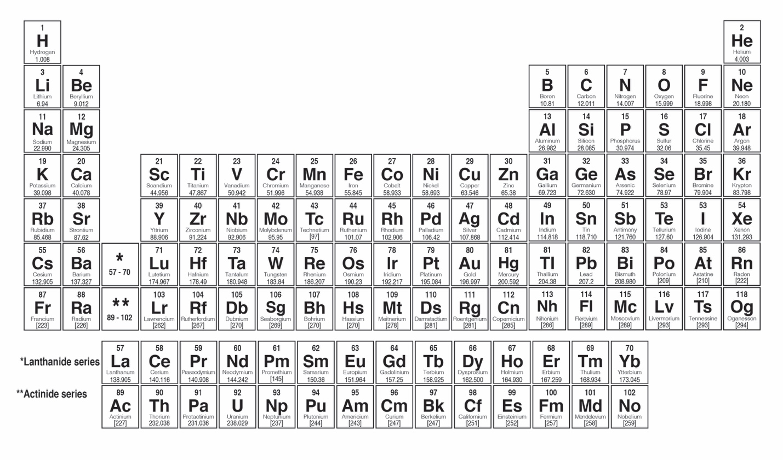

Useful websites:

Quick calculation of the entropy, enthalpy of air given T and P:

<http://www.peacesoftware.de/einigewerte/luft_e.html>

Energy:

•kcal (= “food calorie”, or Cal) = 4184 J

•kWh = 3.6 MJ

•quads – quadrillion BTUs ≈ 1018 J

•kWh/d = 1/24 kW = 42 W; 1GJ/d = 11.6 kW

**Lecture 1 – Intro**

**Fuels:**

•Barrel of oil – 159 L ≈ 130 kg

•kgoe – kg oil equivalent, reckoned at 42 MJ/kg oil (by convention)

•Gasoline (*ρ* ≈ 0.75 kg/L) – 34 MJ/L

•Natural gas 56 MJ/kg

**Carbon and CO2:**

•Atmospheric carbon= 12/44 times the mass of CO2

•Coal 15-33 MJ/kg

•Carbohydrates (food) ~ 16 MJ/kg

•CO2e: sum of all GHGs weighted by climate forcing relative to CO2 (e.g. CH4 is 23 times CO2, by molecule)

• Current [CO2] = 410 ppmv

(ppmv = parts per million by volume (i.e. not by mass), the same as “by molecule”.)

Solar, Earth, Greenhouse Gases:

•Solar intensity at Earth’s orbit (Solar Constant S) = 1370 W/m2

•On top of Earth’s atmosphere (distributed across the whole sphere) = 1370/4 ≈ 340 W/m2

•Absorbed by Earth = S*(1-albedo)/4 ≈ 240 W/m2 (average albedo = 0.3)

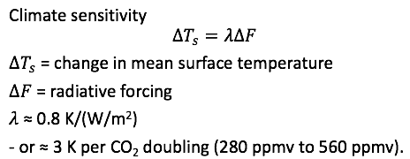

**EXAMPLE 1:** How much CO2 generated for the amount of burned bitumen (Fossil Fuel)?

• Calculated total mass of Bitumen = x tonnes

• Composition of coal is roughly (CH)n and oil is roughly (CH2)n, let’s take diluted bitumen (dilbit) to be (CH1.5)n, with molecular mass 13.5*n*.

• Every carbon atom in the dilbit will end up as CO2, so the mass multiplier is 44/13.5 = 3.26

• Mass of CO2 produced = (3.26 * x) = X tonnes

• Mass of Atmosphere = m_A = 5.15 * 10^15 tonnes, molar mas of air = 0.02897 kg/mol

• Increase in CO2 by ppm = (X / m_A) * 10^6 = k ppm

• Increase in CO2 by ppmv = k * (28.97/44) ppmv

**EXAMPLE 2**: What fraction of leakage would make natural gas as bad a climate-forcer as coal?

• enthalpy of methane - ~ CH4 -  is 56 MJ/kg; enthalpy of coal - ~ (CH)n -  is 20 MJ/kg.

• 1 kg of burnt coal produces 44/13 = 3.38 kg of CO2 and 20 MJ or 0.169 kgCO2/MJ

• Leak a natural gas fraction *x*

• Burning (with x fraction leaking) 1 kg CH4 produces (1- *x*) ⋅ 56 MJ and

   (1- *x*) ⋅44/16 kgCO2 + 23*x* ⋅ 44/16 kgCO2e

•Total GHG emissions per unit energy = **(1+22*x*) ⋅44/16 kgCO2e divided by (1- *x*) ⋅ 56 MJ**

•Natural gas is as “bad as coal” if **this** equals 0.169 kgCO2/MJ

•Solve: *x* = 0.096, or 9.6%

**Lecture 2 - Heat Transfer along a rod:**

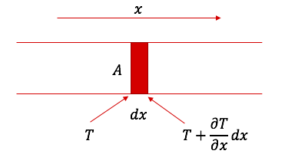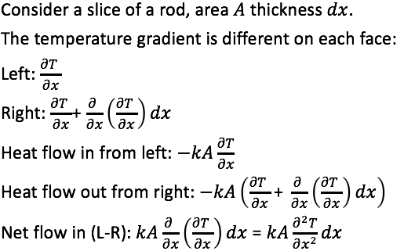

• **k =** **Conductivity** (W/K/m) is defined in terms of the rate of heat flow ∂Q/∂t across an area A under a temperature gradient ∂T/∂x:

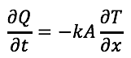

**• c = heat capacity** (J/kg/K)

• **ρ = density** (kg/m^3), ), the mass is ρAdx (kg)

• The term converts W/m^2 to K/s

• Rate in temperature change due to **Conduction (**for slices **1<n<N)**

Screen%20Shot%202018-06-25%20at%209.33.58%20PM.png

• Double differential estimation by considering the initial condition of groups of three slices.

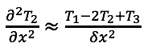

• Rate in temperature change due to **Conduction** (first slice #1)

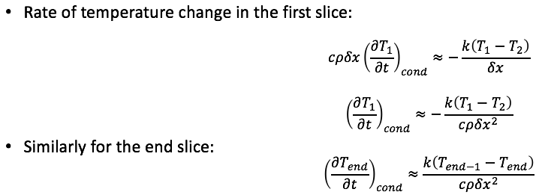

• Rate in temperature change due to **Conduction** (last slice #N)



• Rate in temperature change due to **Convection (**for all slices**)**

where k_c is the convection coefficient (W/m2/K), depends on geometry, atmosphere etc.

a = radius

**Screen%20Shot%202018-06-25%20at%209.54.59%20PM.png**

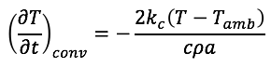

• Rate in temperature change due to **Radiation (**for all slices**)**

where σ is the Stefan-Boltzmann constant for radiation (5.67 x 10-8 W/m2/K4)

• ε is the emissivity of the *surface* of the object: 0<ε<1

(0 = perfect reflector, 1 = perfect blackbody)

Screen%20Shot%202018-06-25%20at%209.55.56%20PM.pngScreen%20Shot%202018-06-25%20at%209.55.56%20PM.png

• Rate in temperature change due to **the heat source** (first slice #1)

**Lecture 3 – 1st Law of Thermodynamics**

Ideal Gas Law: PV = nRT

State functions: f(P,V,T) = 0;

Path functions: Q and W (depends on HOW the present state was arrived at)

**1st Law of Thermodynamics:**

energy can be transformed from one form to another but can neither be created nor destroyed.

ΔU=Q - W

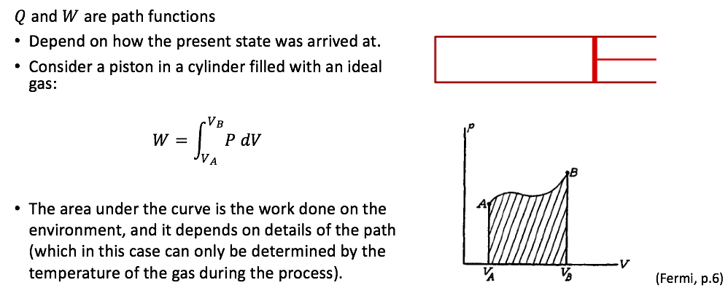

**Thermally Isolated system:**

ΔU+W=0

**Thermally Non-Isolated system:**

ΔU+W=Q

Heat Capacities:

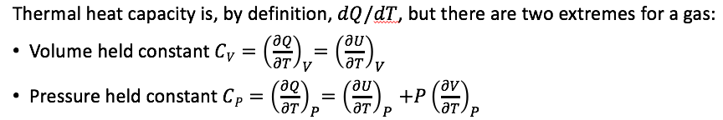

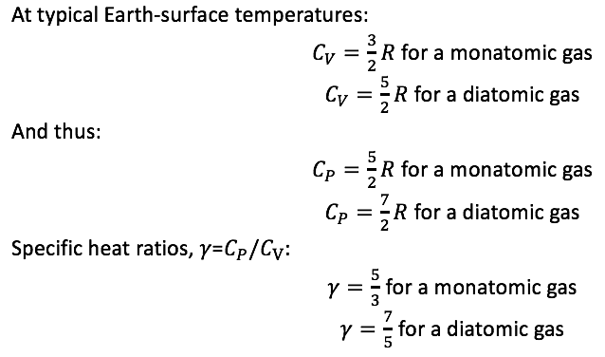

**Isothermal Expansion: (T constant)**

Work done by the gas:

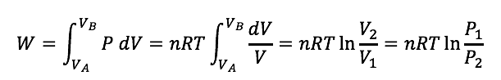

Entropy change:

Heat change:

Screen%20Shot%202018-06-26%20at%2012.51.15%20AM.png

**Isobaric process: (P constant)**

Work done by the gas:

Entropy change:

m = 0.029 kg (molar mass of air)

**Isochronic process: (V constant)**

Work done by the gas = 0

Entropy change:

**Adiabatic Change:**

•No heat exchanged, perfect insulation or rapid change so heat cannot enter/leave within time.

•On a PV diagram, adiabatic curves are steeper than isothermal hyperbolae, because γ > 1.

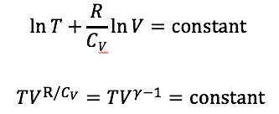

Screen%20Shot%202018-06-25%20at%2011.00.38%20PM.png

**Isentropic Process (dS = 0):**

• Idealized process that is **both adiabatic and reversible**.

• No transfer of heat or matter.

Change in pressure (for a given change in volume):

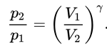

Change in temperature:

Screen%20Shot%202018-06-25%20at%2011.26.40%20PM.png

Change in entropy (dS = 0):

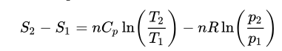

Work done:

**Lecture 4 – Second Law of Thermodynamics, Heat Engines**

**Second Law of Thermodynamics:**

The total entropy of an isolated system can never decrease over time.

Heat Engine general case:

Heat is put in as the temperature rises (Q_H), and is expelled as the temperature falls (Q_C).

Net work on the environment is the enclosed area, W.

Specific Entropy of Air at Room temperature (20 C) = 6.8484 kJ / kg K

**Efficiency:**

**Mechanical efficiency**, η=W/Q_H = 1 - T_C/T_H

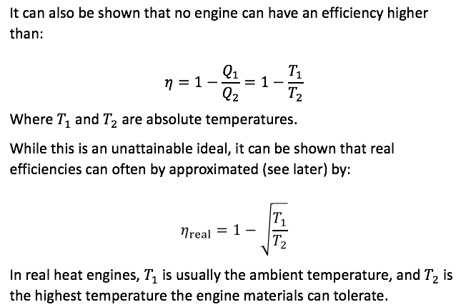

**Carnot Cycle**

Two isotherms, two adiabats

CW – does work on the environment, CCW –work done by the environment

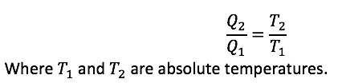

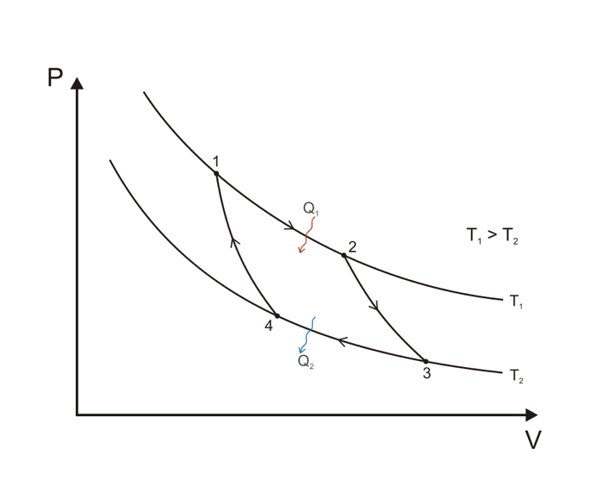 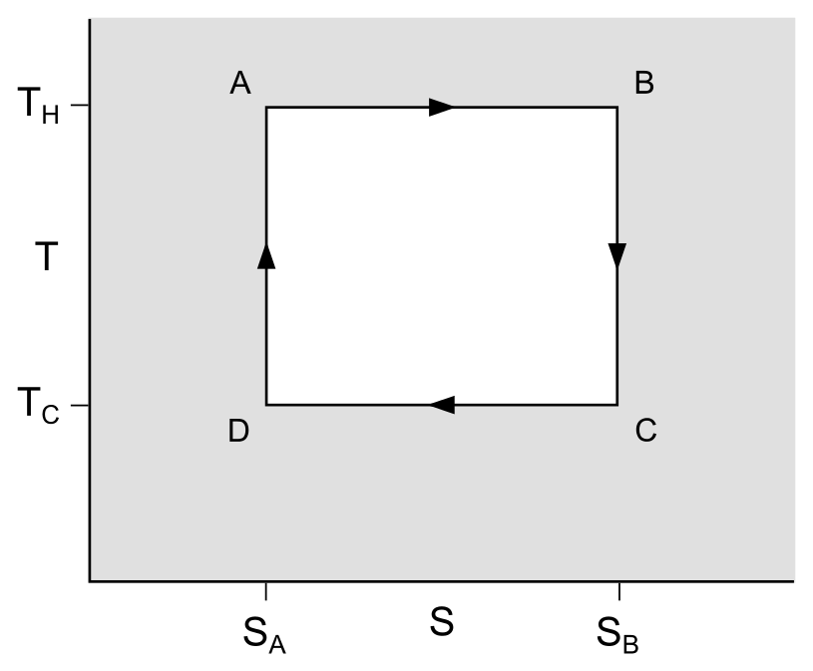

1🡪2 (A🡪B): Reversible isothermal expansion of the gas at T1 (hot temp)

2🡪3 (B🡪C): Isentropic (reversible adiabatic) expansion of the gas

3🡪4 (C🡪D): Reversible isothermal compression of the gas at T2 (hot temp)

4🡪1 (D🡪A): Isentropic (reversible adiabatic) compression of the gas

**Carnot cycle in reverse (Refrigeration):**

**Coefficient of performance for heating (cooling)**

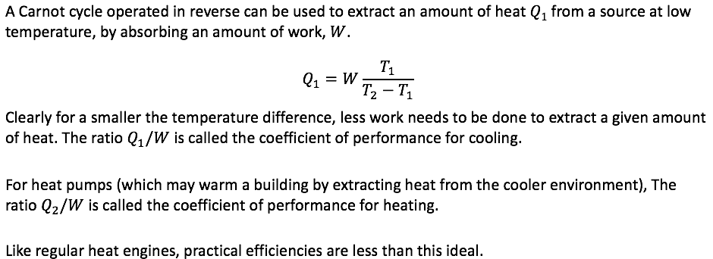

**Brayton Cycle**

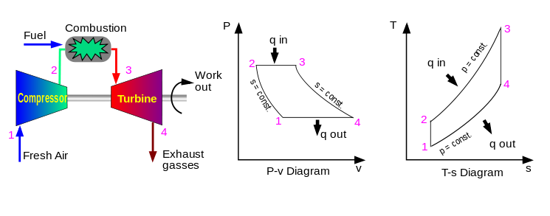

Efficiency:

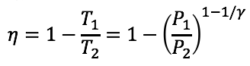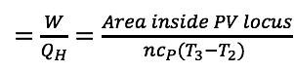

1🡪2: Isentropic (reversible adiabatic) compression of the gas

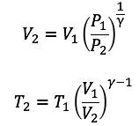

2🡪3: Isobaric process (dP = 0), expansion of gas, heat addition

3🡪4: Isentropic (reversible adiabatic) expansion of the gas

4🡪1: Isobaric process (dP=0), compression of gas, heat rejection

**Lecture 5 – Atmosphere**

 • Scale Height: where the pressure is 1/𝑒 of the sea level value

• The “International Standard Atmosphere” (shown) has a lapse rate of 6.5 K/km.

Rate of change in pressure of the atmosphere over height (assume constant T with altitude)

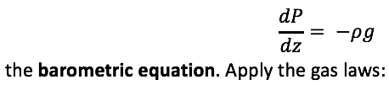

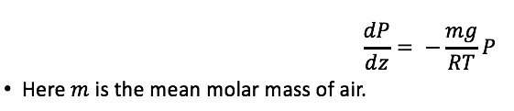

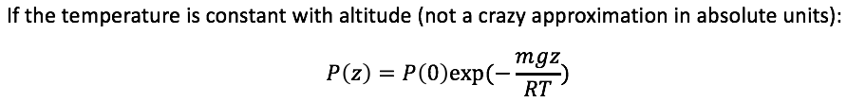

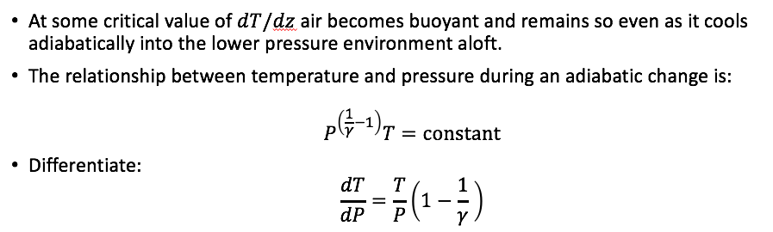

Lapse Rate (change in temperature of the atmosphere over height)

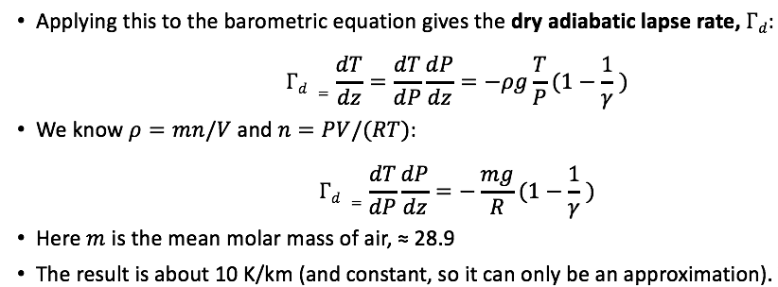

**Lecture 6 – Latent Heat, Clapeyron**

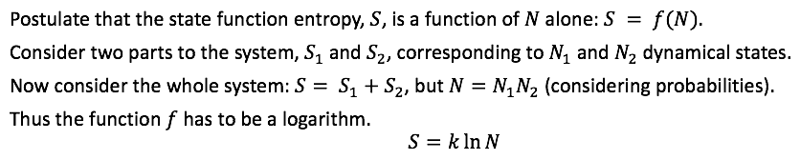

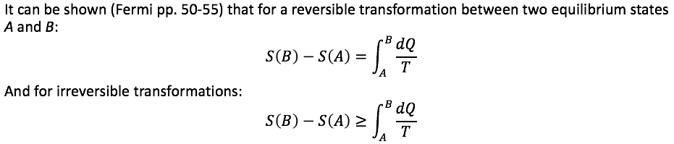

General equations for change in entropy:

Screen%20Shot%202018-06-26%20at%201.32.08%20AM.png



Change in entropy for a two-part system with heat flowing from one to another:

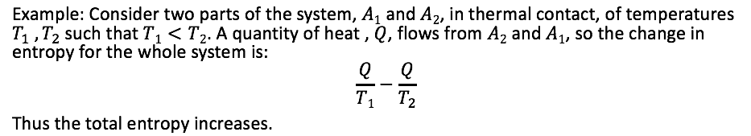

Clapeyron’s Equation

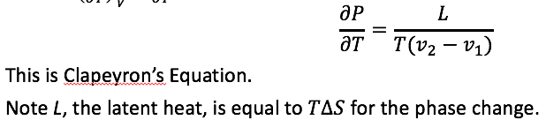

v = unit volume of the gas liquid mix

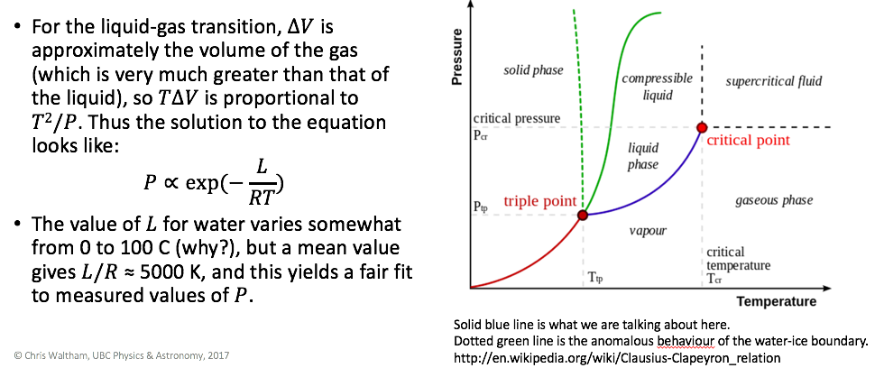

Example RH% derivation from dry-bulb and wet-bulb temperature

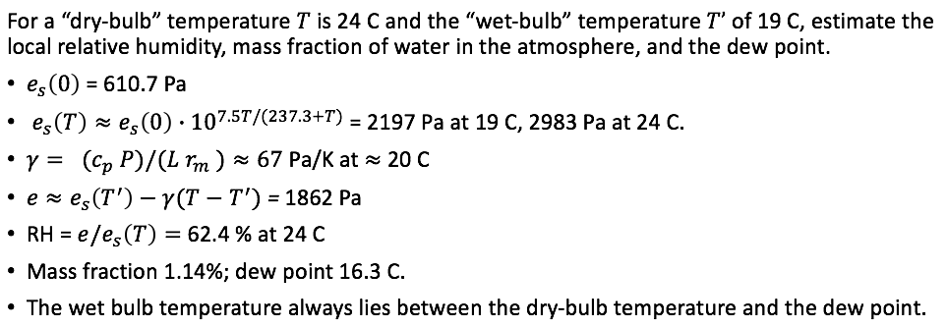

**Dry bulb temp definition:**

The Dry Bulb temperature, usually referred to as *"air temperature"*, is the air property that is most commonly used. The Dry Bulb Temperature refers basically to the ambient air temperature.

**Wet bulb temp definition:**

The **wet-bulb temperature** is the [temperature](https://en.wikipedia.org/wiki/Temperature) read by a [thermometer](https://en.wikipedia.org/wiki/Thermometer) covered in water-soaked cloth ([wet-bulb thermometer](https://en.wikipedia.org/wiki/Wet-bulb_thermometer)) over which air is passed.[[1]](https://en.wikipedia.org/wiki/Wet-bulb_temperature#cite_note-Gupton2002-1) At 100% [relative humidity](https://en.wikipedia.org/wiki/Relative_humidity), the wet-bulb temperature is equal to the air temperature ([dry-bulb temperature](https://en.wikipedia.org/wiki/Dry-bulb_temperature)) and is lower at lower humidity. It is defined as the temperature of a parcel of air cooled to saturation (100% relative humidity) by the [evaporation](https://en.wikipedia.org/wiki/Evaporation) of water into it, with the [latent heat](https://en.wikipedia.org/wiki/Latent_heat) supplied by the parcel.

**Wet bulb vs. Dew Point:**

The wet-bulb temperature is the lowest temperature which may be achieved by [evaporative cooling](https://en.wikipedia.org/wiki/Evaporative_cooling) of a water-wetted (or even ice-covered), ventilated surface. By contrast, the [dew point](https://en.wikipedia.org/wiki/Dew_point) is the temperature to which the ambient air must be cooled to reach 100% [relative humidity](https://en.wikipedia.org/wiki/Relative_humidity) assuming there is no evaporation into the air; it is the point where condensate (dew) and rain would form.

<https://www.engineeringtoolbox.com/dry-wet-bulb-dew-point-air-d_682.html>

**Lecture 7 – Gibbs Free Energy**

Example – Gibbs Free Energy Calculation

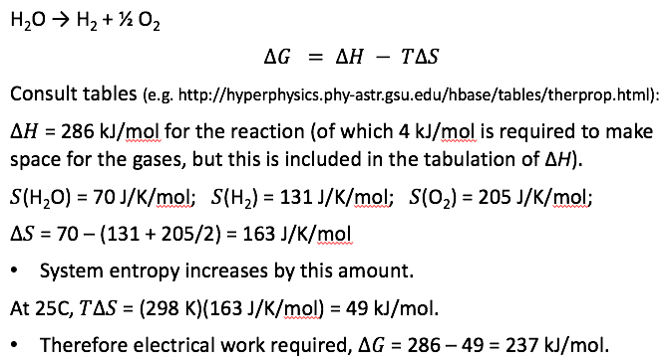

Exothermic (release heat) vs. endothermic (gain heat) reaction:

In an exothermic reaction, by definition, the enthalpy change has a negative value:

Δ*H* < 0

**Lecture 8 – Boltzmann Distribution**

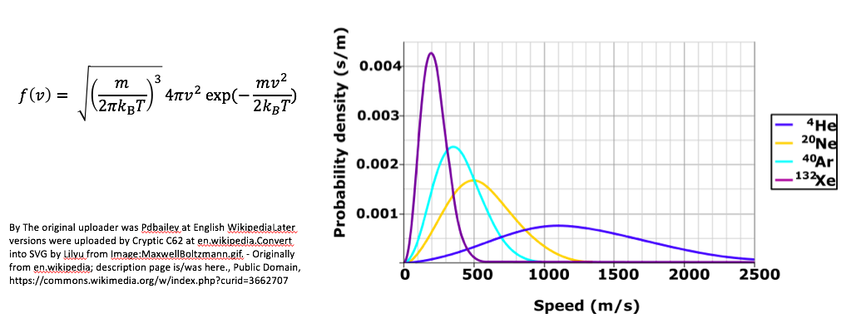

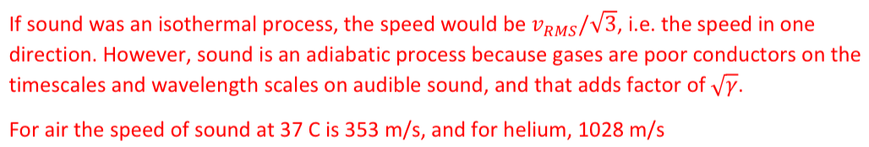

v = velocity in m/s

f = probability s/m

**Lecture 9 – Physical Properties of Ideal Gases**

**Sound and RMS speed of air**

m = molecular mass of a molecule = (molar mass in kg) / Avogadro_#

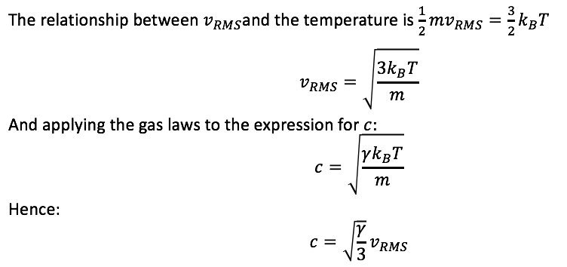

**Number density calculation:**

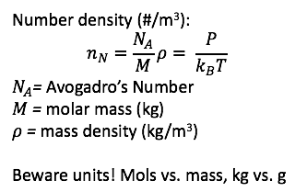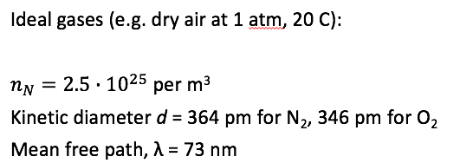

Conductivity estimation for an ideal gas (see lecture slide #9 for details)

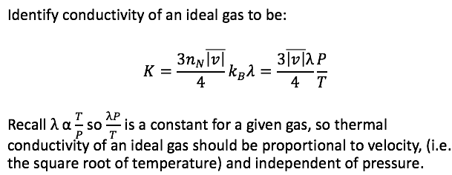

Mean distance between collisions (lambda)

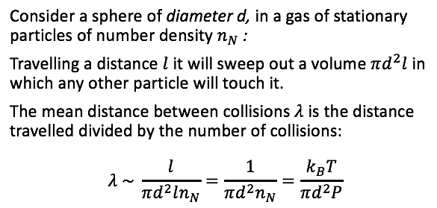

**Lecture 10 – EM Radiation**

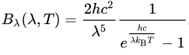 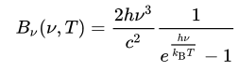



**Reason for non-matching peak wavelength and peak frequency:**

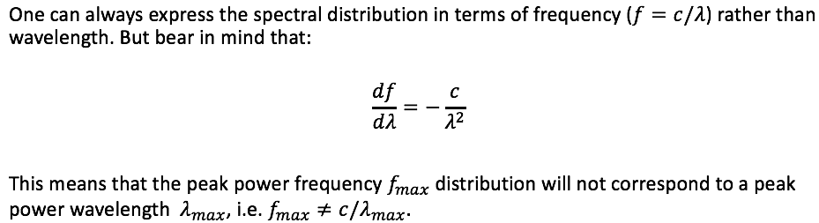

**Peak wavelength calculation (Wien’s Law)**

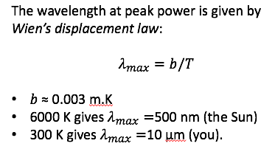

**Solid Angle Concept**

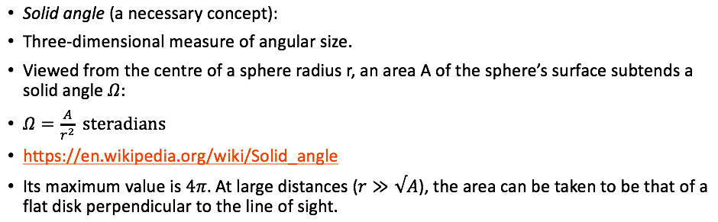

**Sun-Earth System Solid Angle**

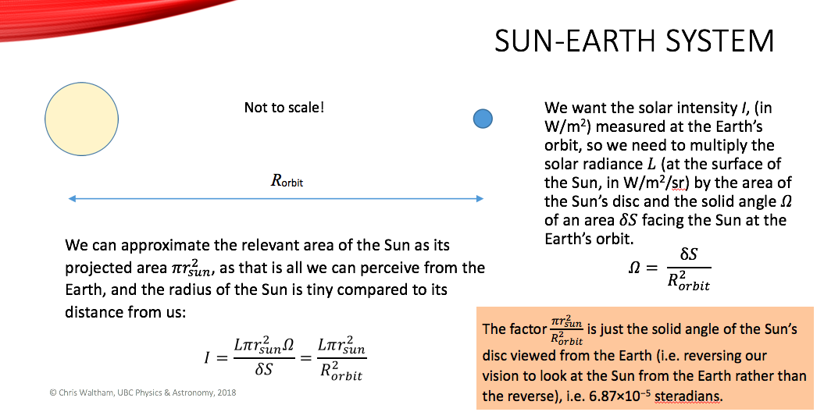

**Lecture 11 – Photovoltaic Cell**

Example: photovoltaic cell of bandgap 1.1 V, which corresponds to a maximum wavelength of 1.13 μm.

Efficiency: The ideal efficiency of such a cell is 45%, the ratio of areas under the two curves.

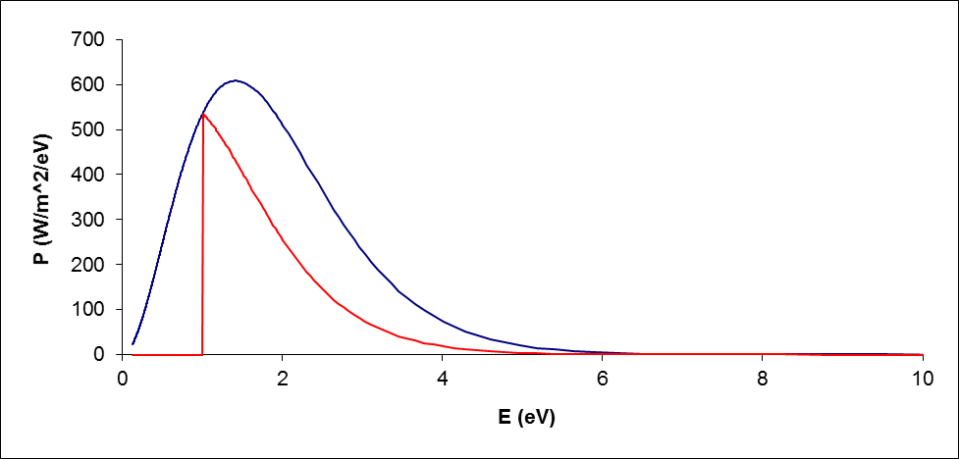

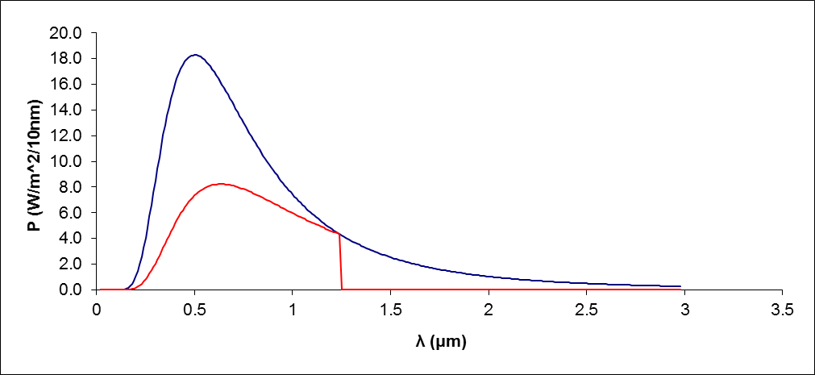

Example: direct heating of a black sphere

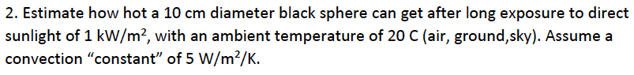

When the black sphere reaches its maximum temperature, its power in equals power out.

where = 5 W/m^2/K, = 293 K, r = 0.05 m, = 1000 W/m^2, = 5.67 *10^-8

Thus, the black sphere will reach a maximum of approximately 42 degree Celsius.

**Lecture 12 – Earth Systems**

Heating of a black sphere through glass

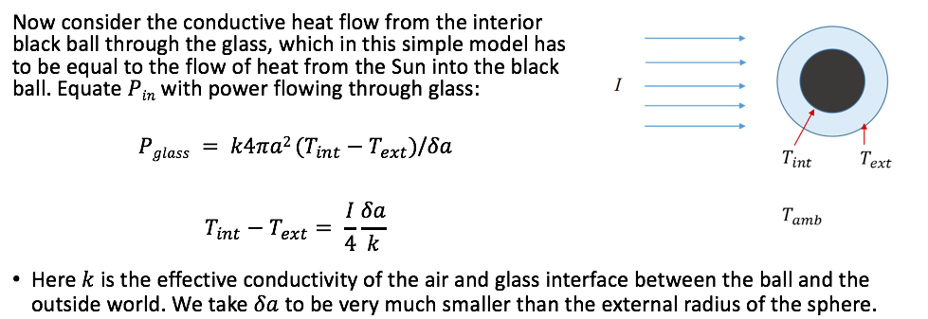

R insulation factor unit = K m2 / W 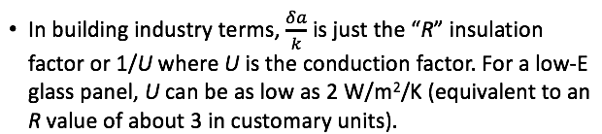

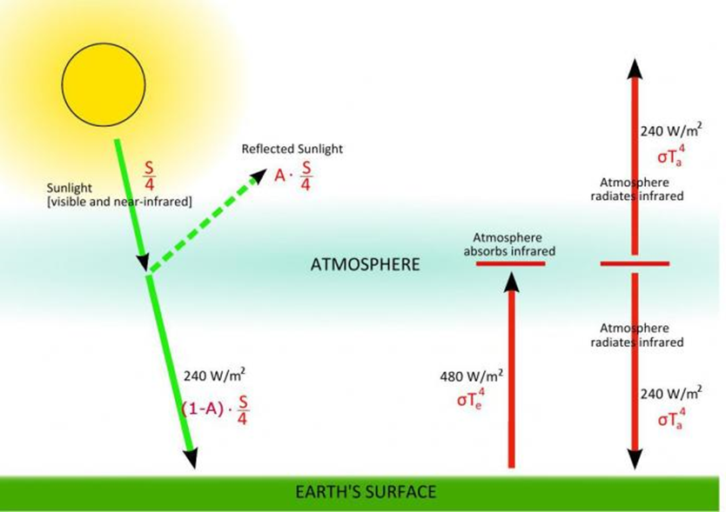

**Mean radiation temperature of earth (if there is no atmosphere):**

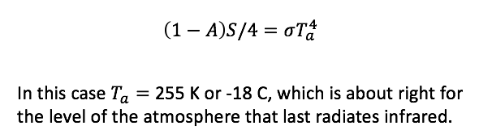

Reason for a warmer temperature: (Why are we warmer than -18 C?)

The atmosphere is largely transparent to incoming solar radiation, but absorbs and reradiates terrestrial thermal infrared, and this keeps the Earth’s surface a lot warmer than the upper atmosphere. By analogy with the properties of glass greenhouses used for growing plants, this is called the greenhouse effect.

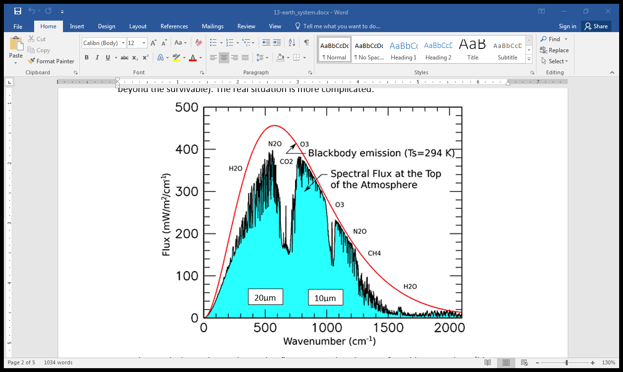

*The graph shows the total outgoing flux measured at the top of Earth's atmosphere (blue curve). This is compared to the radiation of a perfect blackbody (red curve). The difference between the red and the blue curve is due to absorption. Most of the absorption is due to the presence of water vapour, ozone, and carbon dioxide.*