**Terrain Smoothing for Numerical Weather Prediction in Mountainous Western Canada**

*Chris Jing, Prof. Roland Stull*

Geophysical Disaster Computational Fluid Dynamics Centre

University of British Columbia

April 30, 2018

**Abstract**

In Numerical Weather Prediction (NWP), the Courant-Friedrich-Lewy (CFL) condition is an important domain-wide horizontal and vertical stability criterion. It is a necessary condition to ensure convergence while solving the prognostic partial differential equations governing the state of the atmosphere via the finite difference integration scheme (Courant et al. 1986). Due to the short vertical dimensions of the NWP model grid cells, CFL violation may arise when the most extreme vertical wind motions are too fast for the NWP model to solve. This problem is particularly common when modeling a mountainous region. One way to address this problem is to apply smoothing before modeling in order to minimize terrain steepness and complexity. However, many obvious topographic features may be oversimplified and become a source of model errors after smoothing is made on the interpolated data. A new smoothing approach has been developed and experimented with the Weather Research and Forecast (WRF) model to improve the accuracy of the modified terrain used in NWP modeling without encountering the CFL error.

**1.Introduction**

* 1. Geogrid in the WRF Preprocessing System

Prior to running WRF, a set of three programs in the WRF Preprocessing System (WPS) have to be executed to prepare input for real-data simulations. Geogrid, which interpolate the static geographical data to the grids inside model domains is one of these programs. It is also responsible for any further processing such as smoothing to be applied to the field after the interpolation.

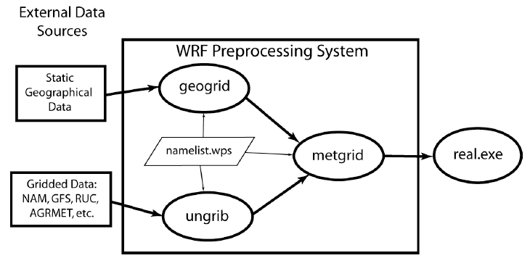

Figure. 1. Work Flow of the WRF Preprocessing System

(Photo Source: User’s Guides for the Advanced Research WRF (ARW) Modeling System, Version 3.9 <http://www2.mmm.ucar.edu/wrf/users/docs/user_guide_V3/contents.html>)

* 1. Geographical Input Data for Geogrid

When WRF users download the required geographical input data available on the WRF webpage (<http://www2.mmm.ucar.edu/wrf/users/download/get_sources_wps_geog.html>), the highest resolution available for topography is in 30 arc seconds. The topo_30s directory contains a single text metadata file index and a number of binary files. Each binary file represents a rectangular block covering 10 degrees in latitude and 10 degrees in longitude known as a tile. The tiles are named as %05i-%05i.%05i-%05i specifying the index range contained by each tile. For example, the tile for -180°~-170° in longitude and -90°~-80° in latitude is named 00001-01200.00001-01200. In total, a matrix of 18 tiles in the longitudinal direction and 36 tiles in the latitudinal direction enables complete coverage of the entire surface of Earth.

In any given binary data tile from the topo_30s directory, three extra rows and columns are provided on each side of the tile. The extra data known as the halo region provide the boundary condition between two adjacent tiles needed when Geogrid interpolates the boundary data points.

Therefore, a tile named 01201-02400.03601-04800 actually contains columns 1198-2403 and rows 3598-4803.

* 1. Interpolation in Geogrid

Having interpolation in Geogrid is necessary since users can choose from various model projection formats, but the topo_30s topographical input data is offered in a constant latitude-longitude grid system only.

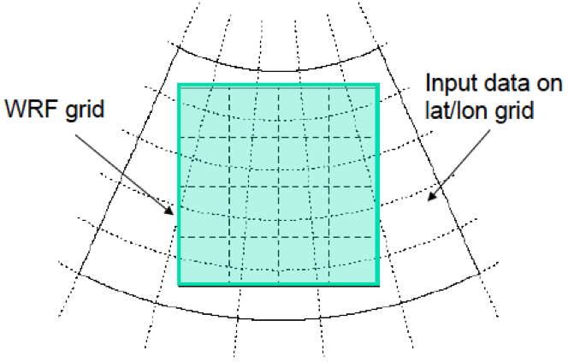

Figure. 2. In general, source data are given in a different projection format from the model grid

(Photo Source: The WRF Preprocessing System: Description of General Functions, The Basic WRF Users’ Tutorial [www.icimod.org/resource/14306](http://www.icimod.org/resource/14306))

There are nine interpolation methods that can be found in interp_module.F within the src directory of Geogrid. We could specify an ordered list of interpolation options in GEOGRID.TBL. If the first option in the list encounters an error, the methods that followed will be tried until the interpolation succeeded.

The default Geogrid interpolation method used in the study is average_gcell. For any model grid cell, this method takes a simple average of all source data points that are nearer to the center of this grid cell than to the center of any other grid cell. It is only valid for source data with a resolution higher than that of the model grids.

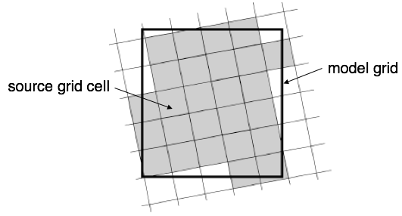

Figure. 3. All shaded source grid cells are used to take a simple average as the interpolated value of the large rectangular model grid cell.

(Photo Source: User’s Guides for the Advanced Research WRF (ARW) Modeling System, Version 3.9 <http://www2.mmm.ucar.edu/wrf/users/docs/user_guide_V3/contents.html>)

1.4 Smoothing in Geogrid

Only one smoothing options can be specified through GEOGRID.TBL at the same time. There are six smoothing options from smooth_module.F, within the src directory of Geogrid. The default smoothing option used in the study is smth-desmth_special, a one-two-one smoother-desmoother applied along two axes.

smth-desmth_special first smooth a grid cell by taking a weighted average of itself and its two adjacent grid cells in the east-west and north-south direction respectively. It then counteracts the effects of over-smoothing by taking a weighted average again with adjacent cells assigned negative weights. These weights are specified within the function and cannot be changed externally. The term special implies any grid points that were not originally negative but which have been smoothed to a negative value will be restored to their original values.

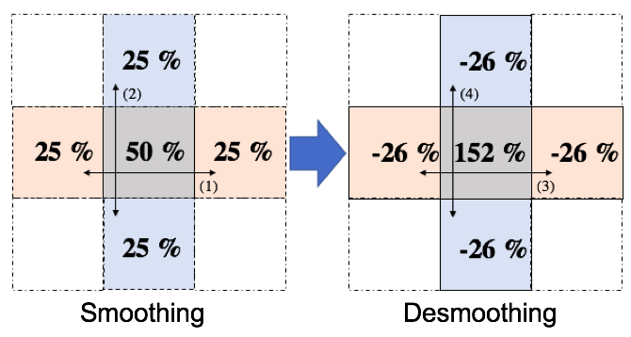

Figure. 4. A one-two-one smoother / desmoother works by taking a weighted average of the grid and its adjacent grids along two axes.

**2.Methods**

2.1 Interpolation and Smoothing Scheme Replication

In order to improve the existing WPS smoothing scheme, one must be able to regenerate the WPS smoothed result independently from the WPS. In addition, since the average_gcell interpolation scheme can be understood as a disguised form of running average smoothing method, it also needs to be investigated and replicated before any modifications can be made on the terrain model. Considering the much-outdated source codes written in Fortran language, a replication of the average_gcell interpolation option and the smth-desmth_special smoothing option were made in Python language. These two programs take the Geogrid generated netCDF model domain file geo_em.d01.nc and the topo_30s binary data files as inputs and produce their own version of the interpolated or smoothed netCDF files. A relative error plot can be made between two versions of processed terrain data to examine whether the reconstructions were valid or not.

2.2 Two-dimensional Fourier Analysis

The process of decomposing a function into the frequencies that make it up is known as the Fourier transform, and the 2D terrain field can be treated as such a two-variable function. In general, the two-dimensional forward Fourier transform for a finite, discrete signal (DFT) is

$$F\left[k, l\right]= \frac{1}{\sqrt{MN}}\sum_{n=0}^{N-1}{\sum_{m=0}^{M-1}{f[m,n]e^{-j2π\left(\frac{mk}{M}+ \frac{nl}{N}\right)}}}$$

while the inverse Fourier transform (inverse DFT) is:

$$f\left[m, n\right]= \frac{1}{\sqrt{MN}}\sum_{l=0}^{N-1}{\sum_{k=0}^{M-1}{F[k,l]e^{j2π\left(\frac{mk}{M}+ \frac{nl}{N}\right)}}}$$

with the conditions:

$$0≤m,k ≤M-1, 0 ≤n,l≤N-1$$

where M and N are the numbers of data points in the x and y directions in both spatial and frequency domains respectively, and F[k, l] is the 2D discrete spectrum of f[m, n]. Both F[k, l] and f[m, n] can be considered as elements of two M by N matrices f and F respectively.

The Python NumPy array package contains a built-in two-dimensional discrete forward and inverse Fourier transform function known as numpy.fft.fft2 and numpy.fft.ifft2, which operate exactly as defined above. The details about these functions can be found at <https://docs.scipy.org/doc/numpy-1.14.0/reference/routines.fft.html>.

2.3 Frequency Spectrum Filtering

With a reasonable filter applied to the DFT of the input topographic data, we can expect a more accurate terrain model as the output of the inverse DFT. Different filters were developed to meet special needs, but in general, we are looking for a modified low-pass filter. Figure 5 illustrates such a low pass filter. From small to high wavenumber (low to high frequency), the filter response stayed constant at x_1, increases, and peaks between x_2 and x_3, then decreased and reaches 0 at x_4 and stayed constant. Since we can specify the slope and response value at four locations, namely x_1, x_2, x_3 and x_4, we can write eight equations for two third-degree polynomials (one between x_1 and x_2, the other between x_3 and x_4) each with four coefficients and solve these eight unknown constants by solving the corresponding matrix as shown in figure 6.

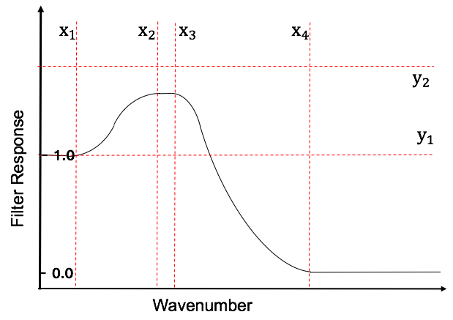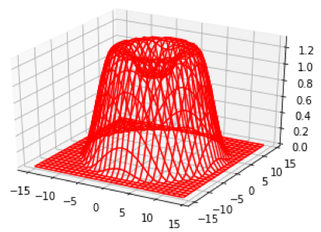

Figure. 5. Polynomial Low-pass filter in one-dimension and two-dimension

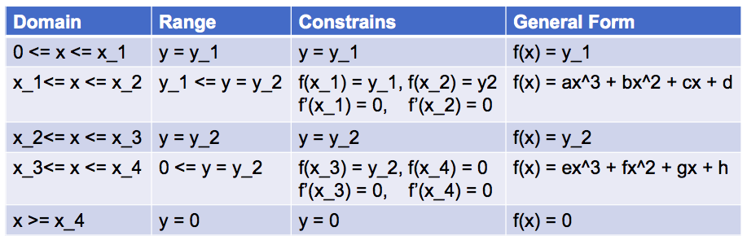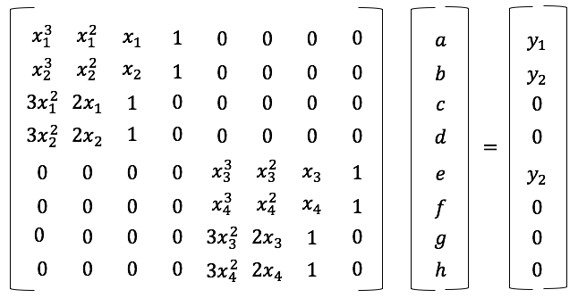

Figure. 6. (left) Conditions for solving the polynomial; (right) Same conditions expressed in matrix form

After solving the matrix, we can define any polynomial filter with such general shape by specifying the six values x_1, x_2, x_3, x_4, y_1, and y_2. This filter can then be experimented optimized for any desired filtering effect we are interested.

2.4 WRF Runs

After obtaining modified smoothed terrain netCDF files, consider running two WRF simulations in parallel with the same initial conditions except replacing one of the Geogrid generated terrain data files with the modified version processed by the filter derived in 2.3. To visualize the WRF modeling output files, use the Integrated Data Viewer (IDV) to plot variable vector fields side by side and examine the differences.

**References**

Courant, R., Friedrichs, K., & Lewy, H. (1986). Über die partiellen Differenzengleichungen der mathematischen Physik. Kurt Otto Friedrichs, 53-95. doi:10.1007/978-1-4612-5385-3_7