Id - Vcm

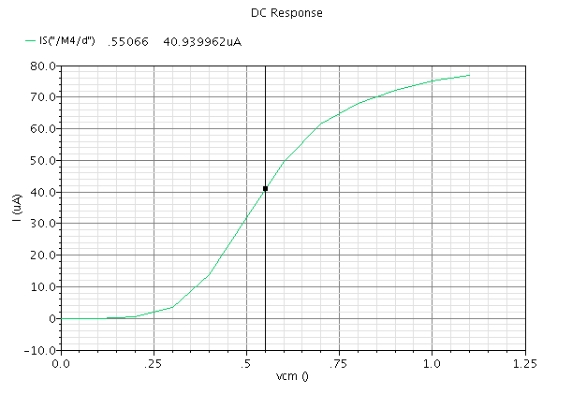

gm – Vcm

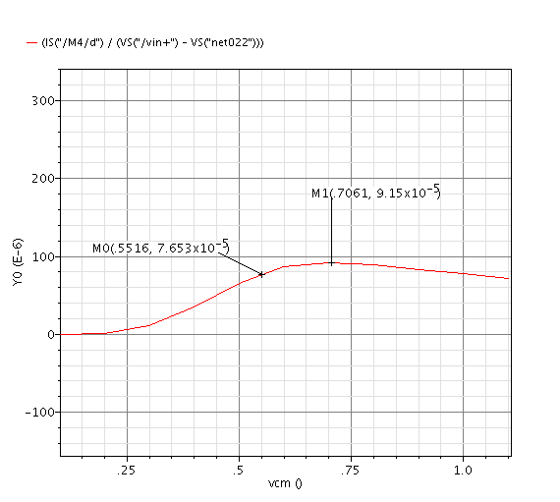

Gm when ibias=34u @ 200MHz

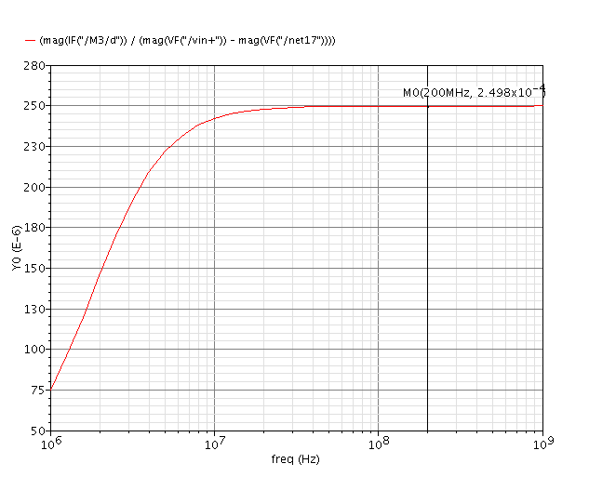

Gm when ibias=4.4u @ 200MHz

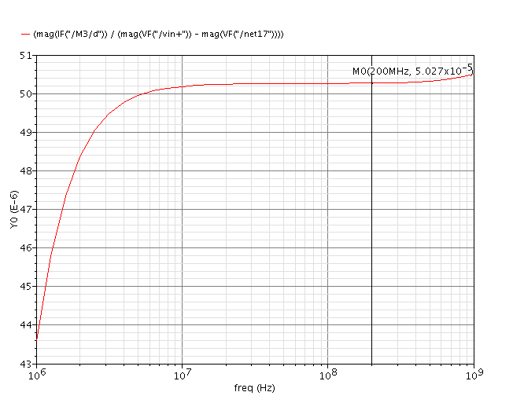

2.

A)

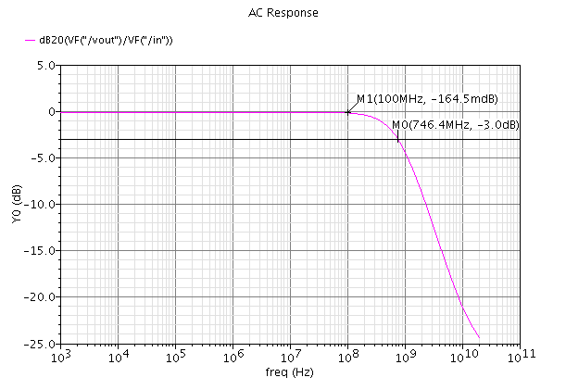

$$w_{t}:unity gain freq of the op-amp$$

$$H\left(s\right)=\frac{V_{out}}{V_{in}}= -\frac{A_{0}}{\left(1+sA_{0}RC\right)\left(1+\frac{s}{w_{t}}\right)}=-\frac{A_{0}}{1+\frac{s}{w_{t}}+sA_{0}RC-\frac{w^{2}A_{0}RC}{w_{t}}}=-\frac{A_{0}}{\left(\frac{1}{w_{t}}+A_{0}RC\right)s+\left(1-\frac{w^{2}A_{0}RC}{w_{t}}\right)}=-\frac{\frac{A_{0}}{\left(\frac{1}{w_{t}}+A_{0}RC\right)}}{[s+\frac{1-\frac{w^{2}A_{0}RC}{w_{t}}}{\frac{1}{w_{t}}+A_{0}RC}]}$$

A general expression for a bi-linear filter:

$$\frac{V_{out}}{V_{in} }=\frac{k_{1}s+k_{0}}{s+w_{0}}$$

It is easy to tell that: $k_{1}=0,$ therefore:

$$H\left(s\right)=\frac{V_{out}}{V_{in} }=\frac{k_{0}}{s+w_{0}}$$

At $f=0$, where $\left|H\left(s=0\right)\right|≈0 dB=1$:

$$\left|H\left(s=0\right)\right|=A_{0}=\frac{k_{0}}{w_{0}}≈1→k_{0}=w_{0}$$

$$w_{0}≈2π746.4MHz=4.7×{10}^{9}\frac{rad}{s}=k_{0}$$

B)

Input waveform (1mV, 1MHz):

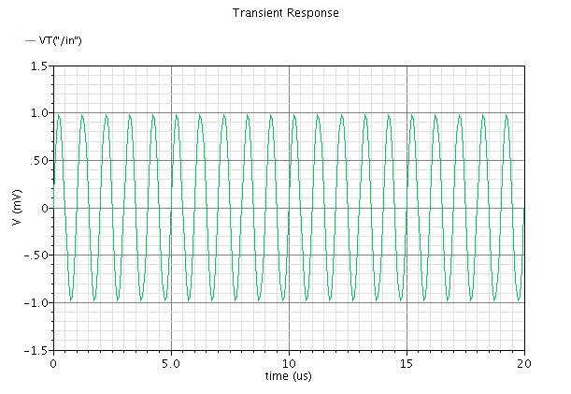

Output waveform (1mV, 1MHz):

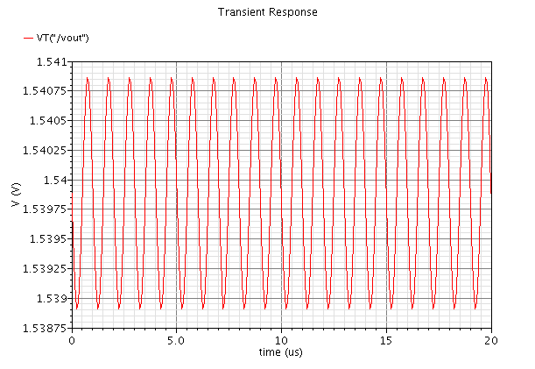

Output DFT (1mV, 1MHz)

Select $f_{s}=64MHz$, $N=1024$, leading to a resolution of $\frac{64MHz}{1024}=62.5kHz$, set stop time to 16us, which contains 16 cycles of 1MHz signal, and in total 1024 points.

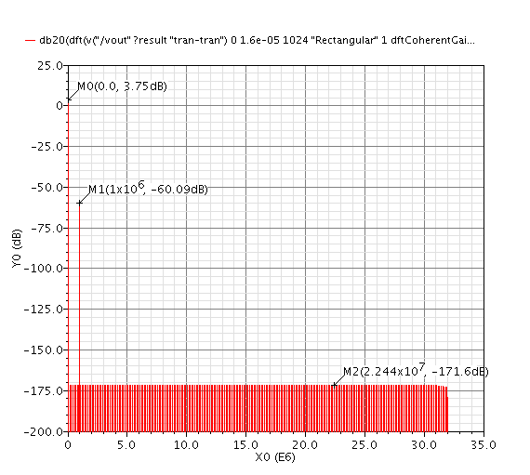

THD (1mV, 1MHz):

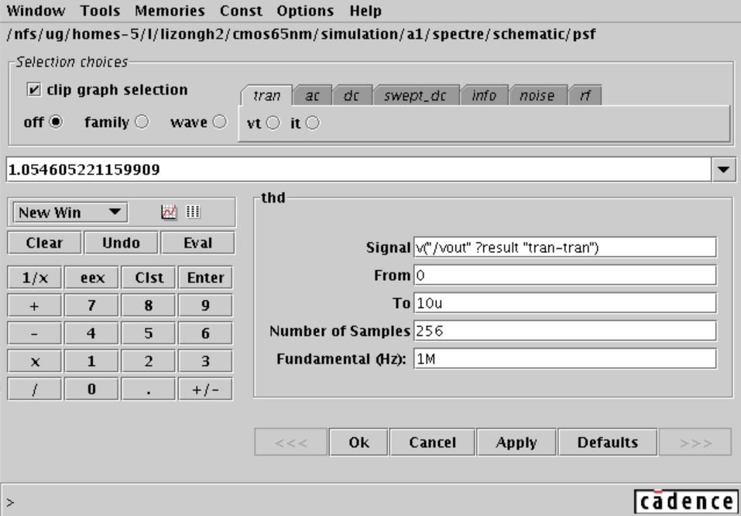

C)

Input Waveform (100mV, 1MHz)

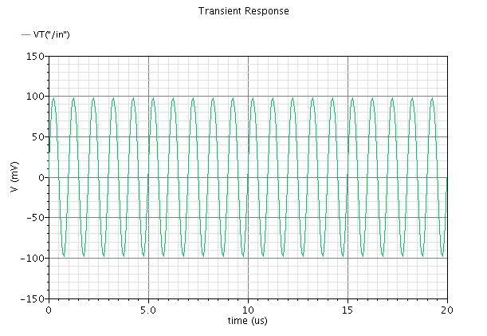

Output Waveform (100mV, 1MHz)

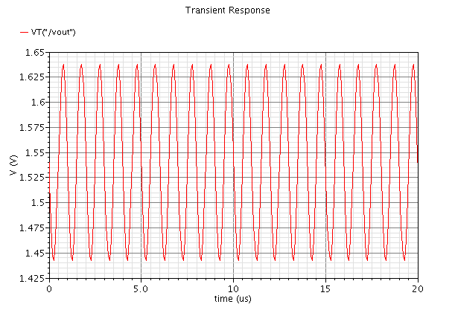

DFT (100mV, 1MHz)

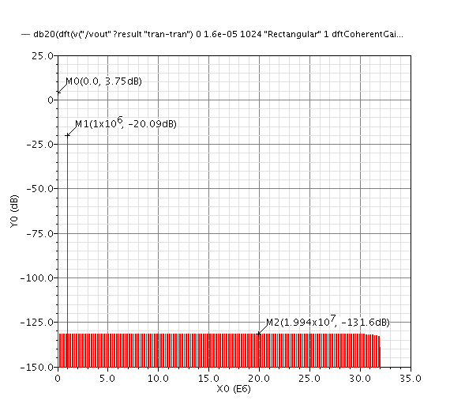

THD (100mV, 1MHz)

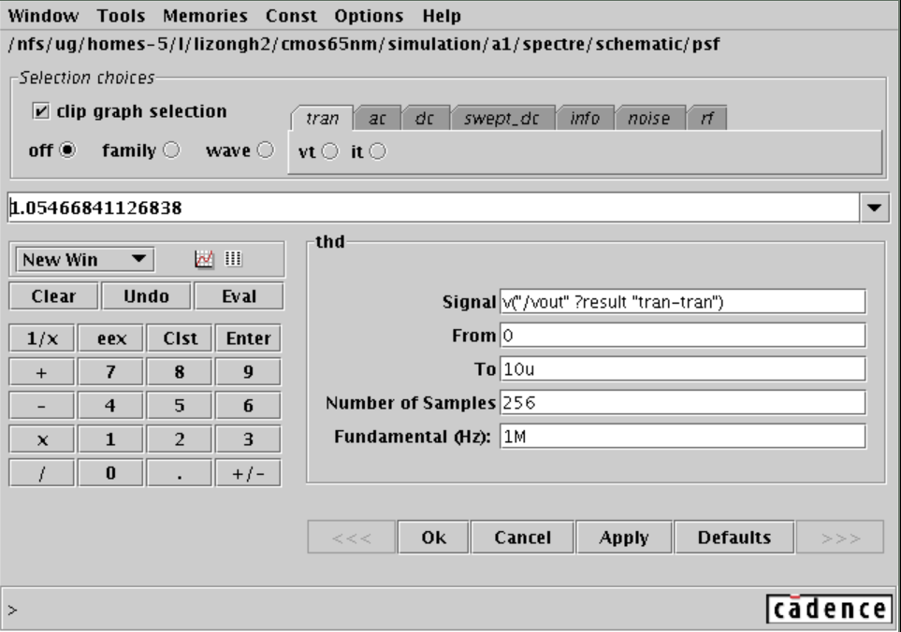

D)

D) 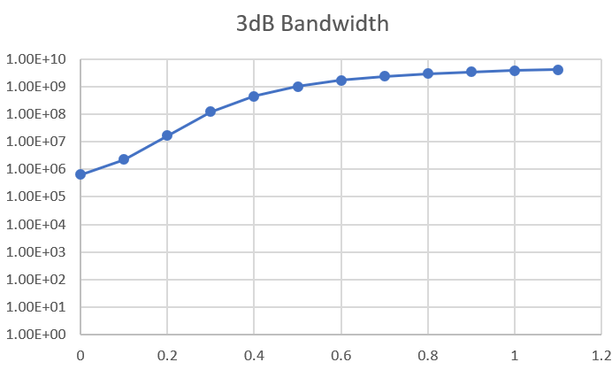

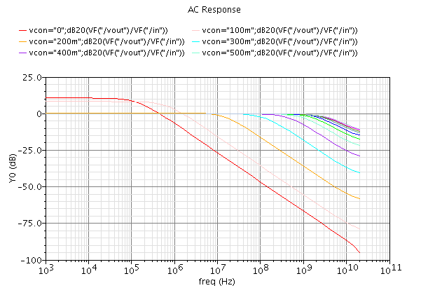

3.

A general second order filter:

$$H\left(s\right)=\frac{k_{2}s^{2}+k_{1}s+k_{0}}{s^{2}+s\frac{ω_{0}}{Q}+ω_{0}^{2}}$$

For a bandpass filter with $ω_{0}=200MHz$, $k_{2}=k_{0}=0$, therefore:

$$H\left(s\right)=\frac{k_{1}s}{s^{2}+s\frac{ω_{0}}{Q}+ω_{0}^{2}}$$

Using the design equation from Lecture 3:

$$H\left(s\right)=\frac{\frac{G_{m5}}{C_{B}}s}{s^{2}+s\frac{G_{m3}}{C_{B}}+\frac{G_{m1}G_{m2}}{C_{A}C_{B}}}$$

Say, if the G = 1, $C_{A}=C_{B}=200fF$:

$$G_{m1}=0.2512mS$$

$$G_{m2}=0.2512mS$$

$$G_{m3}=50.25uS$$

$$G_{m5}=50.21uS$$

For DFT simulations (200MHz):

Fs = 1024MHz, N = 1024, t = 1us

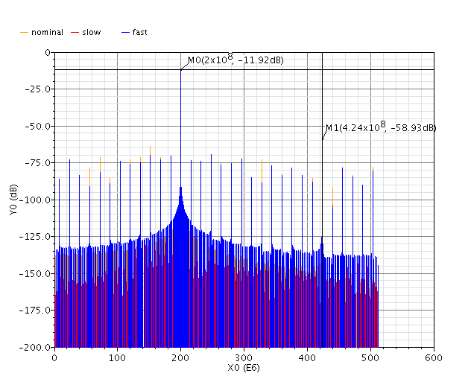

||

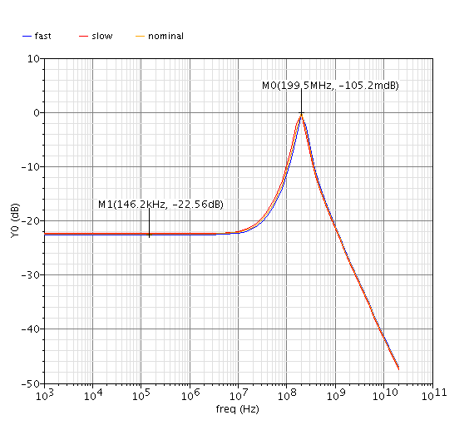

Transient response

