2.

$$en_{0}=\frac{kTF}{P_{avs}}=-160\frac{dBc}{Hz}={10}^{-16}\frac{rad^{2}}{Hz}$$

$$L_{ref}\left(f=10 kHz\right)=\frac{en_{2}}{f^{2}}+en_{0}≈\frac{en_{2}}{f^{2}}={10}^{-14}→en_{2}={10}^{-6}\frac{rad^{2}}{Hz}$$

Since only $en_{2}$ is considered here

$$en_{3}=en_{1}=0$$

Therefore

$$L_{ref}=\frac{{10}^{-6}}{f^{2}}+{10}^{-16}$$

3.

$$en_{0}=\frac{kTF}{P_{avs}}=-140\frac{dBc}{Hz}={10}^{-14}\frac{rad^{2}}{Hz}$$

$$L_{vco}\left(f=1MHz\right)=\frac{en_{3}}{f^{3}}+en_{0}≈\frac{en_{3}}{f^{3}}={10}^{-12}\frac{dBc}{Hz}→en_{3}={10}^{6}\frac{rad^{2}}{Hz^{2}}$$

$$L_{ref}=\frac{{10}^{6}}{f^{3}}+{10}^{-14}$$

4.

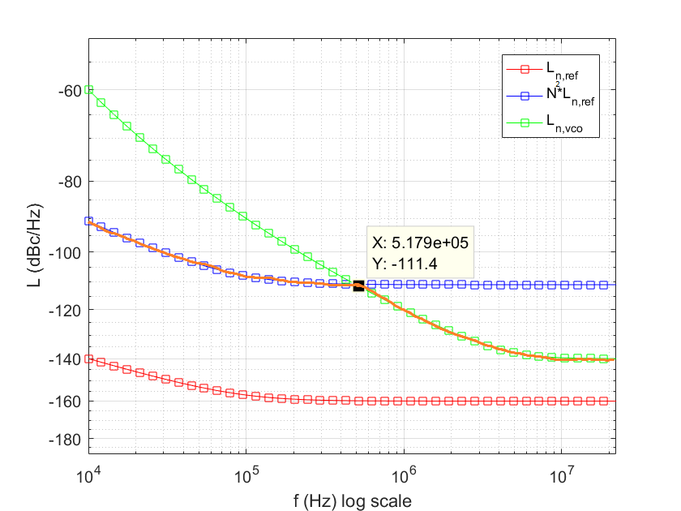

$$N∈\left[\frac{5.5 GHz}{20 MHz}, \frac{5.7 GHz}{20 MHz}\right]=\left[275, 285\right]$$

Take the larger $N$ as the worst-case scenario for noise calculation

$$20\log{N_{max}}=20\log{285}=49.1 dB$$

$$K_{osc}=2π(300×{10}^{6})\frac{rad}{sV}, Q=0.5 selected$$

$$ω_{3dB}=2π\left(5.2×{10}^{5}\right)rad/s$$

$$ω_{pll}=0.4ω_{3dB}=0.8π\left(5.2×{10}^{5}\right) rad/s$$

$$\frac{I_{ch}}{C_{1}}=\frac{ω_{pll}^{2}2πN_{max}}{K_{osc}}=1.62×{10}^{6}→select C_{1}=5 pF, I_{ch}=8.1 μA$$

$$ω_{z}=Qω_{pll}=0.5ω_{pll}=0.4π\left(5.2×{10}^{5}\right) rad/s$$

$$R=\frac{1}{ω_{z}C_{1}}=\frac{1}{0.4π\left(5.2×{10}^{5}\right)(5 pF)}=306 kΩ$$

$$C_{2}=\frac{1}{10}C_{1}=0.5 pF$$

For 3rd order PLL:

$$K_{lp}H_{lp}\left(s\right)=\frac{1}{s\left(C_{1}+C_{2}\right)}\frac{1+sRC_{1}}{1+sR\frac{C_{1}C_{2}}{C_{1}+C_{2}}}=\frac{1}{RC_{1}C_{2}}\frac{sRC_{1}+1}{s^{2}+s\frac{C_{1}+C_{2}}{RC_{1}C_{2}}}$$

Since

$$ω_{z}=\frac{1}{RC_{1}}$$

Therefore

$$K_{lp}H_{lp}\left(s\right)=\frac{1}{RC_{1}C_{2}}\frac{\frac{s}{ω_{z}}+1}{s^{2}+sω_{z}(1+\frac{C_{1}}{C_{2}})}$$

Therefore, it introduces one more pole:

$$ω_{p}=\frac{1}{\left(1+\frac{C_{1}}{C_{2}}\right)ω_{z}}$$

Therefore

$$L_{out}\left(s\right)=\frac{ω_{pll}^{2}}{s^{2}}\frac{\frac{s}{ω_{z}}+1}{\frac{s}{ω_{p}}+1}=\frac{\frac{ω_{pll}^{2}}{ω_{z}}s+ω_{pll}^{2}}{\frac{1}{ω_{p}}s^{3}+s^{2}}$$

Phase margin is about 60 degrees.

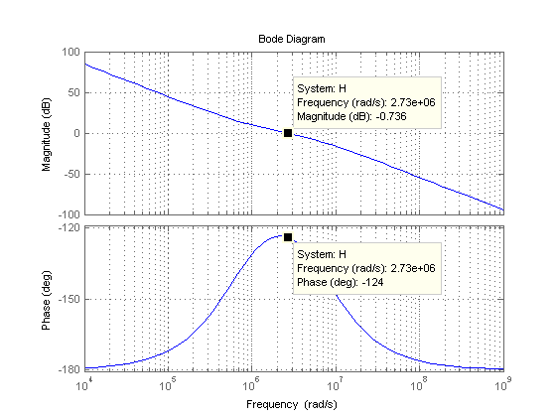

At 1 MHz, the main noise contributor is VCO.

The rms phase error from 1 kHz – 100 MHz:

From 1 kHz to 100 kHz: $L_{n,ref}$ dominate the noise source, specifically, $en_{2}$ noise; from 100 kHz to $f_{3dB}=518$ kHz, $L_{n,ref}$ dominate the noise source, specifically, $en_{0}$ noise; from $f_{3dB}=518$ kHz to 10 MHz, $L_{n,vco}$ dominate the noise source, specifically, $en_{3}$ noise; from 10 MHz to 100 MHz, $L_{n,vco}$ dominate the noise source, specifically, $en_{0}$ noise.

$$θ_{rms,pll}=\sqrt{2\left(N_{max}^{2}\int_{{10}^{3}}^{{10}^{5}}{\frac{en_{2,ref}}{f^{2}}}df+N_{max}^{2}\int_{{10}^{5}}^{5.18×{10}^{5}}{en_{0,ref}}df+\int_{5.18×{10}^{5}}^{{10}^{7}}{\frac{en_{3,vco}}{f^{3}}}df+\int_{{10}^{7}}^{{10}^{8}}{en_{0,vco}}df\right)}$$

$$=\sqrt{2[{285}^{2}×{10}^{-6}×\left(-1\right)×\left({\left({10}^{5}\right)}^{-1}-{\left({10}^{3}\right)}^{-1}\right)+{285}^{2}×{10}^{-16}×\left(5.18×{10}^{5}-{10}^{5}\right)+{10}^{6}×\left(-\frac{1}{2}\right)×\left({\left({10}^{7}\right)}^{-2}-{\left(5.18×{10}^{5}\right)}^{-2}\right)+{10}^{-14}×\left({10}^{8}-{10}^{7}\right)]}$$

= $\sqrt{2\left[8×{10}^{-5}+3.3952×{10}^{-6}+1.85×{10}^{-6}+9×{10}^{-7}\right]}$

= $\sqrt{0.000172316838}$

=0.013 rad = 0.745 deg

$$σ_{rms,pll}=\frac{1}{2π(5.7×{10}^{9})}θ_{rms,pll}=0.36 ps$$