Q8

close all

clear all

p_mean = [1.1 1.35 1.25 1.05];

% sigma = [0.2 -0.2 -0.12 0.02;

% -0.2 1.4 0.02 0;

% -0.12 0.02 1 -0.4;

% 0.02 0 -0.4 0.02];

sigma = [0.2 -0.2 -0.12 0.02;

-0.2 1.4 0.02 0;

-0.12 0.02 1 -0.4;

0.02 0 -0.4 0.02];

H = sigma;

f = [0;0;0;0];

A = [-1 0 0 0; % -x1 <= 0

0 -1 0 0; % -x2 <= 0

0 0 -1 0; % -x3 <= 0

0 0 0 -1; % -x4 <= 0

-1.*p_mean]; % trans(-p_mean)x <= -r_min

Aeq = [1 1 1 1];

beq = 1;

for i = 1:1:15

b(:,i) = [0;0;0;0;-0.1*i]; % -r_min = 0.1*i

[x(:,i), fval(:,i), exitflag(:,i), output, lambda] = ...

quadprog(H, f, A, b(:,i), Aeq, beq);

end

% x, fval, exitflag

exp_return = p_mean * x;

figure(1)

p1 = plot(exp_return, fval);

hold on

p2 = plot([1.3 1.3], [-0.5 1], 'r');

set(gca,'linewidth',2)

set(p1, 'linewidth', 3)

set(p2, 'linewidth', 3)

xlabel('expected return')

ylabel('risk of profolio')

legend('expected return vs risk of profolio')

grid

hold off

figure(2)

bar([x(:,1); x(:,2); x(:,3); x(:,4); x(:,5); x(:,6); x(:,7); x(:,8); x(:,9);

x(:,10); x(:,11); x(:,12); x(:,13)])

(To the right of the line indicates the feasible region)

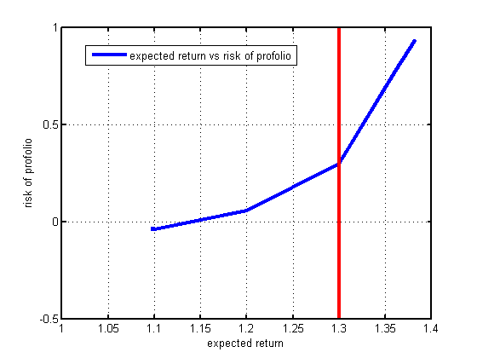

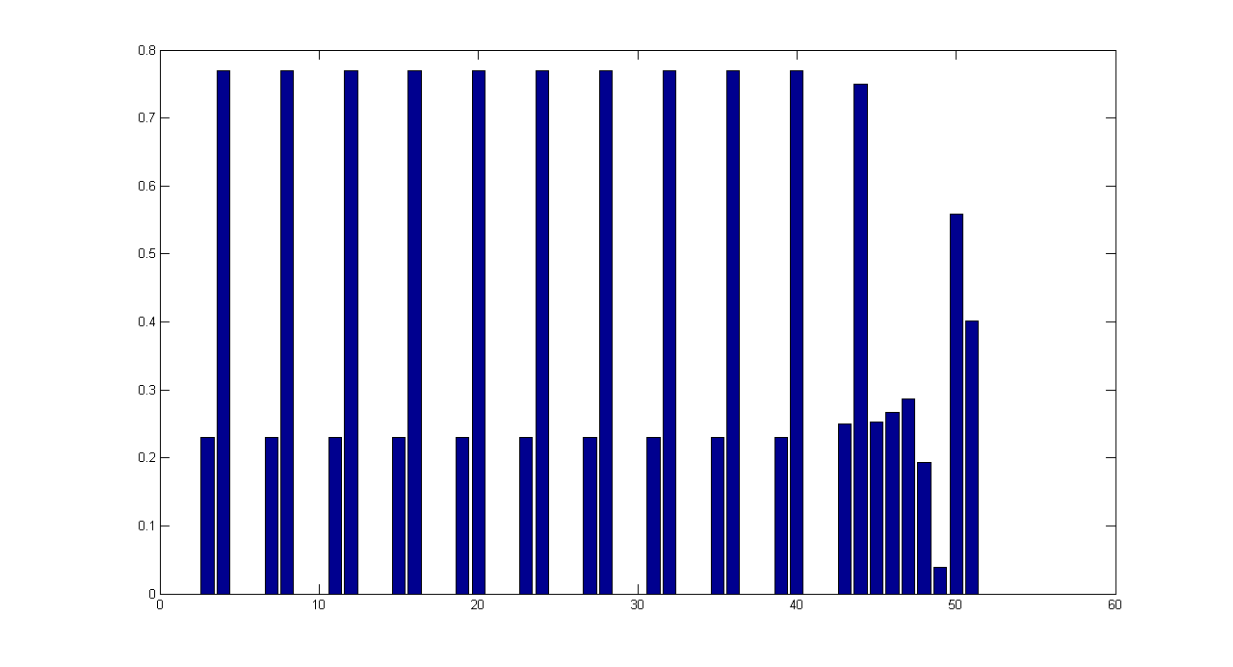

Minimum expected return constraint: 0.1 0.2 0.3 0.4 0.5 0.6 0.7 0.8 0.9 1.0 1.1 1.2 1.3

Composition

|  |  |  |  |  |  |  |  |  |  |  |  |  |
| --- | --- | --- | --- | --- | --- | --- | --- | --- | --- | --- | --- | --- |
| 6.39461435480326e-17 | 6.86670287399952e-17 | 7.38121847943036e-17 | 2.04573676885185e-16 | 1.01268802778177e-15 | 3.00235206255833e-15 | 3.81713767141727e-15 | 2.26539303203320e-15 | 3.54037352048975e-16 | 2.11106650101455e-16 | 1.73029137194440e-16 | 0.253179811359817 | 0.0391534391523836 |
| 5.17034233759066e-13 | 5.55124395683706e-13 | 5.96628176618747e-13 | 1.65126769815236e-12 | 8.16415285934602e-12 | 2.42312344234802e-11 | 3.08594160357170e-11 | 1.83744871734884e-11 | 2.85021838961996e-12 | 1.65587089531608e-12 | 8.94064451650595e-17 | 0.266871523709986 | 0.558730158730200 |
| 0.230769230769106 | 0.230769230769097 | 0.230769230769087 | 0.230769230768832 | 0.230769230767257 | 0.230769230763375 | 0.230769230761773 | 0.230769230764792 | 0.230769230768542 | 0.230769230768846 | 0.250000000000958 | 0.286397761610403 | 0.402116402116620 |
| 0.769230769230377 | 0.769230769230348 | 0.769230769230317 | 0.769230769229517 | 0.769230769224577 | 0.769230769212391 | 0.769230769207363 | 0.769230769216832 | 0.769230769228607 | 0.769230769229498 | 0.749999999999042 | 0.193550903319795 | 7.96954365497068e-13 |

Comments: the diversity of the composition will give a better expected return but also keep small risk.

Q9

We need to relate the force applied to the unit mass object and its velocity and position, defined by $v$ and $p$, respectively in the below Matlab code. The displacement is defined by $s$. We know that within each time instance $t$ (t=1 in this case, the modal is discrete in time instance.)

$$f\left(t\right)=ma_{i}=a_{i}=p_{i}$$

$$v\left(t\right)=v_{i-1}+a_{i}t=v_{i-1}+p_{i}t$$

$$s\left(t\right)=v_{i-1}t+\frac{1}{2}a_{i}t^{2}=v_{i-1}t+\frac{1}{2}p_{i}t^{2}$$

$$p=Σ_{t}s(t)$$

Where $i=1,…10$, $i-1<t≤i$ And from the constraint in a)

$$v_{10}=0$$

$$p=1$$

See the below table

|  |  |  |  |  |  |  |  |  |  |  |
| --- | --- | --- | --- | --- | --- | --- | --- | --- | --- | --- |
| t | 1 | 2 | 3 | 4 | 5 | 6 | 7 | 8 | 9 | 10 |
| f | $$p_{1}$$ | $$p_{2}$$ | $$p_{3}$$ | $$p_{4}$$ | … | … | … | … | … | $$p_{10}$$ |
| v | $$p_{1}$$ | $$p_{1}+p_{2}$$ | $$p_{1}+p_{2}+p_{3}$$ | $$p_{1}+p_{2}+p_{3}+p_{4}$$ | … | … | … | … | … | $$Σ_{t=1}^{t=10}p_{t}$$ |
| s | $$\frac{1}{2}p_{1}$$ | $$p_{1}+\frac{1}{2}p_{2}$$ | $$p_{1}+p_{2}+\frac{1}{2}p_{3}$$ | $$p_{1}+p_{2}+p_{3}+\frac{1}{2}p_{4}$$ | … | … | … | … | … | $$Σ_{t=1}^{9}p_{t}+\frac{1}{2}p_{10}$$ |
| p | $$s_{1}$$ | $$s_{1}+s_{2}$$ | $$s_{1}+s_{2}+s_{3}$$ | … | … | … | … | … | … | $$Σ_{t=1}^{10}s_{t}$$ |

Therefore, re-organize and the rewrite the constraint

$$1^{T}f=0 (velocity constraint)$$

$$\left[9.5 8.5 7.5 6.5 5.5 4.5 3.5 2.5 1.5 0.5\right]f=1 (position constraint)$$

Therefore

$$minimize f^{T}f$$

$$subject to 1^{T}f=0$$

$$\left[9.5 8.5 7.5 6.5 5.5 4.5 3.5 2.5 1.5 0.5\right]f=1$$

For b), just add one more constraint:

$$\left[4.5 3.5 2.5 1.5 0.5 0 0 0 0 0\right]f=0$$

close all

clear all

H = ones(10,10);

%%%%constraint for a, uncomment this%%%%%%

%Aeq = [1 1 1 1 1 1 1 1 1 1;9.5 8.5 7.5 6.5 5.5 4.5 3.5 2.5 1.5 0.5];

%beq = [0;1];

%%%%constraint for a, uncomment this%%%%%%

Aeq = [1 1 1 1 1 1 1 1 1 1;9.5 8.5 7.5 6.5 5.5 4.5 3.5 2.5 1.5 0.5;...

4.5 3.5 2.5 1.5 0.5 0 0 0 0 0]; % constraint for b

beq = [0;1;0]; % constraint for b

[x,fval,exitflag,output,lambda] = ...

quadprog(H,[],[],[],Aeq,beq);

% x = f, force

v = zeros(10,1); % velocity

for t = 1:1:10

v(t,:) = sum(x(1:t));

end

a = [0;x]; % add a zero to the front, acceleration

s = zeros(10,1); % displacement

for t = 1:1:10

s(t,:) = sum(a(1:t)) + 0.5 * x(t,:);

end

p = zeros(10,1); % position

for t = 1:1:10

p(t,:) = sum(s(1:t));

end

figure(1)

p1 = plot(x);

set(gca,'linewidth',2)

set(p1, 'linewidth',3)

xlabel('time')

ylabel('force')

legend('force')

grid on

figure(2)

p1 = plot(v);

set(gca,'linewidth',2)

set(p1, 'linewidth',3)

xlabel('time')

ylabel('velocity')

legend('velocity')

grid on

figure(3)

p1 = plot(p);

set(gca,'linewidth',2)

set(p1, 'linewidth',3)

xlabel('time')

ylabel('position')

legend('position')

grid on

Part a)

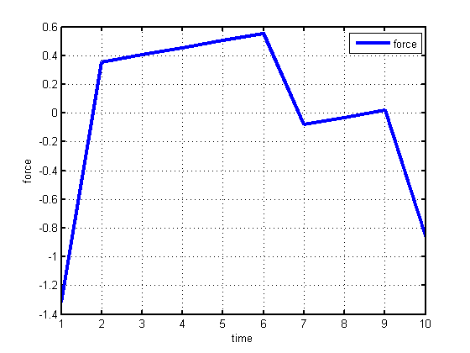

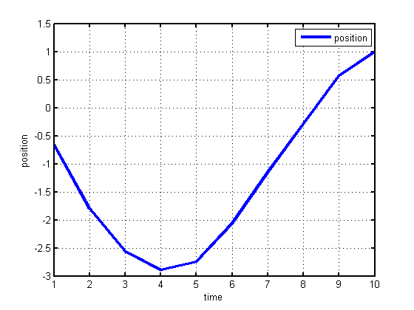

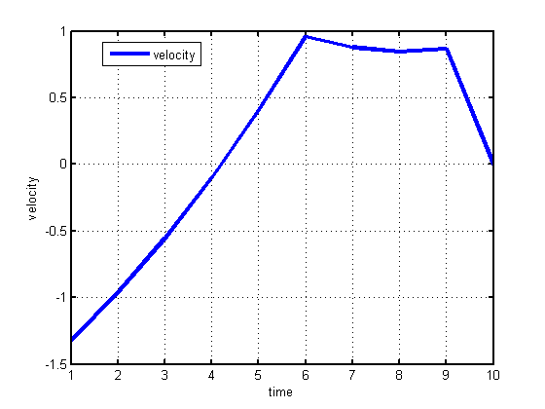

Part b)

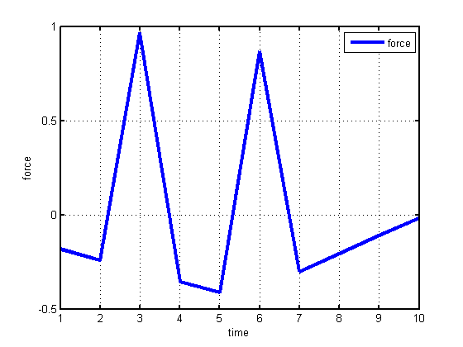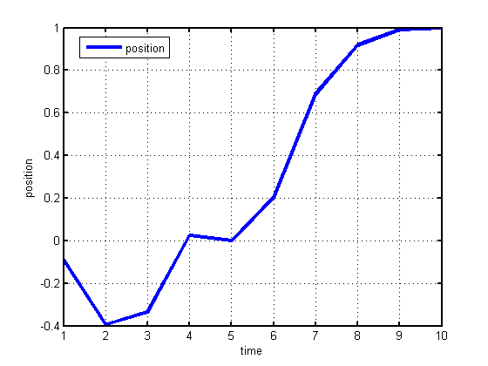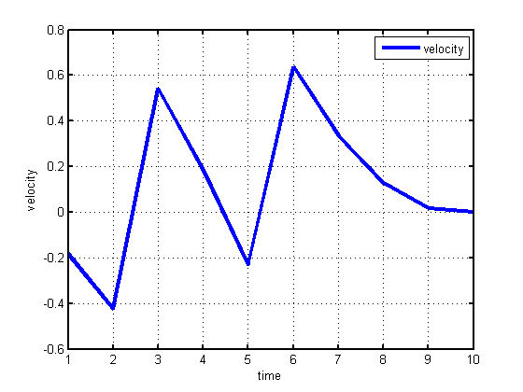

Q10

Reformulating the least-square optimization problem; since

$$minimize Σ_{t≠D}{\left(\left(g*h\right)\left(t\right)\right)}^{2}$$

$$subject to \left(g*h\right)\left(D\right)=1$$

Is effectively the same as

$$minimize Σ{\left(\left(g*h\right)\left(t\right)\right)}^{2}-1$$

$$subject to \left(g*h\right)\left(D\right)=1$$

Or one more step

$$minimize Σ{\left(\left(g*h\right)\left(t\right)\right)}^{2}$$

$$subject to \left(g*h\right)\left(D\right)=1$$

Therefore, we need to rewrite $Σ{\left(\left(g*h\right)\left(t\right)\right)}^{2}$ so that it is a standard form quadratic programming (Q.P.) optimization problem. Recall the circulant matrix, which is used to write the convolution of two vectors in linear product fashion such that

$$(g*h)(t)=C(t,:)g$$

Define circulant matrix C, where each row will be the shifted version of impulse response vector h(n).

$$C= \left[\begin{aligned}h\left(0\right) 0 0…..0 \\ h\left(1\right) h\left(0\right) 0 0…0 \\ h\left(2\right) h\left(1\right) h\left(0\right) 0 0…0 \\ … \\ h\left(10\right) h\left(9\right) h\left(8\right) h\left(7\right) h\left(6\right) h\left(5\right) h\left(4\right) h\left(3\right) h\left(2\right) h\left(1\right) h\left(0\right) 0 0…0 \\ 0 h\left(10\right) h\left(9\right) h\left(8\right) h\left(7\right) h\left(6\right) h\left(5\right) h\left(4\right) h\left(3\right) h\left(2\right) h\left(1\right) h\left(0\right) 0…0 \\ 0 0 h\left(10\right) h\left(9\right) h\left(8\right) h\left(7\right) h\left(6\right) h\left(5\right) h\left(4\right) h\left(3\right) h\left(2\right) h\left(1\right) h\left(0\right) 0…0 \\ 0 0 0 h\left(10\right) h\left(9\right) h\left(8\right) h\left(7\right) h\left(6\right) h\left(5\right) h\left(4\right) h\left(3\right) h\left(2\right) h\left(1\right) h\left(0\right) 0…0 \\ … \\ 0 0 0…h\left(2\right) h\left(1\right) h\left(0\right) \\ 0 0 0…h\left(1\right) h\left(0\right) \\ 0 0 0…h(0)\end{aligned}\right]$$

Where $C(t,:)$ means the $t$ row of C, where $t∈\left[1,n+m-1\right]$, meaning that after $t=29$ the channel output will be zero, also means there are in total 29 time steps. The dimension of C is related to the dimension of g(m) and h(n):

$$C∈R^{\left(n+m-1\right)×m}=R^{29×20}$$

Which means C has 29 rows and 20 columns. The matrix C is computed through Matlab code below. After the calculation of C, ${\left(\left(g*h\right)\left(t\right)\right)}^{2}$ can be rewritten as

$${\left(\left(g*h\right)\left(t\right)\right)}^{2}={\left(C\left(t,:\right)g\right)}^{2}={\left(C\left(t,:\right)g\right)}^{T}\left(C\left(t,:\right)g\right)=g^{T}\left[C{\left(t,:\right)}^{T}C\left(t,:\right)\right]g=g^{T}A(t)g$$

A is the product of $C{\left(t,:\right)}^{T}C\left(t,:\right)$, which is the coefficient (square) matrix of each time instance. This is defined below in Matlab code. Further rewrite $Σ{\left(\left(g*h\right)\left(t\right)\right)}^{2}$ as

$$Σ{\left(\left(g*h\right)\left(t\right)\right)}^{2}= Σg^{T}A\left(t\right)g=g^{T}ΣA\left(t\right)g=g^{T}Pg$$

P is the summation of all A, also defined in the below Matlab code. Rewrite the optimization problem as

$$minimize g^{T}Pg$$

$$subject to C\left(D,:\right)g=1$$

It is a Q.P.

clear all

load('hw2data.mat','h')

load('hw2data.mat','y')

m = 20; % dimension of g

n = 10; % dimension of h

C = zeros(m+n-1,m) % initialize circulant matrix

H = transpose([transpose(h) zeros(1,10)]); % impulse response with zero padding

B = zeros(size(H)); % buffer

%% Formulating Circulating Matrix

for i=-(n+(n-1)):1:-1

B(-i+1:end) = H(1:end+i);

C(i+m,:) = fliplr(transpose(B));

end

for q=m:1:(m+n-1)

k = 1; % right shifting each row by one

B = C(q-1,:);

B(k+1:end)=B(1:end-k);

C(q,:) = B;

end

%% Formulating the coefficient for Q.P., defined by matrix P

A = zeros(m,m,m+n-1);

for j=1:1:(m+n-1) % in total there are 29 time samples are meaningful

A(:,:,j) = transpose(C(j,:))*(C(j,:)); % second-order term coefficicent for each time step

end

P = zeros(m:m);

for k=1:1:(m+n-1)

P = P + A(:,:,k); % pull out the variable g, the summation of all second-order term coefficicent for each time step

end

%% Formulating Q.P., with variable D (delay), and variable g (equalizer)

H = P;

f = transpose(zeros(1,m));

objective = (zeros(1,m+n-1));

for D = 1:1:(m+n-1)

Aeq = C(D,:); % the constraint at t = D

beq = 1;

[x(:,D),fval(:,D),exitflag(:,D),output,lambda] = ...

quadprog(H,f,[],[],Aeq,beq);

objective(:,D) = transpose(x(:,D))*P*(x(:,D)) - 1; % objective function, {sum(cov(g*m))^2(t), t not equal to D}

end

%% Plot objective function versus D

D = 1:1:(m+n-1);

figure(1)

p1 = plot(D, objective);

set(gca,'linewidth',2)

set(p1, 'linewidth',3)

xlabel('delay D')

ylabel('sum of squared errors')

legend('delay vs sum of squared errors')

grid on

% D = 9 gives the optimal solution, check C(9,:)*x(:,9) to see if the

% constraint is satisfied

%% Apply deconvolution to the data

g = x(:,9); % best least-square equalizer

z = conv(y,g);

z = z(n-1:10000+(n-1)-1); % 10000 samples, reconsrtucted

% normalize the data

% for r=1:1:10000

% z(r,:) = z(r,:)/abs(z(r,:));

% end

figure(2)

hist(y)

xlabel('amplitude of y')

ylabel('count')

figure(3)

hist(z)

xlabel('amplitude of z')

ylabel('count')

