Let me make my words clear so that you can follow what I mean here (I did not change anything in the following, I am just break down what I mean in my proof, you may misunderstand my language):

a)

We know that for the problem to be bounded, we should have

$$c-A^{T}λ_{1}-λ_{2}=0$$

$$λ_{1}≥0$$

$$λ_{2}≥0$$

I agree that for the problem to be unbounded, there should be at least one entry of $c$ to be negative. But here I said $c^{T}<0$, the $<$ is the general inequality (in this class I did not see any use of the curly inequality so I just follow the convention), so it renders it is a partially comparison. It might be trivial to see that A has to be PSD here (which is the reason why I did not write it down).

It can be easily seen that, since for the primal problem, for it to be unbounded, $x^{*}=∞$ gives the optimal value. To be so, therefore, for the first constraint $Ax≥b$, $A$ has to be PSD otherwise $Ax→ -∞$. Therefore:

$$c-A^{T}λ_{1}<0$$

Again, here $<$ is the general inequality.

However:

$$c-A^{T}λ_{1}=λ_{2}≥0$$

Therefore, the above two violates each other, we conclude that for primal to be unbounded, the dual will be infeasible.

b)

I am just listing all possible cases for the primal to be infeasible. Since there are two constraints here, there will be three possible cases:

1. $x<0$ and $Ax≥b$
2. $x>0$ and $Ax<b$
3. $x<0$ and $Ax<b$

In my assignment I am just listing the discussion for different cases. From a) we know that $A≥0$ (again, general inequality). And if any of the case above makes the dual infeasible, this problem is proved. Say for case 1, since $x<0 and A>0$:

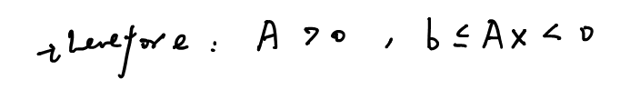

Therefore $b<0$ (general inequality), the dual $minimize λ_{1}^{T}b$ is unbounded where $λ_{1}^{*}=∞$



For question 6, you are right that I should be more clear on stating that since Slater’s conditions and convexity holds, the strong duality holds (it is just trivial so that I neglect it). But I do have a concern on your marking scheme. Since all part a) b) and c) you deduct the grade all because of the same mistake, should you just deduct the grade once? I think it is not very reasonable within one question you remove the grades multiple times because of the initial mistake (here is just missing the statement, which I agree is important). Unless you do this to all other people, then it is fair to me.