For 1 and 11 see the picture after.

2. are support vectors.

3.

4. Fix

5. Plug back to

6. We know that the first point $x_{2}$ is not the support vector and should be removed from the constraint

$$L\left(\overline{w},b,α_{j}\right)=\frac{1}{2}{\left|\left|\overline{w}\right|\right|}^{2}-Σ_{j≠j^{*}}α_{j}\left[\left(\overline{w} ∙x_{j}+b\right)y_{j}-1\right]$$

7.

$$Σ_{j≠j^{*}}α_{j}y_{j}=0$$

8.

$$Y={\left[y_{1} y_{2} y_{3} y_{4}\right]}^{T}$$

$$X={\left[x_{1} x_{2} x_{3} x_{4}\right]}^{T}$$

$$Σ_{j}α_{j}y_{j}x_{j}=α_{1}y_{1}x_{1}+α_{2}y_{2}x_{2}+α_{3}y_{3}x_{3}+α_{4}y_{4}x_{4}$$

$$=α_{1}x_{1}-α_{2}x_{2}-α_{3}x_{3}-α_{4}x_{4}$$

$$=\left[α_{1} α_{2} a_{3} α_{4}\right]{\left[x_{1} {-x}_{2} {-x}_{3} {-x}_{4}\right]}^{T}$$

Therefore

$${\left(Σ_{j}α_{j}y_{j}x_{j}\right)}^{T}\left(Σ_{j}α_{j}y_{j}x_{j}\right)=\left[x_{1} {-x}_{2} {-x}_{3} {-x}_{4}\right]{\left[α_{1} α_{2} a_{3} α_{4}\right]}^{T}\left[α_{1} α_{2} a_{3} α_{4}\right]{\left[x_{1} {-x}_{2} {-x}_{3} {-x}_{4}\right]}^{T}$$

$$=\left[α_{1} α_{2} a_{3} α_{4}\right]{\left[x_{1} {-x}_{2} {-x}_{3} {-x}_{4}\right]}^{T}\left[x_{1} {-x}_{2} {-x}_{3} {-x}_{4}\right]{\left[α_{1} α_{2} a_{3} α_{4}\right]}^{T}$$

$$\left[α_{1} α_{2} a_{3} α_{4}\right]{\left[\begin{matrix}1 & 1 & -1 & 0 \\ 1 & 1 & 0 & -1\end{matrix}\right]}^{T}\left[\begin{matrix}1 & 1 & -1 & 0 \\ 1 & 1 & 0 & -1\end{matrix}\right]{\left[α_{1} α_{2} a_{3} α_{4}\right]}^{T}$$

$$=Α^{T}HA$$

Where

$$A={\left[α_{1} α_{2} a_{3} α_{4}\right]}^{T}$$

$$H= {\left[\begin{matrix}1 & 1 & -1 & 0 \\ 1 & 1 & 0 & -1\end{matrix}\right]}^{T}\left[\begin{matrix}1 & 1 & -1 & 0 \\ 1 & 1 & 0 & -1\end{matrix}\right]=\left[\begin{matrix}2 & 2 & -1 & -1 \\ 2 & 2 & -1 & -1 \\ -1 & -1 & 1 & 0 \\ -1 & -1 & 0 & 1\end{matrix}\right]$$

Rewrite the original optimization problem into quadratic programming (Q.P.) form:

$$minimize_{A} \frac{1}{2}Α^{T}HA-1^{T}A$$

$$subject to A^{T}Y=0$$

$$A≥0$$

By solving the above optimization problem, it gives

$$A={\left[4 0 2 2\right]}^{T}$$

Which means

$$α_{1}=4, a_{2}=0, α_{3}=α_{4}=2$$

9.

$$\overline{w}=Σ_{j}α_{j}y_{j}x_{j}=4{\left[1 1\right]}^{T}+0-2{\left[1 0\right]}^{T}-2{\left[0 1\right]}^{T}={\left[2 2\right]}^{T}$$

10.

$$\left(\overline{w} ∙x_{j}+b\right)y_{j}-1=0$$

Select a support vector, say $x_{1}$, plug it into the above equation:

$$\left(\left[2 2\right]{\left[1 1\right]}^{T}+b\right)\left(1\right)=1→b=-3$$

Therefore:

$$\overline{w} ∙x+b=0$$

$$\left[2 2\right]x-3=0→ -\left[1 1\right]x+1.5=0$$

Therefore:

$${\overline{w}}^{*}={\left[-1 -1\right]}^{T}$$

$$b^{*}=1.5$$

Which is the same as the initial guess in q1.

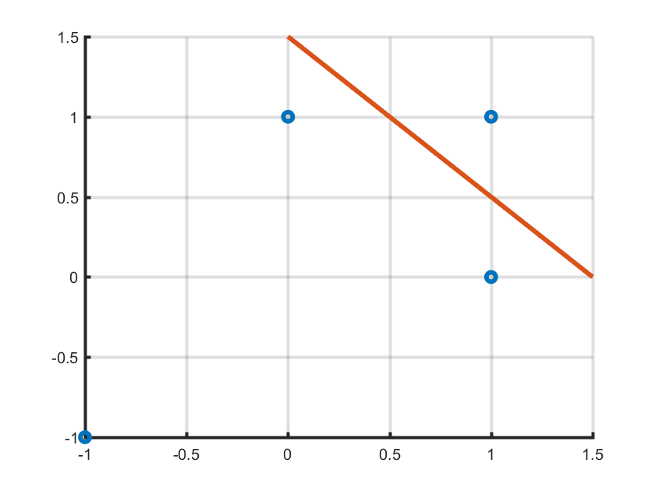

close all

clear all

x1 = [1;1];

x2 = [-1;-1];

x3 = [1;0];

x4 = [0;1];

x = [x1 x2 x3 x4];

j = 4;

Y(:,:,4) = [1;-1;-1;-1];

m = 0:0.1:1.5;

k = - m + 1.5;

figure(1)

p1 = scatter(x(1,:), x(2,:));

set(p1, 'linewidth', 3)

hold on

p2 = plot(m,k);

set(p2, 'linewidth', 3)

grid on

set(gca,'linewidth',2)

% support point: x1, x3 and x4

X = transpose(x);

% Formulating Q.P.

H = [2 2 -1 -1; 2 2 -1 -1; -1 -1 1 0; -1 -1 0 1];

f = [-1; -1; -1; -1];

lb = zeros(4,1);

Aeq = [1 -1 -1 -1];

beq = 0;

[x,fval,exitflag,output,lambda] = ...

quadprog(H,f,[],[],Aeq, beq, lb, []);