Log 1 Context Engineering
Name Chrisandra Vaz
Course __________________________________________________________________________
Date of test September 10, 2026
Model used Sol in Codex, unchanged across all three runs

Research question
Before I begin, I will write my research question by hand. My test will focus on how adding visual and technical context changes the model's animated lake surface.
My exact question How does adding visual and technical context change the output of the same WebGL lake prompt?

Test plan
I will use the same model, browser, computer, window size, and test actions for all three runs. Each prompt will go into a new chat. I will not send follow-up prompts or fix the generated files.
- Run 1 gives only the basic task.
- Run 2 adds a visual style, water details, interaction, and judging criteria.
- Run 3 adds technical constraints and a required code structure.

What I will do during each run
- Start the screen recording and show the date, model, and blank chat.
- Paste the prompt once and save the full response and HTML file.
- Watch for 10 seconds while writing notes by hand.
- Move the cursor, click once, wait five seconds, then click eleven times.
- Test full screen and capture dated screenshots and any console errors.

Evidence to save
I need the screen recording, complete chat logs, all three HTML files, dated screenshots of each result, any console errors, and a clear photo or scan of the notes I wrote during the test.

Prompts
I will use each prompt in a separate new chat.

Run 1 Basic context
Build one self-contained HTML file that uses a WebGL fragment shader to show an animated lake or pond surface from directly above. It must work in a modern browser with no libraries, build step, or external visual assets. Save it as lake-pond.html.

Run 2 Visual context
Build one self-contained HTML file that uses a WebGL fragment shader to show an animated lake or pond surface from directly above. It must work in a modern browser with no libraries, build step, or external visual assets. Save it as lake-pond.html.
Make the scene calm, bright, and illustrated rather than photographic. Use blue-green water that becomes slightly darker near the edges. Add broad, soft cloud reflections, faint sunlight lines under the surface, and a few small drifting leaves. Everything should move slowly enough to feel peaceful. Clicking or tapping should create circular ripples that expand and fade in about five seconds. Moving the cursor should make a weaker local wobble. Add a simple white title in the centre and a small caption at the bottom.
I will judge the result by whether the water looks like a lake, the movement feels calm, the reflections are easy to see without being distracting, the title stays readable, and the click ripples fade smoothly.

Run 3 Visual and technical context
Build one self-contained HTML file that uses WebGL 1 to show an animated lake or pond surface from directly above. It must work in a modern browser with no libraries, build step, textures, or external visual assets. Save it as lake-pond.html.
The scene should feel like a calm illustrated poster. Use blue-green water with a soft darkening near the edges. Add broad cloud reflections, a subtle web of underwater light, and a few small leaves drifting at different speeds. Keep the motion slow and smooth. Clicking or tapping should add rings that expand and fade over about five seconds. Keep up to ten ripples without a visible pop when the buffer wraps. Cursor movement should create a weaker wobble. Add a centred white title reading Still Water and a small mono caption at the bottom.
Technical requirements: use WebGL 1 and GLSL ES 1.00 with one full-screen quad and one fragment shader. Include uniforms for resolution, time, aspect-corrected mouse position, mouse activity, and a fixed ripple array containing position and start time. Create the water with hash randomness, value noise, fractal Brownian motion, and light domain warping. Use constant loop bounds. Cap device pixel ratio at 1.5 and use screen-space smoothstep antialiasing. Show a visible message if WebGL is unavailable. Keep the shader readable and comment the noise, ripples, water, reflections, leaves, and compositing sections.

Results
The three outputs were generated in separate clean Codex tasks on September 10, 2026. Each untouched file was tested in the same 1280 by 720 browser view with the same click pattern. None of the runs produced a warning or console error.
Run | What worked | What changed or failed | Hosted result
1 | Opened correctly. The water moved smoothly, the title stayed readable, and clicks produced visible ripples. | With almost no direction, the model invented a dark realistic shoreline and bright floor reflections. It used eight ripple slots. | Open live Run 1
2 | Opened correctly. It added pale blue-green water, broad cloud reflections, five drifting leaves, and a centred title. | The result matched the calm illustrated style much more closely. Eleven quick clicks made strong dark rings, which were more noticeable than the rest of the design. | Open live Run 2
3 | Opened correctly. It used the requested title, ten-ripple array, mouse flag, noise methods, pixel-ratio cap, and commented shader sections. | It looked similar to Run 2, but the ripples were lighter and cleaner. The largest improvement was in the code's compliance with the technical instructions. | Open live Run 3

Visual evidence
Screenshots captured September 10, 2026 from the untouched files in the same 1280 by 720 browser view.
Run 1 Basic | Run 2 Visual | Run 3 Technical
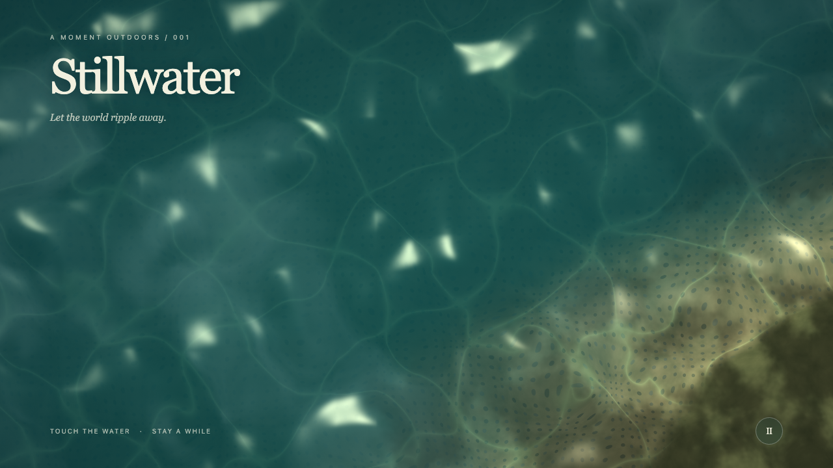 | 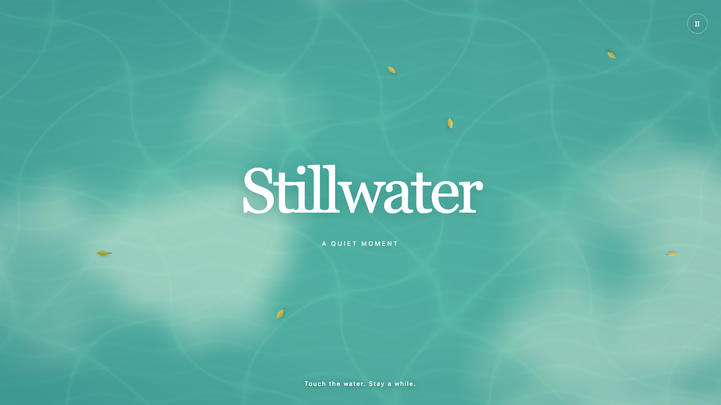 | 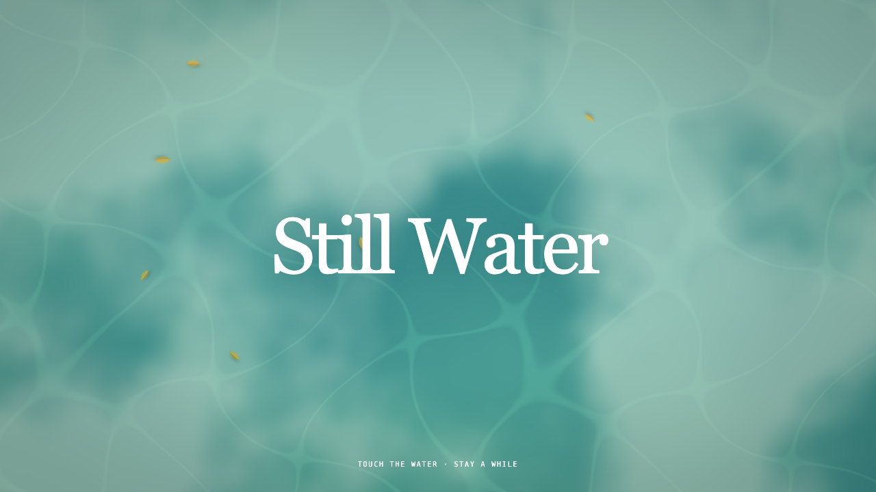
Dark realistic water and an invented shoreline. | Bright illustrated water with drifting leaves. | Similar calm look with tighter code compliance.

GitHub links
Repository: https://github.com/ChrisandraVaz/context-engineering-pond-experiment
Overview: https://chrisandravaz.github.io/context-engineering-pond-experiment/
Run 1: https://chrisandravaz.github.io/context-engineering-pond-experiment/run-1.html
Run 2: https://chrisandravaz.github.io/context-engineering-pond-experiment/run-2.html
Run 3: https://chrisandravaz.github.io/context-engineering-pond-experiment/run-3.html
All hosted links were verified live on September 11, 2026.

Main comparison
The biggest difference between Run 1 and Run 2 was the style. Run 1 looked darker and more realistic, while Run 2 looked brighter, flatter, and calmer.
The biggest difference between Run 2 and Run 3 was technical compliance. Their finished scenes looked similar, but Run 3 followed the requested WebGL structure more closely.
The clearest evidence was the change from Run 1's invented shoreline to the broad reflections and separate drifting leaves in Runs 2 and 3.
A limit is that each context setup was tested only once, so some differences could come from normal variation between model outputs.

My reflection
The initial goal of this experiment was to create a realistic version of water on a pond or lake-like surface from the top and visualize it using WebGL fragment shaders in a self-contained HTML file. I expected the added context to change how the illustration’s colours, typography, and motion differed per run. My main research question was: How does adding visual and technical context change the output of the same WebGL lake prompt?
I kept the three runs fair by generating them in separate, clean Codex tasks. Each untouched file was tested in the same 1280 by 720 browser view with the same click pattern. None of the runs produced a warning or console error. I also tested them with the mouse and cursor, checked whether the titles were readable, looked for grammar and legibility issues, clicked to test the ripple effect, and moved the cursor to see if that changed the water. What stayed mostly the same was the Still Water title style and the use of ripple effects, although the capitalization was not consistent. Run 1 used about eight ripple slots, while Run 3 used ten.
Run 1 started with only the basic context: make a self-contained WebGL lake or pond viewed from above. Because there was almost no visual direction, the model invented a dark, realistic shoreline with bright reflections. Run 2 added much more visual language. The prompt said to make the scene calm, bright, and illustrated rather than photographic, with blue-green water, darker edges, broad cloud reflections, and drifting leaves. Those details tap into emotion, colour, and specific visual forms. You can see that this was the main differentiator between Run 1 and Run 2.
Run 3 included the basic and visual context, but elevated it with much more technical detail. It requested hash randomness, value noise, fractal Brownian motion, domain warping, constant loop bounds, a device pixel ratio cap, and screen-space antialiasing. Run 2 had softer, brighter illustrated water with drifting leaves. Run 3 had a similar calm look, but to me it had more depth and looked more natural. Run 2’s repeated ripples also became stronger than expected, while Run 3 followed more of the technical requirements and produced cleaner ripples.
Honestly, Run 2 caused the biggest visual turning point, which makes sense because that was where the prompt first added a real visual context layer. Looking back, though, I think the technical details also affected the appearance. You can see a shift between Run 2, which focused heavily on the visual direction, and Run 3, which kept that direction but added real technical depth. Comparing the outputs was useful because it showed me what a successful context prompt can look like when it includes a high degree of nuance in both its visual and technical details.
A limitation is that each setup was tested only once, so some differences may have come from normal model variation. I used Sol in Codex for all three runs. If I did the experiment again, I would run each setup more than once and focus even more on the visual and technical depth.

My two judgement sentences
Output: I trust the result because the changes accurately connected to how I wrote the context, and Run 2 honestly stands out as my favourite because the drastic difference from Run 1 made them look like two different artists from two different worlds.
Process: What worked was keeping the test fair by using clean chats, equal browser sizes, the same expectations, and the same test actions for every run; the parts I could improve are testing each setup more than once and defining realism more consistently across the runs.

